# Power BI Assignment 2025 Submission

Name: **Shaurya Chand**

Project Title: **Return Performance & Employee Contribution Dashboard**

## Objective

## The objective of this project was to design a Power BI dashboard that analyzes product return performance and employee contribution across regions. The goal was to track return trends over time, evaluate employee-level performance using year-over-year (YoY) comparisons, and generate actionable insights that can help optimize return management, employee productivity, and business decision-making.

## Dataset

* **Orders Dataset:** Contains details of customer orders including order date, region, and sales information.
* **Returns Dataset:** Captures records of returned items with corresponding order details.
* **People Dataset:** Includes employee information mapped to regions.
* **Date Table:** A custom date dimension created to enable time intelligence functions such as YoY difference, monthly trends, and period comparisons.

## Approach

* **Data Preparation:** Cleaned and transformed raw data in Power Query, ensuring date formats were consistent and removing errors.
* **Data Modeling:** Built a star schema model linking Orders (fact table) with Returns, People, and the Date table (dimension tables).
* **DAX Measures:** Created calculated measures for key KPIs including Return Count, Return Rate %, Average Return Value, and YoY % change using CALCULATE, DIVIDE, and SAMEPERIODLASTYEAR.
* **Visualization Design:** Developed a professional dashboard featuring:

1. KPI cards for Return Count, Return Rate %, and Avg Return Value with YoY indicators.
2. Employee-level performance table with Return Count YoY difference and Monthly YoY %.
3. Bar chart of top employees by returns with YoY comparison.
4. Line chart overlaying Monthly Return Count vs Last Year.
5. Donut chart highlighting % contribution by employee.

* **Interactivity:** Added slicers for Date, Region, and Employee to allow drill-down analysis.

## Key Insights

* **Return Growth:** Return Count increased by **40.8% YoY**, with the Return Rate reaching **11.5%**, showing a consistent upward trend.
* **Value Impact:** Despite higher return volumes, the **Average Return Value dropped by 5.8%**, suggesting customers are increasingly returning lower-value items.
* **Employee Contribution:** Anna from the West region accounted for **62% of all returns**, with a **43% YoY growth**, making her the dominant contributor. Other employees such as Magee (16%) and Kelly Williams (13%) showed smaller contributions.
* **Regional/Seasonal Trends:** Returns peak strongly in **Q4 (Oct–Dec)**, highlighting a seasonal effect that requires better planning during year-end.
* **Performance Variation:** While Anna and Cassandra Brandow show strong positive YoY changes, other employees have flatter or negative trends, indicating areas for review.

## Dashboard Screenshot

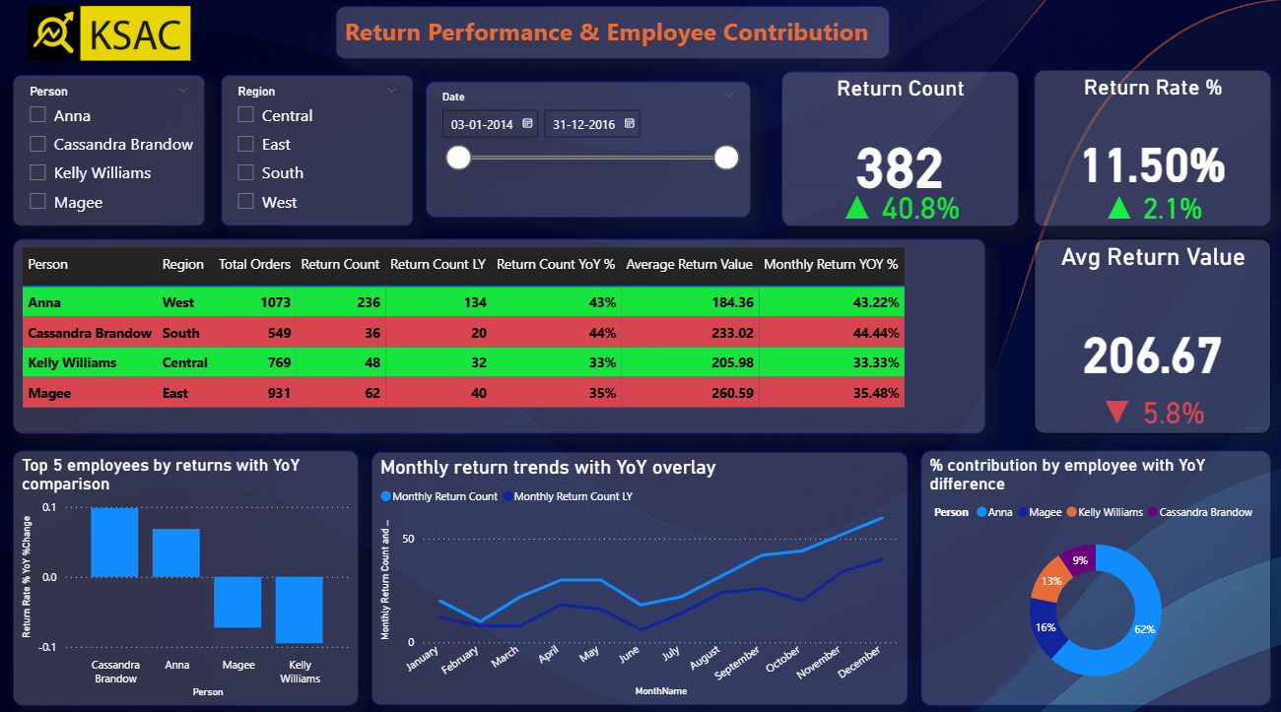

## PBIX File Link

The Power BI (.pbix) file has been uploaded to Google Drive. You can access it using the link below:  
  
<https://drive.google.com/file/d/1c3YOuSp7ryU2NHQisCtXV6hvs6msas7v/view?usp=sharing>