http://public-repo-1.hortonworks.com/ambari/centos6/2.x/updates/2.4.0.1/AMBARI-2.4.0.1-centos6.tar.gz

Backup ambari database

Update repo file to point new ambari repo

yum -y upgrade ambari-server

yum -y upgrade ambari-agent

On Ambari server host execute the bello command

ambari-server upgrade

Error output from schema upgrade command:

Exception in thread "main" org.apache.ambari.server.AmbariException: Duplicate key name 'hstcmpnntdesiredstatecmpnntnme'

at org.apache.ambari.server.upgrade.SchemaUpgradeHelper.executeUpgrade(SchemaUpgradeHelper.java:207)

at org.apache.ambari.server.upgrade.SchemaUpgradeHelper.main(SchemaUpgradeHelper.java:347)

Caused by: com.mysql.jdbc.exceptions.jdbc4.MySQLSyntaxErrorException: Duplicate key name 'hstcmpnntdesiredstatecmpnntnme'

at sun.reflect.NativeConstructorAccessorImpl.newInstance0(Native Method)

at sun.reflect.NativeConstructorAccessorImpl.newInstance(NativeConstructorAccessorImpl.java:62)

at sun.reflect.DelegatingConstructorAccessorImpl.newInstance(DelegatingConstructorAccessorImpl.java:45)

at java.lang.reflect.Constructor.newInstance(Constructor.java:422)

at com.mysql.jdbc.Util.handleNewInstance(Util.java:411)

at com.mysql.jdbc.Util.getInstance(Util.java:386)

at com.mysql.jdbc.SQLError.createSQLException(SQLError.java:1052)

at com.mysql.jdbc.MysqlIO.checkErrorPacket(MysqlIO.java:3597)

at com.mysql.jdbc.MysqlIO.checkErrorPacket(MysqlIO.java:3529)

at com.mysql.jdbc.MysqlIO.sendCommand(MysqlIO.java:1990)

at com.mysql.jdbc.MysqlIO.sqlQueryDirect(MysqlIO.java:2151)

at com.mysql.jdbc.ConnectionImpl.execSQL(ConnectionImpl.java:2619)

at com.mysql.jdbc.ConnectionImpl.execSQL(ConnectionImpl.java:2569)

at com.mysql.jdbc.StatementImpl.execute(StatementImpl.java:824)

at com.mysql.jdbc.StatementImpl.execute(StatementImpl.java:667)

at org.apache.ambari.server.orm.DBAccessorImpl.executeQuery(DBAccessorImpl.java:827)

at org.apache.ambari.server.orm.DBAccessorImpl.addFKConstraint(DBAccessorImpl.java:472)

at org.apache.ambari.server.orm.DBAccessorImpl.addFKConstraint(DBAccessorImpl.java:456)

at org.apache.ambari.server.upgrade.UpgradeCatalog240.updateServiceComponentDesiredStateTableDDL(UpgradeCatalog240.java:1630)

at org.apache.ambari.server.upgrade.UpgradeCatalog240.executeDDLUpdates(UpgradeCatalog240.java:303)

at org.apache.ambari.server.upgrade.AbstractUpgradeCatalog.upgradeSchema(AbstractUpgradeCatalog.java:889)

at org.apache.ambari.server.upgrade.SchemaUpgradeHelper.executeUpgrade(SchemaUpgradeHelper.java:204)

... 1 more

ERROR: Error executing schema upgrade, please check the server logs

After executing ambari upgrade command again the above error gone

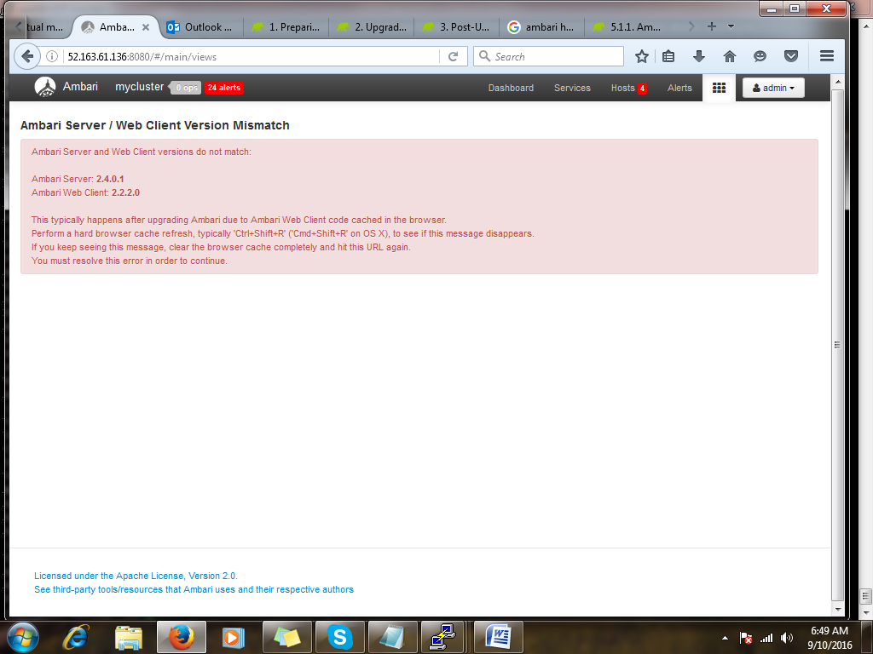

Pressing Ctrl + shift + r resolved above issue

HDP Upgrade

http://public-repo-1.hortonworks.com/HDP-UTILS-1.1.0.21/repos/centos6/HDP-UTILS-1.1.0.21-centos6.tar.gz

http://public-repo-1.hortonworks.com/HDP/centos6/2.x/updates/2.5.0.0/HDP-2.5.0.0-centos6-rpm.tar.gz

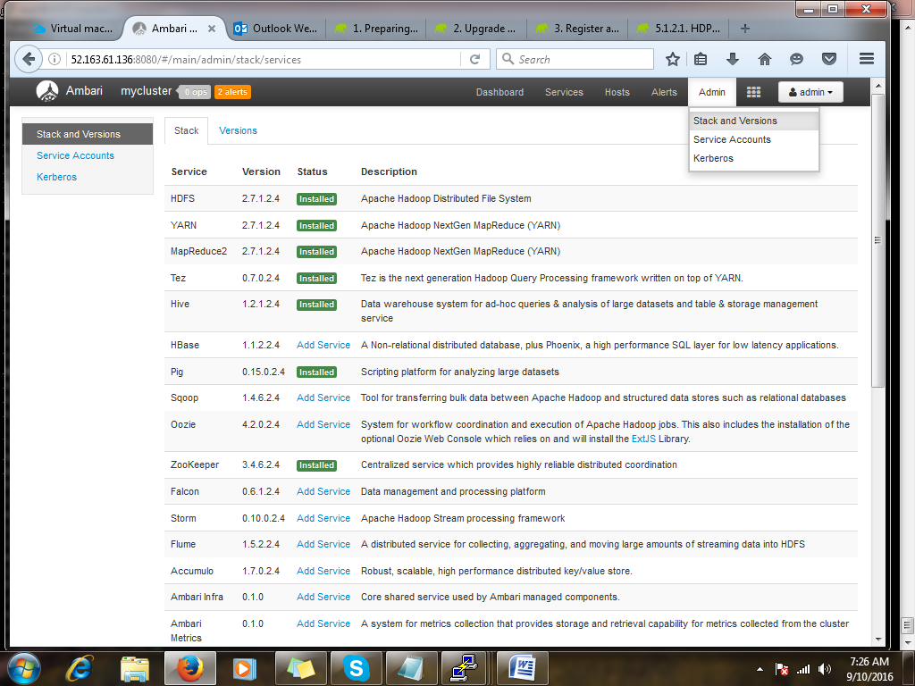

Select versions

