**HUE Installation on Kerberos enabled HDP Cluster**

1. Install HUE service using yum command

yum -y install hue

1. Enable Web HDFS

Open Ambari -> HDFS -> Configuration -> WebHDFS

Restart the services if required.

1. Create principal and key tab for hue service

Connect to KDC admin , create a new service principal for hue , generate the keytab file and copy to appropriate location. Change the permission and ownership of the file.

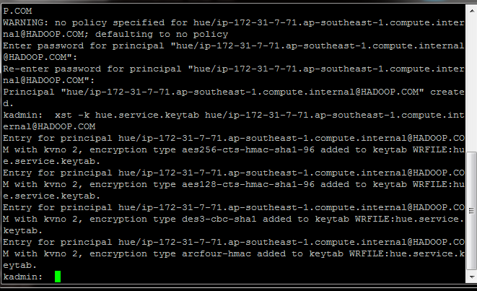

add_principal hue/ip-172-31-7-71.ap-southeast-1.compute.internal@HADOOP.COM

xst -k hue.service.keytab hue/ip-172-31-7-71.ap-southeast-1.compute.internal@HADOOP.COM

modprinc -maxrenewlife 90day krbtgt/HADOOP.COM@HADOOP.COM

modprinc -maxrenewlife 90day +allow_renewable hue/ip-172-31-7-71.ap-southeast-1.compute.internal@HADOOP.COM

1. Open the HUE configuration file /etc/hue/conf/hue.ini and add bellow properties

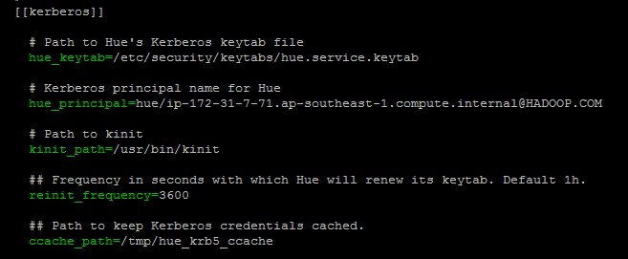

1. In hue configuration file hue.ini change the parameter value to security_enabled=true

Default value is false, we need to change that to true

1. In core-site.xml file add the following parameters and values ( We can do these steps using Ambari )

<property>

<name>hadoop.proxyuser.hue.hosts</name>

<value>*</value>

</property>

<property>

<name>hadoop.proxyuser.hue.groups</name>

<value>*</value>

</property>

<property>

<name>hadoop.proxyuser.hcat.groups</name>

<value>*</value>

</property>

<property>

<name>hadoop.proxyuser.hcat.hosts</name>

<value>*</value>

</property>

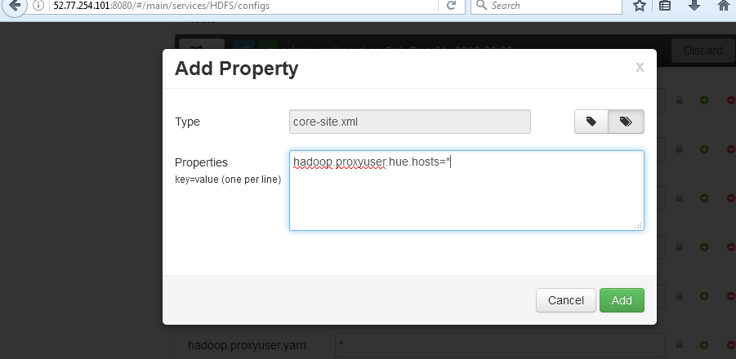

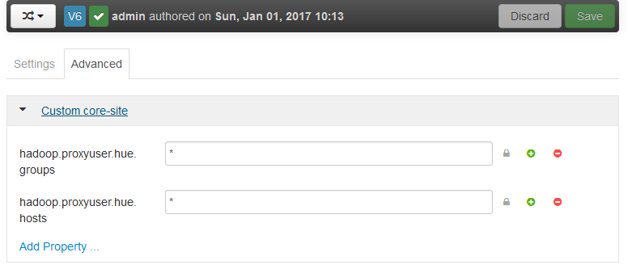

1. In webcat-site.xml file add following values ( Ambari based steps are attached )

<property>

<name>webhcat.proxyuser.hue.hosts</name>

<value>*</value>

</property>

<property>

<name>webhcat.proxyuser.hue.groups</name>

<value>*</value>

</property>

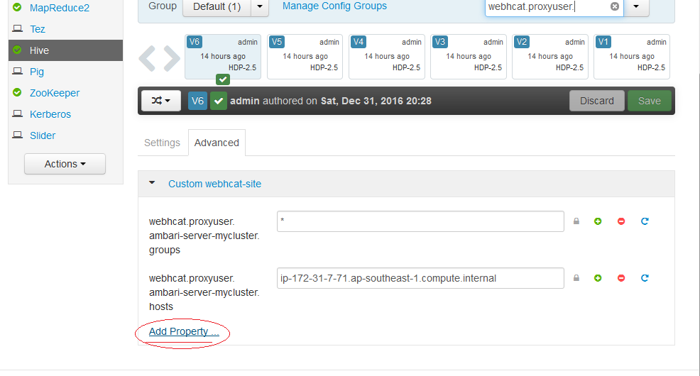

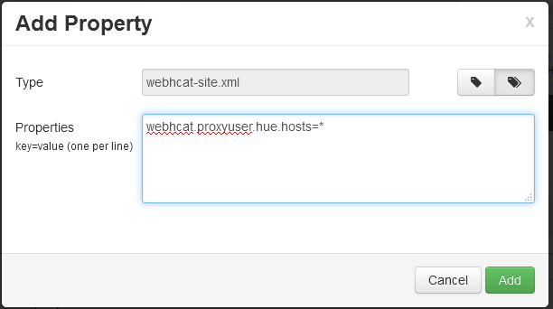

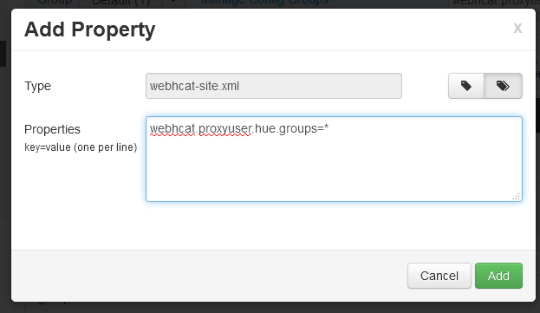

1. Add the following parameter for Oozie configuration

<property>

<name>oozie.service.ProxyUserService.proxyuser.hue.hosts</name>

<value>*</value>

</property>

<property>

<name>oozie.service.ProxyUserService.proxyuser.hue.groups</name>

<value>*</value>

</property>

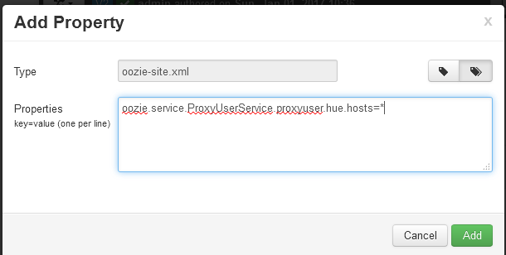

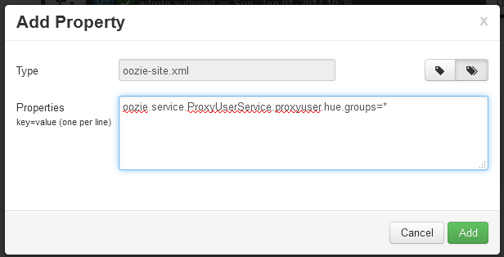

1. Add bellow value to hive-site.xml

<property>

<name>hive.server2.enable.doAs</name>

<value>true</value>

</property>

**Referance:-**

**http://docs.hortonworks.com/HDPDocuments/HDP2/HDP-2.3.0/bk_installing_manually_book/content/configure_hdp_hue.html**

