Create a new topic ubuntutopic

kafka-topics --zookeeper ip-172-31-19-170.ap-south-1.compute.internal:2181 --create --replication-factor 1 --partitions 1 --topic ubuntutopic

list the available topics

kafka-topics --zookeeper ip-172-31-19-170.ap-south-1.compute.internal:2181 –list

open producer on one terminal

kafka-console-producer --topic ubuntutopic --broker-list ip-172-31-19-178.ap-south-1.compute.internal:9092

open another terminal and open consumer

kafka-console-consumer --zookeeper ip-172-31-19-170.ap-south-1.compute.internal:2181 --topic ubuntutopic

type message at producer terminal , if working properly the same message would be visible at consumer terminal

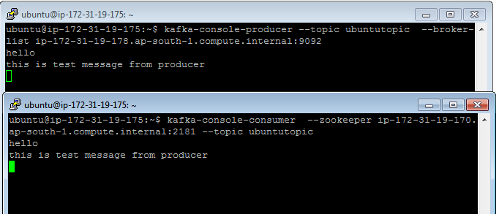

**New test on HDP 2.5**

/usr/hdp/current/kafka-broker/bin/kafka-topics.sh --zookeeper node2.hadoop.com:2181,node1.hadoop.com:2181,master.hadoop.com:2181 --create --replication-factor 1 --partitions 1 --topic sijeeshtopic

/usr/hdp/current/kafka-broker/bin/kafka-topics.sh --zookeeper node2.hadoop.com:2181,node1.hadoop.com:2181,master.hadoop.com:2181 –list

/usr/hdp/current/kafka-broker/bin/kafka-console-producer.sh --topic sijeeshtopic --broker-list node2.hadoop.com:6667

/usr/hdp/current/kafka-broker/bin/kafka-console-consumer.sh --zookeeper node2.hadoop.com:2181,node1.hadoop.com:2181,master.hadoop.com:2181 --topic sijeeshtopic