OpenLDAP-Ambari Integration

Prepared by : Sijeesh Kunnotharamal

Configure open LDAP server /AD

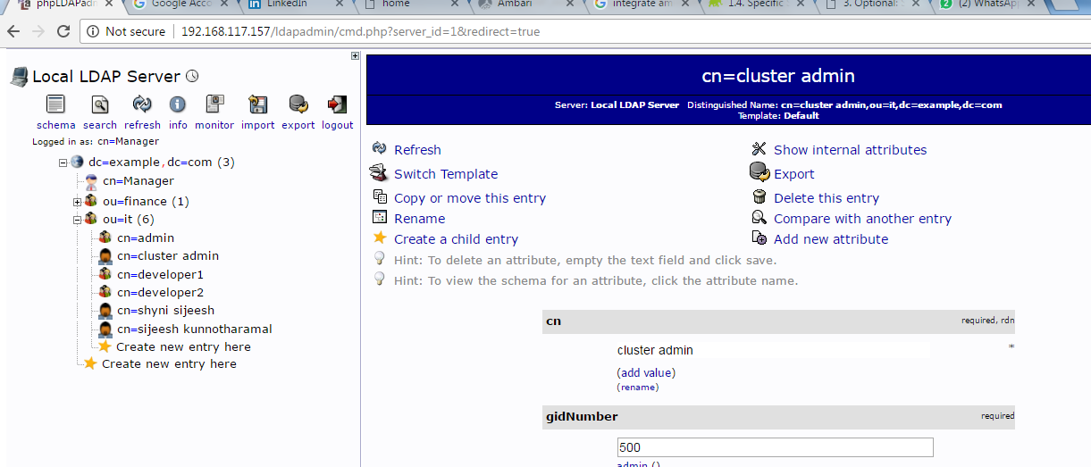

On Ambari server machine stop ambari-server service



Execute ambari-server setup-ldap ( one time activity )

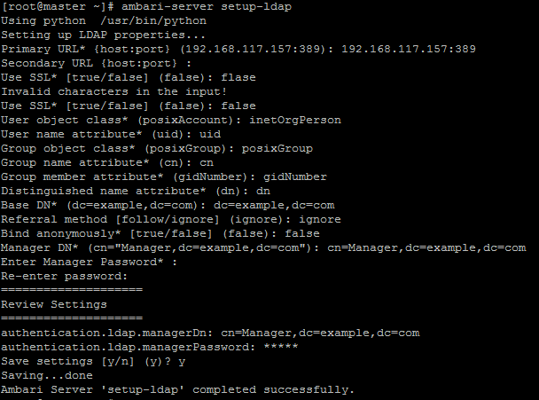

Execute following commands whenever you need to add new users or groups

Adding particular user , add list of users name in a simple text file and do execute ldap-sync command



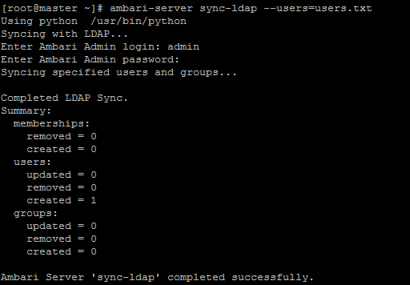

Similarly for adding a new group execute the bellow command ,users belong to this group would be able to login to ambari

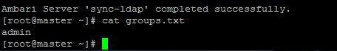

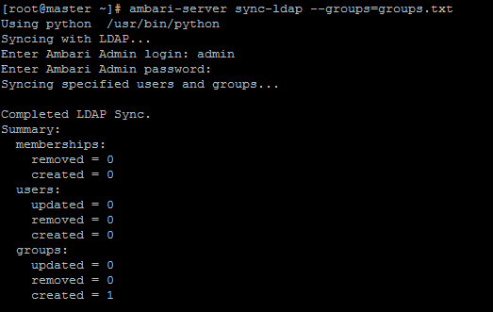

Verify that the users are imported properly

