## SUPPORTED DATABASES

* IBM DB2 11.1 and above.
* IBM Informix 12.10.
* Intersystem Cache 2017.2 and above.
* MariaDB.
* Microsoft SQL 2005 and above.
* MongoDB.
* MySQL.
* Oracle Database 9 and above.
* PostgreSQL 9.5 and above.
* Sybase/SAP Adaptive Server Enterprise 15.7 and above.
* Teradata 14.10.00.02 and above.
* Tibero 6.

## REQUIREMENTS:

| **Component** | **Description** |
| --- | --- |
| Proxy Agent | **Windows Agent with database runtime components**  The Windows Agent with Database Runtime Components can scan all supported databases and is recommended for scanning IBM DB2 and Oracle Databases.  **Windows Agents (without database runtime components) and Linux Agents**  To use Windows Agents (without database runtime components) and Linux Agents to scan databases, make sure the ODBC drivers for the Target database are installed on the Agent host.  Specific requirements for each database type are listed in DBMS Connection Details. |
| Database Credentials | Your database credentials must have the minimum required privileges to access the databases, schemas, or tables to be scanned.  Example: To scan a MySQL database, use credentials that have SELECT (data reader) permissions. |

## DBMS CONNECTION DETAILS

### Microsoft SQL Server

| **Settings** | **Description** |
| --- | --- |
| Default Port | 1433  If connection to the database uses a port other than 1433, the [:<port>] value must be defined in the **Path** field. |
| Recommended Proxy Agents | * Windows Agent with database runtime components |
| **Path** Syntax | * All locations: [:<port>] Example: Leave the Path blank, or :9999 * Specific database: <database[:<port>]> Example: GLDB:9999 * Specific schema: <database[:<port>]/schema> Example: GLDB:9999/HRAdmin * Specific table: <database[:<port>]/schema/table> Example: GLDB:9999/HRAdmin/Employees * Scan a specific SQL Server instance (where multiple are running): <database(instance=<instance_name>)[:<port>][/schema][/table]> Example: GLDB(instance=MsSQLInst2):9999/HrAdmin/Employees   NOTE: In Microsoft SQL Server, a "database" may also be referred to as a "catalog". |

### Oracle Database

| **Settings** | **Description** |
| --- | --- |
| Default Port | 1521  If connection to the database uses a port other than 1521, the [:<port>] value must be defined in the **Path** field. |
| Recommended Proxy Agents | * Windows Agent with database runtime components |
| **Path** Syntax | * All locations: [:<port>] Example: Leave the Path blank, or :9999 * Specific schema: <schema[:<port>]> Example: hr:9999 * Specific table: <schema[:<port>]/table> Example: hr/employees   **Connect using a fully qualified domain name (FQDN)**  When adding an Oracle Database as a Target location, you may need to enter the fully qualified domain name (FQDN) of the database server instead of its host name.  **Oracle 12x/TNS: protocol adapter error**  If you are using Oracle 12x, or if the Oracle database displays a “TNS: protocol adapter error”, you must specify a SERVICE_NAME   * Scan a specific schema or table using service name: <schema(SERVICE_NAME=<ServiceName>)[:port]/table Example: hr(SERVICE_NAME=GLDB)/employees |

### PostgreSQL

| **Settings** | **Description** |
| --- | --- |
| Default Port | 5432  If connection to the database uses a port other than 5432, the [:<port>] value must be defined in the **Path** field. |
| Recommended Proxy Agents | * Windows Agent with database runtime components * Windows Agent * Linux Agent with database runtime components * Linux Agent |
| **Path** Syntax | * Specific database: <database[:<port>]> Example: gldb:9999 * Specific schema: <database[:<port>]/schema> Example: gldb:9999/hr * Specific table: <database[:<port>]/schema/table> Example: gldb/hr/employees   NOTE: PostgreSQL by default blocks remote connections to the PostgreSQL server. To configure the PostgreSQL to allow remote connections, see Allow Remote Connections to PostgreSQL Server. |

### MySQL

| **Settings** | **Description** |
| --- | --- |
| Default Port | If connection to the database uses a port other than 3306, the [:<port>] value must be defined in the **Path** field. |
| Required Proxy Agents | * Windows Agent with database runtime components * Windows Agent * Linux Agent with database runtime components * Linux Agent |
| **Path** Syntax | * All locations: [:<port>] Example: Leave the Path blank, or :9999 * Specific database: <database[:<port>]> Example: hr:9999 * Specific table: <database[:<port>]/table> Example: hr/employees   Pagination is enabled by default when scanning MySQL databases. To disable pagination, set the option (paged=false).   * All locations: (paged=false)[:<port>] Example: (paged=false) * Specific database: <database(paged=false)[:<port>]> Example: hr(paged=false):9999 * In MySQL, a "database" may also be referred to as a "schema". |

## ADD A DATABASE TARGET LOCATION

1. From the **New Scan** page, [Add Targets](https://www.groundlabs.com/documentation/v2p1/er/Content/Targets/Add-Targets.html).
2. In the **Enter New Target Hostname** field, enter the host name of your database server.
3. Click **Test**. If **ER2** can connect to the Target, the button changes to a **Commit** button.
4. In the **Select Types** dialog box, click on **Database**.
5. In **Database**, select the DBMS type running on your database server. Click **Done**.
6. In the next window, enter the database connection settings. Fill in the following fields:

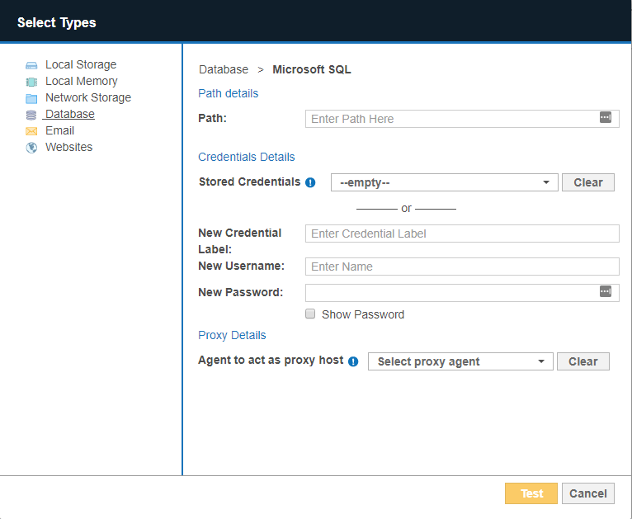

| **Field** | **Description** |
| --- | --- |
| Path | Enter path details of the database. See DBMS Connection Details for information on the Path syntax to use. |
| Credential Details | If you have stored the credentials, select from **Stored Credentials**. If not, enter:   * + **Credential Label**: Enter a descriptive label for the credential set.   + **Username**: User name for the database.   + **Password**: Password for the database.   **Windows Authentication for Microsoft SQL**  From **ER2** 2.0.21, Windows authentication is supported for Microsoft SQL 2008 and above.  To use Windows authentication, enter your Windows account credentials:   * + **Username**: Windows domain and username in the <domain_name\user_name> format.   + **Password**: Windows password.   For more information on Windows or SQL Server authentication modes, see Choose an Authentication Mode. |
| Proxy Details | Select an Agent.  See DBMS Connection Details for database-specific Agent requirements. For optimal performance, use an Agent installed on the database server. |

1. Click **Test**. If **ER2** can connect to the Target, the button changes to a **Commit** button.
2. Click **Commit** to add the Target.