Smart Urban Mobility and Traffic Intelligence
Milestone 2: Geospatial & Transit Analytics Report

Executive Summary & Introduction

This document details the completion of Milestone 2 for the Smart Urban Mobility and Traffic Intelligence Dashboard. The primary focus of this phase was to construct a geospatial analytics layer to evaluate transit performance, map passenger demand, and identify systemic disruptions across the
Chennai metropolitan area. The resulting Power BI dashboard transforms raw locational and operational data into an interactive, enterprise-grade spatial intelligence tool.

Problem Statement

Urban transit authorities frequently struggle with spatial blindness. While aggregate ridership data exists, the inability to visualize where demand concentrates, when disruptions occur, and how specific routes perform geometrically leads to inefficient fleet allocation. Without a unified geographic data model, transit managers cannot respond dynamically to weather events, time-based bottlenecks, or regional service failures.

Core Objectives

  - Geospatial Mapping: Translate raw latitude/longitude coordinates into accurate, interactive heatmaps to visualize passenger density.
  - Hierarchical Drill-Down: Enable granular data exploration from the macro level (City) down to micro levels (Zone, Location, and Route).
  - Performance Tracking: Compute critical operational KPIs (Total Trips, Total Passengers, Reliability Rate, Total Disruptions) using optimized DAX formulas.
  - Multi-Dimensional Interactivity: Implement unified filtering across temporal (Date, Time), environmental (Weather), and spatial (Zone, Route) dimensions.

Real-World Applications & Use Cases

- Dynamic Fleet Allocation: By monitoring the Mobility Demand Heatmap, dispatchers can reroute idle vehicles from low-density zones to high-demand clusters during peak hours.
- Weather-Impact Analysis: Using the Weather slicer, city planners can isolate the correlation between adverse conditions (e.g., Rain) and the drop in the Reliability Rate, informing preventative maintenance or schedule adjustments.
- Route Decommissioning/Expansion: The Passenger Volume by Route chart explicitly identifies underperforming and over-utilized routes, providing empirical backing for budget allocation.
- Disruption Management: High Total Disruptions isolated to specific geographic zones trigger immediate investigation into localized infrastructure failures or traffic bottlenecks.

Dashboard Architecture & Metrics Report

The dashboard is built on a robust Star Schema connecting Fact_Transit with three dimension tables (Dim_Location, Dim_Date, Dim_Weather). The active Milestone 2 metrics reflect the following operational baseline:
5K
TOTAL TRIPS
2M
TOTAL PASSENGERS
84.44%
RELIABILITY RATE
778
TOTAL DISRUPTIONS

Visual Component | Technical Implementation & Purpose
Mobility Demand Heatmap | Utilizes exact Latitude and Longitude coordinates. Rendered with a 25px radius blur to identify critical demand hotspots across Chennai. Stripped of legend categorizations to ensure accurate continuous density mapping.
Zonal Passenger Distribution | Built utilizing a custom geographical hierarchy (City → Geo_Zone → Geo_Location → Route_ID). Enables executives to drill down into specific regional sectors to analyze localized ridership.
Passenger Volume by Route | A horizontal bar chart sorted by passenger count. It strips away redundant axes and utilizes exact data labels, providing an immediate ranking of network utilization.
Daily Passenger Trends | A dual-axis line chart mapping Total Passengers against the calculated Reliability Rate over precise calendar dates. Date hierarchy defaults were disabled to prevent unwanted temporal aggregation.
Interactive Control Panel | Five horizontal dropdown slicers configured to maximize the data-ink ratio. Permits complex cross-filtering (e.g., isolating Route RT-105 during Rain on a specific date).

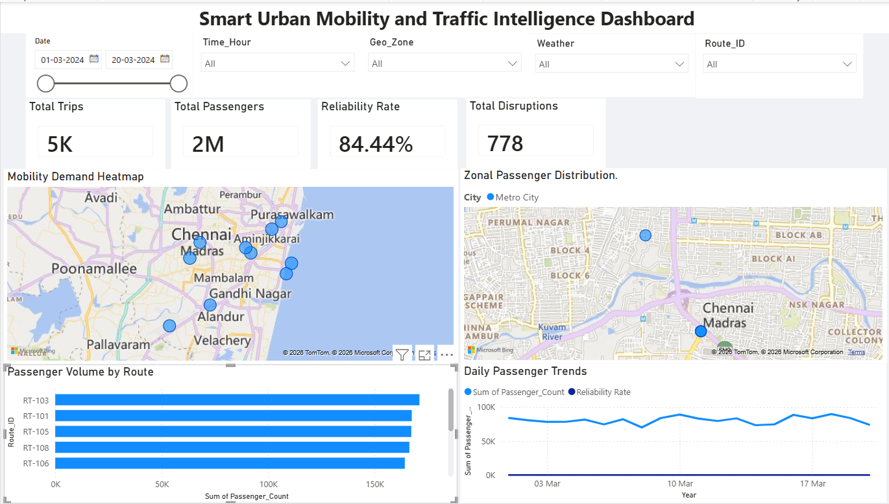
6.Dashboard

