INTERNSHIP PROJECT REPORT
Smart Urban Mobility and
Traffic Intelligence Dashboard
End-to-End Data Engineering, Geospatial Analytics,
Demand Intelligence and Executive Mobility Reporting

Student | CH. Venkata Chandu
Project Domain | Smart Mobility & Transit Analytics
Primary Platform | Microsoft Power BI Desktop
Engineering Stack | Python (Pandas) via VS Code
Internship Context | Infosys Springboard Internship Program
Prepared as a consolidated internship project report

Document Control
Item | Details
Report Title | Smart Urban Mobility and Traffic Intelligence Dashboard
Prepared By | CH. Venkata Chandu
Project Type | Internship Project
Domain | Smart Urban Mobility, Transit Analytics and Business Intelligence
Tools | Power BI Desktop, DAX, Python, Pandas, VS Code
Report Scope | Milestones 1–4 and final dashboard outputs

Contents
1. Executive Summary
2. Project Overview and Objectives
3. Technology Stack and Solution Architecture
4. Milestone 1 – End-to-End Data Pipeline & Architecture
5. Milestone 2 – Geospatial & Transit Analytics
6. Milestone 3 – Demand Intelligence & Mobility Analytics
7. Milestone 4 – Executive Intelligence, Mobility Equity & Demand Forecasting
8. Integrated Dashboard Insights
9. Conclusion
10. References
Report note
This report consolidates the supplied milestone documents and the three final dashboard screenshots. Dashboard values are presented as shown in the supplied project artifacts.

1. Executive Summary
The Smart Urban Mobility and Traffic Intelligence Dashboard is a Power BI-based business intelligence solution designed to convert raw urban transit telemetry into actionable mobility intelligence. The project combines a Python ETL pipeline, a relational Star Schema, explicit DAX measures, interactive geospatial analysis, modal-substitution analytics, mobility-equity indicators and demand forecasting.
The engineering workflow begins with 5,000 raw telemetry records. Python and Pandas are used to clean and engineer the data, standardize spatial sectors and route identifiers, harmonize weather categories, and enrich the model with demographic attributes. The resulting analytical model uses Fact_Transit as the central fact table with Dim_Location, Dim_Date and Dim_Weather as dimensions.
Across the milestones, the dashboard progresses from foundational data engineering and KPI validation to geospatial mapping, behavioral mobility analysis, executive intelligence, mobility equity and predictive demand analysis. The final output provides a unified view of passenger demand, operational friction, spatial accessibility and future demand patterns.
Key reported baseline
The supplied artifacts report approximately 2 million passengers, 5K trips, 84.44% reliability, 778 disruptions and a 15.79°C average temperature baseline. The final executive screen additionally reports 470K ride-hail volume, 328K micromobility volume and 7.78 minutes average delay.

2. Project Overview and Objectives

2.1 Problem Statement
Urban transit authorities often have access to large volumes of operational data but lack a unified analytical layer that explains where demand is concentrated, when disruptions occur, how routes perform, and how external conditions influence passenger behavior. Denormalized telemetry logs can contain redundant attributes, missing categorical keys and weak spatial structure, making direct analysis slower and less useful for operational decision-making.

2.2 Project Objectives
- Automated ETL Engineering: ingest 5,000 raw telemetry logs and build a modular Python cleaning and feature-engineering pipeline.
- Relational Data Modeling: transform flat telemetry data into a Star Schema with three dimension tables and one central fact table.
- Geospatial Mapping: translate latitude and longitude into interactive spatial views that expose passenger-demand hotspots.
- DAX Metric Calculation: create explicit measures for passenger volume, temperature, utilization and data quality.
- Mobility Intelligence: analyze weather sensitivity, modal substitution and operational friction across transport modes.
- Executive Decision Support: combine operational KPIs, spatial equity, forecasting and anomaly analysis into an interactive dashboard.

2.3 Expected Business Value
- Support dynamic fleet allocation by identifying high-demand spatial clusters.
- Improve disruption management by locating geographically concentrated operational issues.
- Support route expansion or decommissioning decisions using passenger-volume evidence.
- Identify relationships between weather conditions, reliability and modal shifts.
- Highlight mobility-access disparities between geographic zones.
- Provide forward-looking demand information for proactive capacity planning.

3. Technology Stack and Solution Architecture
Layer | Technology | Purpose
Data Ingestion & ETL | Python + Pandas | Cleaning, transformation, feature engineering and structured CSV generation
Development | VS Code | Implementation and testing of the Python ETL workflow
Data Model | Power BI Star Schema | Fact/dimension modeling for analytical performance and maintainability
Analytics | DAX | Explicit reusable measures for KPIs and analytical ratios
Visualization | Power BI Desktop | Interactive dashboards, maps, matrices, charts, slicers and forecasting
Spatial Analysis | Latitude / Longitude mapping | Passenger-density and mobility-access visualization

3.1 Star Schema
The analytical model separates descriptive attributes from measurable transit events. Fact_Transit stores individual trip and passenger measures, while Dim_Location, Dim_Date and Dim_Weather provide spatial, temporal and environmental context. The supplied Milestone 1 documentation specifies 1:* single-directional relationships from the dimensions to the fact table using surrogate integer keys.
Table | Type | Representative Attributes
Fact_Transit | Fact | DateKey, LocationKey, WeatherKey, Passenger Count, Temperature, Delay_Minutes
Dim_Location | Dimension | LocationKey, Route ID, Location, Population, Population Density
Dim_Date | Dimension | DateKey, Date, Year, Month, Day, DayOfWeek
Dim_Weather | Dimension | WeatherKey, Weather category: Clear, Rain, Fog, Snow

3.2 ETL Flow
Stage | Processing
1. Raw telemetry | Load denormalized urban transit observations.
2. Cleaning | Resolve missing or inconsistent values and standardize categorical fields.
3. Spatial engineering | Partition coordinates into standard transit sectors and connect routes to spatial zones.
4. Feature engineering | Calculate passenger counts and align weather and demographic attributes.
5. Relational output | Generate structured fact and dimension datasets for Power BI.
6. BI modeling | Create relationships, DAX measures and interactive report pages.

4. Milestone 1 – End-to-End Data Pipeline & Architecture
Milestone 1 established the foundation of the solution. The Python ETL pipeline ingests 5,000 raw telemetry records, engineers ten standard transit sectors from latitude and longitude, maps route identifiers RT-101 through RT-110 to engineered zones, standardizes weather categories, calculates passenger counts and enriches the model with demographic metrics.
The Power BI model then organizes the data into a Star Schema and introduces explicit DAX measures. The supplied report records approximately 2 million total passengers, an average temperature of 15.79°C, a transit utilization rate of 0.97 and a 100.0% data-quality score.

4.1 Key DAX Measures
Measure | Formula / Logic | Purpose
Total Passengers | SUM(Fact_Transit[Passenger Count]) | Gross transit ridership
Average Temperature | AVERAGE(Fact_Transit[Temperature]) | Ambient climate baseline
Transit Utilization Rate | DIVIDE([Total Passengers], SUM(Dim_Location[Population]), 0) | Ridership intensity relative to population
Data Quality Score | Valid rows ÷ total fact rows | Data completeness and governance check

4.2 Milestone 1 Dashboard
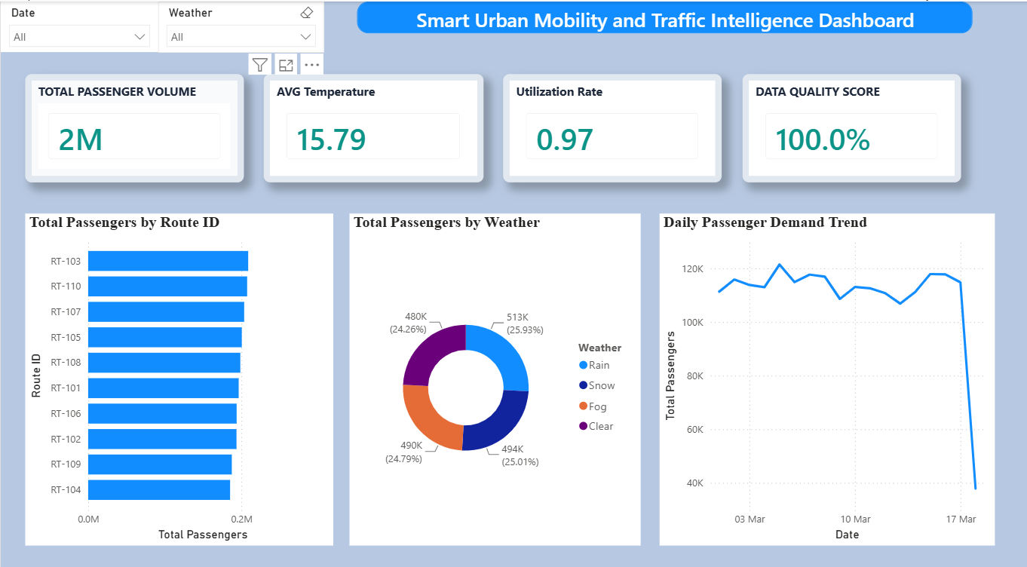
Figure 1. Milestone 1 dashboard: KPI cards, route-level passenger demand, weather distribution and daily demand trend.
Milestone 1 outcome
The foundation phase delivered a validated ETL-to-BI pipeline, a structured relational model, explicit DAX measures and an operational dashboard layout.

5. Milestone 2 – Geospatial & Transit Analytics
Milestone 2 introduced the geospatial analytics layer. The objective was to reduce spatial blindness by mapping passenger demand, identifying high-density clusters and supporting route and disruption analysis across the Chennai metropolitan area.

5.1 Geospatial and Analytical Capabilities
- Mobility Demand Heatmap: uses exact latitude and longitude coordinates with a continuous density representation.
- Hierarchical Drill-Down: supports City → Geo_Zone → Geo_Location → Route_ID analysis.
- Operational KPI Tracking: reports Total Trips, Total Passengers, Reliability Rate and Total Disruptions.
- Daily Passenger Trends: compares passenger volume and reliability across calendar dates.
- Interactive Filtering: supports combined filtering across date, time, weather, zone and route.

5.2 Milestone 2 Dashboard
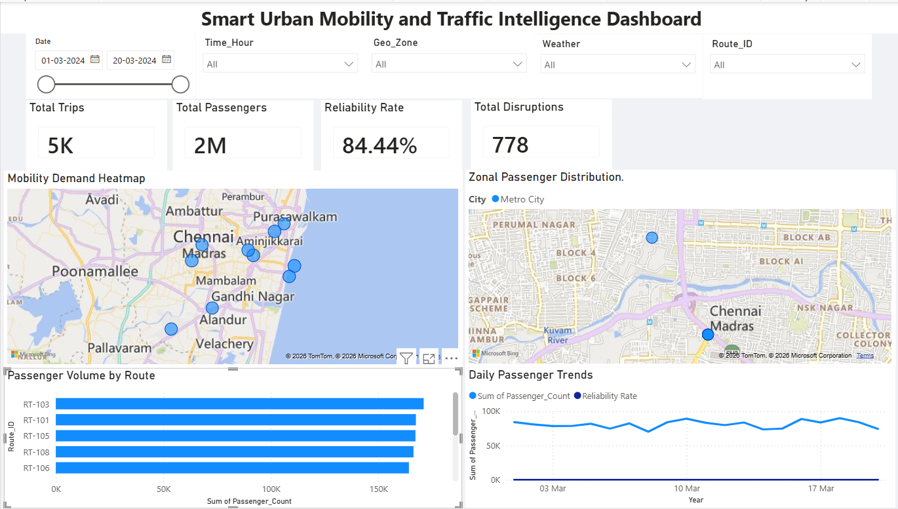
Figure 2. Milestone 2 dashboard: demand heatmap, zonal passenger distribution, route volume and daily passenger trends.

5.3 Operational Applications
- Dynamic Fleet Allocation: shift available vehicles toward high-demand clusters during peak periods.
- Weather-Impact Analysis: isolate reliability changes under adverse weather conditions.
- Route Planning: identify underperforming and over-utilized routes using passenger volume.
- Disruption Management: investigate zones with unusually high disruption counts.
Milestone 2 reported baseline
The supplied Milestone 2 report shows 5K total trips, 2M total passengers, 84.44% reliability and 778 total disruptions.

6. Milestone 3 – Demand Intelligence & Mobility Analytics
Milestone 3 moved from simple volume reporting toward behavioral mobility intelligence. Passenger movement was separated by transport mode and connected with temporal, environmental and spatial variables to examine when, where and why riders shift away from conventional transit toward ride-hailing and micromobility alternatives.

6.1 Core Analytics
- Weather Sensitivity Matrix: cross-tabulates weather conditions against Bike, Bus, Ride-Hail and Scooter activity and applies conditional formatting.
- Modal Substitution Analysis: uses a 100% stacked column chart to compare relative market share rather than raw counts.
- Hourly Demand Velocity: analyzes demand across 24 hourly buckets to expose peak infrastructure stress.
- Operational Friction: compares average delay minutes by transport mode.
- Network Demand Trend: plots demand continuously over calendar time to preserve anomalous patterns.

6.2 Data Architecture
Component | Role
Fact_Transit | Individual trips, passenger metrics, timestamps and Delay_Minutes
Dim_Date | Full date dimension, day flags, seasonality and continuous timeline
Dim_Location | Spatial boundaries, zoning identifiers and station nodes
Dim_Weather | Precipitation, snow and temperature-threshold attributes

6.3 Milestone 3 Dashboard
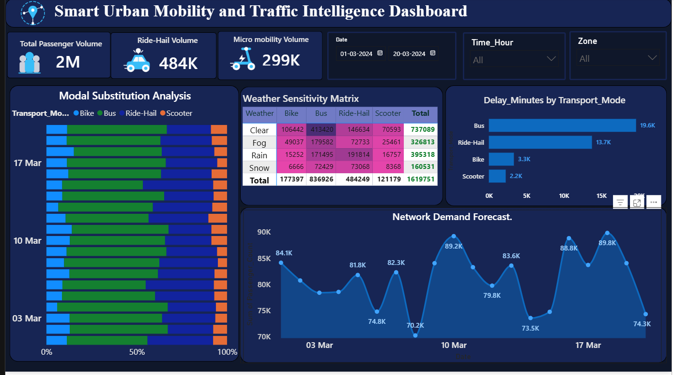
Figure 3. Milestone 3 dashboard: modal substitution, weather sensitivity, operational friction and network demand forecast.
Milestone 3 outcome
The dashboard shifts the analysis from 'how many passengers?' to 'how passenger behavior changes across weather, time, location and transport mode.'

7. Milestone 4 – Executive Intelligence, Mobility Equity & Demand Forecasting
Milestone 4 consolidated the analytical outputs into executive-facing decision pages. The final dashboard is organized into three major analytical views: Executive Intelligence, Mobility Equity and Demand Forecasting.

7.1 Executive Intelligence
The Executive Intelligence page summarizes network-scale passenger activity and operational friction. The supplied screenshot reports 2M total passengers, 470K ride-hail volume, 328K micromobility volume and 7.78 average delay. A 100% stacked modal-substitution chart shows the relative share of Bike, Bus, Ride-Hail and Scooter activity over time, while a horizontal bar chart compares average operational friction by mode.
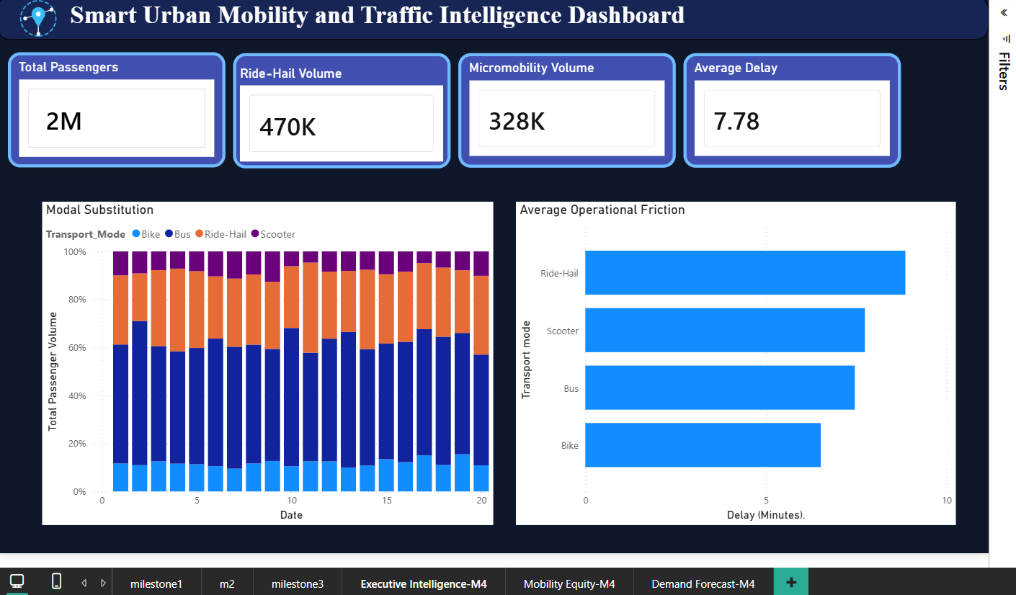
Figure 4. Milestone 4 – Executive Intelligence page showing passenger volume, ride-hail and micromobility KPIs, modal substitution and operational friction.

7.2 Mobility Equity
The Mobility Equity page focuses on accessibility differences across the urban network. It combines a spatial map of Mobility Access Index values with a ranked zone comparison and an Average Reliability KPI. The supplied screenshot reports an overall Mobility Access Index of 5.00 and average reliability of 84.44%.
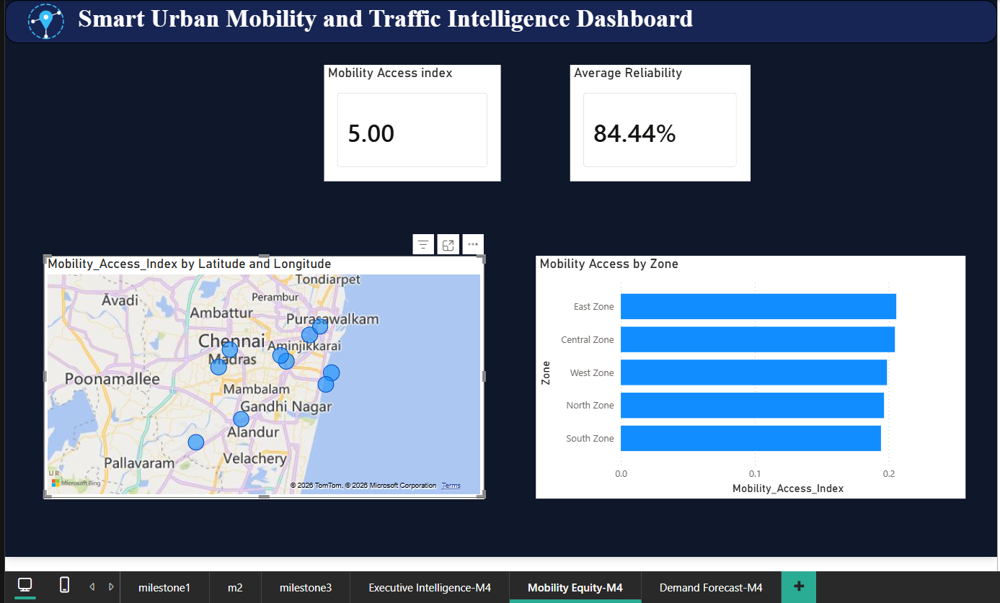
Figure 5. Milestone 4 – Mobility Equity page showing spatial access indicators and Mobility Access Index by zone.

7.3 Demand Forecast and Anomaly Analysis
The Demand Forecast page projects network passenger demand beyond the historical period and presents an anomaly log. The forecast chart shows a central forecast with an uncertainty band, while the anomaly table ranks days by total passenger volume across Bike, Bus, Ride-Hail and Scooter. This view is intended to support proactive capacity planning and investigation of unusual demand patterns.
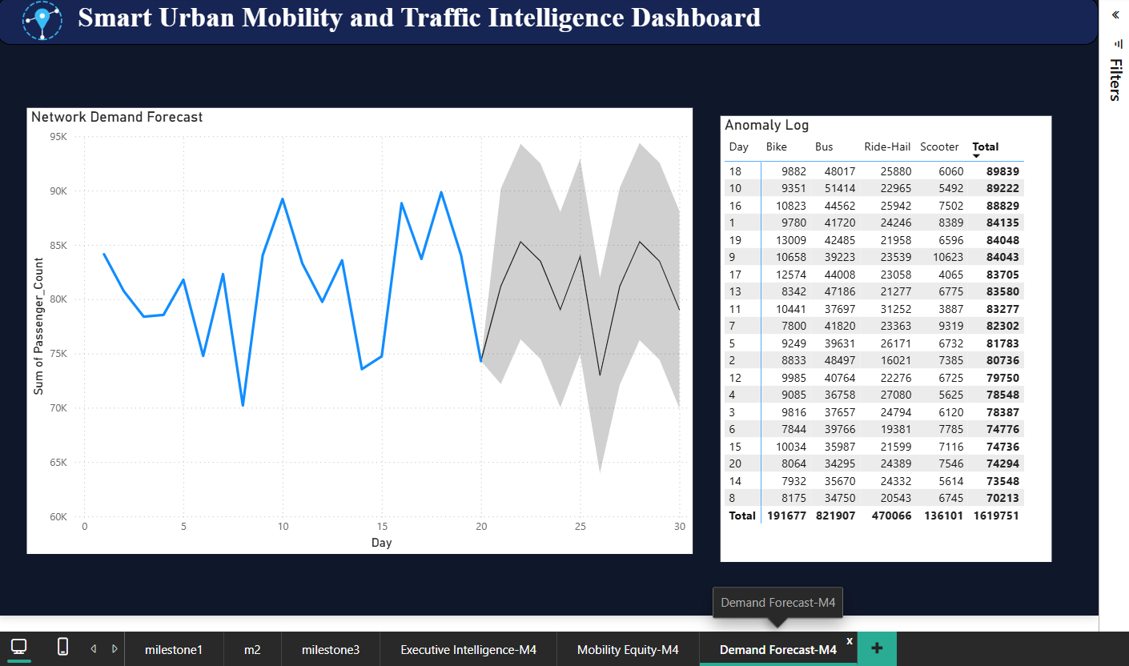
Figure 6. Milestone 4 – Demand Forecast page with projected network demand and anomaly log.
Milestone 4 outcome
The final milestone converts the analytical model into an executive decision-support layer covering network performance, mobility equity and forward-looking demand.

8. Integrated Dashboard Insights

8.1 Demand and Network Scale
Across the supplied dashboard pages, passenger demand is consistently reported at approximately 2 million passengers. The visual progression from daily demand trends to network forecasting allows the user to move from historical observation to forward-looking planning.

8.2 Reliability and Operational Friction
The dashboard reports an 84.44% reliability rate in the geospatial and mobility-equity views. The executive page adds average delay by transport mode, making operational friction directly comparable across the mobility network.

8.3 Modal Substitution
The 100% stacked modal-substitution view emphasizes relative market share among Bike, Bus, Ride-Hail and Scooter. This is more informative for behavioral analysis than comparing only raw passenger counts because it highlights changes in the composition of mobility demand.

8.4 Spatial Equity
The Mobility Equity page adds a spatial-access perspective that complements passenger-volume analysis. The map and ranked zone chart make it possible to compare access patterns across East, Central, West, North and South zones.

8.5 Forecasting and Anomaly Detection
The final demand page introduces a forecast horizon and anomaly log. This extends the dashboard from descriptive and diagnostic analytics toward predictive decision support, enabling planners to investigate unusually high-demand days and prepare capacity responses.

8.6 Recommended Operational Use
Decision Area | Dashboard Evidence | Potential Action
Fleet allocation | Demand heatmap + forecast | Move capacity toward emerging demand clusters.
Disruption response | Reliability + disruption KPIs + map | Investigate affected zones and adjust service.
Route planning | Passenger volume by route | Review under-utilized and overloaded corridors.
Weather response | Weather sensitivity matrix | Adjust schedules and capacity during adverse conditions.
Mobility equity | Access index map + zone ranking | Prioritize underserved zones for service improvements.
Capacity planning | Forecast + anomaly log | Prepare for expected peaks and investigate outliers.

9. Conclusion
The Smart Urban Mobility and Traffic Intelligence Dashboard establishes an end-to-end analytics workflow from raw telemetry to executive decision support. The project combines Python-based ETL, Star Schema modeling, explicit DAX measures, geospatial visualization, behavioral mobility analysis, equity indicators and demand forecasting in one Power BI solution.
The milestone progression demonstrates a clear analytical maturity path: Milestone 1 establishes data quality and modeling foundations; Milestone 2 adds spatial intelligence; Milestone 3 explains modal behavior and operational friction; and Milestone 4 packages these capabilities into executive, equity and forecasting views.
The resulting dashboard can support practical transit planning activities such as fleet allocation, disruption investigation, route assessment, weather-response planning, mobility-access evaluation and demand-capacity preparation. The supplied project artifacts therefore demonstrate a complete business intelligence workflow with a strong emphasis on actionable urban mobility analytics.
Final project statement
The project bridges raw transit telemetry and business intelligence by structuring the data, defining reusable analytical measures and presenting the results through interactive decision-oriented dashboards.

10. References
1. Infosys Springboard Internship Program Guidelines.
2. Microsoft Power BI documentation: Data Modeling, DAX, visualization and forecasting capabilities.
3. Python Pandas documentation and data-engineering practices used for ETL and data transformation.
4. Project Milestone 1 report: Smart Urban Mobility and Traffic Intelligence Dashboard – End-to-End Data Pipeline, Star Schema Architecture & DAX Validation.
5. Project Milestone 2 report: Smart Urban Mobility and Traffic Intelligence Dashboard – Geospatial & Transit Analytics.
6. Project Milestone 3 documentation: Smart Urban Mobility & Traffic Intelligence Dashboard – Demand Intelligence & Mobility Analytics.
7. Final Power BI dashboard screenshots supplied for Milestone 4: Executive Intelligence, Mobility Equity and Demand Forecast.

Appendix A – Dashboard Screenshot Index
Figure | Dashboard Page | Primary Purpose
Figure 1 | Milestone 1 | ETL validation, KPI foundation and baseline demand analysis
Figure 2 | Milestone 2 | Geospatial demand, zones, routes and reliability
Figure 3 | Milestone 3 | Modal substitution, weather sensitivity and operational friction
Figure 4 | Milestone 4 – Executive Intelligence | Network-scale executive summary
Figure 5 | Milestone 4 – Mobility Equity | Spatial accessibility and zone comparison
Figure 6 | Milestone 4 – Demand Forecast | Forecasting and anomaly analysis

