**Experiment No. 3**

**Aim:**  To produce a Dovetail joint and Mortise joint and T-shaped joint in the carpentry shop

**Materials Used: TEAK WOOOD**

**Size of work piece:** Dovetail joint- 125mm length, 50mm breadth, 35mm thickness.

**Measuring Instruments:**  1.Try square 2. steel rule

3.Marking gauge 4.Pencil

**Tools required**  :

**1.Flat File:** It is a rectangular shaped instrument . Consits a handle attached to a blade.

**2.Triangular file:** it is instrument with triangular cross section

**3.Square file:** It is a file with square cross section.

**4.Bench Vise**: It is a device used to hold the object(work piece).it is made of metal ,has 2 jaws one is fixed and one is movable and a screw to adjust.

**5.MALLET HAMMER:** used for removing edges of a chisel.

**6.Mortise Chisel:** used for making strong mortise joints.

**7.Wood Rasp:** it is a tool consisting a round or circular cross section made of steel and a handle to hold it.

**8.Jack plane:**it is a tool used for cutting or removing chips from the wood.

**Sequence of operation for dovetail joint:**

1. **Take the tesk wood and mark the dimensions as shown in the drawing.**
2. 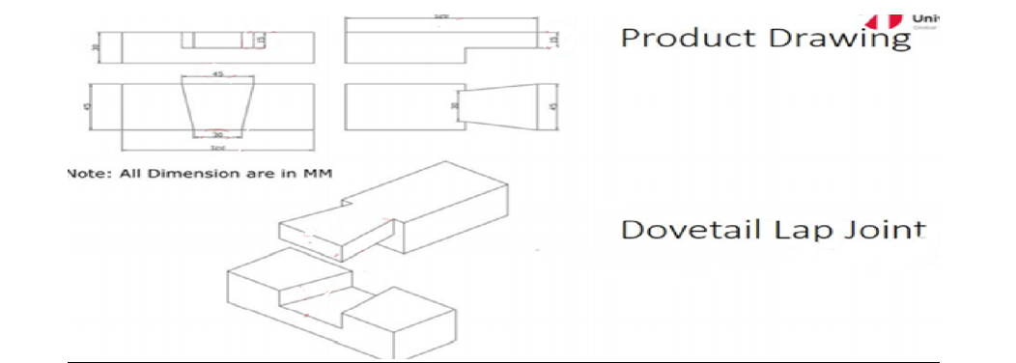
3. **Now cut 2 vertical work pieces of teak wood using hand saw and mortise chisel**
4. **Take the vertical worpices and perform rough filing for both the peices.**
5. **Cut the unnecessary material using band saw.**
6. **Chisel the ends of the worpieces.**

**6.now for the dovetail part perforn wood rasp filling.**

**7.check weather both the pieces are fitting properly.**

**8 .f not perform further filing.**

**9.final product is achived**

**10.clean the workspace after use.**

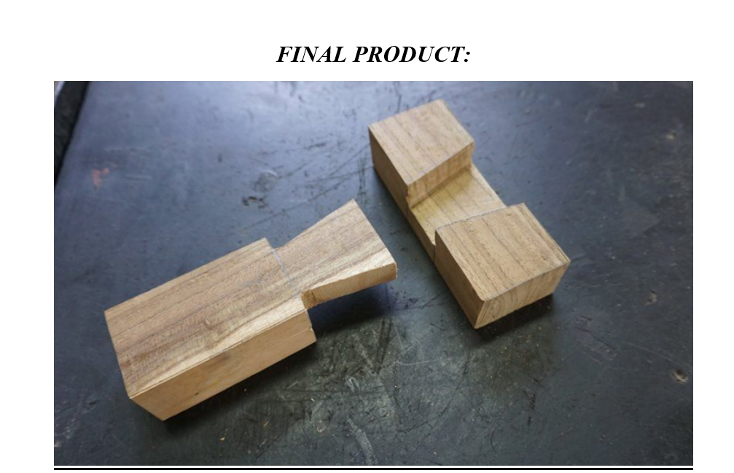

**Result:**

**the dovetail joint is exactly prepared in the workshop.**

**Conclusion:**

**I learnt to make dove tail joint in the work shop sucessfully.**

**Sequence of operations for Mortise tail:**

**1.take the workpiecse and mark the dimesions as present in the drawing.**

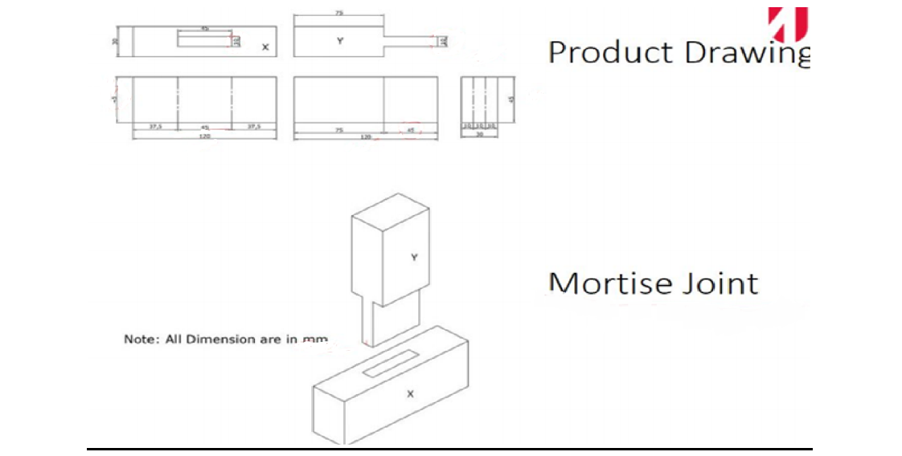

**2.Check weather all marking are made and perform cutting for 2 workpiecses.**

**3.perform rough filing for the edges and to the required places.**

**4.using try square check the angle of the workpieces.**

**5.take the x piece and apply chalk and using vernier height guage mark required lines.**

**6.using dot punch make hole and remove the unwanted material using .**

**7.now take the y piece apply chalk and using vernier height guage mark required lines.**

**8.cut the y piece into desired shape.**

**9.remove the unwanted part using flat chisel.**

**10.for the stepped surface perform filing using square and triangle files.**

**11.now fit both of them together.**

**12.if they are not fitting exactly perform filing.**

**13.final product is obtained.** 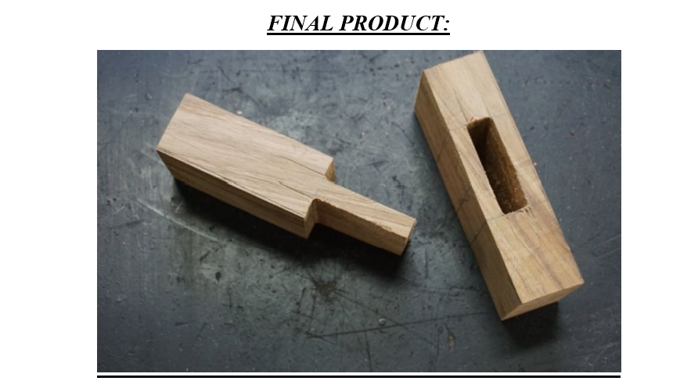

**Sequecne for T-shaped Joint:**

**1.take the take wood and place it inside vise to hold it .**

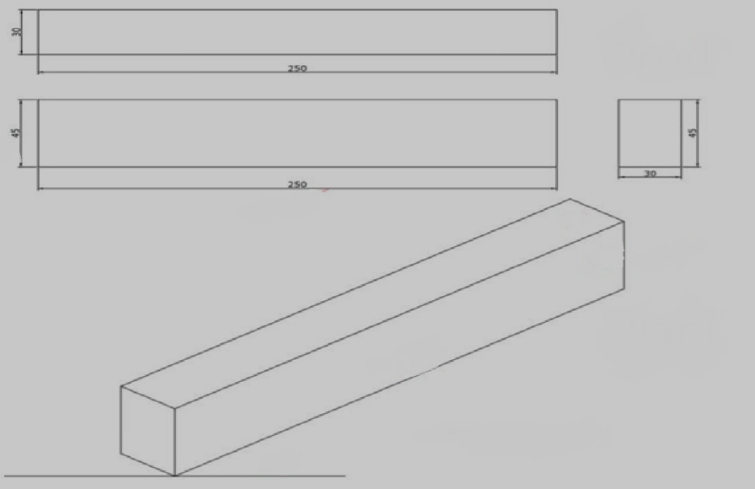

**2.clean the wood using jack plane and remove if there are any chips.**

**3.mark 30mm on the workpiece using height guage.**

**4.remove the extra part using jack plane.**

**5.on the other side of the same workpiece mark 45mm and remove the unwanted part.**

**6.cut the work piece to our desired shape.**

**7.perform filing after cutting.**

**8.make it into 2 havles.**

**9.one part is corner lap joint and another is t-lap joint.**

**10.draw the central line for the both joints.**

**11.mark the lines using height guage on both the workpieces.**

**12.cut the unwanted material using hacksaw.**

**13.now using chisel and mallet hammer remove the marked material.**

**14.perform filing.**

**15.check weather the workpieces fit properly.**

**16.if not perform filing or cut the unwanted pieces.**

**17.final product is obtained.**

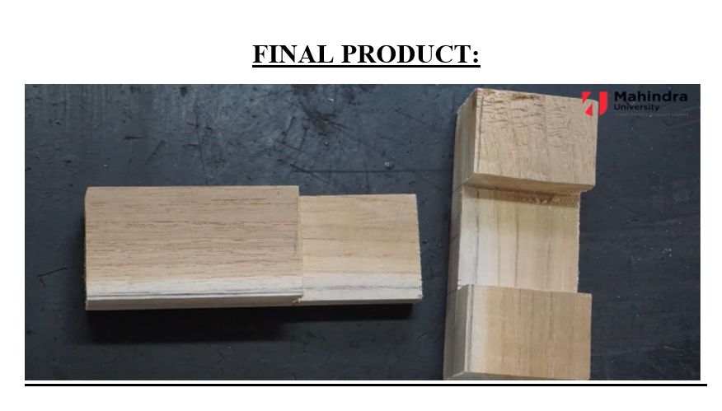

**RESULT:**

**T-shaped joint and** Mortise tail joint are properly made**.**

**CONCLUSION:**

I learnt to make T-shaped joint and Mortise tail joint in the work shop perfectly.