Simple Ethereum Voting Application

1.Remix online IDE (For developing Smart contract).
2.Any code editor (I recommended visual studio code)
3.ganache-cli (Ethereum test rpc network for developing For our decentralized application).

The application is extremely simple, all it does is initialize a set of contestants, let anyone vote for the candidates and display the total votes received by each candidate.

The entire application set up and build was done on a fresh installation of ubuntu 16.04 LTS

1. Setting up the development environment

Instead of developing the app against the live blockchain, we will use an in- memory blockchain (think of it as a blockchain simulator) called ganache. we will interact with the real blockchain. Below are the steps to install ganache, web3js and start the test blockchain on a linux operating system.

Install ganache-cli in your system for this use this command

sudo npm install -g ganache-cli

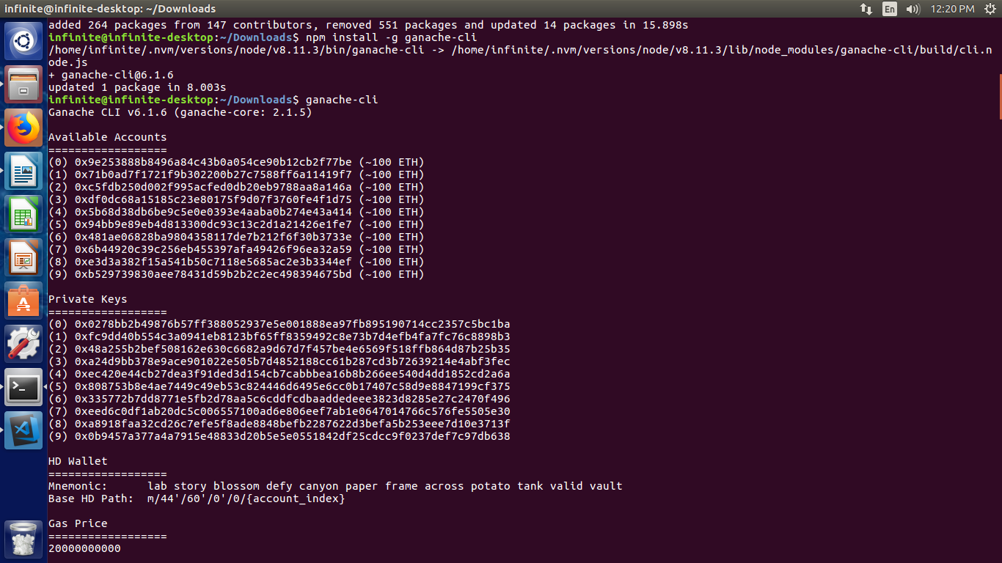

Notice that the ganache-cli creates 10 test accounts to play with automatically. These accounts come preloaded with 100 (fake) ethers.

2. Simple voting contract

Note: The constructor is invoked once and only once when you deploy the contract to the blockchain. Unlike in the web world where every deploy of your code overwrites the old code, deployed code in the blockchain is immutable. i.e, If you update your contract and deploy again, the old contract will still be in the blockchain untouched along with all the data stored in it, the new deployment will create a new instance of the contract.
Below is the voting contract code

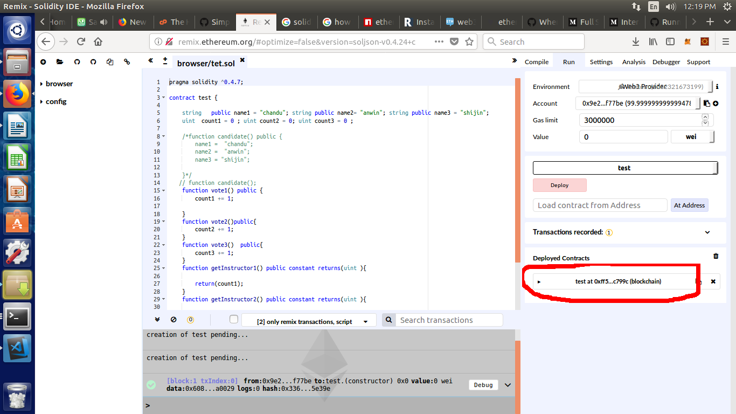

solidity program

// voting.sol program start here.

pragma solidity ^0.4.7;
// We have to specify what version of compiler this code will compile with

contract test {

string public name1 = "name1"; string public name2= "anwin2"; string public name3 = "anwin3";
uint count1 = 0 ; uint count2 = 0; uint count3 = 0 ;
//here I define the variable I used for this voting application.

// function candidate();
//This funtion is for to count how many vote get by first candidate.
function vote1() public {
count1 += 1;

}
//This funtion is for to count how many vote get by second candidate.
function vote2()public{
count2 += 1;
}
//This funtion is for to count how many vote get by third candidate.
function vote3() public{
count3 += 1;
}
//This function is for get the result,how many vote get by the first candidate.
function getInstructor1() public constant returns(uint ){

return(count1);
}
//This function is for get the result,how many vote get by the second candidate.

function getInstructor2() public constant returns(uint ){

return(count2);
}
//This function is for get the result,how many vote get by the third candidate.

function getInstructor3() public constant returns(uint ){

return(count3);
}
}

//solidity voting program end here.

Open remix online ide
http://remix.ethereum.org
and create new page name it vote.sol
and paste this code there and save .

And in compile option select start compile after successful compilation Select the run menu
Environment select Web3 provider.(make sure the remix ide is runing in http://).
And deploy the project.

4. Webpage to connect to the blockchain and

vote

Now most of the work is done, all we have to do now is create a simple html file with candidate names and invoke the voting commands (which we already tried and tested in the nodejs console in a js file. Below you can find the html code and the js file. Drop both of them in the hello_world_voting directory and open the index.html in your browser

After just come to terminal create a folder and name it voting.
For this use
mkdir voting
cd voting
install npm for that use down below code.

curl -sL https://deb.nodesource.com/setup_7.x | sudo -E bash -
sudo apt-get install -y nodejs
And type below code.

npm init

npm install ethereum/web3.js

after building web3 create a page and name it index.html
and copy the below code and paste
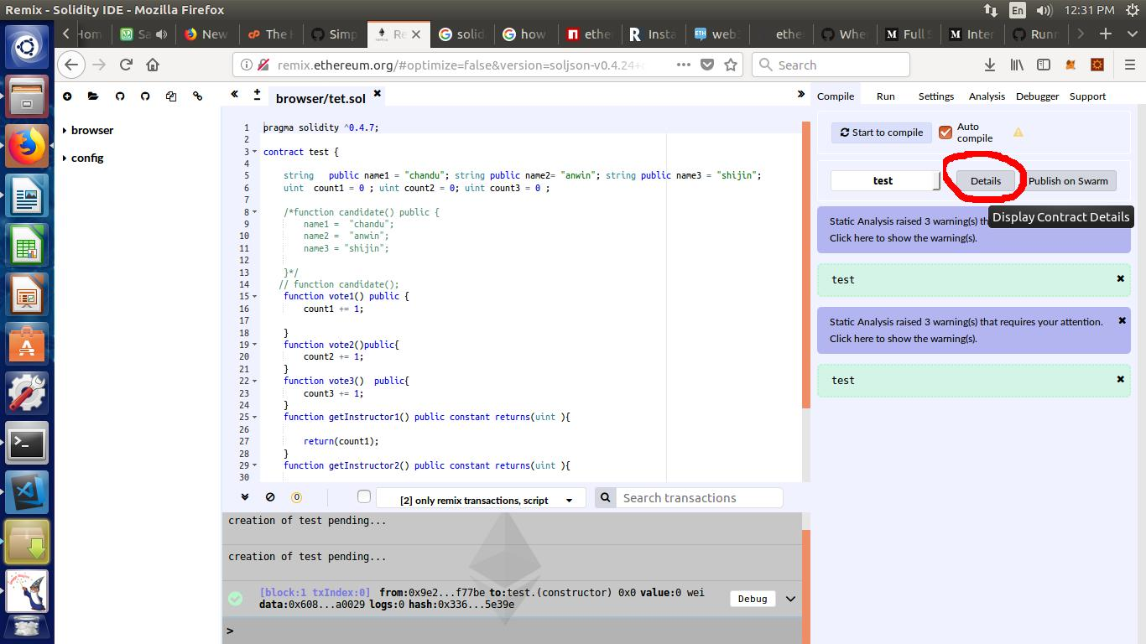
In this index.html you need to edit two things

1.Copy ABI from the remix Ide and paste inb Web3.eth.contract(‘here’)

select Details .

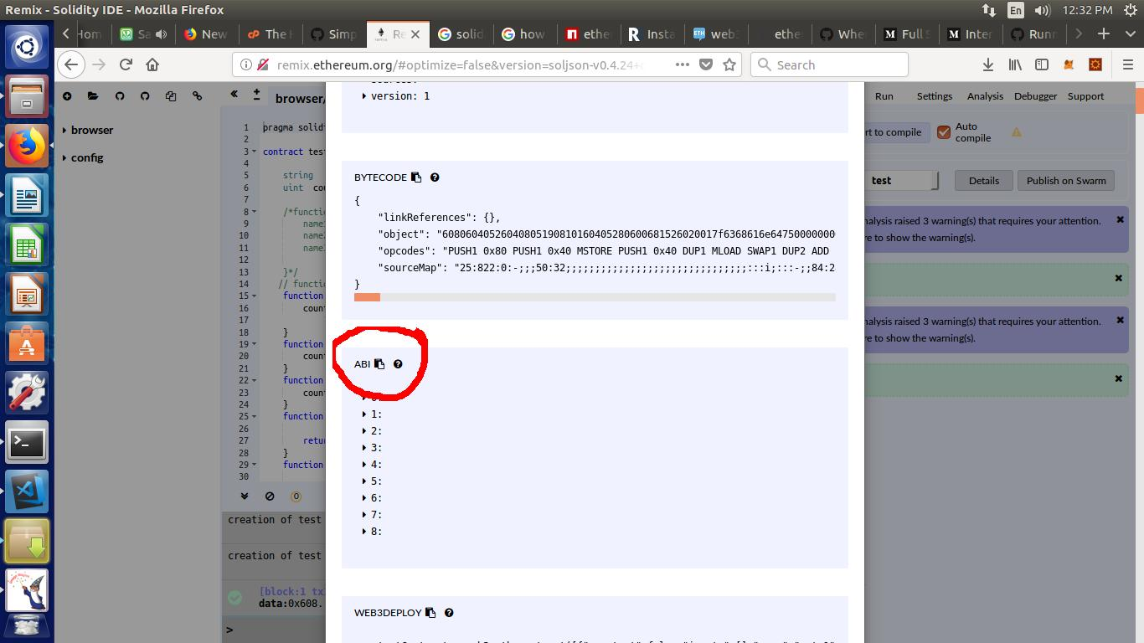

2.Copy your Contract addresss from remix ide and paste it in tesContract.at(‘here’)

You can copy the Contract Address from red marked in the above picture.

<!DOCTYPE html>
<html lang="en">
<head>
<meta charset="UTF-8">
<meta name="viewport" content="width=device-width, initial-scale=1.0">
<meta http-equiv="X-UA-Compatible" content="ie=edge">
<title>Document</title>
<script src="./node_modules/web3/dist/web3.min.js" ></script>
</head>
<!DOCTYPE html>
<head>
<html>
<style>
table, td, th {
border: 1px solid #ddd;
text-align: left;
}
table {
border-collapse: collapse;
width: 100%;
}
th, td {
padding: 15px;
}
</style>
</head>
<body>

<h2 align="center" style="color:blue;">Ethereum Voting System</h2></body>

<table style="width:100%">
<tr>
<th>Name</th>
<th>Vote</th>
<th>count</th>
</tr>
<tr>
<td>name1</td> //here put the name you want
<td ><button id ="button1"></button></td>
<td id ="output1">
<pre id =output1></pre>
</td>
</tr>
<tr>
<td>name2</td> // here put the name you want
<td><button id="button2"></button></td>
<td id="output2"></td>
</tr>
<tr>
<td>name3</td>// here put the name you want
<td><button id="button3"></button></td>
<td id="output3"> </td>
</tr>
</table>

<script>
// set the provider you want from Web3.providers
var Web3 = new Web3(new Web3.providers.HttpProvider("http://localhost:8545"));
Web3.eth.defaultAccount = Web3.eth.accounts[0];

// here is the ABI code you need to put var testcontract = Web3.eth.contract(“//put the abi code that will get it from remix id just go remix id where you alredy deploy the project and in complie down below you can see details select that and from there just find ABI and there option to copy to ABI and paste it here”).
var testContract = Web3.eth.contract([
{
"constant": false,
"inputs": [],
"name": "vote1",
"outputs": [],
"payable": false,
"stateMutability": "nonpayable",
"type": "function"
},
{
"constant": false,
"inputs": [],
"name": "vote3",
"outputs": [],
"payable": false,
"stateMutability": "nonpayable",
"type": "function"
},
{
"constant": true,
"inputs": [],
"name": "name1",
"outputs": [
{
"name": "",
"type": "string"
}
],
"payable": false,
"stateMutability": "view",
"type": "function"
},
{
"constant": true,
"inputs": [],
"name": "name2",
"outputs": [
{
"name": "",
"type": "string"
}
],
"payable": false,
"stateMutability": "view",
"type": "function"
},
{
"constant": true,
"inputs": [],
"name": "getInstructor3",
"outputs": [
{
"name": "",
"type": "uint256"
}
],
"payable": false,
"stateMutability": "view",
"type": "function"
},
{
"constant": true,
"inputs": [],
"name": "getInstructor1",
"outputs": [
{
"name": "",
"type": "uint256"
}
],
"payable": false,
"stateMutability": "view",
"type": "function"
},
{
"constant": false,
"inputs": [],
"name": "vote2",
"outputs": [],
"payable": false,
"stateMutability": "nonpayable",
"type": "function"
},
{
"constant": true,
"inputs": [],
"name": "name3",
"outputs": [
{
"name": "",
"type": "string"
}
],
"payable": false,
"stateMutability": "view",
"type": "function"
},
{
"constant": true,
"inputs": [],
"name": "getInstructor2",
"outputs": [
{
"name": "",
"type": "uint256"
}
],
"payable": false,
"stateMutability": "view",
"type": "function"
}
]);

//here you need to put your contract adderess that will get it from the remix ide
once you deploy the project using remix ide in Run menu down below you can get the contract address put that address in var test = testContract(‘put the adress here’)

var test = testContract.at('0xf03011b80aae40d3c1cb8925fe84336d3f285922');

var button1 = document.getElementById("button1");
var button2 = document.getElementById("button2");
var button3 = document.getElementById("button3");
var output = document.getElementById("output1");
output.innerHTML = test.getInstructor1();
var output2 = document.getElementById("output2");
output2.innerHTML = test.getInstructor2();
var output3 = document.getElementById("output3");
output3.innerHTML = test.getInstructor3();
button1.addEventListener("click",function(){

test.vote1();
location.reload();
});

button2.addEventListener("click",function(){

test.vote2();

location.reload();
});
button3.addEventListener("click",function(){

test.vote3();

location.reload();
});

</script>
</body>
</html>

Thats it.
ready now put your folder /var/www/html/

In your browser just open http://localhost/yourprojectfoldername/

