QR4Change: Smart QR Grievance System for India

*Yash Maske¹ , Chandrakant Thakare^{2,} Shubhankar Jakate ³ , Sakshi Lokhande ⁴ ,
Pranjal Pandit ⁵,Anuradha Yenkikar ⁵

¹²³⁴ Dept. of Computer Engineering Artificial Intelligence, Vishwakarma Institute of Information Technology, Pune, India
^{5,6} Dept. of Computer Engineering Artificial Intelligence, Vishwakarma Institute of Technology, Pune, India

* ¹yash.kishor.maske@gmail.com, ²chandrakant.22310303@viit.ac.in, ³shubhankar.22310371@viit.ac.in, ⁴sakshi.22310541@viit.ac.in, ⁵pranjalpandit90@gmail.com, ⁶anu.jamkhande@gmail.com
Abstract. Urban residents in India face considerable barriers to reporting civic issues due mostly to bureaucratic delays, lack of knowledge, fear of retribution, and outdated mechanisms. QR4Change addresses these obstacles, giving a user-friendly, transparent, and scalable mechanism to report grievances, leveraging QR code technology, computer vision, and natural language processing (NLP). Residents can scan a QR code at a civic hotspot and get a prefilled digital complaint form that enables them to classify complaints (for example, as a pothole or garbage), offer brief descriptions, and upload a picture, in near real time. A multi-stage deep learning pipeline utilizing YOLOv11n (to detect potholes) and InceptionV3 (to classify garbage) will verify the accuracy of submitted photos. The model for this program is a natural language processing or NLP model that has been fine-tuned from a model called ELECTRA that is used to score the urgency of complaints for prioritization. A strong back-end was built using Express.js and are stored in MongoDB. The verified complaints are routed to the appropriate municipal departments. A public facing dashboard built using ReactJS allows for real-time updates and a heat-map to monitor complaints with transparency. QR4Change connects citizens and local government institutions to further participatory governance and engage citizens in the smart city initiatives of India.

Keywords: Natural Language Processing, YOLO, Smart City, Grievance System, InceptionV3 , QR, Deep Learning

1 Introduction
The ongoing rapid urbanisation of India [1-2] has increased pressure on urban facilities and created many issues, including potholes, waste buildup, leaking water lines and inoperable street lamps. Even with a grievance redressal system established by municipalities, many systems still face delays in processing grievances due to bureaucratic procedures, lack of awareness among residents [3] and a complicated system that prevents citizens from reporting their grievances. QR4Change addresses these impediments by providing a simple, quick and clear method for residents to submit grievance reports using QR codes [4]. Residents can scan a QR code posted at public locations to gain direct access to a pre-existing form to create a warranty for their grievance, add photos and provide details of the issue they are reporting in a very user-friendly manner.
The transition from traditional means of managing citizen complaints to using technology enabled smart/connected governance began with cities moving to implement smart governance solutions. Recent work examines how new technologies, including AI, machine learning and blockchain are utilized for improving efficiency, accountability and engagement through online grievance mechanisms [5]. Other successful implementations, including Indian Government’s Swachhata app, MCD311, FixMyStreet (UK) and SeeClickFix have demonstrated how tracking public complaints through geo-tagging provides citizens with more transparency around how their concerns were addressed and the ability to follow the progress of their complaint. Enabling citizens to interact with government services through QR codes has also been used by numerous local governments including those located in Srinagar, Gurugram and BNCMC [6-8] to increase public engagement, therefore demonstrating that QR codes are practical and scalable means for enabling citizen engagement with their governments. While there are numerous benefits associated with smart complaint reporting systems, a large majority of current systems lack the intelligent automation to allow for dynamic prioritisation and authenticating the legitimacy of submitted complaints.
The application of AI for complaint management includes categorizing text automatically, conducting sentiment analyses [9, 10], performing predictive analyses and developing decision support systems that help assess the severity of the complaint and recommend an appropriate response [11]. However, the existing literature indicates that there continues to be a significant lack of platforms providing multi-modality, whereas most available platforms are only capable of processing text or images using only a single modality [12-14]. QR4Change has addressed this gap by integrating an AI-based model for reporting QR codes and using multi-modality. The model includes image verification, urgency ranking, auto-routing and real-time tracking of complaints by way of an Express.js-MongoDB back end and a React-based public dashboard. This comprehensive approach not only builds trust in the system but also increases responsiveness of service providers and furthers India's smart city governance objectives.
2 Methodology
2.1 Overview
QR4Change comprises six interconnected modules (QR Code Generation and Placement, Citizen Reporting Interface, Complaint Verification, Urgency Scoring, Backend Management, User Interface Design) focused on enhancing how citizens report civic complaints, verification of complaints, prioritization of grievances and remediation of grievance complaints. These modules will also produce a number of benefits in regards to scalability, transparency, security and usability for both citizens and civic leaders. QR4Change employs the following technologies to solve issues relating to urban governance: QR Codes, Artificial Intelligence-based Verification, and user-friendly interfaces. The overall structure of the QR4Change system is shown in Fig 1; further details about the user interface's design and functionality can be found below, as well as an overview of user workflows.

QR Code Generation and Placement. A unique QR code has been assigned to certain open spaces (such as an active roadway, an area where debris is collected or an area where garbage is picked up), and the location has been GPS tagged (i.e., on a map with latitude/longitude/area of responsibility or other techniques). When residents scan that QR code, the QR code will direct residents directly to a form that they may complete to document the related community issue electronically, without having to enter data about the location. In essence, this approach yields a more definitive address with a shorter document duration.

Citizen Reporting Interface. A web-based reporting application for the public was created using ReactJS as a development framework, and it allows citizens to open an already-prepared complaint report by using a QR code to Scan it. Users can select a type of issue (such as pothole or garbage) and also optionally enter a description of the issue as well as upload an image of it. There are no login requirements to use this application, making it less complicated to use and therefore more likely for citizens to engage with their community by reporting on issues.

Complaint Verification (CNN-based). Pothole identification is completed with YOLOv11n, and litter classification is conducted using InceptionV3, which means that any images submitted via upload will first pass through a deep learning assessment pipeline. To prevent spam and provide an accurate assessment of complaints, only valid complaints for either potholes or litter are evaluated in this process.

Urgency Scoring (NLP-based). Municipalities utilize a complaint urgency scoring model based on Natural Language Processing (NLP) technology through the ELECTRA transformer model to quickly assess incoming complaint descriptions [15]. Complaints are classified as being either High Urgency (e.g., "Pothole causing accidents") or Low Urgency (e.g., "Non-serious urgency"). This classification system assists municipalities in utilizing their limited resources to the best effect possible.

Backend Management. Express and mongoDB support creating, controlling and tracking customer complaints via RESTful API on the backend. Django is responsible for validating the complaint status and for determining its urgency. The flexible structure of mongoDB allows for storing information about user profiles, complaints, QR codes and additional logs (if needed) to allow for future functionality for any other complaint categories.

User Interface Design. The QR4Change solution uses the human-centred method of design to provide the most robust and accessible user experience possible so that municipal representatives and the public may engage effectively with the system. All front-end systems of QR4Change are developed in ReactJS making it easier for citizens and municipal representatives to connect with QR4Change, whether on mobile or desktop devices as they will provide a pleasant user experience for the citizen and the municipal representative. Each user interface consists of three distinct areas: Citizen Reporting Interface, Public Dashboard, and Authority Dashboard.

2.2 Design Principles and Implementation
The user interface for ReactJS is user-friendly, easy-to-use and responsive to changes in data. Real-time data is connected to ReactJS through Express and MongoDB. The user interface includes several features that enhance user engagement, including a no-login citizen interface, Unique Complaint ID that can be used to track and reference your complaint with the government and a public dashboard that visualizes all complaints, thereby enhancing transparency with the community. The design intent for ReactJS was to create a very low threshold for user engagement to submit and track an issue (i.e., you can create a complaint in just a few clicks). The usability testing has confirmed completion of this design goal; therefore, the system will be useable by all members of the community, because it will be intuitive to them.
The primary elements of the user interface are on Fig 2; (A) The citizen reporting form contains location fields that can be pre-filled for you when you enter the report, a drop-down menu to select the type of issue (i.e., a complaint or request for assistance) and the ability to attach photos to your report. (B) The public dashboard includes filter options to view by either state or district, metrics that track the number of complaints submitted, the number of complaints that were resolved and what percentage of them were resolved in a timely fashion.
The example screenshots show how the system builds trust between the citizen and the government by providing a transparent view of government activity in a manner that encourages substantive engagement between the parties.

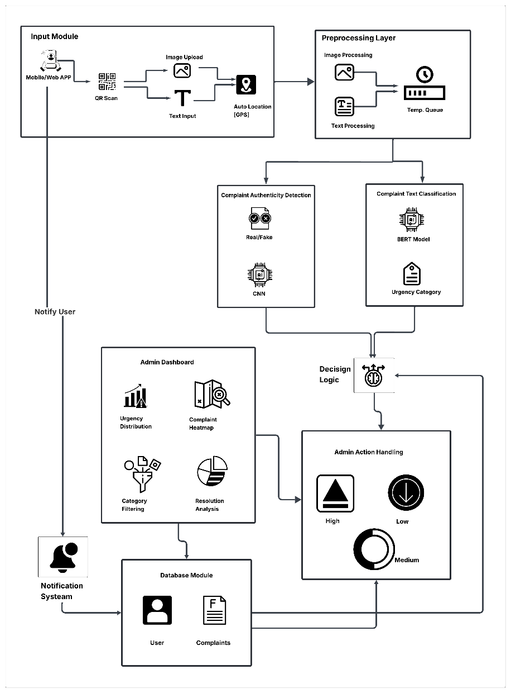
Fig1. System Architecture of Proposed System

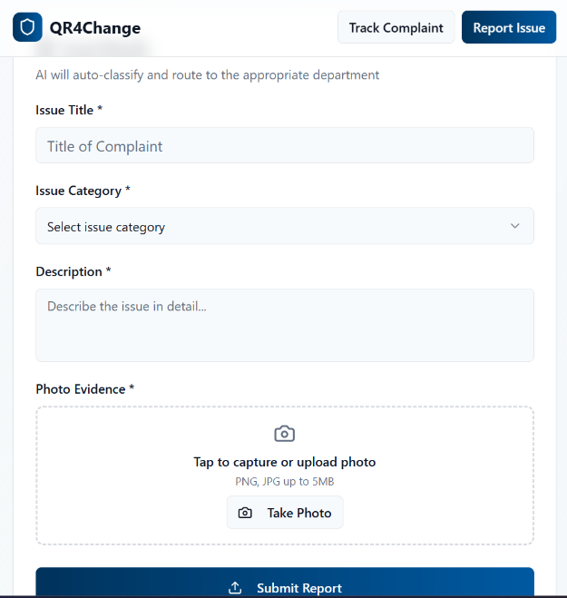 | 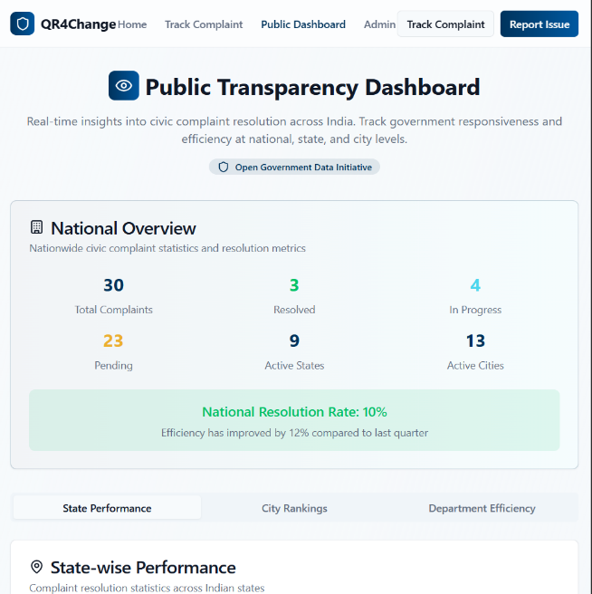
(A) | (B)
Fig 2. QR4Change User Interface (A) Complaint Reporting Form (B) Public Transparency Dashboard

2.3 System Workflow
The QR4Change process illustrates how someone uses the QR4Change system, starting with a citizen reporting a civic problem and concluding with the resolution of that problem and any necessary follow-up from their city. Our proposed QR4Change system workflow illustrates that the entire process is both genuine and efficient, along with being extremely transparent, as shown by Fig 3.
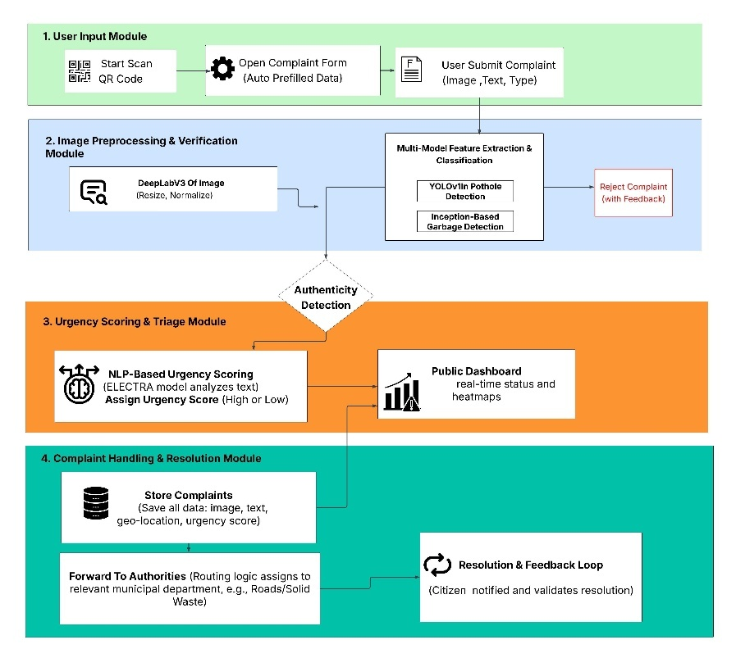
Fig 3. Flow Chart of Proposed System

The system for handling grievances from citizens is an Automated, Transparent, and Scalable Civic Grievance Redressal System that allows citizens to report their issues utilizing 9 integrated steps. Citizens will be instructed to scan a QR code that is located in public places within their municipality. Each QR code contains metadata related to the latitude and longitude of the QR code, ward info, and the routing information related to the complaint made by the citizen. When a citizen scans the QR code, the ReactJS Reporting Interface will automatically populate the fields indicating the location and department related to the complaint [16] allowing the complainant to simply indicate the type of complaint, a detailed description (optional), and attach an image. An additional module based on Deep Learning, utilizing YOLOv11n and InceptionV3, will verify whether or not the attached image is relevant to a public issue (valid complaint) and filter out any spam. A Deep Learning model based on an ELECTRA Transformer architecture, will score verified complaints based on urgency, high vs low priority, allowing staff to route the complaint based on urgency. ExpressJS API sends verified complaints to the backend for staff review. At the backend, staff will confirm the proper format and include any necessary metadata before creating a unique complaint ID that can be shared for tracking purposes without requiring the citizen to log in. Based on severity and the location metadata, verified complaints are routed directly to the municipal department that has responsibility for the claim, and the municipal department staff access verified complaints via a secured dashboard, which displays a listing of verified complaints, heatmaps, and performance metrics. Agencies are able to update their status, add comments, and upload documents that support each complaint. The public dashboard provides a comprehensive view of complaints, including real-time information about each complaint, maps of where they occurred, rankings of cities, and how each complaint was handled by the agency in order to provide transparency. After resolving a complaint, the agency will indicate how the complaint was resolved through evidence submitted by the agency and citizen satisfaction feedback, thus creating a loop of continuous improvement that will improve civic engagement and trust in the agency. The system is built on four basic components: data collection, verification models, urgency scoring models and automated complaint routing. These four technological components work together to provide an efficient, scalable, and citizen-friendly grievance redressal framework.

2.4 Dataset collection
To build robust models for complaint verification a multi-modal dataset consisting of images was created by us.

Image Dataset (for Verification Model). We gathered the dataset from multiple open-source repositories, various government portals, and in-person visits to Pune (Kondhwa, Bibewadi, Swargate, and Market Yard). There are 3 types of classes for each dataset: pothole, garbage, and irrelevant (spam or incorrect). The pothole dataset is made up of 2,966 images; 1,004 are potholes and 1,962 are pictures of smooth pavement. The garbage dataset contains 1,971 total, which consist of 712 images of garbage and 1,259 images of non-garbage [17]. Fig 4 is a pie-chart showing the percentage makeup of our 2 datasets. To achieve better balance within the datasets and reduce chances of overfitting the model we applied Data Augmentation methods (rotation, cropping, brightness changes, and flips).
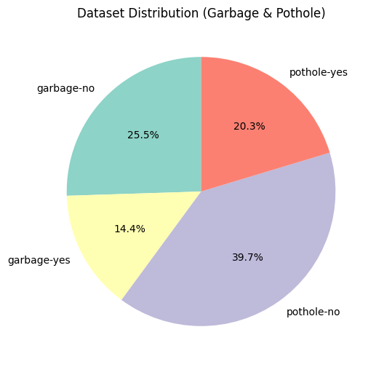
Fig 4. Dataset Distribution

Text Dataset (for Urgency Scoring Model). A dataset was created from citizen complaints regarding potholes and garbage, categorizing complaints as either High or Low Urgency based on trigger words (e.g., large, unsafe, urgent). An effort was made to increase diversity in language by generating additional complaints through use of the Gemini large language model. These complaints were based on the same structure and style as previously collected manually. After both the manually generated and Gemini generated datasets were compiled together, they were cleaned and deduplicated to limit overfitting and ensure consistent quality. A final dataset was produced with a total of 3,785 samples, including 1,965 Low Urgency and 1,793 High Urgency samples, to use when training and evaluating the urgency classification model.

2.5 Verification Model
The Verification Model ensures that only genuine complaints are processed, thereby preventing spam and irrelevant submissions.

Architecture. To determine the presence of a road in the uploaded image, the researchers used a DeepLabV3-ResNet101 segmentation model [18], which was pre-trained using COCO and then processed through the following layers: Convolution, ReLU activation, Pooling, Fully Connected and Softmax output, before being used for the purpose of image segmentation. The pothole detection step of the study used the fine-tuned YOLOv11n model [19-20], whereas the identification of garbage was managed using an Inception-based classifier that had been trained to detect the presence of excessive garbage.

Training and Optimization. The custom YOLOv11n-cls model was trained on the dataset for 30 epochs using a batch size of 16 with image input sizes of 224x224 pixels each. The classification portion used Categorical Cross-Entropy (CCE) as the loss for the classification, while the YOLO detection portion was trained using the traditional YOLO detection loss to localize the potholes. The model was trained using the Adam optimizer, and the learning rate was adjusted during training to optimize convergence. To evaluate the model, the evaluation metrics included Accuracy, Precision, Recall, and F1-score for classification tasks and mean Average Precision (mAP) and Intersection over Union (IoU) for detection tasks. This leads to confidence in the model's ability to classify correctly and locate potholes correctly in the image data.

Working. The image depicting the citizen will first go through a scaling/training procedure and then be passed through a series of multi-stage procedures within a deep learning pipeline to validate the legitimacy of the complaint and ascertain the correct category of classification. The first of these stages is "semantic segmentation" accomplished using DeepLabV3. The segmentation step will confirm the presence of a roadway or other public area, thus supplying "context" for the image. This will serve as an initial safeguard against non-relevant submissions. Once the context is confirmed, the image will be directed to either of two ‘Specialized Models Based on the Initial Complaint Category’.
For detecting objects in the images, the system relies on the use of YOLOv11n (You Only Look Once version 11 nano) as its main method of object detection. Fig 5 shows the architecture of YOLO model. YOLO (You Only Look Once) divides the image into a grid and predicts the bounding boxes and class probabilities for each cell at the same time (as demonstrated in Fig 5), enabling it to detect one or more pothole objects at once when fed into the Convolution Neural Network (CNN) in real-time.

A custom classification model for YOLOv11n was created specifically to improve performance. The input to this model is a 224×224 dimension RGB image. The Backbone of our design is made up of different Convolution Layers and C2f blocks, allowing for a Hierarchical Feature Extraction mechanism that facilitates the use of multi-scale representations. In order to gain Contextual Information across multiple scales of the image, a Spatial Pyramid Pooling Fast (SPPF) layer was added to the model, then followed by a custom C2f block containing 512 filters to improve High-Level Feature Representation quality. To classify the images, the Classification Head performs Global Average Pooling, a Linear layer, and applies Softmax activation to provide class probabilities.
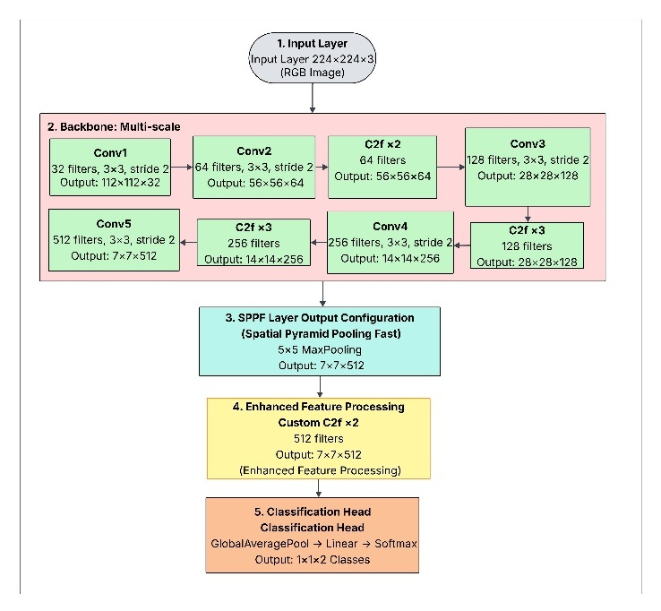
Fig 5. Architecture of the YOLO11n model for pothole detection.

The system also uses InceptionV3, a deep CNN with excellent Performance in Classifying Images and Processing Speed, to classify garbage-related complaints. Fig 6 shows architecture of InceptionV3 model. The Inception module constructs the model whereby there are multiple sets of Convolution Filters of different heights (1×1, 3×3, 5×5), which are applied concurrently (as shown in Fig 6). Due to the origin of the model's architecture, it can be very effective at Detecting and Classifying different categories of vehicles in complex urban landscapes, as it can Capture Visual Characteristics from a Multi-Scale Analysis of the Image, from Fine-Grained Textures to Larger Item Shapes.
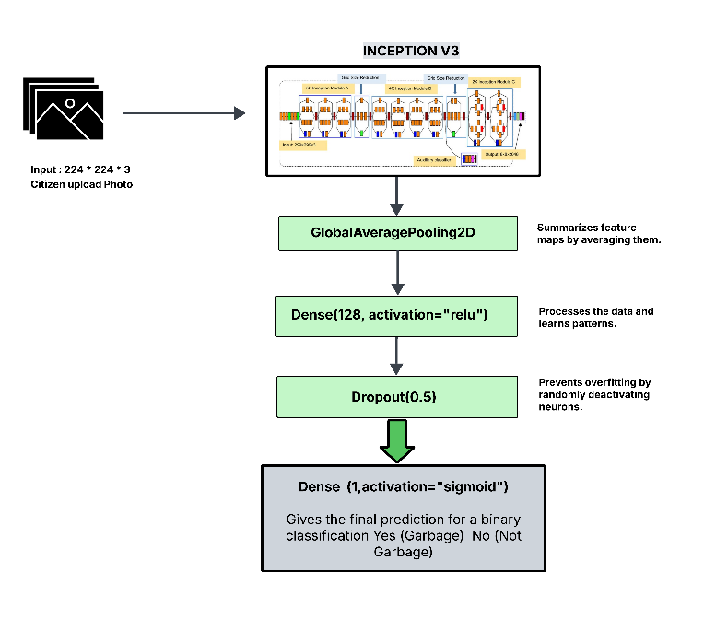
Fig 6. Architecture of the InceptionV3 model for garbage classification.

By using the selected model, the system produces a score as an estimate of the validity of a complaint. If a contribution is determined to be false, it will automatically be disregarded by the system, and the user will be notified of the reasons why. The primary purpose of this step is to prevent the system from being misused and to guarantee that only legitimate complaints will be submitted to local authorities to resolve.

Urgency Model Working: Developed an Urgency Scoring Model to categorize citizen's complaints as either H or L urgency. Based on analysis of 3,785 texts of citizen's complaints related to potholes and garbage. Each text was preprocessed and cleaned and tokenized using the ELECTRA tokenizer, which uses contextually aware embeddings. While more traditional methods, such as TF-IDF or RNNs, make use of fixed-length vectors, ELECTRA uses the transformer architecture, as depicted in Fig 7, to identify the semantics of citizen's complaints.
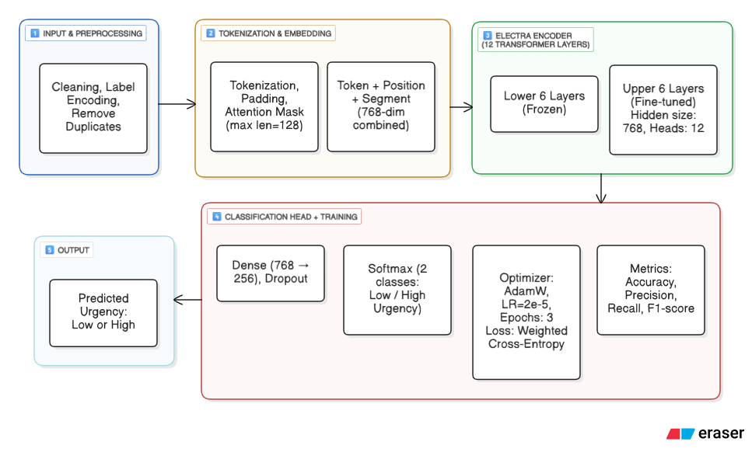
Fig 7. Architecture of the ELECTRA model for urgency detection.

As shown in Fig 7, the model uses an ELECTRA-base transformer as its main feature extractor and is designed specifically for the binary classification of urgency on text data. The structure of the model consists of a pipeline with several stages: (1) preprocessing, including data cleaning, label encoding, and removal of duplicates; (2) tokenization; and (3) embedding (with maximum input length of 256 tokens). In this case, only the top six layers of ELECTRA's encoder were fine-tuned because six of them were "frozen." In the original, pretrained model the lower six layers were trained on specific linguistic tasks, so those remain unchanged to provide the desired linguistic features (which are retained in a frozen state). The upper layers, or dense layers, were fully trained to adapt to the new classification task of determining how much urgency exists with a particular message (low or high urgency).
In summary, the dense layer uses dropout and produces predictions regarding "low" and "high" urgency messages using a softmax classifier. The AdamW optimizer (with learning rate set to 0.00002) and weighted cross-entropy loss are the performance metrics that have been used to assess the model's performance (e.g., accuracy, precision, recall, F1 score). The results of the model show that urgent incidents (e.g. large pothole, flooding, garbage accumulation near the hospital) get higher priority than non-urgent incidents.

2.6 Complaint Routes Management
Once verified and urgency scored, the system directs the complaints to the correct department and provides tracking.

Routing Mechanism. Complaints that come in to the municipality serve multiple purposes by way of classification: Both by Issue Type (e.g. pothole, garbage) Geographic Locations via QR codes and by Urgency. The backend system will determine to which municipal Authority the complaint will be assigned based on the supporting notes plus issue type such as "Pothole" or "Solid Waste" or by the geographical location of the complaint within on the Map plus the supporting notes associated with both those Issue Types.

Authority Dashboard. Authorities can view assigned complaints through login to the system where all incoming complaints will be displayed with filters for urgency, location, type of complaint; authorities may also update the status of each complaint as "Pending," "In Progress," or "Resolved" and attach any necessary photos showing the evidence of resolution(s).

Public Dashboard (Transparency Layer). Through the use of technology citizen's will have a clear, simple way to track their complaint at any given moment, with access to a 'dashboard' displaying heatmaps, statistics and trends associated with complaints submitted by citizens. The ability to track how many complaints received by the authorities show a clear degree of accountability, as it makes them aware of the volume of complaints received.

Feedback Loop. The Complaint Resolution System sends out a notification to users who have filed the complaint that it has been resolved, as well as an opportunity for them to provide feedback on their satisfaction with the resolution offered by the organization. This process allows for greater accountability of organizations, faster resolution times, and increased citizen participation in the resolution of complaints.

3 AI Usage and Alignment
This paper proposes the integration of Artificial Intelligence (AI) techniques into QR4Change: Smart QR Grievance System to improve effectiveness, scalability, and transparency in India. AI is used in QR4Change to facilitate AI-based decision-making and enhance efficiency of service delivery by allowing for replacement of human authorities or to support the existing human authority of the government.
AI primarily supports automatic classification of grievances into categories (domains) based on the text input that users submit via QR Code. Natural Language Processing (NLP) techniques will allow machine learning algorithms and intelligent computer systems to group grievances by their content into specific categories of Public Infrastructure, Health, Sanitation and Administrative Services. Once the grievance is automatically classified, it is routed to the department responsible for handling that type of grievance, reducing the amount of time and effort needed for personnel to address each complaint.
Machine learning–based scoring mechanisms will be used to evaluate the sense of urgency and severity of a grievance. By using historical records of complaints, relevancy of keywords, and context, the system can assign priority levels that help guide officials toward addressing critical issues first, thereby improving equitable treatment of grievances and ensuring that all grievance types receive timely resolution.
Pattern recognition and automated pattern display/reporting are other applications of AI technology. By analyzing aggregated grievance data/user submittal during this analysis, AI identifies patterns that allow for examination of issues recurring inn certain geographic areas, service shut down times, or other places of activity. These pattern/timing reports provide a source of information that can be used by policymakers/administrators to provide greater support for urban improvement and social support systems based on the patterns that were established through data aggregation.
In terms of societal impact, the introduction of AI technology through QR4Change allows for citizen empowerment and enhancing inclusive governance for all users – regardless of background – using QR Code to facilitate easy user submissions to their issues through the application. AI handles large amounts of user grievance data with no bias toward particular individuals or geographic locations. The AI functions proposed are consistent with AI for Societal Impact and also demonstrate the way that responsible and explainable AI may be used within public service systems in a real-world context. The application of AI in QR4Change maintains full human oversight throughout its lifespan, and: Transparency – access to all data will be open to all human users. Accountability – anyone may identify who is responsible for the use of AI to improve public systems for all users. Ethical Use – users will be provided with an adequate opportunity, through an automated user verification system, to verify the information that has been submitted through the application.

4 Results

Confusion Matrix Analysis. An examination of the confusion matrix of a classification model can provide support in determining how well you have classified between classes by using the following performance metrics: accuracy, precision, recall, and F1 Score (see eq. [1] to [4]). In order to compute these metrics, four major counts need to be calculated. They are true positives, true negatives, false positives, and false negatives; these counts will allow you to analyze the manner in which your classification algorithm performs when predicting on unseen data [21].
Accuracy:

$Accuracy=\frac{TP+TN}{T+TN+FP+FN}$ (1)

Precision (Positive Predictive Value):
$Precision= \frac{TP}{TP+FP}$ (2)

Recall (Sensitivity):
$Recall= \frac{TP}{TP+FN}$ (3)

F1-Score:
$F1=2 × \frac{Precision ×Recall}{Precision+Recall}$ (4)

The confusion matrix for pothole detection shown in Fig 8 (A), indicates that the model's true negatives (TN) were 147, false positives (FP) 7, false negatives (FN) 3, and true positives (TP) 195. Using the values from this matrix in (equations 2,3,4) yields precision (Yes) of ~0.965, recall (Yes) of ~0.984, and F1-score (No) of ~0.96, indicating excellent ability to accurately detect and classify without substantial misclassification [22].

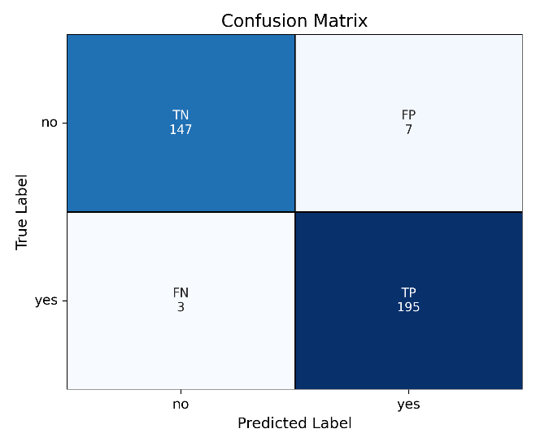 | 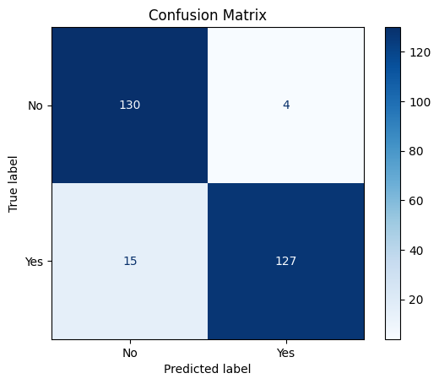
(A) | (B)
Fig 8. (A) Confusion Matrix for pothole detection (B) Confusion Matrix for garbage detection

The confusion matrix summarising the results of InceptionV3 for garbage detection shown in Fig 8 (B) has TN = 130, FP = 4, FN = 15, and TP = 127. Applying the same formulas results in precision (Yes) of ~0.96, recall (Yes) of ~0.89, F1-score (No) of ~0.93, and accuracy of ~0.93, showing that these deep learning models are reliable for both categories of urban complaints.

3.1 Model Comparison and Selection Rationale
The use of transfer learning models which are pre-trained on ImageNet is advantageous for garbage classification, as it will create additional features that help with classification. The model called InceptionV3 generated many different spatial patterns of the garbage objects and has been calculated to have a precision of 0.96 and recall of 0.89 with very little false positives from these calculations using (equations 2 ,3). In the case of pothole detection, the YOLO model made a significant impact in comparison to the other models because of the anchor box and spatial attention features of the YOLO model. The YOLO model identified nearly all of the pothole locations accurately with precision, recall, and F1-score of approximately 0.96. These results, summarized in Table 1, support the selection of InceptionV3 for garbage detection and YOLO for infrastructure defect identification (Table 1) [23].

Table 1. Performance outcomes of implemented models
Models | Precision (%) |  | Recall (%) |  | F1 – Score (%) |  | Accuracy (%)
 | Garbage Dataset | Pothole Dataset | Garbage Dataset | Pothole Dataset | Garbage Dataset | Pothole Dataset | Garbage Dataset | Pothole Dataset
RestNet50 | 68 | 73 | 67 | 79 | 66 | 76 | 89 | 74
VGG16 | 52 | 49 | 75 | 49 | 62 | 48 | 90 | 93
MobileNetV2 | 48 | 50 | 49 | 50 | 48 | 50 | 91 | 97
DenseNet121 | 90 | 96 | 88 | 95 | 89 | 95 | 89 | 95
EfficientNetB0 | 27 | 0 | 50 | 0 | 35 | 0 | 53 | 52
InceptionV3 | 96 | 96 | 89 | 98 | 93 | 96 | 93 | 97
YOLO11n | 90 | 96 | 82 | 98 | 87 | 96 | 88 | 97

3.2 Processing Efficiency and System Advantage
A key focus of QR4Change's design and implementation efforts were to develop a system that was highly efficient in terms of computational resource utilization and supported maximized system-level performance through best design processes available. Specifically, QR4Change combines highly efficient methods for mobile upload (InceptionV3), rapid pothole detection (YOLO11n), automated QR-based logging, precise geolocation capture, automatic AI validation, natural language processing urgency scoring, and interactive GIS dashboards (Table 2) [24]. This combination of advanced methods allows QR4Change to provide service levels exceeding those of traditional grievance registry systems.

Table 2. Comparative Analysis of Grievance Management Systems
Parameter | Existing Systems | Proposed System
Complaint Submission | Manual Entry | QR-based instant logging
Location Capture | User-entered, often inaccurate | Auto-location via QR Metadata
Automation Level | Mostly Manual | AI-driven classification and routing
Verification Accuracy | Human-dependent | Autoencoder + CNN validation
Urgency Detection | Absent | NLP-based prioritization
Spam Handling | Limited | AI duplicate/spam filtering
User Feedback | Delayed updates | Real-time notifications
Visualization | Static reports | Interactive GIS dashboard
Cost and Deployment | High setup cost | Low-cost QR integration

3.3 Urgency Prediction Model Results

Table 3. Performance outcomes of implemented models for urgency detection
Models | Dataset | Accuracy (%) | Precision (%) | Recall (%) | F1 Score (%)
DistilBERT | 10000 rows | 51.70 | 63.61 | 48.75 | 48.99
BERT-based-uncased | 10000 rows | 85.41 | 86.12 | 84.30 | 84.89
ELECTRA | 3785 rows | 99.73 | 99.45 | 100 | 99.72

Total of 3 models were trained for urgency detection as shown in Table 3, out of this DistilBERT and BERT-based-uncased showed low results and ELECTRA showed most significant results. Also ELECTRA was choosen because it uses masked token detection instead of randomly masking 15% tokens as in BERT models.
Using 3,785 complaints to build its urgency prediction model through training with ELECTRA has allowed the model to achieve 99.73% Accuracy, 99.45% Precision, 100% Recall and 99.72% F1 Score (Recall = Eq. 3) [25]. The fact that this was built using ELECTRA means that the model is optimised to identify and capture high amounts of urgency (for example, high and severe pothole or critical garbage). Based on the methodology, it is expected that municipalities will respond to all urgent issues in an efficient manner using this model.

4 Discussion
Based on the findings generated from the QR4Change project, tackling civic grievances (issues affecting communities) will become easier for municipal authorities using a combination of specialized models for both computer vision and Natural Language Processing (NLP) alongside a QR-based Approach to Reporting. Rather than focusing on each model's metrics in detail again, the key finding is that there was a clear architecture that was best suited to identify potholes, whereas a second architecture was best suited to classify garbage and finally a transformer-based architecture was ideal for scoring urgency. When combined, these three architectures work in unity to form a process whereby city leadership can automatically filter out illegitimate complaints, validate complaints regarding true infrastructure issues, and prioritize legitimate complaints in such a way that better reflects the associated risk and potential impact of each complaint submitted. The operational flow of the developed architectures and workflow reflects how actual complaints have been generated by citizens in local communities specifically that potholes can be identified visually as well as contextually, whereas garbage can be identified only contextually and urgency is represented in language that is attributed to citizen submissions of complaint, therefore it is essential to decouple these various tasks through optimized and dedicated models for the best results. The behaviour of the system across all experiments demonstrates that, once trained on a reasonably good but still small training dataset, the models will generalise well to new data drawn from the same distribution, and therefore based on current architecture choices, the architecture is just as important as increasing model size/complexity when building models. In addition, QR4Change has two significant implications in the civic domain. Through QR4Change, the complaint process is being transformed from a manual, form-driven process that is department-driven to an AI-assisted process that is initiated by citizens. Rather than having to perform the tasks of sorting and verifying the reports and determining their priority, the focus of the process now shifts to the resolution of the complaints by officials. The first important implication of this shift is for researchers, as it demonstrates that multi-modal task-specific AI Systems can effectively operate in the real civic sector without requiring a "monolithic", fully developed "smart" model to operate effectively in this environment. The second important implication is for municipal practitioners, as it provides clear evidence that it is possible for a municipal body to eventually move toward implementing an AI model incrementally starting with the verification and prioritisation of incoming complaints while maintaining the ultimate decision-making authority of the body with staff. However, despite the strengths of the system in achieving this objective, it does have limitations that need to be considered. To further advance QR4Change from concept to production, additional features such as adding multilanguage capabilities, integrating with current municipal IT systems, and extending the urgency model to include multi-level/contextual prioritisation will be necessary. In practice, by pilot testing this platform in a real municipality while ensuring proper monitoring, this application will facilitate quicker response times for serious issues, provide greater transparency on both the administrative and citizen-level for complaint volumes/resolution performance, and serve as a data foundation for planning proactive preventive maintenance rather than only responding reactively after system failures occur.
5 Conclusion
The QR4Change Smart City Grievance Redressal System is a good example of how AI-enabled civic engagement can enhance local governments. This system applies QR code technology and deep learning to assure improvements in transparency and response. Of the eight models analyzed, InceptionV3 had a detection accuracy of 93% for garbage, and YOLO11n had detection accuracy of 97% for potholes. The ELECTRA fine-tuned NLP model had a 99.73% average accuracy of predicting urgency, and its results were reliable for the prioritization of complaints. The system stack is ReactJS, Express.js, Django, and MongoDB, and provides real-time, scalable and mobile optimized performance with less than 100 milliseconds inference time.
QR4Change enhances smart city capabilities by providing for greater engagement and more efficient service delivery. To do this, a complaint submission process that is informed by the context of the submission is made possible to assure geographic analysis and an AI-based validation process that eliminates reporting error, coupled with automated routing to reallocate resources—all made possible by data analysis. It is easily scaled across sectors such drainage, street lighting, and road signage, and is also suitable for smart city applications more broadly. The added element of the cited “citizen-centric” QR interfaces, and applying AI technologies that are well-trusted for citizen identification, create an organic connection between the citizen, and public services identify by government- the first step in a real connection that may one day lead to a real way even for urban governance, in a format that is visible, accountable, and responsive. QR4Change contributes to the sustainable development of smart city output by facilitating the standardization of multimodal AI interfaces to monitor civic infrastructures, while also revealing, even if just a little, a new framework towards citizenship engagement within urban governance.

Declarations

Competing Interests
The authors declare that they have no competing interests.

Funding Information
No external funding was received for this research.

Author Contribution
Yash Maske worked on the development and training of the YOLO-based pothole detection model,system integration, and manuscript preparation. Shubhankar Jakate developed, trained, and evaluated the InceptionV3 garbage classification model, while Sakshi Lokhande built the NLP-based urgency scoring model and contributed to the methodology section. Chandrakant Thakare handled dataset collection, preprocessing, backend data management, and user interface development. The project was supervised by Pranjal Pandit, who provided guidance during model development and reviewed technical components, and by Anuradha Yenkikar, who offered overall academic supervision and assisted in manuscript review. All authors reviewed and approved the final manuscript.

Data Availability Statement
The dataset used in this study is publicly available at:
Maske, Yash; Jakate, Shubhankar; Thakare, Chandrakant; Lokhande, Sakshi (2025), “Urban Civic
Issues Image Dataset: Potholes and Garbage (QR4Change)”, Mendeley Data, V2, DOI:
10.17632/zndzygc3p3.2

Research Involving Human and/or Animals
This research did not involve experiments on humans or animals.

Informed Consent
Not Applicable.

References
- Vedik Basetti, Chandan Kumar Shiva, Mohan Rao Ungarala, & Rangarajan, S. S. (2023). Artificial Intelligence and Machine Learning in Smart City Planning. Elsevier.
- Chatterjee, S., Kar, A. K., & Gupta, M. P. (2018). Success of IoT in Smart Cities of India: An empirical analysis. Government Information Quarterly, 35(3), 349–361. https://doi.org/10.1016/j.giq.2018.05.002
- Faris Abdulrahman Alenezy, & Muhammad Akhlaq. (2023). Fix-It: Design and Implementation of a Public Complaint Management System. https://doi.org/10.1109/iccosite57641.2023.10127715
- Kormpho, P., Liawsomboon, P., Phongoen, N., & Pongpaichet, S. (2018, July 1). Smart Complaint Management System. IEEE Xplore. https://doi.org/10.1109/ICT-ISPC.2018.8523949
- Berko, A., Chyrun, L., Ohonovsky, Y., Chyrun, S., Schuchmann, V., & Matseliukh, Y. (2023). Content Monitoring and Big Data Analysis of Smart City Residents Appeals and Complaints Management. 2023 IEEE 18th International Conference on Computer Science and Information Technologies (CSIT), 1–6. https://doi.org/10.1109/csit61576.2023.10324159
- Alkhayyat, A., Kumar, R., Singh, S., Singh, R., Kumar, Y., & Sharma, U. (2024). An Online QR Code Scanner for Real-Time User Feedback and Ratings Collection with Local Web Server. https://doi.org/10.23919/indiacom61295.2024.10498871
- Vuksanović, N., Bajrami, D., Petrović, Marko D, & Grigorieva, E. M. (2020). QR codes as a tool for receiving feedback about guests’ satisfaction at destinations. Journal of Place Management and Development, 14, 1. https://doi.org/10.1108/JPMD-03-2020-0025
- Pantin, R., Rimma Yunusova, Barno Abdullaeva, & Saodat Yuldasheva. (2025). AI Integration with Digital Infrastructure: Advancing Governance, Efficiency, and Inclusivity. 136–145. https://doi.org/10.1109/scme62582.2025.11104890
- Arjapure, S., & Kalbande, D. R. (2021, June 1). Deep Learning Model for Pothole Detection and Area Computation. IEEE Xplore. https://doi.org/10.1109/ICCICT50803.2021.9510073
- Cortiz, D. (2021). Exploring Transformers in Emotion Recognition: a comparison of BERT, DistillBERT, RoBERTa, XLNet and ELECTRA. ArXiv:2104.02041 [Cs]. https://arxiv.org/abs/2104.02041
- Hui, Z., Li, Z., & Du, A. (2022). Garbage classification system based on improved faster r-cnn with audio-visual combination. 1235–1239. https://doi.org/10.1109/ICSP54964.2022.9778441
- Song, F., Zhang, Y., & Zhang, J. (2020). Optimization of CNN-based Garbage Classification Model. Proceedings of the 4th International Conference on Computer Science and Application Engineering. https://doi.org/10.1145/3424978.3425089
- J. Vimala Roselin, M. Sakthivanitha, T. Thirumalaikumari, Sebastian, A., & S. Silvia Priscila. (2025). A Framework for Automated Waste Classification System using Machine Learning and Deep Learning Techniques. 834–838. https://doi.org/10.1109/icoeca66273.2025.00147
- Malik, M., Sharma, S., Uddin, M., Chen, C.-L., Wu, C.-M., Soni, P., & Chaudhary, S. (2022). Waste Classification for Sustainable Development Using Image Recognition with Deep Learning Neural Network Models. Sustainability, 14(12), 7222. https://doi.org/10.3390/su14127222
- B, Mala J, Angel, A., Raj, A., & Rajan, R. (2023). Efficacy of ELECTRA-based language model in sentiment analysis. 682–687. https://doi.org/10.1109/ICISCoIS56541.2023.10100342
- Mountain, D., & Raper, J. (2001). Positioning techniques for location‐based services (LBS): characteristics and limitations of proposed solutions. Aslib Proceedings, 53(10), 404–412. https://doi.org/10.1108/eum0000000007074
- Maske, Y. (2025). QR4Change: A Smart QR-Based Civic Grievance Reporting System. Mendeley Data, 1. https://doi.org/10.17632/zndzygc3p3.1
- Silvister, S., Komandur, D., Kokate, S., Khochare, A., More, U., Musale, V., & Joshi, A. (2019). Deep learning approach to detect potholes in real-time using smartphone. 1–4. https://doi.org/10.1109/PuneCon46936.2019.9105737
- He, Z., Wang, K., Fang, T., Su, L., Chen, R., & Fei, X. (2024). Comprehensive Performance Evaluation of YOLOv11, YOLOv10, YOLOv9, YOLOv8 and YOLOv5 on Object Detection of Power Equipment. ArXiv.org. https://arxiv.org/abs/2411.18871
- Gupta, K., Dhyani, A., Sille, R., & Choudhury, T. (2025). Object detection in low light using YOLOv11. 1–6. https://doi.org/10.1109/OTCON65728.2025.11071218
- Feng, J., & Tang, X. (2020). Office Garbage Intelligent Classification Based on Inception-v3 Transfer Learning Model. Journal of Physics: Conference Series, 1487, 012008. https://doi.org/10.1088/1742-6596/1487/1/012008
- Manalo, M. C., Alvin Sarraga Alon, Austria, Y. D., Merencilla, N. E., Misola, M. A., & Sandil, R. C. (2022). A Transfer Learning-Based System of Pothole Detection in Roads through Deep Convolutional Neural Networks. 2022 International Conference on Decision Aid Sciences and Applications (DASA). https://doi.org/10.1109/dasa54658.2022.9765227
- John Raphael Pangilinan, Legaspi, J., & Linsangan, N. (2022). InceptionV3, ResNet50, and VGG19 Performance Comparison on Tomato Ripeness Classification. https://doi.org/10.1109/isriti56927.2022.10052920
- Mir, Mahmud, A., & Rahman, M. S. (2024). SafeWalkBD: A Roadside Object Detection Dataset for Visually Impaired Pedestrians in Bangladesh. 1357–1362. https://doi.org/10.1109/iccit64611.2024.11022523
- Ali, A.-I. H. (2023). Using Densenet121 to extract roads from satellite images. International Journal of Nonlinear Analysis and Applications, 14(1), 1577–1584. https://doi.org/10.22075/ijnaa.2022.7123

