**PEST IDENTIFICATION USING DEEP LEARNING**

|  |  |  |
| --- | --- | --- |
| *D Chandu*  *Student*  *Computer Science and Engineering*  *Narasaraopeta Engineering College*  *Narasaraopeta, India*  *divvelachandu21@gmail.com* | *K Rajesh*  *Student*  *Computer Science and Engineering*  *Narasaraopeta Engineering College*  *Narasaraopeta, India*  [*rajeshkandula11@gmail.com*](mailto:rajeshkandula11@gmail.com) | *J Sai*  *Student*  *Computer Science and Engineering*  *Narasaraopeta Engineering College*  *Narasaraopeta, India*  *jujjurisai7989135700@gmail.com* |

**Abstract:**

Accurate identification of pests is essential for crop protection and effective pest management. Timely detection of pests is essential for effective pest management and crop protection. The techniques used in many traditional methods rely on visual inspection and expert intervention, so can be time-consuming and inaccurate A high-performance computer vision system can be used to deep learning methods developed have detected insects. In this study, we adopted the deep learning models VGG16 and VGG19 to develop a passive insect detection system. We were able to improve model performance in identifying insect species through techniques such as data enhancement, refinement of validated models etc. We documented that both VGG16 and VGG19 models gave a high accuracy rate of 99.78% and 98.12%, respectively.

1. **Introduction:**

Agriculture is the backbone of the global economy, but pests pose a significant challenge to crop production and food security. Pests are responsible for the largest crop losses worldwide, hampering agricultural growth, especially in light of increasing global demand for food. The reliance on pesticides to control pests is decreasing due to their unsustainable long-term effects on ecosystems and human health thus precise methods that do not cause harvesting our surroundings are immediately important.  
  
Pest identification is crucial in order to protect crops that will in turn, lead to a sustainable eradication of the pests. Expert methods involving the visualization of flows are usually lengthy, highly intensive, and highly prone to errors. This is because there is a wide form, size and number of insects which is a difficult task to search even by professionals in the field of study known as entomologists.

Advances in computer vision and innovative AI may provide solution in better pest identification in the last few years. Machine learning has been more specific to this classification known as deep learning and has recorded significant innovations in image categorization Across various industries ranging from healthcare imaging systems to direct object detection Convolutional Neural

networks (CNNs) have recorded exceptional image data analysis and handling.

However, it should be noted that the use of deep learning for pest detection in agriculture is not as popular at the moment. Some of the challenges relates to efficient insect imaging, including the obtainment of high quality images, variability of image quality due to different conditions, and creation of models, which are able to detect numerous species of insects.  
  
This research present a new identification method for insects that will address the above challenges. Utilizing superior methods of data augmentation and converting them with complex deep learning models which are VGG16 & VGG19 enhancing the effectiveness and applicability of the models in the real sense. Our target is to contribute to the improvement of pest diagnostics and offer feasible recommendations that will be employed across the agricultural sector by farmers and the like.  
  
In this context and by overcoming these above mentioned problems, the present study intends to offer important findings and methods to agricultural technology about the pest management for establishing more rational consumption patterns.

This paper makes the following key contributions:

i. Comprehensive Pest Dataset: The dataset is created with nine kinds of pests; all of them are photographed in an actual environment real-life pests. For increasing the images and thus richness of the dataset in order to gain higher quality and stability of the model we used different techniques of data augmentation.

ii. Enhanced VGG Models: To rectify this, we used VGG16 and VGG19 models in the pest identification process and hence the improved approach. Some adjustments we made are presented as follows: First, the specifics of pest detection allowed fine-tuning these models for the given application based on their ability to efficiently perform feature extraction.

iii. Comparative Analysis: Therefore, we performed a comparative analysis of the VGG16 and VGG19 models with regard to other existing deep learning models. The results reveal that all both the enhanced VGG models have better accuracy in pest identification which confirms that the models are useful in real-life agricultural use.

1. **LITERATURE REVIEW**

Cheng et al [1] developed a deep residual learning technique in the effort to solve this difficult problem using farmland environment and ResNet-101 model. In comparison with conventional techniques for machine learning, the authors’ approach provided a classification accuracy of 98. 67 percent of pest classes across the 10 classes.

Gong et al. [2] has put forward an FCN and DenseNet model with Efficient Channel Attention for rice pest identification at edge. Their model achieved 98. The recognition performance achieved 28% accuracy of 10 pest species, more accurate, and more robust than others.

Yang et al. [3] published a paper on identification of crop pests by using Edge Distance-Entropy with higher accuracy of 100% with utilization of only 60% of the data. This approach decreases the data required by 5% to 15% as well as enhances performance with an Anomaly Feature Detection Strategy.

Lin et al. [4] proposed a realistic approach named as GPA-Net based on the graph pyramid attention for improving the identification of pests and diseases in an accurate manner. This method enhance feature extraction and multiscale spatial capture whereby the accuracy rate of the model can reach up to 99%. 0% on cassava leaf data and 97. 0% on AI Challenger.

Li et al. [5], the authors suggested the plant disease and pest recognition by employing the pre-processing and data enhancement approaches. Their method achieved 96.71% Algorithms accuracy achieved on the Plant_Village dataset which is better than traditional CNN models and its usefulness for smart agriculture.

To enhance the early jute pest detection system, Talukder et al. [6] proposed the JutePestDetect model that was based on transfer learning. When validated with 17 classes of pest data set, the proposed method attained 99% accuracy which proved better than others and thus is effective for pest control in jute farming.

Hu et al. [7] proposed a rice pest identification model based on a multi-scale double-branch GAN-ResNet. This model combines GANs with ResNet for improved feature learning and obtains a high of 99. 34% accuracy that is higher than traditional networks. The presence of the two-branch paradigm and the data augmentation increases the reliability of the model even under difficult circumstances.

Mask R-CNN was improved by Rong et al. [8] to identify and count pest on yellow plates in the field. It can be seen that the proposed Feature Pyramid Network (FPN) optimization raised the model’s accuracy to above 99%. 4 % detection accuracy, which is two percentage points higher than that of the original. 7%. It increases the rate and accuracy of pest monitoring systems.

The ANN based pest identification system has been proposed in Singh et al., [9] integrated with WSN for smart agriculture. Pest detection is done more accurately in the system leading to an improvement by 3 on the initial measures. It increases the crop management and reduces the environmental impacts nine percent over traditional methods and offers accurate recommendations for pesticides.

1. **MATERIALS AND METHODOLOGY**

**A. DATASET**

1. **DATASET DESCRIPTION**

The dataset comprises 3,150 images of nine distinct crop pests: Aphids, army worms, boll worms, beetles, grasshoppers, mites, sawflies, mosquitoes and stem borers. These images were downloaded from some publicly available datasets [10] and more images were searched from the internet. To keep the image size consistent, all images were resized to 224 x 224 pixels even if the original image had been of different size. Further, the dataset is divided into labelled categories for every type of pest for easy segregation while training and testing. Figure 1 shows the some images from dataset. Table 1 describes about images in dataset.

**Table 1 Dataset description**

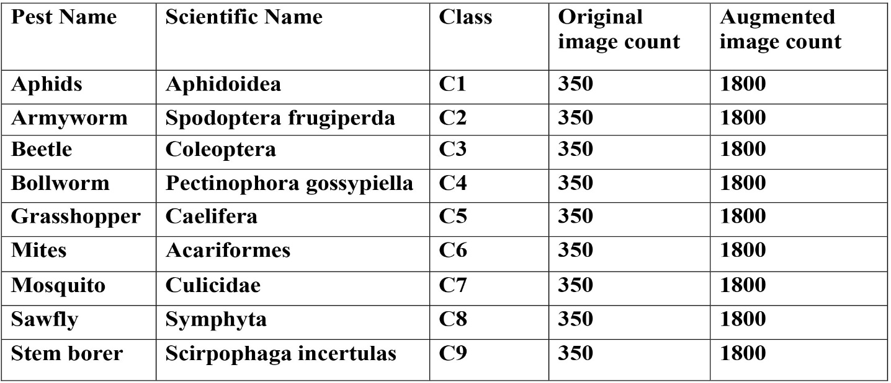

1. **DATA AUGMENTATION**

This is done with the help of data augmentation methods that help to improve the dataset and model performance. These technique included the flipping of the images along the horizontal axis, shearing, rotation of image, brightness modification of the image, zooming and the addition of Gaussian noise to the original image. By applying the above transformations, variance of the data is added hence reduces the problem of imbalance in data and over fitting. Thus, the alterations described above are presented in the given visualizations in figure 2, that demonstrate the impact of the augmentations on the images indicating how every change transforms the data.

**Figure 1 Sample images of pest**

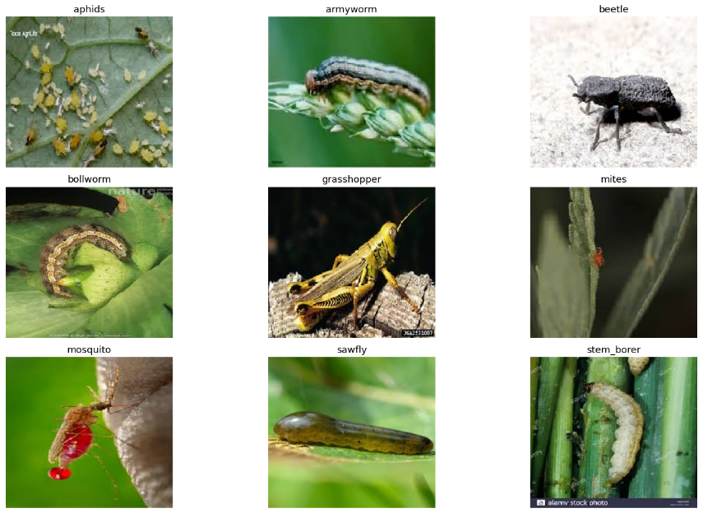

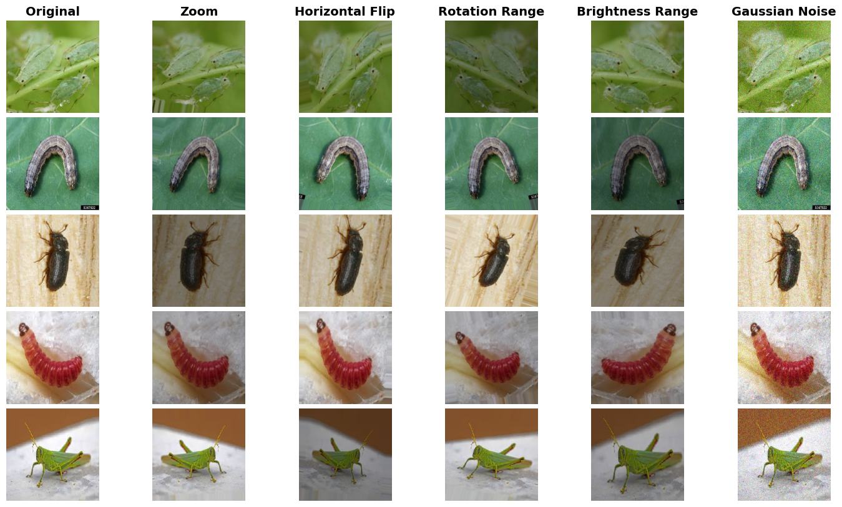

**Figure 2 Sample images augmented images**

**B. SYSTEM OVERVIEW**

In this work, our major concern is on the differentiation of different pests that affect crop production. First, we collected pictures from varying origins and data/birth records. Having so, random sampling was used to divide the dataset into training and validation data sets. To make data even more variable and numerous, we used several techniques of data augmentation so that models would work properly with different conditions of environment and appearance of pests.

To enhance feature extraction, we employed VGG16 and VGG19 models, which has a tendency of offering the best results in image classification . Not only were these models fine tuned for pest recognition but it was also modified to accompany the specific morphological challenges posed by pest variety. Using the depth and architecture of these models, we hoped to capture details in pest images which are indispensable for identification.

During the training process, the Adam optimizer was applied with learning rate being equal to 0. 001. The models trained and tested to show the feasibility of the models to eliminate all the barriers that might exist between successful model training and real life agricultural problem application. In the next sections, it will be further explained what system components are included into the proposed models and how the models should be implemented.

**C. DEEP LEARNING ARCHITECTURES**

We explore the deep learning architectures employed in our research, specifically focusing on the VGG16 and VGG19 networks. These architectures are famous for the depth of the present model, and feature extraction, which are useful for complicated image classification tasks such as identification of pest.  
  
This involves the fine-tuning of these models with an aim of increasing their competencies in the identification of different pest species. The hyperparameters were chosen and adjusted to fine-tune the models and further, new strategies of data augmentation were added to make the models more resistant to variations in the pest images presented. To determine the efficiency of the VGG16 and VGG19 models in correctly distinguishing between various pest species the performance of these models was adequately tested.

**1. VGG NETWORK**

The VGG architecture proposed by Simonyan and Zisserman can be considered one the most popular deep learning models for image recognition tasks. A kind of CNN with its simple and heavy network structure, it only uses very small convolutional kernel of 3×3 and multiple convolutional layers. The two VGG networks, VGG16 and VGG19 [11], is named that because there are 16 and 19 weight layers in the networks.

This is the principle upon which VGG rests: The basic building deterministic of VGG is a uniform pattern, where one loads convolutional layers right after the other, all of which have small areas of reception, or 3×3, and subsequent max-pooling layers that shrink the features maps. This kind of design is rather simple, but at the same time the depth of the network allows for extracting hierarchical features which are essential, for example, in pest identification process.

According to VGG16 architecture, there is 13 convolutional layer and 3 fully connected layer. The convolutional layers are grouped in five blocks where each of them is followed by the max pooling. Further, similarly as the previous two, the new architecture known as VGG19 has three more convolutions layers added to the second, third, and fourth block of the network.

Unfortunately, VGG models have a large number of parameters resulting in them being computationally intensive while providing good performances in many image classification tasks. However, due to their depth as well as structure, VGG16, and VGG19 are more efficient in terms of feature extraction that is quite helpful when it comes to pest recognition in agricultural environments.

**2. VGG16 AND VGG19 ARCHITECTURES**

Thus, VGG16 architecture of network contains 13 convolutional layers, 5 max-pooling layers and 3 fully connected layers and has, nearly 138 Million parameters Table 2. Each of the convolution layers applies a 3×3 kernel and the corresponding stride is 1 with padding of 1, so that the spatial size of the features maps does not change much. The convolutional layers are followed by a max-pooling layer with filter size of 2x2, and a stride of 2 so as to reduce the size of the feature maps.

Thus, VGG19 has the similar structure as VGG16 but contains 16 Convolution layers Table 3 and this enhances the network’s capacity to capture high detailed features in an image. The extra steps enable further abstraction of the information that ultimately give the model a better understanding of what it is being fed with as inputs. Finally, there is three fully connected layer with the first two having 4096 channels each for both VGG16 and VGG19 and then classification using softmax layer.  
  
Even though the VGG models are somewhat complex requiring high computational power the fact that they are able to handle multiple image recognition tasks with efficiency makes them proper candidates for pest identification. The architecture of VGG16 and VGG19 has a consistent and deep structure which is important when it comes to feature extraction and debugging the pest species one from the other especially where the differences in appearance are almost negligible.

The architecture of both VGG16 in figure 3 and VGG19 in figure 4 models are displayed in the pictures, which reveal their manifest layers intended for optimal image recognition. These models are Popular because of their high performance and their talent to analyze images and extract thick features.

**Figure 3 VGG16 Architecture**

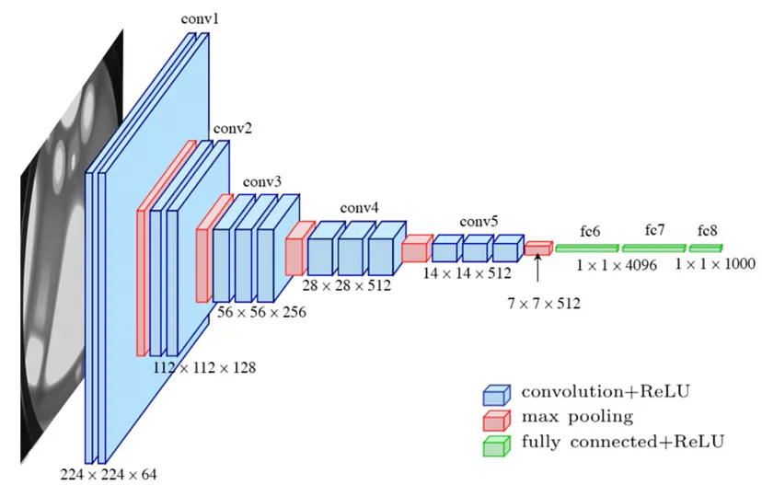

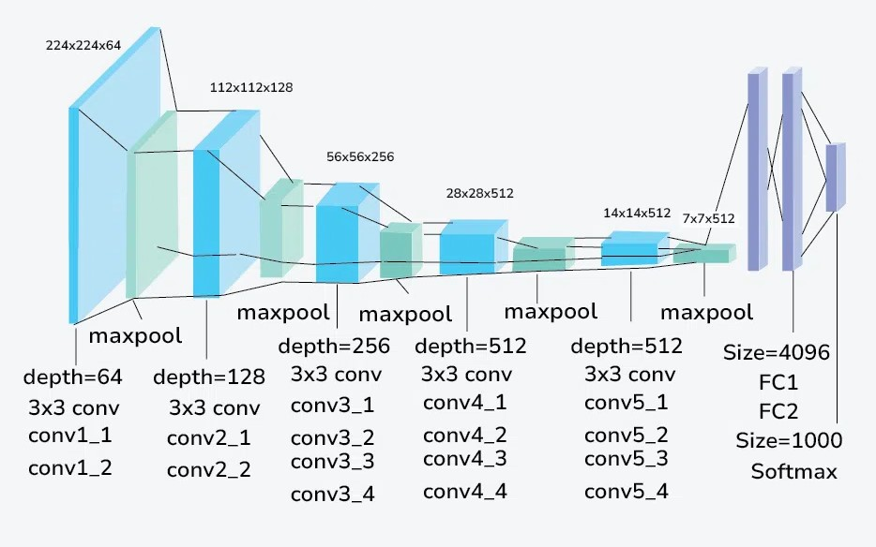

**Figure 4 VGG19 Architecture**

**Table 2 Layered details of VGG16 model**

**Table 3 Layered details of VGG19 model**

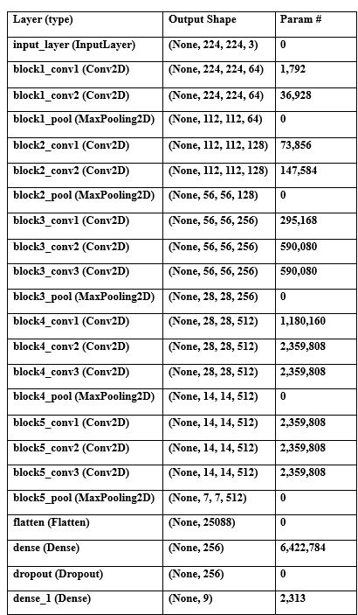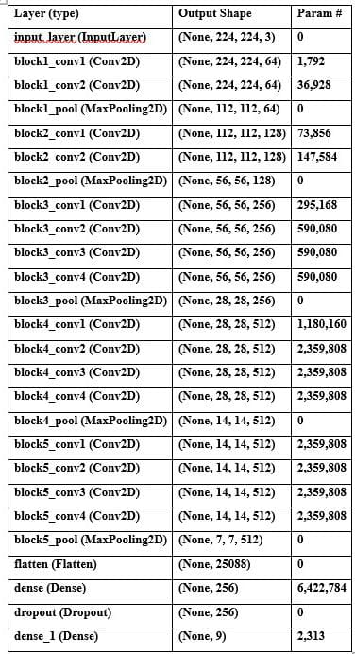

**IV. RESULTS**

The data set was split into an 80/20 split between a training set and a validation set at random to check on the model. To fine-tune VGG16 and VGG19 we tuned hyperparameters including batch sizes, learning rates, weight decay and trained until the models achieve best performance. Checking the accuracy and loss of the training/validation set was done to determine the effectiveness of the models. Both of the models were trained and validated carefully till the process of their convergence and learning reached the goal which was set beforehand: to achieve the highest possible percentage of validation accuracy with the lowest possible validation error.

The test accuracy, test loss along with validation accuracy and validation loss are included in table 4. Both the models are having 50 epochs to evaluate their performance. Figure 5 and Figure 6 shows confusion matrix and performance results of VGG16 model. The figures 7 and 8 shows the confusion matrix and performance results of VGG19 mod

**Table 4 Performance comparison**

|  |  |  |  |  |  |
| --- | --- | --- | --- | --- | --- |
| Model | Training acc | Training loss | Validation acc | Validation loss | Epoch |
| VGG16 | 0.9913 | 0.0474 | 0.9978 | 0.0057 | 50 |
| VGG19 | 0.9768 | 0.1176 | 0.9867 | 0.0472 | 50 |

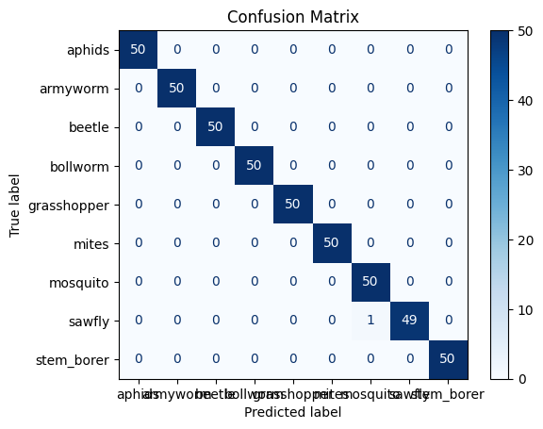

**Figure 5 Confusion matrix for VGG16**

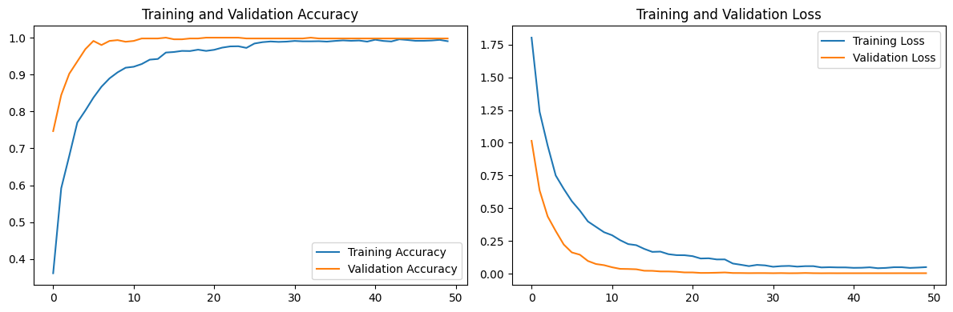

**Figure 6 Performance results for VGG16**

**Figure 7 Confusion matrix for VGG17**

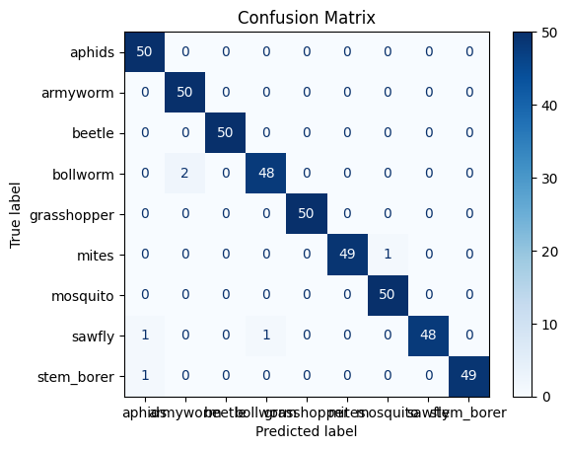

**Figure 8 Performance results for VGG19**

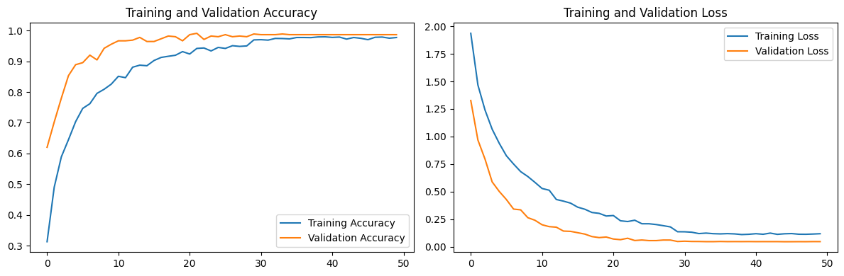

**V. CONCLUSION**

This research brings out the potential of deep learning to enhance Pest Identification and recommendation on Agriculture. Using VGG16 and VGG19 approaches, we designed a sensitive detection program that provided attentiveness assessments of 99%. 78% and 98. 12%. To provide more data into the dataset which consists of 3150 images of nine different pest species, we have incorporated data augmentation strategies which also assisted in the minimization of over-fitting. Such results recommend that the proposed system can be useful for pest identification in real-life agriculture contexts. It is further possible to build on this work and consider real-time pest identification of a more diverse range of species, thus making it an even more useful tool for sustainable agriculture practices.

**REFRENCES**

1. Cheng, X., Zhang, Y., Chen, Y., Wu, Y. and Yue, Y., 2017. Pest identification via deep residual learning in complex background. Computers and Electronics in Agriculture, 141, pp.351-356.

2. Gong, H., Liu, T., Luo, T., Guo, J., Feng, R., Li, J., Ma, X., Mu, Y., Hu, T., Sun, Y. and Li, S., 2023. Based on FCN and DenseNet framework for the research of rice pest identification methods. Agronomy, 13(2), p.410.

3. Yang, J., Ma, S., Li, Y. and Zhang, Z., 2022. Efficient data-driven crop pest identification based on edge distance-entropy for sustainable agriculture. Sustainability, 14(13), p.7825.

4. Lin, S., Xiu, Y., Kong, J., Yang, C. and Zhao, C., 2023. An effective pyramid neural network based on graph-related attentions structure for fine-grained disease and pest identification in intelligent agriculture. Agriculture, 13(3), p.567.

5. Li, H., Li, S., Yu, J., Han, Y. and Dong, A., 2022, April. Plant disease and insect pest identification based on vision transformer. In International conference on internet of things and machine learning (IoTML 2021) (Vol. 12174, pp. 194-201).

6. Talukder, M.S.H., Chowdhury, M.R., Sourav, M.S.U., Al Rakin, A., Shuvo, S.A., Sulaiman, R.B., Nipun, M.S., Islam, M., Islam, M.R., Islam, M.A. and Haque, Z., 2023. JutePestDetect: An intelligent approach for jute pest identification using fine-tuned transfer learning. Smart Agricultural Technology, 5, p.100279.

7. Hu, K., Liu, Y., Nie, J., Zheng, X., Zhang, W., Liu, Y. and Xie, T., 2023. Rice pest identification based on multi-scale double-branch GAN-ResNet. Frontiers in Plant Science, 14, p.1167121.

8. Rong, M., Wang, Z., Ban, B. and Guo, X., 2022. Pest Identification and Counting of Yellow Plate in Field Based on Improved Mask R‐CNN. Discrete Dynamics in Nature and Society, 2022(1), p.1913577.

9. Singh, K.U., Kumar, A., Raja, L., Kumar, V., Singh kushwaha, A.K., Vashney, N. and Chhetri, M., 2022. An Artificial Neural Network‐Based Pest Identification and Control in Smart Agriculture Using Wireless Sensor Networks. Journal of Food Quality, 2022(1), p.5801206.

10. Pest Dataset. Available: Sep. 15, 2023. Available: https://www.kaggle.com/datasets/simranvolunesia/pest-dataset

11. Mascarenhas, S. and Agarwal, M., 2021, November. A comparison between VGG16, VGG19 and ResNet50 architecture frameworks for Image Classification. In 2021 International conference on disruptive technologies for multi-disciplinary research and applications (CENTCON) (Vol. 1, pp. 96-99). IEEE.