EcomPulse
E-Commerce Sales, Customer & Return Analytics
———
INTERNSHIP PROJECT REPORT
Interactive Streamlit analytics for a 30,000-order e-commerce dataset:
sales performance, customer mix, operational reliability and return-risk
evidence from January 2023 to December 2026.
Dataset: E-Commerce Orders Dataset 2026 (Kaggle)
Source code: github.com/chandu8861/BharatCares-Internship-Project
September 2026

Table of Contents
1. Executive Summary 4
2. Introduction 5
2.1 Background 5
2.2 Business Context 5
2.3 Problem Statement 5
2.4 Project Objectives 5
2.5 Scope of the Project 6
2.6 Expected Outcomes 6
3. Dataset Description 7
3.1 Source and Identity 7
3.2 Nature of the Dataset 7
3.3 Important Data Fields 7
4. Data Understanding & Quality Assessment 9
4.1 Assessment Approach 9
4.2 Validation Results 9
4.3 Documented Data Caveats 9
5. Data Preprocessing & Feature Engineering 11
5.1 Cleaning Pipeline 11
5.2 Verified Formulas 11
5.3 Derived Fields (Feature Engineering) 11
6. Analytical Methodology 13
6.1 End-to-End Workflow 13
6.2 Analytical Framework 14
6.3 Return-Risk Methodology 14
7. Exploratory Data Analysis 15
7.1 Sales Performance 15
7.2 Revenue Analysis 15
7.3 Product & Category Analysis 16
7.4 Customer Analysis 17
7.5 Operational Analysis 18
7.6 Return Overview (Driver Scan) 18
7.7 Discount Analysis 19
7.8 Time-Based Analysis 19
8. KPI Analysis 21
8.1 Return Rate 21
8.2 Revenue at Risk 21
8.3 High-Value Order Share 21
8.4 Profit and Margin 21
8.5 Repeat Customer Rate (with caveat) 22
9. Business Insights 23
10. Return Risk Analysis 26
10.1 Position: Descriptive Return-Risk Analysis 26
10.2 Baseline, Driver Scan and Risk Tiers 26
10.3 Quantified Opportunity: Fashion 26
10.4 Modelling Assessment: The Rejected ML Probe 27
10.5 Why the Exclusions Are Correct 27
10.6 The Analytical Decision 27
11. Dashboard Design & Implementation 29
11.1 Interaction Model 29
11.2 The Six Tabs 29
11.3 Design System and Robustness 30
12. Technical Implementation 32
12.1 Technology Stack 32
12.2 Module Responsibilities 32
12.3 Architecture 33
12.4 Verification and Self-Testing 33
13. Project Structure 34
14. Results & Business Value 35
15. Limitations 36
16. Recommendations 37
16.1 How to Pursue These Actions 37
17. Future Enhancements 39
17.1 Data Foundations (highest leverage) 39
17.2 Analytics 39
17.3 Engineering & Delivery 39
18. Conclusion 40
19. References 41

How this works: Headings use Word’s built-in Heading 1 / Heading 2 styles, so the table updates itself.

1. Executive Summary
EcomPulse is an interactive analytics application, built in Python with Streamlit, that turns a 30,000-order synthetic e-commerce dataset into decision-ready evidence. It answers three business questions end to end: how the business is performing (sales, revenue, profit, trends), who the customers are and how reliably operations deliver, and where return-related revenue is at risk — with every insight computed directly from the data rather than asserted.
The business problem is a familiar one: order-level exports show what was sold, but not what to do next. EcomPulse closes that gap with a two-module architecture — an analytics layer (analytics.py) that loads, validates, cleans and aggregates the data, and a presentation layer (app.py) that exposes the results through six dashboard tabs driven by live sidebar filters. The dataset is the Kaggle “E-Commerce Orders Dataset 2026” (mmumairkhattak/e-commerce-orders-dataset-2026-scra): 30,000 orders × 41 columns covering 1 January 2023 to 31 December 2026 across ten countries and eight product categories.
Key results for the full period: $11,370,044 total revenue across 30,000 orders (average order value $379.00) and $2,215,916 total profit (19.49% margin). The return rate is 10.11% (3,033 orders), which places $1,121,122 of revenue — 9.86% of sales, and $222,872 of profit — at risk. Concentration is the defining structural fact: Electronics contributes 55.59% of revenue from only 15.66% of orders, and the top quartile of baskets (≥ $388.19) carries 71.45% of revenue from 25.0% of orders.
Return behaviour is concentrated by what is bought, not how it is bought. A scan of seventeen dimensions finds notable variation only in product subcategory (8.34 percentage-point spread) and category (5.22 pp); Fashion runs at 13.87% versus the 10.11% baseline (Bags 15.56%, Women Clothing 14.59%). Operational dimensions — delivery time, payment method, membership, discount band — all sit within about one point of the baseline. Closing Fashion’s 3.76-point gap would avoid roughly 229 returns ($49,788 revenue, $12,961 profit) over the period.
A deliberate analytical decision shapes the deliverable: a leakage-free logistic-regression probe on 24 pre-order features was measured at AUC ≈ 0.54 — essentially random — so no predictive return model ships. Post-outcome fields (Review_Rating, Order_Status) are excluded as leakage, and the dashboard instead uses descriptive return-rate tiers (High ≥ 1.25× baseline, Medium 0.90–1.25×, Low < 0.90×) computed from observed behaviour. The result is a dashboard whose every number is traceable, whose limitations are documented on-screen, and whose recommendations are hedged to claim association, never causation.

2. Introduction

2.1 Background
E-commerce organisations accumulate rich order-level data, yet the analytical layer between raw orders and decisions is often thin: spreadsheet extracts that go stale, charts without context, or dashboards that present metrics without data-quality caveats. This project was carried out as an internship-level data-analytics assignment with the goal of demonstrating the full craft — validation, cleaning, exploration, KPI design, insight generation and presentation — on a realistic, publicly available dataset. The delivered system, EcomPulse, is a compact two-module Streamlit application (app.py + analytics.py) accompanied by an implementation plan, a Kaggle exploration notebook and this report.

2.2 Business Context
The dataset describes an online retailer operating across ten countries (Australia, Canada, France, Germany, India, Pakistan, Saudi Arabia, UAE, United Kingdom, United States) with eight product categories spanning Electronics to Groceries, four shipping methods and five warehouse regions. Orders carry the full commercial record: pricing and discount detail, shipping and tax, payment and device, delivery outcome, return flag and review rating. Management questions in this context are straightforward: Is revenue growing? Where is it concentrated? Which segments and categories carry value? How reliable is delivery? And how much money is exposed to returns — and where should prevention effort be spent?

2.3 Problem Statement
Given a 30,000-order export with 41 columns, build a trustworthy analytical view that (a) verifies the data before analysing it, (b) quantifies sales, customer-mix, operational and return-risk performance with consistent KPIs, (c) explains the findings with evidence and clearly separated hypotheses, and (d) surfaces limitations honestly — including the synthetic nature of the data and the fields that cannot be used as predictors. The project must decide, on evidence, whether a predictive return-risk model is justified, and deliver the analysis as an interactive dashboard a business user can filter and explore.

2.4 Project Objectives
- Load and validate the dataset programmatically; document every cleaning action in an auditable log.
- Run automated quality checks (14 checks) covering missing values, duplicates, formula tolerance, referential consistency and semantic integrity.
- Compute a compact KPI set (revenue, orders, AOV, profit, return rate, revenue at risk, high-value share, repeat rate, rating, delivery time, discount spend) on any filtered slice.
- Explore sales, product, customer, operational and discount dimensions with consistent aggregations and clearly labelled caveats.
- Analyse returns descriptively: baseline rate, driver scan across seventeen dimensions, and risk tiers with volume guards.
- Assess — and if unjustified, formally reject — a predictive return-risk model, documenting the evidence.
- Deliver an interactive six-tab Streamlit dashboard with adaptive light/dark theming, filters, downloads and empty-state handling.

2.5 Scope of the Project
In scope: one CSV dataset in data/ (no database, no external APIs), cleaning and quality instrumentation, descriptive and diagnostic analytics, KPI computation, return-risk tiering, insight and recommendation generation, and a Streamlit dashboard UI. Self-testing of the analytics layer is included.
Out of scope: a production predictive model (rejected on evidence — Chapter 10), customer or product master-data management, city-level geospatial analysis (City is independently assigned in the data), causal or incremental-lift measurement, authentication, and cloud deployment. scikit-learn is intentionally not a runtime dependency because no model ships.

2.6 Expected Outcomes
The project was expected to produce: a validated, documented data pipeline; a KPI layer that always agrees with the raw data; a dashboard that a non-technical stakeholder can operate unaided; a defensible return-risk narrative with quantified opportunity sizing; and an explicit, evidence-based position on predictive modelling. All of these outcomes were achieved and are demonstrated in the chapters that follow.

3. Dataset Description

3.1 Source and Identity
The project analyses a single public dataset. All findings in this report derive from it; no external data was joined.
Table 3.1: Dataset identity and structure
Attribute | Value
Dataset name | E-Commerce Orders Dataset 2026 (ecommerce_orders_dataset.csv)
Kaggle source | mmumairkhattak/e-commerce-orders-dataset-2026-scra
Kaggle URL | https://www.kaggle.com/datasets/mmumairkhattak/e-commerce-orders-dataset-2026-scra
Records | 30,000 orders (one row = one order)
Columns | 41 raw columns; 54 columns after cleaning adds 13 derived fields
Date range | 2023-01-01 to 2026-12-31 (1,461 distinct dates — complete daily coverage of four calendar years)
Geography | 10 countries (marginal distribution only — see Section 4.3)
Catalogue breadth | 8 categories · 32 subcategories · 10 brands · 2,500 Product_IDs
Customer IDs | 8,683 distinct Customer_IDs (not a stable master — see Section 4.3)
Nature | Synthetic, complete-period dataset; no missing cells; includes 2,101 orders dated after the build date, as designed

3.2 Nature of the Dataset
The dataset is synthetic: it was generated to be internally complete rather than collected from live transactions. It is nevertheless structurally realistic — order amounts obey an exact accounting identity (Section 5.2), dates cover every day of four calendar years, and categorical mixes are plausible. Completeness is a strength for learning analytics engineering, but several identifiers and geographic fields behave in ways a real CRM would not; those behaviours are verified by the quality checks in Chapter 4 and respected throughout the analysis. Dates extend beyond the build date (2,101 orders lie in the future), which the dashboard treats as synthetic complete-period data requiring no as-of truncation.

3.3 Important Data Fields
Table 3.2 lists the fields with the strongest analytical role. The full 41-column data dictionary ships with the project at data/data_dictionary.csv; calendar duplicates of the order date (Year, Month, Day, Day_Of_Week, Quarter) and descriptive attributes (Device_Type, Traffic_Source, Warehouse_Region, Season, Holiday_Season, Customer_Lifetime_Value, Coupon_Used, Customer_Age, Customer_Gender, City) follow the same conventions.
Table 3.2: Key analytical fields (selected from the 41-column dictionary)
Column | Type | Description | Analytical role
Order_ID | Integer | Unique order identifier | Primary key; one unique identifier per order row
Customer_ID | Text | Unique customer identifier | Groups orders for frequency views (not a stable master)
Order_Date | Date | Date when the order was placed | Order placement date; basis for all trend analysis
Product_Category | Text | Main product category | Top level of the merchandise hierarchy
Product_Subcategory | Text | Product subcategory | Finer merchandise level (32 values)
Brand | Text | Product brand | Brand level (10 values)
Unit_Price | Decimal | Price per unit | List price per unit
Quantity | Integer | Number of units ordered | Units ordered
Discount_Percent | Integer | Discount percentage applied | Discount depth applied to the order
Discount_Amount | Decimal | Discount amount applied to the order | Discount value (backfilled from formula only if missing)
Shipping_Cost | Decimal | Shipping cost charged | Shipping charge included in the order amount
Tax_Amount | Decimal | Tax amount applied | Tax included in the order amount
Order_Amount | Decimal | Final order amount including discount, shipping, and tax | Final charged amount; core measure for revenue and AOV
Profit_Amount | Decimal | Estimated profit amount | Estimated profit; Profit_Margin_Percent is its percentage form
Payment_Method | Text | Payment method used | Checkout method (6 values)
Shipping_Method | Text | Selected shipping method | Delivery promise (4 values)
Delivery_Days | Integer | Number of days taken for delivery | Actual delivery time in days
Order_Status / Returned | Text | Current or final order status | Outcome flags; Returned = Yes ⇔ Order_Status = Returned
Review_Rating | Decimal | Customer review rating from 1 to 5 | Post-delivery 1–5 rating; context only, never a driver
Customer_Segment / Membership_Status | Text | Customer segment category | Order-level customer attributes (4 values each)
Country / City | Text | Customer country | Geography; Country used as marginal split, City not mapped
High_Value_Order | Text | Target variable indicating whether order is high value | Provided top-quartile flag of Order_Amount (threshold $388.19)

4. Data Understanding & Quality Assessment

4.1 Assessment Approach
Quality assessment is a first-class pipeline stage, not an afterthought. The loader resolves the dataset path (data/ with a project-root fallback), and a schema validator (validate_schema) distinguishes 15 required columns from 26 optional ones. Required columns gate the whole application; optional columns degrade gracefully — a missing field disables only the charts that need it, never the app. After cleaning, run_quality_checks() executes 14 automated checks spanning structure, arithmetic, referential behaviour and semantics, returning a status (ok / warn), a measured result and an interpretation for each. The same checks are surfaced inside the dashboard so consumers see the evidence, not just a claim of quality.

4.2 Validation Results
Table 4.1: Automated quality checks (run_quality_checks, all 14 checks)
Check | Measured result | Status | Interpretation
Dataset shape | 30,000 rows x 54 columns | ok | Row and column counts after cleaning.
Missing values | 0 missing cells | ok | No missing values.
Duplicate rows | none found | ok | Cleaned frame should contain no exact duplicate rows.
Order_Amount arithmetic | mean abs diff 0.0000 | ok | Order_Amount should equal Unit_Price x Quantity - Discount_Amount + Shipping_Cost + Tax_Amount (derived field).
Returned vs Order_Status | perfectly aligned | ok | Returned=Yes occurs exactly when Order_Status=Returned, so treat them as one outcome, not drivers.
Customer_ID attribute stability | 49,289 attribute switches | warn | Same Customer_ID appears with different attribute values across rows. Analyses on these IDs are order-level, not master-level.
Product_ID attribute stability | 10,000 attribute switches | warn | Same Product_ID appears with different attribute values across rows. Analyses on these IDs are order-level, not master-level.
Country / City independence | 100 distinct pairs | warn | Country and City look independently assigned (all combinations appear). Use country marginals only and never map City.
Delivery vs Shipping_Method | 64.9% of Same-Day orders took longer than 0 days | warn | Delivery_Days only loosely follows Shipping_Method; treat delivery fields as indicative, not contractual.
Order_Status vs delivery speed | spread of means 0.08 days | ok | Status is unrelated to delivery speed, so funnel-by-delivery analysis adds no signal.
Date coverage | 2023-01-01 to 2026-12-31 (1,461 distinct dates) | ok | Complete daily coverage across four calendar years.
Future-dated records | 2,101 orders after today | warn | Dates extend beyond the current date: synthetic complete-period data, no as-of truncation needed.
Season / Holiday consistency | deterministic from month | ok | Season and Holiday_Season are fixed calendar functions of the month, not business responses.
High_Value_Order definition | min Yes order $388.19 vs 75th pct $388.19 | ok | Flag equals a top-quartile threshold of Order_Amount: classificatory convenience, not a behaviour label.

Ten checks pass outright: the frame has no missing cells and no duplicate rows or duplicate Order_IDs; the accounting identity behind Order_Amount reproduces to a mean absolute difference of 0.0000; Returned and Order_Status are perfectly aligned; Order_Status carries no relationship to delivery speed (0.08-day spread of means); dates cover 1,461 consecutive days; Season and Holiday_Season are deterministic calendar functions; and the High_Value_Order flag coincides exactly with the 75th-percentile threshold ($388.19). Four checks warn — not because the data is broken, but because it must be read correctly. Those warnings define the caveats below.

4.3 Documented Data Caveats
- Customer_ID is not a stable customer master. The same ID appears with different ages, genders, segments, countries, cities, memberships and lifetime values across orders (49,289 attribute switches detected). Segment, loyalty and repeat views are therefore order-level mixes, not tracked cohorts; the 87.72% repeat-order rate counts orders per ID, it does not measure loyalty.
- Product_ID is not a product master. 10,000 attribute switches mean an ID maps to several categories, subcategories, brands and prices. Performance is analysed at category, subcategory and brand level only; no product-level ranking is attempted.
- Country and City are independently assigned. All 100 country–city combinations occur (for example Germany / Dubai), so the dashboard shows Country as a marginal split and never maps City.
- Review_Rating is post-outcome information. It drops sharply for returned orders (mean 3.08 versus 4.16 for delivered orders), which is exactly why it is displayed as context and never used as a driver or predictor (Chapter 10).
- High_Value_Order is a derived threshold label. It marks the top quartile of Order_Amount (minimum flagged order $388.19 = the 75th percentile). It is a classificatory convenience — a value band, not a behaviour.
- Delivery fields are indicative, not contractual. 64.9% of Same-Day orders took longer than zero days; Order_Status is unrelated to delivery speed. Delivery_Days is analysed as an observed distribution, not a service level.
- The dataset is synthetic. Season and Holiday_Season are calendar functions of the month; warehouse regions and traffic sources are near-uniform; dates run past the current date. Findings describe this dataset, and transfer to a live business only as hypotheses to re-test.

5. Data Preprocessing & Feature Engineering

5.1 Cleaning Pipeline
clean_data() applies a fixed, logged sequence: it strips and standardises column names, removes exact duplicate rows and duplicate Order_ID values (keeping the first), parses Order_Date with coercion of failures, coerces seventeen numeric columns, normalises whitespace in text fields, maps Yes/No style flags (Returned, Coupon_Used, Holiday_Season, High_Value_Order) onto a canonical Yes/No vocabulary, and finally backfills two derived values only where they are missing, using verified formulas. Every step is appended to a cleaning log that the dashboard can display; raw values are never overwritten — Order_Date is preserved alongside its parsed form in Order_Date_Raw. On this dataset the log records a clean pass-through:
Table 5.1: Cleaning log for the full dataset (clean_data)
Step | Recorded outcome
Rows read | 30,000 records x 41 columns
Exact duplicate rows | none found
Duplicate Order_ID values | none found
Order_Date parsing | all dates parsed
Numeric coercion | no invalid numeric values
Text standardisation | whitespace stripped; Yes/No fields normalised
Conditional backfill | no backfill needed
Rows after cleaning | 30,000 records

5.2 Verified Formulas
Two accounting identities from the source data were verified before use and drive both the quality checks and the backfill logic:
Order Amount = (Unit Price × Quantity) − Discount Amount + Shipping Cost + Tax Amount
Profit Amount = Order Amount × Profit Margin Percent ÷ 100
Discount Amount (backfill only) = Unit Price × Quantity × Discount Percent ÷ 100
Rebuilding Order_Amount from its components reproduces the stored value with a mean absolute difference of 0.0000 across all 30,000 rows (self-test tolerance: < 0.05). Derived analytics build on these verified quantities:
Return Rate = Returned Orders ÷ Total Orders × 100
Revenue at Risk = Σ Order Amount where Returned = Yes
Profit at Risk = Σ Profit Amount where Returned = Yes
Average Order Value (AOV) = Revenue ÷ Orders
High-value threshold = 75th percentile of Order Amount ($388.19)

5.3 Derived Fields (Feature Engineering)
add_derived_columns() adds thirteen fields — and never mutates a raw column. Binning uses fixed, human-readable bands so that filtered views stay comparable:
Table 5.2: Derived fields added by the pipeline (add_derived_columns)
Derived field | Definition | Analytical purpose
Is_Returned | Returned = “Yes” (boolean) | Return flags and rates everywhere
Is_High_Value | High_Value_Order = “Yes” (or Order_Amount ≥ 75th percentile if the flag were absent) | Value-band concentration analysis
Line_Subtotal | Unit_Price × Quantity | Component of the order-amount identity
Discount_Bucket | Fixed bands: 0%, 1–10%, 11–20%, 21–30%, 31–40% | Discount-depth comparisons
Rating_Bucket | Fixed bands: ≤2, 2–3, 3–4, 4–5 | Rating context (display only)
Delivery_Bucket | Fixed bands: Same day, 1–2, 3–4, 5–7, 8+ days | Delivery-speed analysis
Age_Bucket | Fixed bands: 18–25, 26–35, 36–45, 46–55, 56+ | Age-mix views
Order_Month / Order_Week | Calendar month / week start of Order_Date | Daily, weekly and monthly trends
Is_Weekend | Day_Of_Week in {Saturday, Sunday} | Weekday-versus-weekend views
Revenue_At_Risk | Order_Amount where Is_Returned, else 0 | Return exposure KPI
Profit_At_Risk | Profit_Amount where Is_Returned, else 0 | Profit exposure KPI
Order_Date_Raw | Original Order_Date string (kept during parsing) | Auditability of date parsing

Guardrail: Cleaning adds new columns and never overwrites raw values. Backfill of Discount_Amount and Profit_Amount happens only when those values are missing, uses the verified subtotal formulas, and is recorded in the cleaning log — on this dataset no backfill was needed.

6. Analytical Methodology

6.1 End-to-End Workflow
The workflow is deliberately linear and auditable: each stage consumes the logged output of the previous one, and every number shown in the dashboard can be traced back through aggregations to the cleaned frame and its cleaning log. Figure 6.1 shows the twelve stages as implemented in analytics.py and app.py.
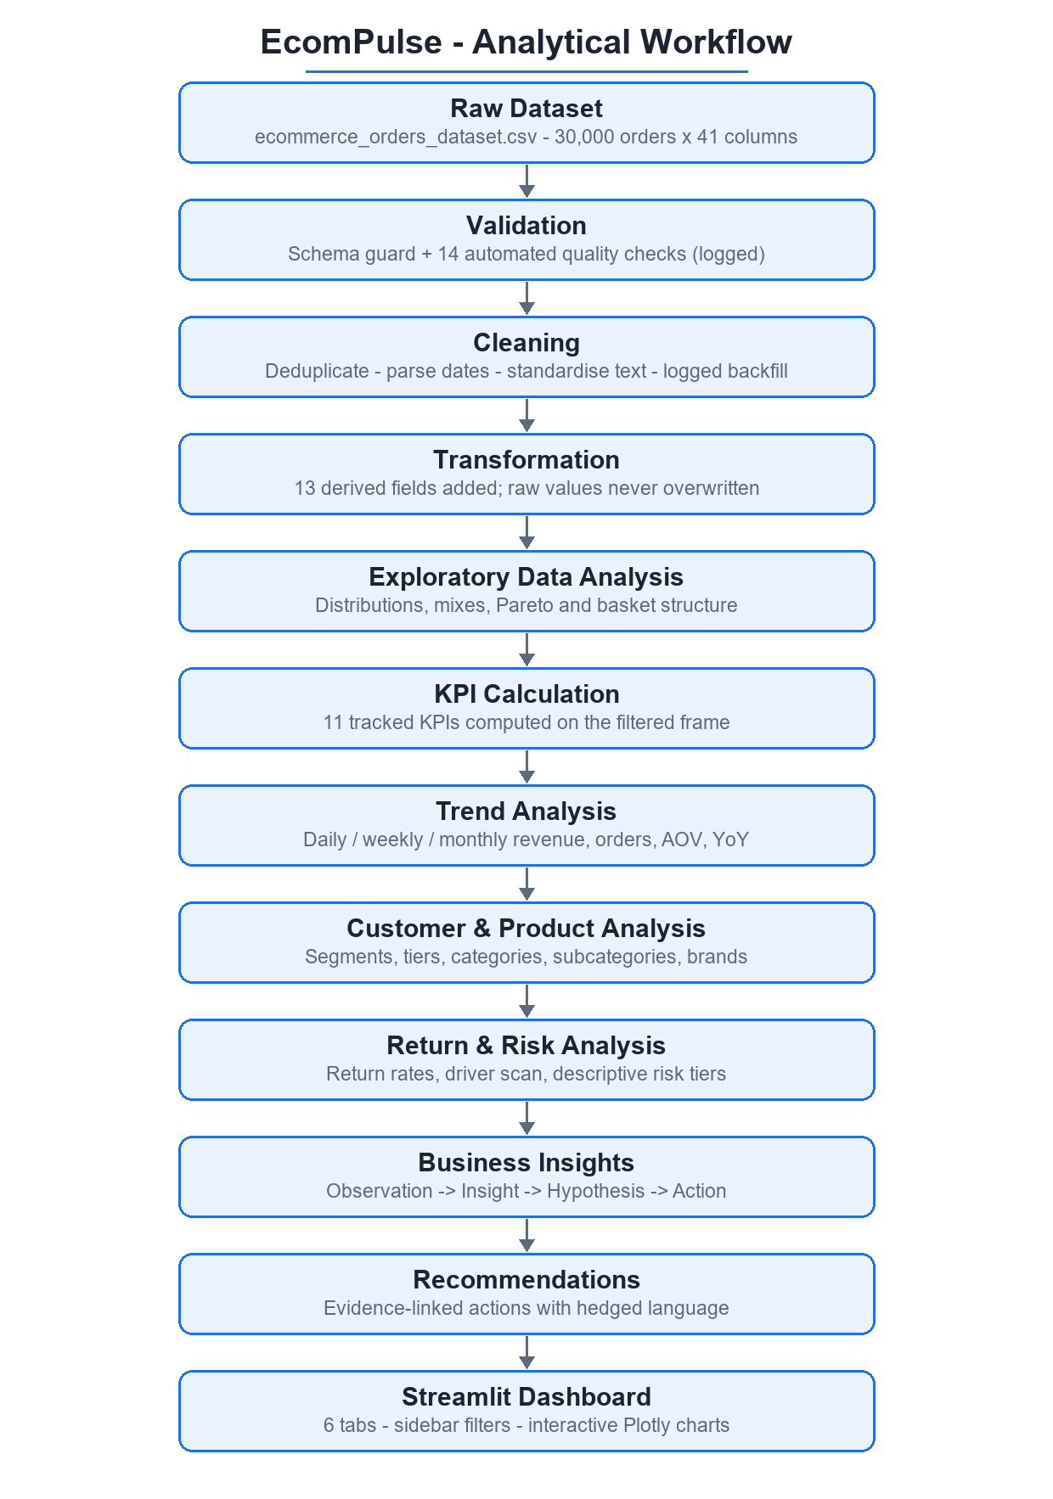
Figure 6.1: EcomPulse analytical workflow, from raw CSV to the six-tab dashboard

6.2 Analytical Framework
Every insight in the project follows the same four-part structure, rendered as a card in the dashboard: Observation (a measured fact), Insight (what the fact implies), Hypothesis (a hedged possible explanation using language such as “may”, “might”, “appears”), and Recommendation (an action linked to the evidence). Causal claims are never made: the data establish association, not mechanism. Recommendations that depend on counterfactuals (for example A/B tests) are labelled as such.

6.3 Return-Risk Methodology
Return analysis is descriptive by design. The baseline return rate is computed on the filtered frame; a driver scan measures the min–max spread of return rates across seventeen dimensions; and risk tiers classify observed rates per dimension value with a minimum-volume guard of 150 orders so that small, noisy cells are excluded:
High: return rate ≥ 1.25 × baseline Medium: 0.90–1.25 × baseline Low: < 0.90 × baseline
With the full-period baseline of 10.11%: High ≥ 12.64%, Medium 9.10–12.64%, Low < 9.10%
Opportunity sizing compares a segment’s rate with the baseline (fashion_opportunity): avoidable returns = gap × segment orders, valued at the segment’s mean order amount and mean profit. A leakage-free modelling probe was also run once to decide whether prediction is justified; its rejection is documented in Chapter 10.

7. Exploratory Data Analysis
This chapter documents the analyses actually implemented, following the dashboard’s own structure. Screenshots of the corresponding tabs are embedded where the analysis is presented; every figure caption states what to look at.

7.1 Sales Performance
Order volume is remarkably stable — about 20.5 orders per day across four years — while revenue drifts gently downward. The strongest year is 2023 ($2,962,427); revenue settles around $2.8M afterwards. The full-period trend insight computed by the dashboard reads: “Annual revenue moved from $2,962,427 (7,577 orders, AOV $390.98) to $2,792,986 (7,520 orders, AOV $371.41), a −5.7% revenue and −5.0% AOV shift over the full period”, with the hedged explanation that this may reflect price sensitivity, heavier discount use, or mix shift — the data show the direction, not the cause.
Table 7.1: Performance by year (aggregate_by on Year)
Year | Orders | Revenue | AOV | Margin | Return rate
2023 | 7,577 | $2,962,427 | $390.98 | 19.65% | 10.14%
2026 | 7,449 | $2,817,369 | $378.22 | 19.26% | 10.46%
2024 | 7,454 | $2,797,263 | $375.27 | 19.43% | 10.24%
2025 | 7,520 | $2,792,986 | $371.41 | 19.62% | 9.61%

Trend detail: Peak month: August 2025 ($291,993 revenue, AOV $433.22). Lowest month: October 2024 ($205,510). Monthly revenue varies within roughly ±15% of the mean with no sustained seasonality — consistent with the synthetic, uniform-by-design calendar fields.

7.2 Revenue Analysis
Revenue concentration is the headline structural finding. Electronics alone contributes $6,320,059 — 55.59% of revenue — from just 15.66% of orders, at an AOV of $1,344.98 versus a business-wide $379.00. The top three categories (Electronics, Home & Kitchen, Fashion) account for 82.79% of revenue cumulatively. The Executive Overview tab renders this as a revenue-share doughnut and a top-10 subcategory bar; the Sales and Product tab (Figure 7.1) adds trend and mix views.
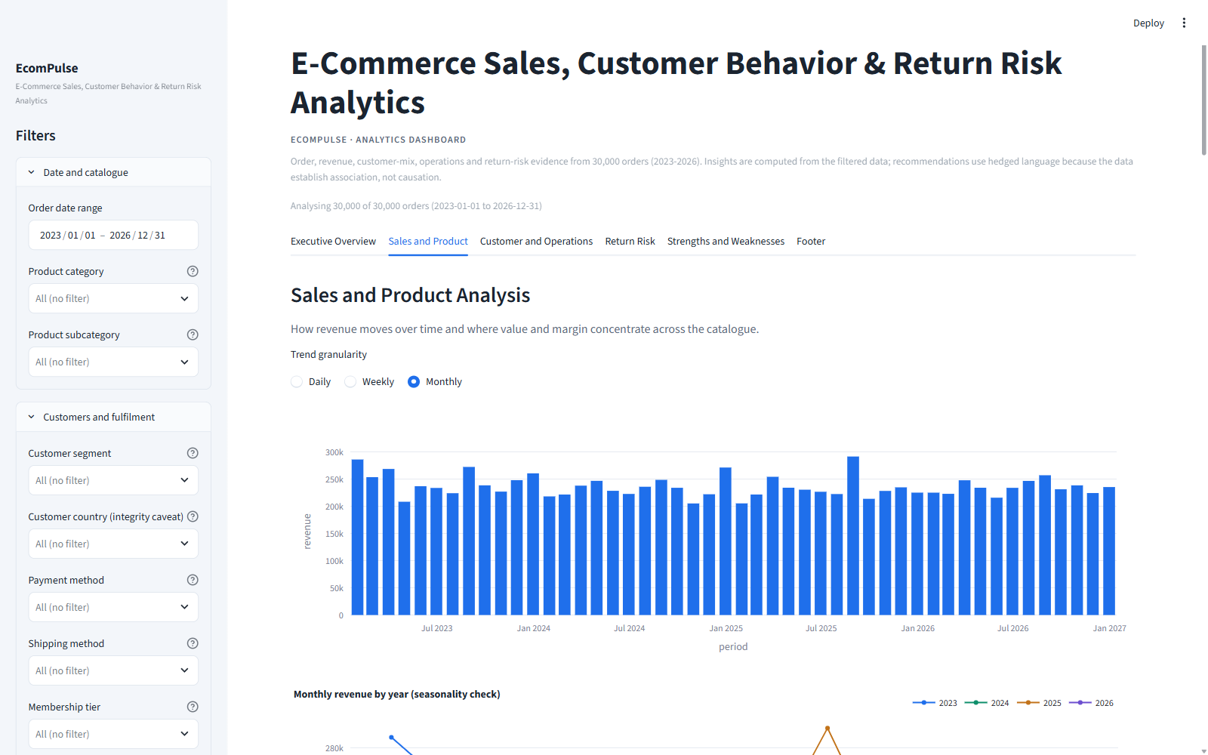
Figure 7.1: Sales and Product tab — trend granularity switcher (daily/weekly/monthly), revenue and orders over time, category/subcategory/brand bars, discount-band and weekday views

7.3 Product & Category Analysis
Table 7.2: Performance by product category (sorted by revenue)
Category | Orders | Revenue | Rev. share | AOV | Margin | Return rate
Electronics | 4,699 | $6,320,059 | 55.59% | $1,344.98 | 16.47% | 9.19%
Home & Kitchen | 4,194 | $1,768,963 | 15.56% | $421.78 | 21.45% | 8.66%
Fashion | 6,092 | $1,323,929 | 11.64% | $217.32 | 26.03% | 13.87%
Sports | 2,439 | $661,448 | 5.82% | $271.20 | 21.13% | 9.80%
Beauty | 2,971 | $460,243 | 4.05% | $154.91 | 29.20% | 8.78%
Groceries | 5,380 | $360,727 | 3.17% | $67.05 | 21.08% | 8.83%
Toys | 2,062 | $279,307 | 2.46% | $135.45 | 21.54% | 8.83%
Books | 2,163 | $195,367 | 1.72% | $90.32 | 20.88% | 10.91%

Table 7.3: Top 10 subcategories by revenue, with cumulative share (pareto_table)
Subcategory | Orders | Revenue | Share | Cumulative
Laptop | 1,171 | $1,608,474 | 14.15% | 14.15%
Mobile | 1,216 | $1,598,520 | 14.06% | 28.21%
Headphones | 1,145 | $1,570,898 | 13.82% | 42.02%
Accessories | 1,167 | $1,542,168 | 13.56% | 55.59%
Furniture | 1,063 | $446,469 | 3.93% | 59.51%
Decor | 1,036 | $444,842 | 3.91% | 63.42%
Cookware | 1,062 | $440,000 | 3.87% | 67.29%
Appliances | 1,033 | $437,653 | 3.85% | 71.14%
Men Clothing | 1,591 | $348,461 | 3.06% | 74.21%
Bags | 1,497 | $335,505 | 2.95% | 77.16%

Four Electronics subcategories — Laptop ($1,608,474), Mobile ($1,598,520), Headphones ($1,570,898) and Accessories ($1,542,168) — each contribute about 14% of total revenue and together reproduce the category’s 55.59% share. Margin, by contrast, is highest in small-basket categories: Beauty runs at 29.20% margin on a $154.91 AOV, while Electronics runs at 16.47% on a $1,344.98 AOV. Fashion combines the highest order count (6,092) with the weakest return profile (13.87%), which Chapter 10 develops into the project’s principal risk finding.

7.4 Customer Analysis
Customer attributes are recorded per order, and the quality checks showed they change between orders of the same ID; every customer view is therefore labelled a basket mix. The Returning segment is the largest (11,987 orders, 40.31% of revenue); New customers return most often (11.53%) and Premium least (9.32%). Membership tiers are volume-weighted toward Standard (53.23% of revenue), with Platinum showing the highest return rate (11.01%) despite its small share.
Table 7.4: Performance by customer segment (order-level attribute)
Segment | Orders | Revenue | Rev. share | AOV | Return rate
Returning | 11,987 | $4,582,714 | 40.31% | $382.31 | 9.44%
New | 7,794 | $2,982,576 | 26.23% | $382.68 | 11.53%
Loyal | 7,214 | $2,659,609 | 23.39% | $368.67 | 10.02%
Premium | 3,005 | $1,145,145 | 10.07% | $381.08 | 9.32%

Table 7.5: Performance by membership tier (order-level attribute)
Tier | Orders | Revenue | Rev. share | Return rate
Standard | 16,049 | $6,051,982 | 53.23% | 10.22%
Silver | 7,246 | $2,805,354 | 24.67% | 9.85%
Gold | 4,916 | $1,811,566 | 15.93% | 9.78%
Platinum | 1,789 | $701,142 | 6.17% | 11.01%

Order frequency per Customer_ID averages 3.46 orders; 87.72% of IDs have two or more orders and 67.20% have three or more. The dashboard flags this card as a data caveat rather than a loyalty result: the pattern is consistent with generated customer keys, and the recommendation is to instrument a stable customer identity before setting retention targets. Figure 7.2 shows the tab that carries these views together with delivery performance.
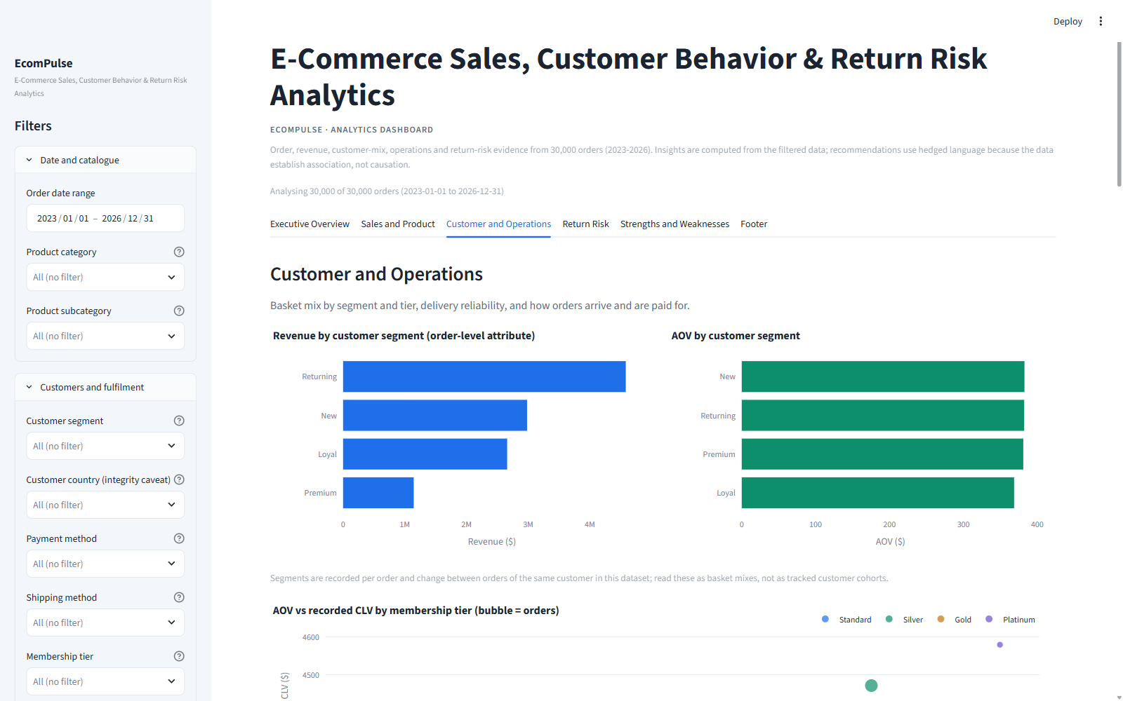
Figure 7.2: Customer and Operations tab — segment and tier mixes, AOV versus recorded CLV scatter, order-frequency distribution with caveat card, delivery statistics by shipping method, payment and device/traffic/warehouse views

7.5 Operational Analysis
Delivery is analysed as promised speed versus observed days (delivery_analysis). Standard carries 54.73% of orders and averages 5.28 days; Express averages 3.31 days; Pickup 5.29 days; Same Day averages 1.67 days — but 64.9% of Same-Day orders were delivered after day 0, making the fastest promise the least reliable, a finding the dashboard renders as a warning card. Payment methods, devices, traffic sources, warehouse regions and weekdays are all near-uniform splits (each within roughly one point of an even share), so they provide context rather than differentiation.
Table 7.6: Delivery statistics by shipping method (delivery_analysis)
Method | Orders | Mean days | Median | P90 | Max | Return rate
Express | 7,914 | 3.31 | 3 | 6 | 11 | 9.87%
Pickup | 2,955 | 5.29 | 5 | 8 | 11 | 9.95%
Same Day | 2,711 | 1.67 | 1 | 4 | 9 | 11.03%
Standard | 16,420 | 5.28 | 5 | 8 | 13 | 10.10%

Age bands concentrate spending in 36–45 (30.49% of orders) and 26–35 (29.06%); Mobile devices account for 61.79% of orders; warehouses span 19.47%–20.77% of revenue; and the six traffic sources each contribute 16.1%–17.4%. These flat distributions are reported as such — the methodology treats “no signal” as a finding, not a failure.

7.6 Return Overview (Driver Scan)
Before any tiering, return_driver_scan() measures the min–max spread of return rates across seventeen analytical dimensions and marks a dimension “notable” when the spread reaches 3.0 percentage points. Only the two product dimensions qualify:
Table 7.7: Return-driver scan across all seventeen dimensions (return_driver_scan)
Dimension | Levels | Min rate | Max rate | Spread (pp) | Verdict
Product subcategory | 32 | 7.22% | 15.56% | 8.34 | notable
Product category | 8 | 8.66% | 13.87% | 5.22 | notable
Customer segment | 4 | 9.32% | 11.53% | 2.22 | flat
Delivery band | 5 | 9.58% | 11.19% | 1.61 | flat
Weekday | 7 | 9.72% | 11.00% | 1.28 | flat
Membership tier | 4 | 9.78% | 11.01% | 1.23 | flat
Brand | 10 | 9.59% | 10.82% | 1.22 | flat
Country | 10 | 9.56% | 10.77% | 1.20 | flat
Device | 3 | 9.26% | 10.43% | 1.18 | flat
Age band | 5 | 9.46% | 10.63% | 1.17 | flat
Shipping method | 4 | 9.87% | 11.03% | 1.16 | flat
Warehouse region | 5 | 9.45% | 10.54% | 1.09 | flat
Payment method | 6 | 9.65% | 10.63% | 0.98 | flat
Traffic source | 6 | 9.50% | 10.34% | 0.84 | flat
Season | 4 | 9.83% | 10.66% | 0.83 | flat
Discount band | 5 | 9.54% | 10.33% | 0.79 | flat
Holiday period | 2 | 9.75% | 10.17% | 0.42 | flat

Exclusion rule: Post-outcome fields (Review_Rating, Order_Status, Returned itself) are excluded from the scan by construction: they describe what happened after the return decision, they do not predict it.

7.7 Discount Analysis
Discount analysis (discount_analysis) compares AOV, quantity and return behaviour across discount-depth bands and coupon use. The pattern is consistent and negative: AOV falls monotonically from $427.84 in the 0% band to $299.68 in the 31–40% band, while mean quantity barely moves (3.07–3.09 units). Coupon orders (20,429) average $358.05 against $423.73 for non-coupon orders (9,571). In total $1,482,982 — 11.54% of gross order value — is spent on discounts, at an average depth of 12.62%. The dashboard’s insight is hedged exactly as the data allow: the discount pattern appears to erode value without buying volume, but observational data cannot separate a mechanical effect (discounts reduce the recorded amount) from a behavioural one.
Table 7.8: Order economics by discount band (discount_analysis)
Discount band | Orders | AOV | Avg quantity | Discount spend | Return rate
0% | 7,882 | $427.84 | 3.08 | $0 | 10.33%
1-10% | 8,373 | $393.49 | 3.08 | $247,340 | 10.06%
11-20% | 7,768 | $363.83 | 3.09 | $528,659 | 10.18%
21-30% | 4,184 | $320.17 | 3.07 | $437,620 | 9.92%
31-40% | 1,793 | $299.68 | 3.07 | $269,362 | 9.54%

Table 7.9: Coupon versus non-coupon orders
Coupon used | Orders | AOV | Avg quantity | Return rate
No | 9,571 | $423.73 | 3.06 | 10.65%
Yes | 20,429 | $358.05 | 3.09 | 9.86%

7.8 Time-Based Analysis
Calendar dimensions are reported with the synthetic-data caveat in view. Season shares are near-identical (Summer 25.69% of revenue to Autumn 24.19%), reflecting that Season is a fixed function of the month. Weekday revenue spans only 13.82% (Sunday) to 14.63% (Wednesday). Holiday_Season, likewise deterministic, shows no material difference. The meaningful time signal is the annual AOV erosion quantified in Section 7.1; the dashboard exposes daily, weekly and monthly granularity through a trend switcher so users can verify the stability themselves.

8. KPI Analysis
compute_kpis() defines eleven KPIs, each computed on the currently filtered frame and carrying a plain-language note. Where the span exceeds two years, revenue, orders and AOV also carry a YoY-style delta (“last 12 months vs prior 12”). Table 8.1 lists the KPI set with full-period values; the definitions below explain calculation and business relevance for the most decision-relevant ones.
Table 8.1: EcomPulse KPI set — full-period values (compute_kpis)
KPI | Value | Definition / note
Total Revenue | $11,370,044 | Σ Order_Amount on the filtered frame (precise: $11,370,043.99)
Total Orders | 30,000 | Row count; ≈ 20.5 orders per day
Average Order Value | $379.00 | Revenue ÷ orders
Total Profit | $2,215,916 | Σ Profit_Amount; margin 19.49% of revenue
Return Rate | 10.11% | 3,033 returned of 30,000 orders
Revenue at Risk (Returns) | $1,121,122 | Σ Order_Amount of returned orders; 9.86% of revenue; profit lost $222,872
High-Value Orders | 25.00% | Top-quartile baskets (≥ $388.19); carry 71.45% of revenue
Repeat Customer Rate | 87.72% | Customer_IDs with 2+ orders; order-frequency based (attributes not stable)
Average Rating | 4.05 / 5 | Mean Review_Rating; post-delivery outcome field, not a driver
Average Delivery Time | 4.44 days | Mean Delivery_Days; indicative, loosely follows shipping method
Total Discount Spend | $1,482,982 | Σ Discount_Amount; 11.54% of gross order value

8.1 Return Rate
Definition: returned orders divided by total orders on the filtered frame (Returned = “Yes” ⇔ Order_Status = “Returned”, verified by a quality check). Business relevance: it is the entry point to the exposure view — every point of return rate on this dataset is worth roughly $111,000 of order value — and it is the reference line against which all risk tiers are drawn.

8.2 Revenue at Risk
Definition: the sum of Order_Amount over returned orders (the derived Revenue_At_Risk column), with Profit_At_Risk as its profit counterpart. Business relevance: it converts a percentage into money — $1,121,122 of revenue and $222,872 of profit in the full period — and is decomposed by category in the risk tables so prevention effort can be prioritised by exposure, not just by rate.

8.3 High-Value Order Share
Definition: share of orders with Order_Amount at or above the 75th percentile ($388.19). Business relevance: 25.0% of orders carry 71.45% of revenue, so the KPI doubles as a concentration alarm; the dashboard pairs it with the basket quintile view (top quintile = 65.72% of revenue) and explicitly labels it a value band, not a customer identity.

8.4 Profit and Margin
Definition: Σ Profit_Amount and its ratio to revenue. Business relevance: margin context prevents revenue-only decisions — Electronics’ 55.59% revenue share comes with the lowest category margin (16.47%), while Beauty’s 29.20% margin sits on just 4.05% of revenue. The mean recorded Profit_Margin_Percent column is 21.97%, and profit values are backfilled from the verified formula only if missing.

8.5 Repeat Customer Rate (with caveat)
Definition: share of Customer_IDs with two or more orders. Business relevance: nominally a loyalty metric — 87.72% here — but the attribute-stability check proves IDs are not a master, so the KPI is displayed with a warning card and the recommendation not to set retention targets from it. This is a deliberate example of the project refusing to let a flattering number outrun its evidence.

9. Business Insights
Each finding below follows the dashboard’s card structure. Observations are measured facts from the full-period data; hypotheses are explicitly labelled and are not established causation; impact quantifies exposure or opportunity; and recommendations mirror the hedged actions generated by the insight builders in analytics.py.

9.1 Revenue depends on one category
Observation — Electronics contributes $6,320,059 of $11,370,044 total revenue (55.6%) from only 15.7% of orders, at an AOV of $1,344.98 versus a business-wide $379.00.
Insight — More than half of revenue depends on one category, so a demand shock, stockout or return spike there would dominate the P&L.
Hypothesis (not established causation) — This may simply reflect that big-ticket items sit in this category — structural rather than a recent strategy win.
Business impact — Top-3 categories hold 82.79% of revenue; the top quartile of baskets holds 71.45% on its own.
Recommendation — Protect availability and service quality for the lead category while deliberately growing profitable secondary categories (Beauty has the highest margin; Home & Kitchen the second-highest revenue).

9.2 Volume is flat; basket value is eroding
Observation — Annual revenue moved from $2,962,427 (7,577 orders, AOV $390.98) to $2,792,986 (7,520 orders, AOV $371.41): a −5.7% revenue and −5.0% AOV shift over the full period.
Insight — Order volume is broadly flat and basket value is gently eroding, so revenue growth is not coming from the current mix or cadence.
Hypothesis (not established causation) — This may reflect price sensitivity, heavier discount use over time, or a shift toward lower-value categories; the data show the direction, not the cause.
Business impact — Flat volume means growth must come from basket value or margin — or be lost to erosion.
Recommendation — Prioritise basket-value initiatives (bundles, minimum-basket perks, attach of profitable electronics accessories) and review whether discount depth is buying volume or just eroding value.

9.3 High-value baskets carry the business
Observation — Baskets at or above the 75th percentile make up 25.0% of orders yet carry 71.5% of revenue; the top basket quintile alone carries 65.7%.
Insight — A small set of high-value baskets drives the business, so their experience and retention deserve disproportionate attention.
Hypothesis (not established causation) — High-value baskets may reflect big-ticket electronics purchases rather than loyalty, so treat the group as a value band, not a customer identity.
Business impact — Losing a small number of large orders moves total revenue materially; the same orders carry the lowest margin (16.47% in Electronics).
Recommendation — Protect these baskets with priority support, assured stock and extended returns in Electronics, and explore attach offers (accessories, warranties) at checkout.

9.4 Deeper discounts accompany smaller, not larger, baskets
Observation — AOV moves from $427.84 at 0% discount to $299.68 at 31–40% discount, while mean quantity barely moves across bands; 11.54% of gross order value is spent on discounts ($1,482,982).
Insight — Deeper discounts in this data accompany lower, not larger, baskets, so the current discount pattern appears to erode value without buying volume.
Hypothesis (not established causation) — This could be mechanical (discounts reduce the recorded amount) or behavioural (price-sensitive shoppers); the observational data cannot separate the two.
Business impact — Coupon orders average $358.05 versus $423.73 without coupons — a 15.5% lower AOV on 68% of orders.
Recommendation — Test shallower, targeted discounts (category-specific or minimum-basket thresholds) with proper A/B measurement of incremental units rather than deepening blanket discounts.

9.5 Returns concentrate by product, not by operations
Observation — The baseline return rate is 10.11%. The highest tier is Fashion at 13.87% (1.37× baseline); all operational dimensions (delivery time, payment method, membership, basket value) sit within about one point of the baseline.
Insight — Returns are concentrated by what is bought (Fashion, especially Bags and Women Clothing) rather than how it is bought, so prevention effort belongs on the product side.
Hypothesis (not established causation) — This may reflect sizing and expectation issues in apparel, a common pattern; the data establish the association, not the mechanism.
Business impact — Returns place $1,121,122 of revenue and $222,872 of profit at risk; Fashion alone accounts for $190,638 of the exposure.
Recommendation — Start with Fashion sizing/fit guidance, richer imagery and a reviewed size chart: closing its 3.8-point gap to the baseline would avoid roughly 229 returns ($49,788 revenue, $12,961 profit) in the period.

9.6 The fastest delivery promise is the least reliable
Observation — 64.9% of orders placed with the Same Day shipping method were delivered after day 0, while Standard and Pickup average about five days.
Insight — The fastest promise in the catalogue is the least reliable, which is a data-trust and customer-experience risk for urgent orders.
Hypothesis (not established causation) — This may be a fulfilment or carrier-SLA issue, or the label may simply be applied inconsistently at checkout.
Business impact — Same Day covers 9.04% of orders ($1,075,499 revenue); its return rate (11.03%) is the highest among shipping methods.
Recommendation — Audit the Same-Day fulfilment path end to end (cut-off times, warehouse assignment, carrier handoff) and either fix the SLA or stop selling the promise where it cannot be met.
Caveat card (displayed in-app): Customers average 3.46 orders across 8,683 distinct IDs; 87.7% have two or more orders and 67.2% have three or more. The pattern is consistent with generated customer keys rather than a stable CRM identity, so no retention targets should be set from this rate.

10. Return Risk Analysis

10.1 Position: Descriptive Return-Risk Analysis
The project’s return-risk methodology is explicitly descriptive. It quantifies where observed returns concentrate and what closing observed gaps would be worth, and it presents every tier as a segment of observed behaviour — not a prediction. This position is the outcome of a modelling assessment (Section 10.4) that found insufficient predictive signal in the pre-order data; the evidence trail is kept in the application itself, on the Return Risk tab.

10.2 Baseline, Driver Scan and Risk Tiers
The baseline return rate over the full period is 10.11% (3,033 of 30,000 orders). The driver scan (Table 7.7) shows notable spread only on the product dimensions: subcategory (8.34 pp) and category (5.22 pp). Tiering with the 1.25× / 0.90× bands and the 150-order volume guard yields the following classification. Note that the largest absolute exposure is Electronics ($587,360 revenue at risk) even though its rate is only Medium — rate and exposure must both be read.
Table 10.1: Return-rate tiers by product category (build_risk_tiers, baseline 10.11%)
Category | Orders | Return rate | Lift | Tier | Revenue at risk | Profit at risk
Fashion | 6,092 | 13.87% | 1.37× | High | $190,638 | $50,543
Books | 2,163 | 10.91% | 1.08× | Medium | $21,164 | $4,240
Sports | 2,439 | 9.80% | 0.97× | Medium | $66,582 | $14,854
Electronics | 4,699 | 9.19% | 0.91× | Medium | $587,360 | $96,262
Groceries | 5,380 | 8.83% | 0.87× | Low | $32,015 | $6,548
Toys | 2,062 | 8.83% | 0.87× | Low | $25,463 | $5,491
Beauty | 2,971 | 8.78% | 0.87× | Low | $37,468 | $11,141
Home & Kitchen | 4,194 | 8.66% | 0.86× | Low | $160,432 | $33,792

Table 10.2: Selected return-rate tiers by subcategory (32 subcategories tiered; shown: all High, first Medium rows, lowest Low rows)
Subcategory | Orders | Return rate | Lift | Tier | Revenue at risk
Bags | 1,497 | 15.56% | 1.54× | High | $54,719
Women Clothing | 1,515 | 14.59% | 1.44× | High | $48,490
Fiction | 555 | 13.33% | 1.32× | High | $6,163
Shoes | 1,489 | 13.16% | 1.30× | High | $43,200
Men Clothing | 1,591 | 12.26% | 1.21× | Medium | $44,228
Comics | 558 | 10.93% | 1.08× | Medium | $5,724
Non-Fiction | 510 | 10.59% | 1.05× | Medium | $5,180
Sportswear | 596 | 10.57% | 1.05× | Medium | $16,040
Decor | 1,036 | 8.11% | 0.80× | Low | $36,520
Appliances | 1,033 | 8.03% | 0.79× | Low | $37,565
Board Games | 497 | 7.24% | 0.72× | Low | $4,803
Beverages | 1,385 | 7.22% | 0.71× | Low | $7,148

10.3 Quantified Opportunity: Fashion
fashion_opportunity() sizes the gap between Fashion’s observed rate and the baseline: 6,092 Fashion orders return at 13.87%, a 3.76-point gap. If Fashion returned at the baseline, roughly 229 returns would be avoided, worth approximately $49,788 of revenue and $12,961 of profit over the period. The dashboard states this precisely as a hedged, quantified opportunity — an input to sizing an intervention, not a forecast of it.

10.4 Modelling Assessment: The Rejected ML Probe
Before committing to descriptive tiers, the project measured whether prediction is feasible at all. The probe (ml_rejection_evidence) asks: can pre-order information predict whether an order will be returned?
- Method. Logistic Regression pipeline (OneHotEncoder for text fields, StandardScaler for numbers), 75/25 stratified split, class_weight=’balanced’. Each candidate feature set was measured once with scikit-learn; scikit-learn is intentionally not a project dependency because no model ships.
- Features. 24 pre-order features: Unit_Price, Quantity, Discount_Percent, Shipping_Cost, Customer_Age, Delivery_Days, Customer_Lifetime_Value, Profit_Margin_Percent, Product_Category, Product_Subcategory, Brand, Customer_Gender, Country, City, Customer_Segment, Payment_Method, Device_Type, Traffic_Source, Membership_Status, Shipping_Method, Warehouse_Region, Season, Holiday_Season, Coupon_Used.
Table 10.3: Leakage-free probe metrics (returned class, base rate 10.11%)
Metric | Value | Reading
AUC | 0.5381 | ≈ 0.5 — no discrimination beyond chance
Accuracy | 0.5725 | Dominated by the majority class
Precision | 0.112 | Most flagged orders would not be returned
Recall | 0.468 | Misses over half of true returns

Leakage demonstration. The same pipeline reaches AUC 0.8790 when Review_Rating is added, and AUC 1.0000 when Order_Status / Order_Amount are added — because rating is a post-delivery outcome and status effectively defines the label. Those numbers are leakage, not skill, and are exactly why both fields are excluded from any driver or predictor role throughout the project.

10.5 Why the Exclusions Are Correct
- Review_Rating excluded. It is recorded after delivery (mean 3.08 for returned orders versus 4.16 for delivered). Using it to predict a return would leak the outcome into the features.
- Order_Status excluded. Returned = “Yes” occurs exactly when Order_Status = “Returned” (verified). The field defines the label; it cannot predict it.
- High_Value_Order not treated as a predictive target. The quality check shows it is exactly the top quartile of Order_Amount — a classificatory convenience rather than a behaviour, so “predicting” it would only restate the basket value already in the features.
- Customer attributes not over-interpreted. Because Customer_ID is not a stable master, any model trained on segment/membership attributes would learn order-level mixes, not customer behaviour.

10.6 The Analytical Decision
Verdict (as recorded in the application): returns in this dataset carry almost no pre-order signal beyond a mild category effect (Fashion ≈ 13.9% versus baseline ≈ 10.1%). The model is rejected; the dashboard therefore uses descriptive return-rate tiers instead of predictions. This is presented to the user inside the Return Risk tab, which carries the baseline caption, the category bar with a baseline reference line, the tiered table with its rationale, the driver-scan table, per-dimension flat-rate charts, and a collapsed panel titled “Why no prediction model? Rejected experiment and evidence”.
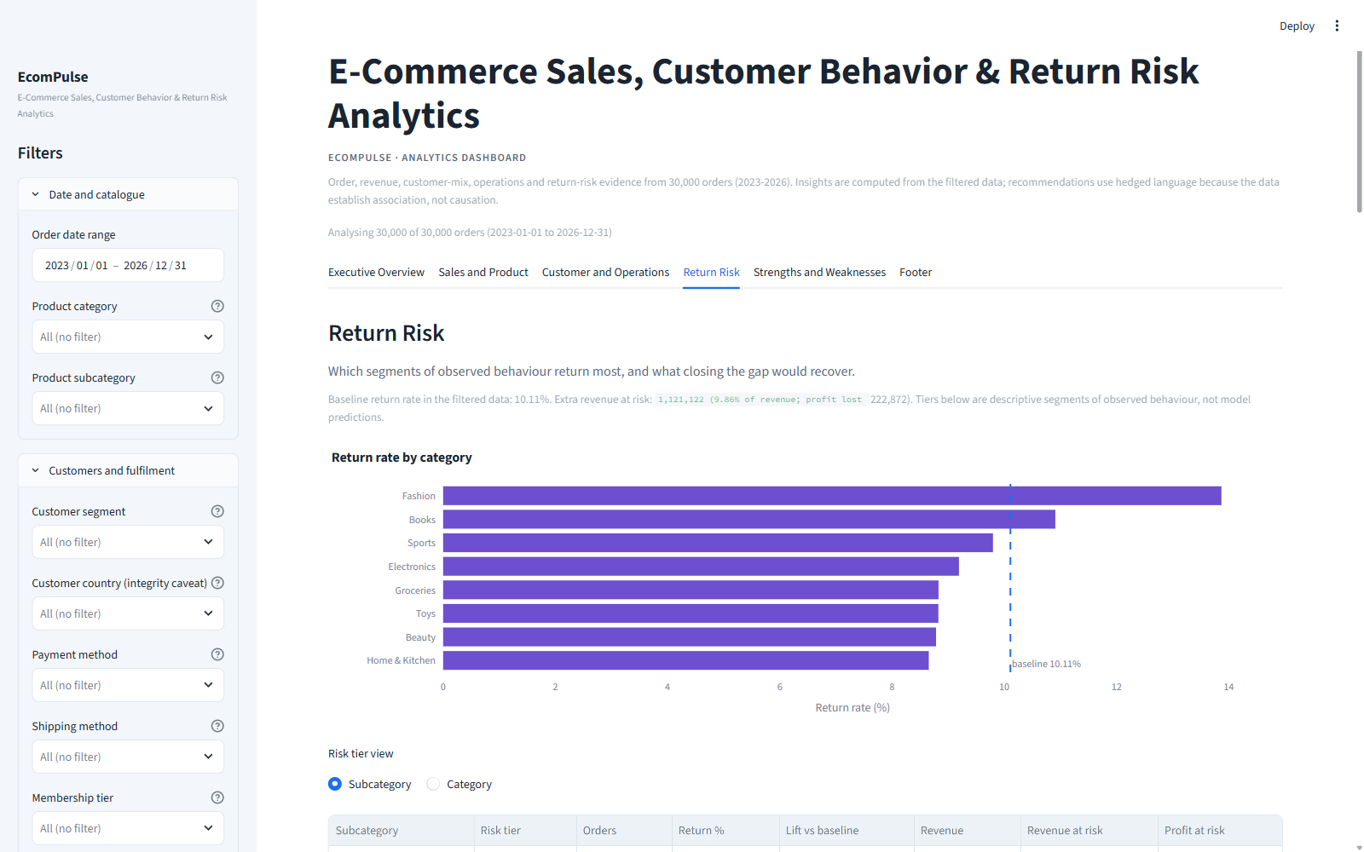
Figure 10.1: Return Risk tab — baseline caption, return rate by category with baseline line, tiered subcategory table and tier chart, Fashion opportunity card, driver-scan table, and the rejected-ML evidence panel

11. Dashboard Design & Implementation

11.1 Interaction Model
All analytics respond to a single shared filter state (FilterState) resolved by get_filtered_frame(): date range, product category and subcategory (with a de-selection control), customer segment, country, payment method, shipping method, membership tier and return status, plus a Reset action. The active selection is echoed under the title (“Analysing X of 30,000 orders …”) and every KPI, chart, insight card, risk tier and the session footer recompute on the filtered frame. The filtered rows can be downloaded as CSV; empty selections show a friendly empty state instead of broken charts, and a missing dataset file raises a friendly error with a file-uploader fallback (load_with_fallback).

11.2 The Six Tabs
Table 11.1: Dashboard tab map (as implemented in app.py main())
Tab | Purpose and principal contents
1. Executive Overview | Eight KPI cards (revenue, orders, AOV, profit, return rate, revenue at risk, high-value share, repeat rate); monthly revenue/orders dual-axis line; revenue-share doughnut; top-10 subcategory bar; insight cards for concentration, trend and value concentration.
2. Sales and Product | Trend switcher (daily/weekly/monthly) with revenue and orders; category/subcategory/brand revenue bars; discount-band and weekday views; revenue-over-time bars by granularity.
3. Customer and Operations | Segment revenue/AOV bars; AOV versus recorded CLV scatter by membership tier; order-frequency distribution with caveat card; delivery statistics table; payment/device/traffic/warehouse mixes.
4. Return Risk | Baseline caption with revenue-at-risk; return rate by category with baseline line; tier view switcher (subcategory/category) with tiered table and chart; Fashion opportunity insight; driver-scan table; flat-dimension bars; rejected-ML evidence expander.
5. Strengths and Weaknesses | Auto-generated cards for the current filter slice: revenue scale (always), return-rate versus baseline (strength / neutral / weakness at ±0.5 pp), and high-value concentration (strength ≥ 30%, weakness ≤ 18%).
6. Footer | Session snapshot KPIs (orders, revenue, return rate, AOV in view), the active-filter list, methodology pointers to analytics.py components, and credits/data note.

A “Data and Method Notes” renderer (render_notes) also exists in the codebase — it displays the cleaning log, the 14 quality checks and the field-reading caveats. In the final layout its content is surfaced where it is needed most: quality captions on the Return Risk tab and the Methodology section of the Footer tab.
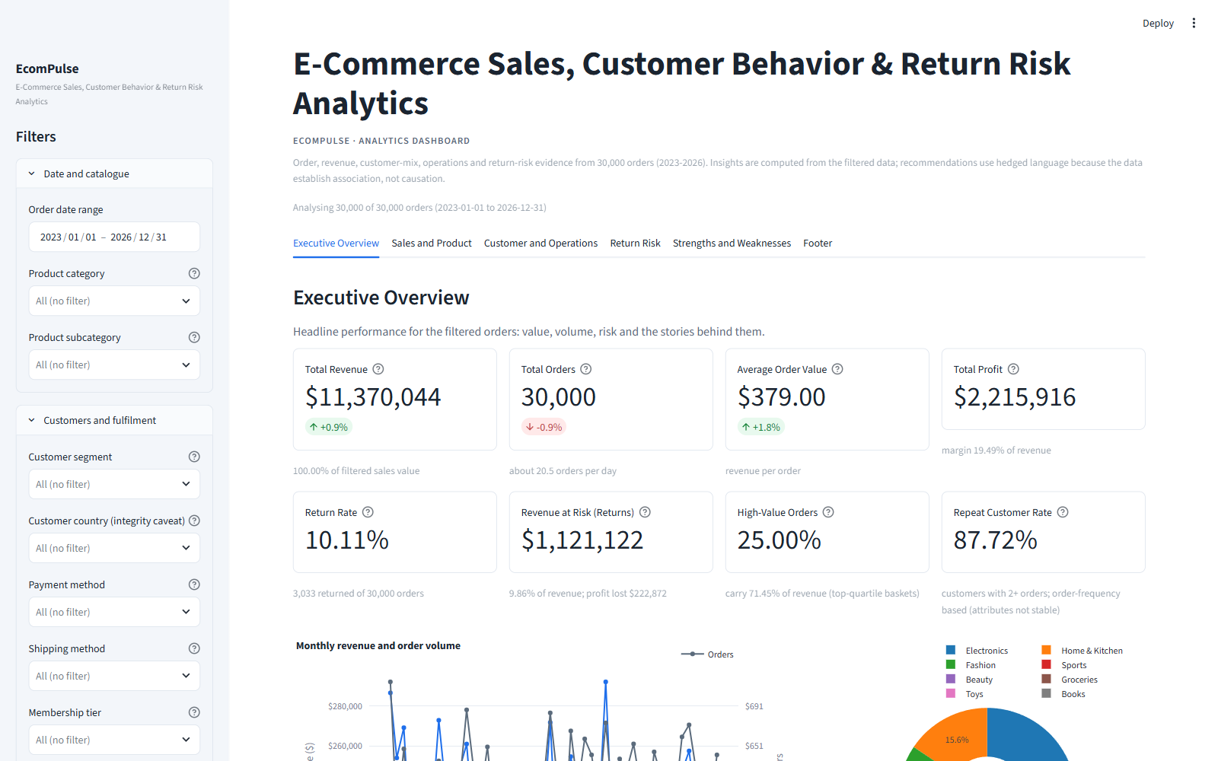
Figure 11.1: Executive Overview tab — KPI rows, monthly revenue and order volume, revenue-share doughnut, top-10 subcategories and computed insight cards
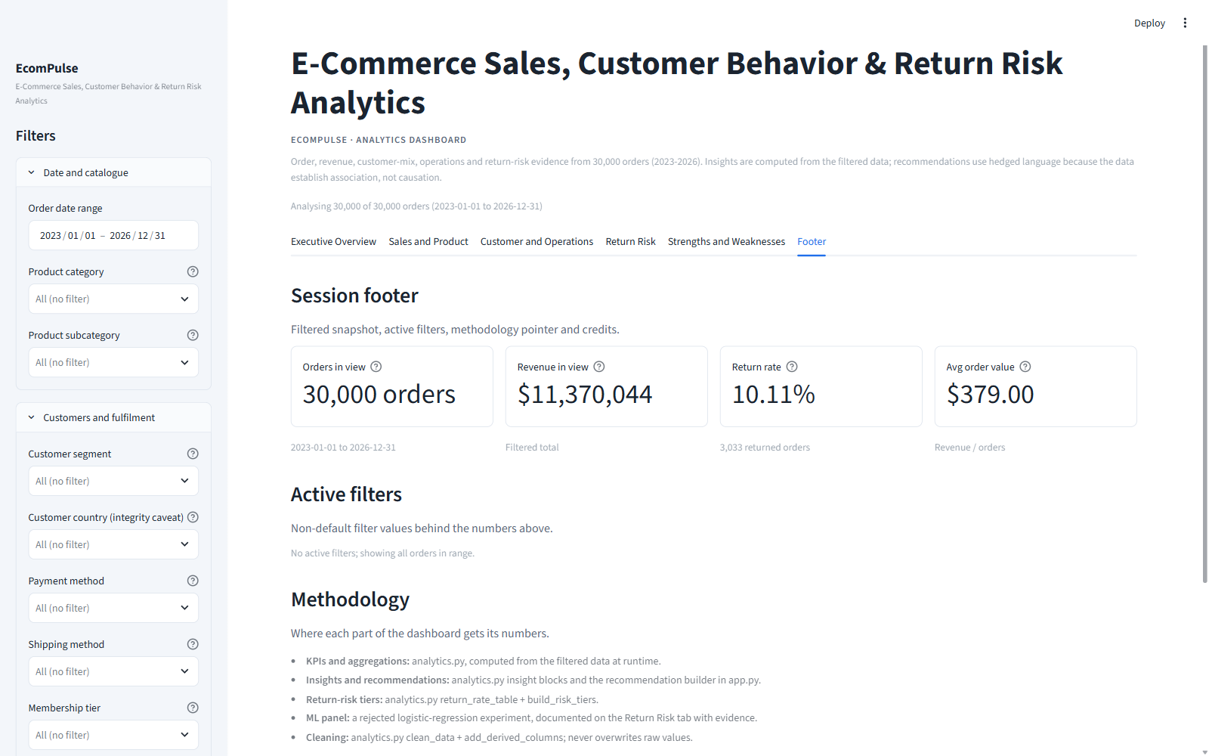
Figure 11.2: Footer tab — filtered session snapshot, active filters, methodology pointers and credits

11.3 Design System and Robustness
The UI is theme-adaptive: it follows the viewer’s OS light/dark setting and the in-app theme switcher, resolving design tokens at runtime (detect_theme / palette) so text never becomes invisible on either background. Charts share one treatment (styled) with currency and percent axis formatting; insight cards visually separate fact, reading, hypothesis and action with colour-coded tags. Guardrails include the empty-filter state, the missing-data state, schema-driven chart degradation and the cached loader (st.cache_data) so filter changes never re-clean the data.

12. Technical Implementation

12.1 Technology Stack
The stack is intentionally minimal and fully declared in requirements.txt. scikit-learn is deliberately absent (the ML probe was a one-off assessment; no model ships), and matplotlib is absent because Plotly covers all visuals.
Table 12.1: Components and versions used in the build environment
Component | Role | requirements.txt | Environment
Python | Application language | — | 3.13.7
pandas | Loading, cleaning, aggregation, KPIs | >= 2.2 | 3.0.5
NumPy | Numeric helpers, conditional risk columns | >= 1.26 | 2.5.3
Plotly Express | All dashboard charts | >= 5.22 | 7.1.0
Streamlit | UI framework, caching, filters, download | >= 1.36 | 1.64.0

12.2 Module Responsibilities
analytics.py is the pure analytics layer: path resolution (resolve_dataset_path), loading (load_raw), schema validation (validate_schema), cleaning (clean_data), derived fields (add_derived_columns), quality checks (run_quality_checks), the KPI layer (compute_kpis), the shared aggregation engine (aggregate_by) plus trend, Pareto, basket, discount, delivery, frequency, return-rate, driver-scan, risk-tier and opportunity builders, seven insight builders that interpolate numbers into hedged text, formatters, and a dependency-free self-test (python analytics.py).
app.py is the presentation layer only: page configuration, theme detection and CSS token injection, cached data loading with uploader fallback, the sidebar filter state, KPI cards, insight cards, one renderer per tab, empty states, the filtered-CSV download, and main() orchestration. It contains no business logic; every analytical fact it shows originates in analytics.py.

12.3 Architecture
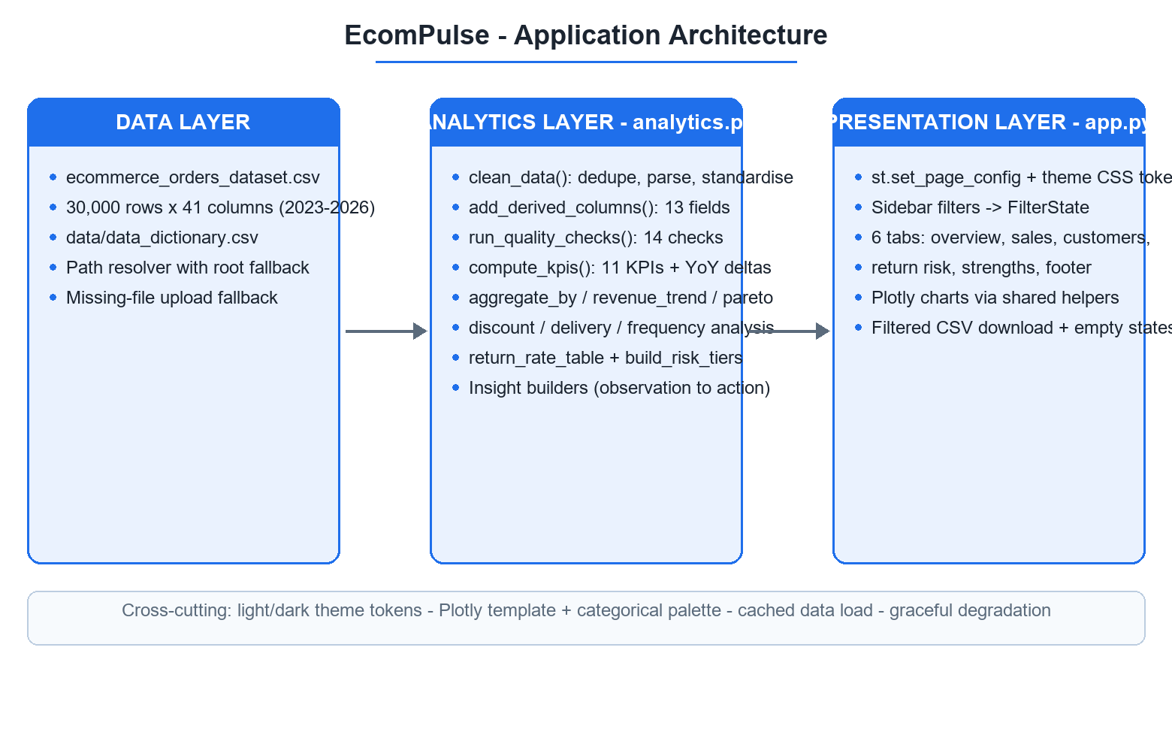
Figure 12.1: Application architecture — data layer, analytics layer and presentation layer with cross-cutting theme and caching concerns

12.4 Verification and Self-Testing
analytics.py ends in a self-test (python analytics.py) asserting the dataset shape, required-column presence, derived-column presence, no NaNs in key columns, the Order_Amount formula tolerance, KPI agreement with raw pandas aggregates, top-quartile high-value share, category revenue summing to the total, yearly orders summing to 30,000, filter reduction, and chronological trend ordering. The independent KPI verification recorded in the implementation plan confirmed revenue, profit, AOV, return rate, at-risk and high-value shares to the cent or 0.01 percentage point, and re-ran the ML probe to confirm the recorded AUC (~0.54) rather than quoting a remembered number.

13. Project Structure
BharatCares-Project/
├── app.py # Streamlit UI layer (6 tabs, filters, cards)
├── analytics.py # Analytics layer (cleaning, checks, KPIs, insights)
├── requirements.txt # pandas, numpy, plotly, streamlit
├── README.md # Project overview and quickstart
├── implementation_plan.md # Approved plan; documents the ML-rejection decision
├── ecommerce_orders_notebook.ipynb # Source-dataset exploration notebook (Kaggle baseline)
├── streamlit_out.log / streamlit_err.log # Local runtime logs (not part of the app)
├── .streamlit/
│ └── config.toml # Light/dark theme tokens and widget styling
├── assets/
│ ├── 01-executive-overview.png # Dashboard screenshots used in this report
│ ├── 02-sales-and-product.png
│ ├── 03-customer-and-operations.png
│ ├── 04-return-risk.png
│ ├── 05-strengths-and-weaknesses.png
│ └── 06-footer.png
└── data/
├── ecommerce_orders_dataset.csv # 30,000 × 41 source dataset (Kaggle download)
└── data_dictionary.csv # Full 41-column data dictionary
Table 13.1: File roles
File | Role
app.py | UI layer: theme tokens, sidebar filters, six tab renderers, KPI and insight cards, downloads, empty states, main() orchestration
analytics.py | Analytics layer: loading, schema validation, cleaning log, quality checks, derived fields, KPIs, aggregations, return tiers, insight builders, self-test
requirements.txt | Runtime dependencies (pandas ≥ 2.2, numpy ≥ 1.26, plotly ≥ 5.22, streamlit ≥ 1.36)
.streamlit/config.toml | Light and dark theme token sets; base theme left unpinned so the app follows the viewer
data/ | Source CSV and its data dictionary; loader falls back to the project root and offers an upload fallback
assets/ | The six dashboard screenshots reproduced in this report
ecommerce_orders_notebook.ipynb | Kaggle-style first exploration of the source dataset (baseline pandas EDA and sklearn experiments); not used by the application
implementation_plan.md | Planning document recording scope, verified data facts, module design and the Option-1 decision to document — not ship — the ML experiment

14. Results & Business Value
The completed system gives a business user a single, trustworthy view of the operation and a defensible risk narrative. Concretely, it delivers:
- A verified performance baseline. Revenue $11,370,044, profit $2,215,916 (19.49%), AOV $379.00 across 30,000 orders — with a cleaning log and 14 quality checks standing behind every number.
- Concentration visibility. The 55.59% Electronics share, the 82.79% top-3 category share and the 71.45% top-quartile basket share are quantified and charted, supporting sourcing, stock and contingency decisions.
- A monetised return-risk view. $1,121,122 revenue and $222,872 profit at risk, decomposed by category and subcategory into High/Medium/Low tiers, with a quantified Fashion opportunity (~229 avoidable returns, $49,788 revenue, $12,961 profit).
- Operational reliability evidence. Delivery statistics by method, including the Same-Day reliability problem (64.9% delivered after day 0), actionable as an SLA audit.
- Discount strategy evidence. The AOV-versus-discount-depth relationship and the $1,482,982 discount spend, framing an A/B-tested move to shallower, targeted promotions.
- Honest customer analytics. Segment and tier mixes presented as order-level attributes, with the repeat-rate figure explicitly caveated rather than oversold.
Decisions the dashboard can support today: assortment and stock prioritisation; where to focus return-prevention effort (product side, Fashion first); whether to deepen or reshape discounting; which fulfilment promises to fix or withdraw; and where high-value-basket protection (stock, service, extended returns) matters most. Decisions it deliberately does not support: retention targets (no stable customer master), city-level operations (independent City field) and individual return prediction (no pre-order signal) — each refusal is itself documented evidence.
Framing: Insights describe association, not proven causation; the dataset is synthetic. Value claims are therefore framed as decision support for this dataset and as hypotheses to re-test on production data.

15. Limitations
The following limitations are inherent to the data and design and are disclosed in the application as well as here.
- Synthetic dataset. The data is generated: seasonality, holiday flags, warehouse and traffic mixes are near-uniform by construction, and 2,101 orders post-date the build date. Findings characterise this dataset; they do not measure a real business.
- No customer master. Customer_IDs switch attributes across orders (49,289 switches), so segments, memberships and the 87.72% repeat rate describe order mixes, not cohorts.
- No product master. Product_IDs map to multiple categories, brands and prices (10,000 switches), so analysis stops at category/subcategory/brand level.
- Geographic data is not usable beyond marginals. Country and City are independently assigned (100 combinations), so City is never mapped and country comparisons carry no location semantics.
- Post-outcome rating leakage. Review_Rating falls to 3.08 on returned orders — useful context, unusable as a predictor; it is excluded from all driver analysis.
- Weak leakage-free return-prediction signal. AUC ≈ 0.54 means no reliable individual-level return prediction is possible from pre-order fields; only category-level descriptive risk is supported.
- Profit is an estimate. Profit_Amount derives from Profit_Margin_Percent (mean 21.97%); margin structure is therefore as recorded, not audited.
- Delivery fields are indicative. 64.9% of Same-Day orders exceed day 0; delivery analysis describes observed distributions, not contractual service levels.
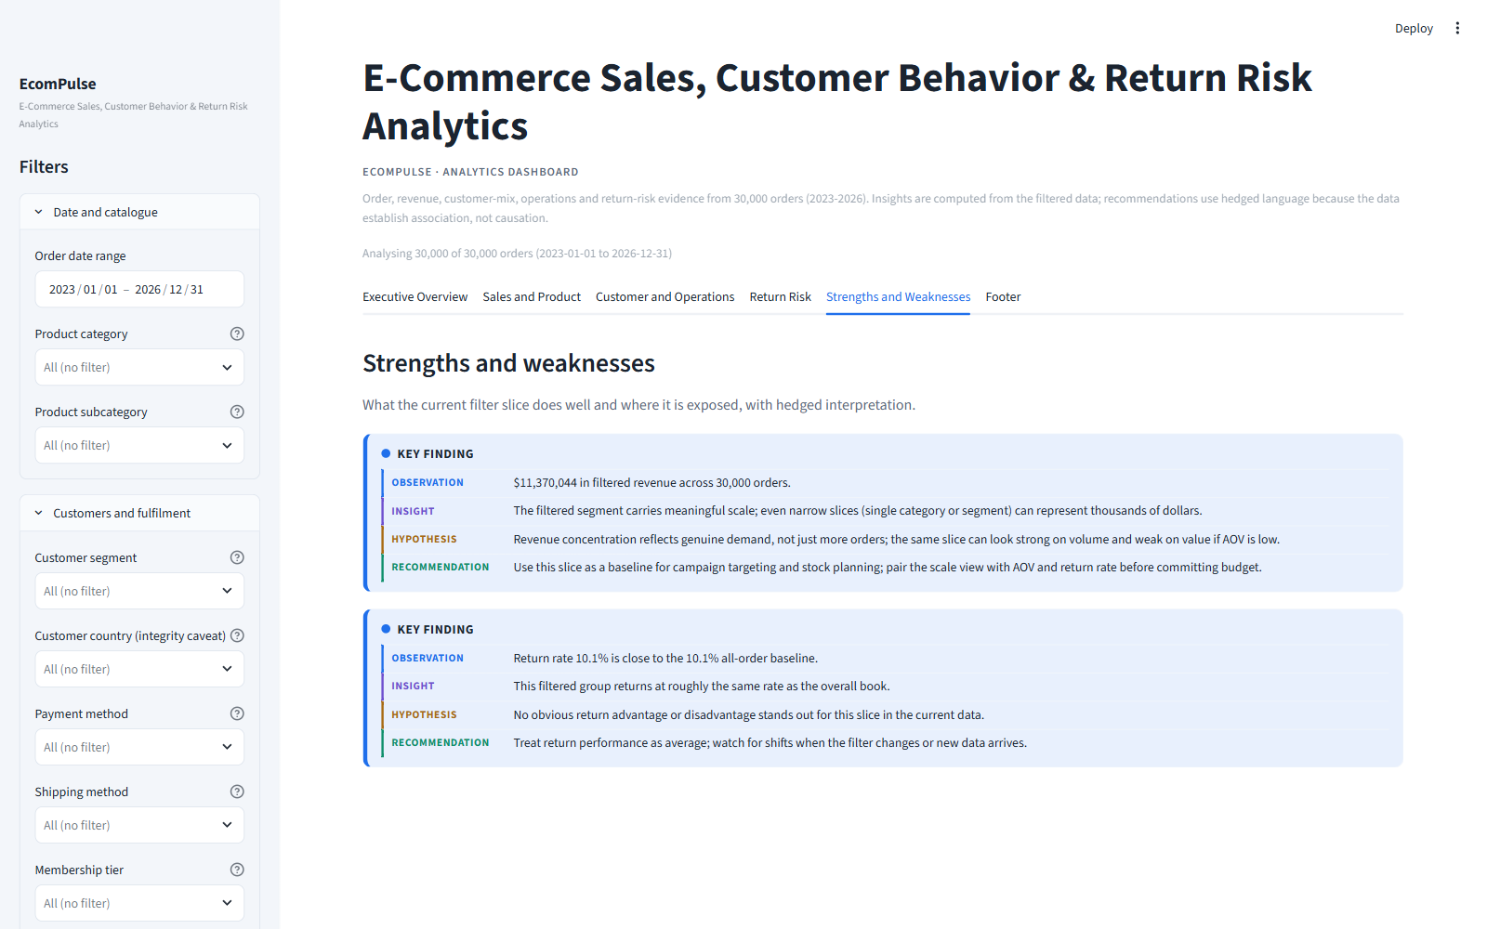
Figure 15.1: Strengths and Weaknesses tab — how the dashboard turns these limitations into explicit, filter-aware cards (revenue scale, return rate versus baseline, high-value concentration)

16. Recommendations
The recommendations below consolidate the actions embedded in the finding cards (§9) into one prioritised programme. Every row is anchored to a measured result from this dataset; expected effects are hypotheses to be confirmed by pilot-versus-control measurement on production data, not projected outcomes.
Table 16.1: Prioritised recommendations, each anchored to verified evidence
No. | Priority | Area | Recommended action | Evidence (verified in this report)
1 | High | Assortment & supply | Protect Electronics availability and service quality; hold contingency stock for its top items and monitor the category revenue share monthly. | Electronics: 55.59% of revenue from 15.7% of orders; top-3 categories 82.79% of revenue (§9.1)
2 | High | Category growth | Develop Beauty (highest margin) and Home & Kitchen (second-highest revenue) as deliberate secondary bets to dilute single-category exposure. | Category revenue and margin mix (§7.3, §9.1)
3 | High | High-value baskets | Give baskets at or above the 75th percentile priority stock, support and extended returns in Electronics; add accessories/warranty attach offers at checkout. | 25.0% of orders carry 71.45% of revenue; Electronics has the lowest margin at 16.47% (§9.3)
4 | High | Return prevention | Fix Fashion sizing signals — fit guidance, richer imagery, a reviewed size chart — and track the category's gap to the 10.11% baseline. | Fashion returns 13.87% vs 10.11% baseline; ≈229 avoidable returns ≈ $49,788 revenue / $12,961 profit (§9.5, §10.3)
5 | High | Fulfilment | Audit the Same-Day path end to end (cut-offs, warehouse assignment, carrier handoff) and either fix the SLA or stop selling the promise where it cannot be met. | 64.9% of Same-Day orders delivered after day 0; method covers 9.04% of orders and $1,075,499 revenue (§9.6)
6 | Medium | Pricing & discounts | Trial shallower, targeted discounts (minimum-basket thresholds, category-specific offers) with A/B measurement of incremental units and profit. | AOV $427.84 at 0% discount → $299.68 at 31–40%; coupon orders −15.5% AOV; $1,482,982 discount spend (§9.4)
7 | Medium | Basket value | Introduce bundles, minimum-basket perks and profitable attach to counter the observed basket-value erosion. | Order volume ≈ flat while AOV fell 5.0% across the period (§9.2)
8 | Medium | Data governance | Repair the customer and product masters before funding any retention or product-level programme; without them the metrics exist but cannot be acted on at entity level. | 49,289 customer-attribute switches; 10,000 product-attribute switches (§4.3, §15)

16.1 How to Pursue These Actions
Because the dataset is observational and synthetic, no action should be rolled out on this evidence alone. The dashboard supplies the baseline — category return rates, discount-band AOV, delivery-day distributions and concentration shares — against which pilots can be measured. A defensible sequence is: (1) instrument and baseline; (2) pilot one intervention per theme alongside a control; (3) scale only what beats the control on profit, not revenue alone; and (4) re-run the 14 quality checks on every data refresh before trusting period-over-period comparisons.
Two recommendations are deliberately absent. No retention programme is proposed — with no stable customer master (§15), retention targets would be built on order mixes, not cohorts. No city-level targeting is proposed — Country and City are independently assigned, so geography carries no operational meaning (§15). Individual-level return targeting is likewise deferred: the leakage-free probe found no usable pre-order signal (§10).
Framing: Each expected effect in Table 16.1 is a hypothesis derived from association in a synthetic dataset. The defensible claim of this project is that it quantifies the exposure and provides the measurement baseline — not that it proves any intervention will work.

17. Future Enhancements
None of the items below are part of the delivered build; the shipped system is exactly what Chapters 11–13 describe. These are the next steps the limitations in §15 point to, grouped by theme and listed in practical order.

17.1 Data Foundations (highest leverage)
- Real customer master. Stable CRM keys would turn the 87.72% repeat-rate caveat into genuine cohort retention analysis and unlock lifetime-value and churn work.
- Real product master. One identity per product would allow SKU-level analysis, price-band control and honest brand comparisons — today Product_IDs switch category, brand and price 10,000 times.
- Trustworthy geography. Consistent Country/City assignment would enable city-level operations and delivery-zone analysis; today the two fields are independently assigned and City is never mapped.
- Pre-return behavioural signals. Delivery exceptions, support contacts, size-guide usage and order-edit events are the features a predictive return model actually needs; Review_Rating is post-outcome and can never serve (§10.5).
- Audited cost and margin. Validated unit costs would turn the estimated 21.97% mean margin into an audited profit baseline.

17.2 Analytics
- Re-run the modelling gate. If and when pre-order behavioural features exist, repeat the leakage-free probe protocol of §10.4 — same split, same leakage demonstrations — and ship a model only if it clears a meaningful AUC threshold and re-validates on new data.
- Designed experiments. A/B tests for discount depth (§9.4) and the Same-Day SLA (§9.6), measuring incremental profit; the dashboard supplies the baseline metrics for both.
- Cohort retention. Once a stable customer master exists, replace the order-mix view with true cohorts and repeat-purchase curves.
- Geography analytics. Only after the Country/City fix: regional demand, coverage and fulfilment analysis.

17.3 Engineering & Delivery
- Automated refresh with quality gates. Scheduled ingestion that re-runs clean_data() and the 14 quality checks, failing loudly before the dashboard serves stale or broken data.
- Continuous integration. Unit tests for the analytics invariants — formula agreement, derived-field correctness, KPI ranges — executed on every commit.
- Deployment and access control. Containerised or Streamlit Community Cloud deployment with authentication, so the dashboard can be shared beyond one analyst's machine.
- Scheduled reporting. Periodic PDF/e-mail snapshots of the Executive Overview for stakeholders who do not open the application.
- Warehouse export. Move from a static CSV to a versioned warehouse table when real transactional feeds arrive.
Boundary: These are future ideas, not implemented features. The only automated behaviours shipped today are the cached load with path/upload fallbacks, the 14 logged quality checks and the filtered CSV download described in §11–§12.

18. Conclusion
EcomPulse set out to turn a raw 30,000-order e-commerce extract into analytics a business user can act on without misreading the data. The delivered system does that: a two-module Python application — analytics.py (validation, cleaning, 13 derived fields, 14 quality checks, 11 KPIs and every aggregation) and app.py (a six-tab Streamlit dashboard with sidebar filters, interactive Plotly charts and a filtered CSV export) — documented end to end in this report.
Analytically, the strongest findings are the concentration and risk facts. One category carries 55.59% of revenue; the top quartile of baskets carries 71.45%. Returns concentrate by product rather than by operations — Fashion returns at 13.87% against the 10.11% baseline — and place $1,121,122 of revenue and $222,872 of profit at risk. Deeper discounts accompany smaller, not larger, baskets while $1,482,982 is spent on discounting, and the fastest delivery promise is the least reliable, with 64.9% of Same-Day orders arriving after day 0.
The most consequential decision, however, was a refusal. A leakage-free logistic-regression probe on 24 pre-order features reached AUC 0.5381 — no usable individual-level return signal — while the same pipeline scored 0.8790 with Review_Rating added and 1.0000 with Order_Status, demonstrating that those fields would leak the outcome into any prediction. Predictive return modelling was therefore rejected and replaced by descriptive, category-level risk signatures — a decision recorded inside the application itself and defended in §10.
What was learned matches what was built: identity fields must be validated before any “customer” metric is interpreted (49,289 attribute switches broke the customer master); post-outcome fields must stay out of driver analysis; and a dashboard that documents its own limits — synthetic data, no stable masters, unusable geography — is more trustworthy, and therefore more useful, than a confident one that hides them. The project meets its objectives: a verified performance baseline, quantified exposure, prioritised and evidence-linked recommendations, and a clearly marked path (§17) for the data work that would unlock the next tier of analysis.

19. References
All metrics, charts and screenshots in this report were produced from the project's own code and the dataset below; no external statistics are cited.
[1] mmumairkhattak, “E-Commerce Orders Dataset 2026 — SCRA”, Kaggle. https://www.kaggle.com/datasets/mmumairkhattak/e-commerce-orders-dataset-2026-scra
[2] Python Software Foundation, “Python 3 documentation”. https://docs.python.org/3/
[3] The pandas development team, “pandas documentation”. https://pandas.pydata.org/docs/
[4] NumPy developers, “NumPy documentation”. https://numpy.org/doc/
[5] Plotly, “Plotly Python Graphing Library documentation”. https://plotly.com/python/
[6] Streamlit, “Streamlit documentation”. https://docs.streamlit.io/
[7] scikit-learn developers, “scikit-learn documentation”. https://scikit-learn.org/stable/ — used only for the one-off leakage probe of §10.4; scikit-learn is not a runtime dependency of the application.

