Prediction of Identical Twins using ML

In real words twins faces are exists and this twins can utilize advantages to dupe peoples in examination or any other organizations. To detect such twins we are applying machine learning algorithms such as Naïve Bayes and Random Forest which may get trained on possible Real and Twins faces. Once after training we can input face to this trained model to identify weather face is Real or Twin. Before training we are applying various image processing techniques such as applying Bilateral Filters to enhance image quality and then convert image to Black & White format and then apply Object detection technique to detect face from image. This processed image will be input to Machine learning algorithm to train a model.

For training we are using below images dataset

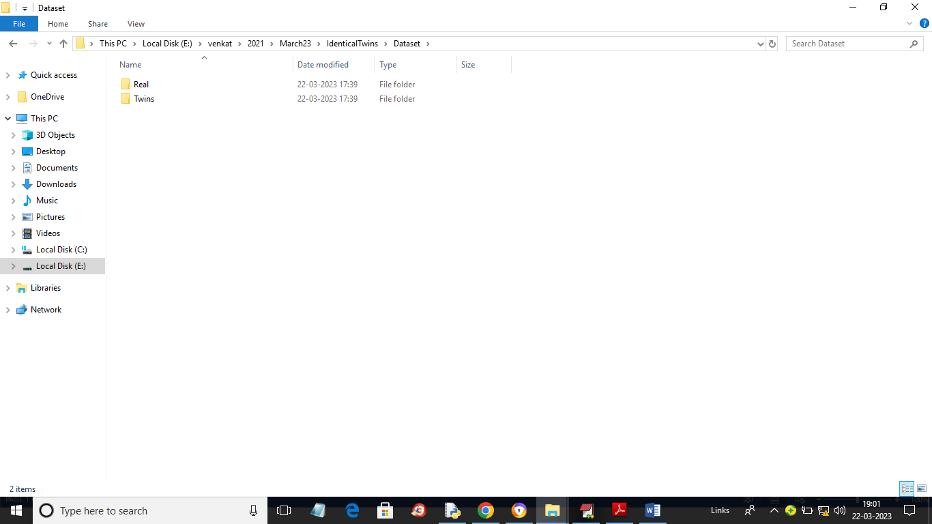

In above screen we have two folders called Twins and Real and just go inside any folder to view images like below screen

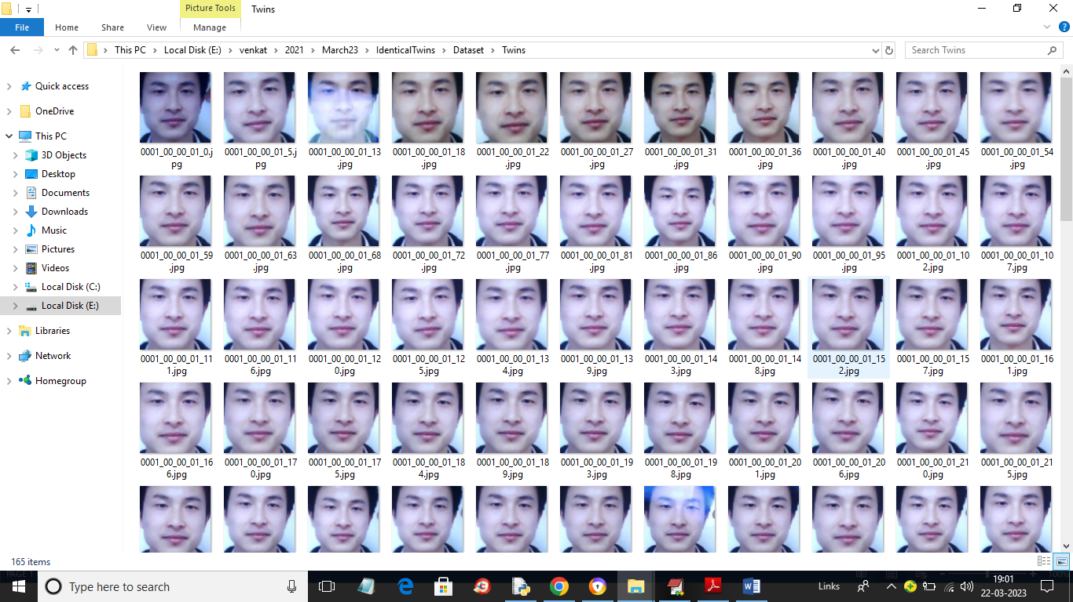

So by using above images we will evaluate performance of both Random Forest and Naïve Bayes Algorithm.

To implement this project we have designed following modules

1. Upload Twins Dataset: using this module we will upload dataset to application and then apply filtration and object detection techniques
2. Dataset Preprocessing: using this module we will normalized and then shuffle and split dataset into train and test where application using 80% dataset for training and 20% for testing
3. Run Naive Bayes Algorithm: 80% processed train images will be input to Naive Bayes Algorithm to train a model and this model will be applied on 20% test images to calculate prediction accuracy
4. Run Random Forest Algorithm: 80% processed train images will be input to Random Forest Algorithm to train a model and this model will be applied on 20% test images to calculate prediction accuracy
5. Comparison Graph: using this module we will plot comparison graph between both algorithms
6. Twins or Real Face Prediction: using this module we will upload test images and then algorithm will predict weather image is real or belongs to twins.

SCREEN SHOTS

To run project double click on ‘run.bat’ file to get below screen

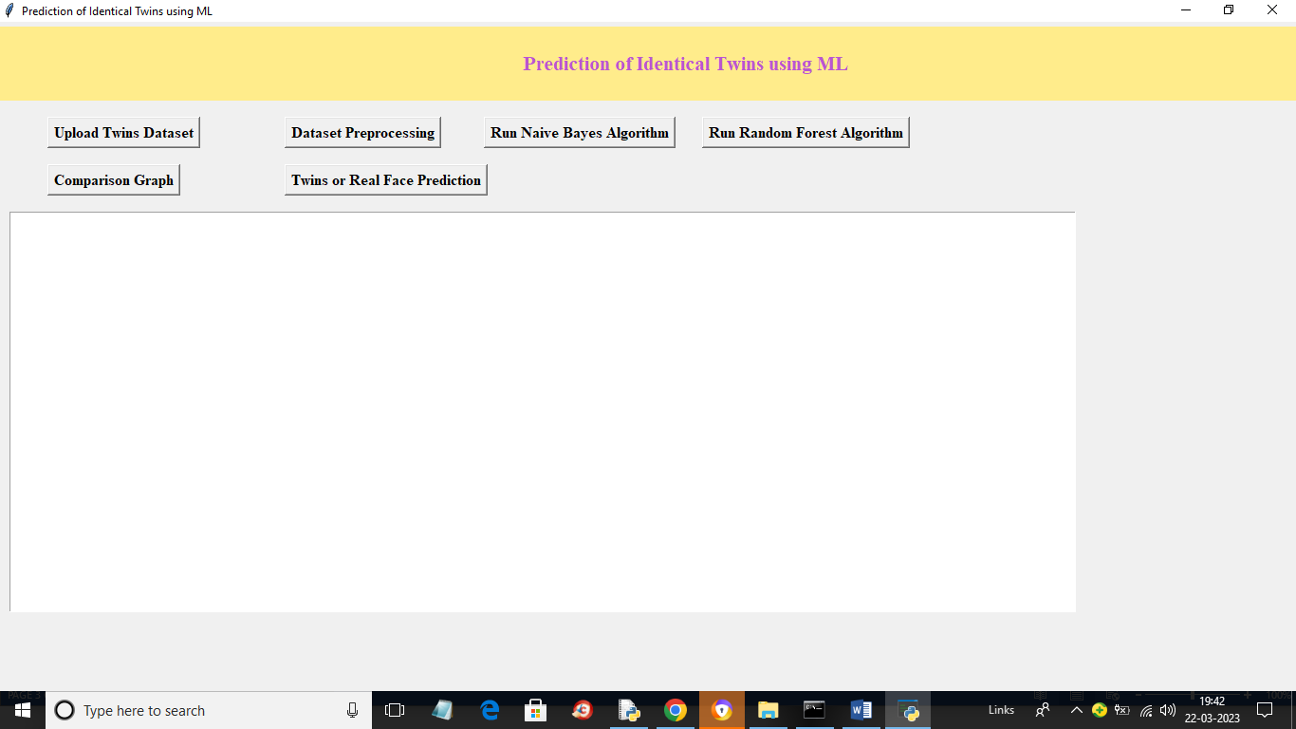

In above screen click on ‘Upload Twins Dataset’ button to upload dataset and get below output

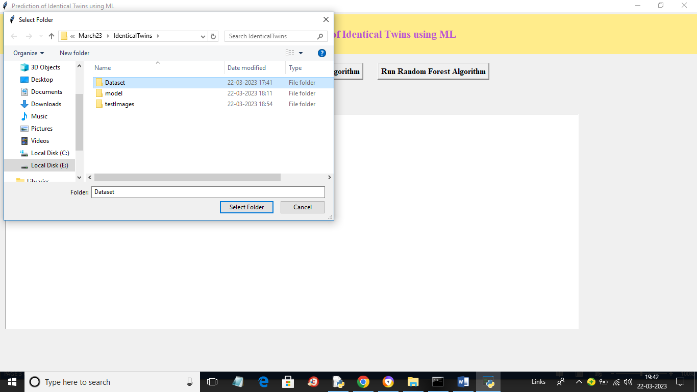

In above screen selecting and uploading ‘Dataset’ folder and then click on ‘Select Folder’ button to load dataset and get below output

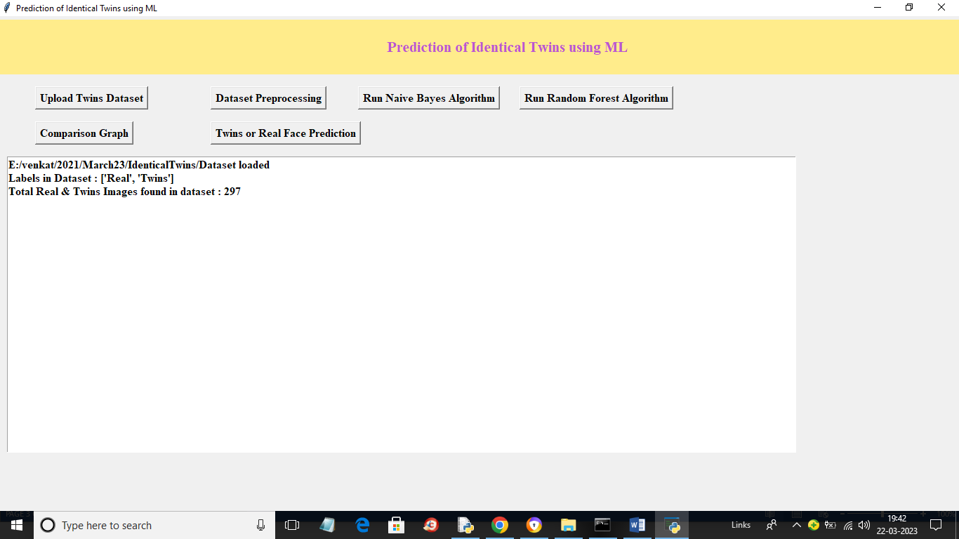

In above screen we can see dataset loaded and we can see available labels and images in the dataset and now click on ‘Dataset Preprocessing’ button to normalize, shuffle and split dataset into train and test and will get below output

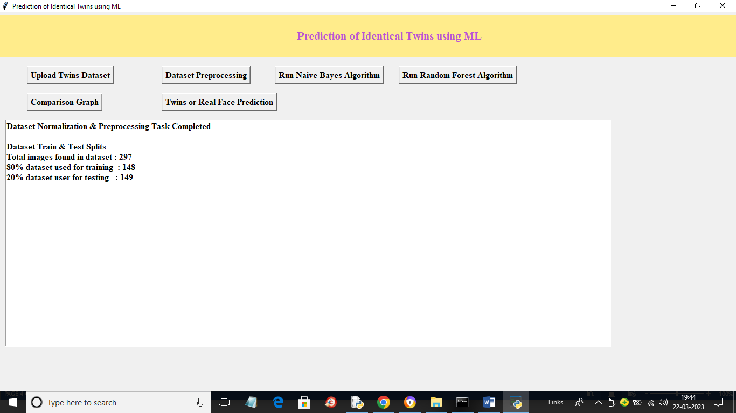

In above screen we can see dataset processed and we can see total images used for train and test and now click on ‘Run Naïve Bayes Algorithm’ button to train Naïve Bayes and get below output

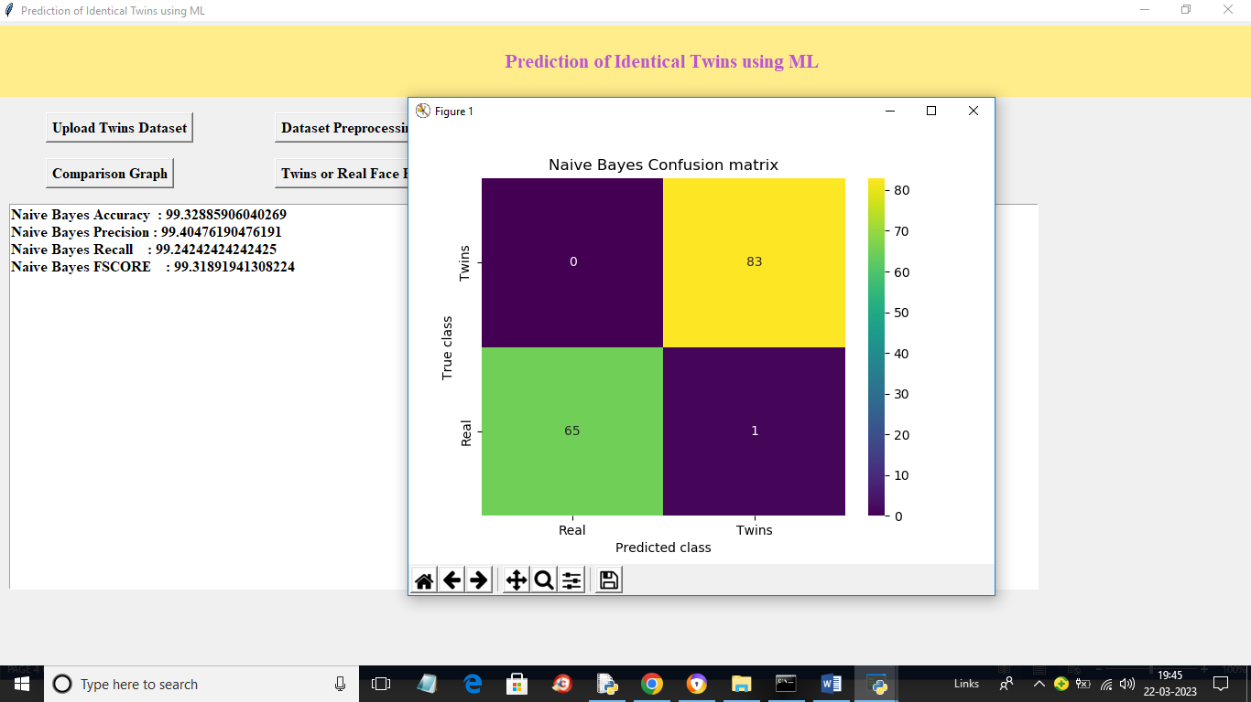

In above screen with Naïve Bayes we got accuracy as 99% and we can see other metrics also and in confusion matrix graph x-axis represents Predicted Labels and y-axis represents True Labels and green and yellow boxes contains Correct Prediction count and blue boxes represents incorrect prediction count which is 1 only and now close above window and then click on ‘Run Random Forest’ button to train Random Forest and get below output

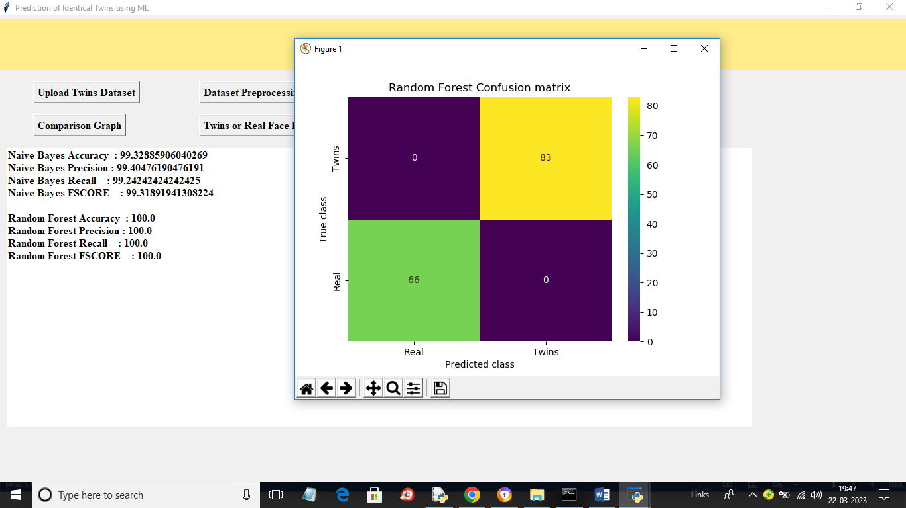

In above screen with Random Forest we got 100% accuracy and we can see confusion graph also and now click on ‘Comparison Graph’ button to get below graph

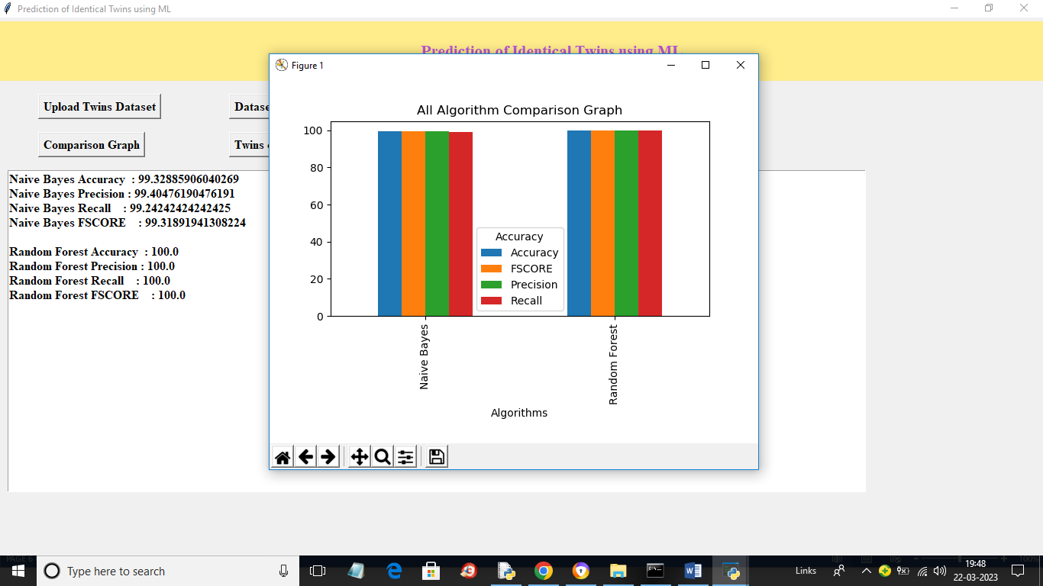

In above graph x-axis represents algorithm names and y-axis represents accuracy and other metrics in different colour bars and in both algorithms Random Forest got high performance and now click on ‘Twins or Real Face Prediction’ button to upload test image and get below output

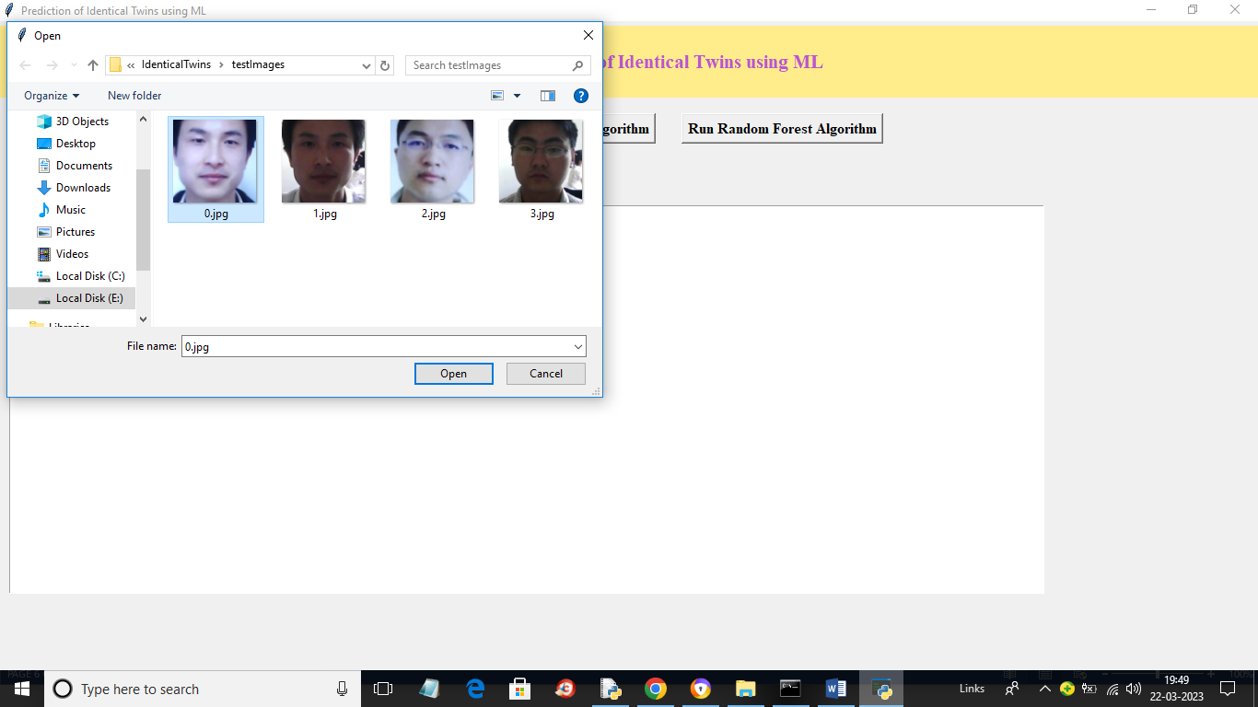

In above screen selecting and uploading ‘0.jpg’ image and then click on ‘Open’ button to load image and get below output

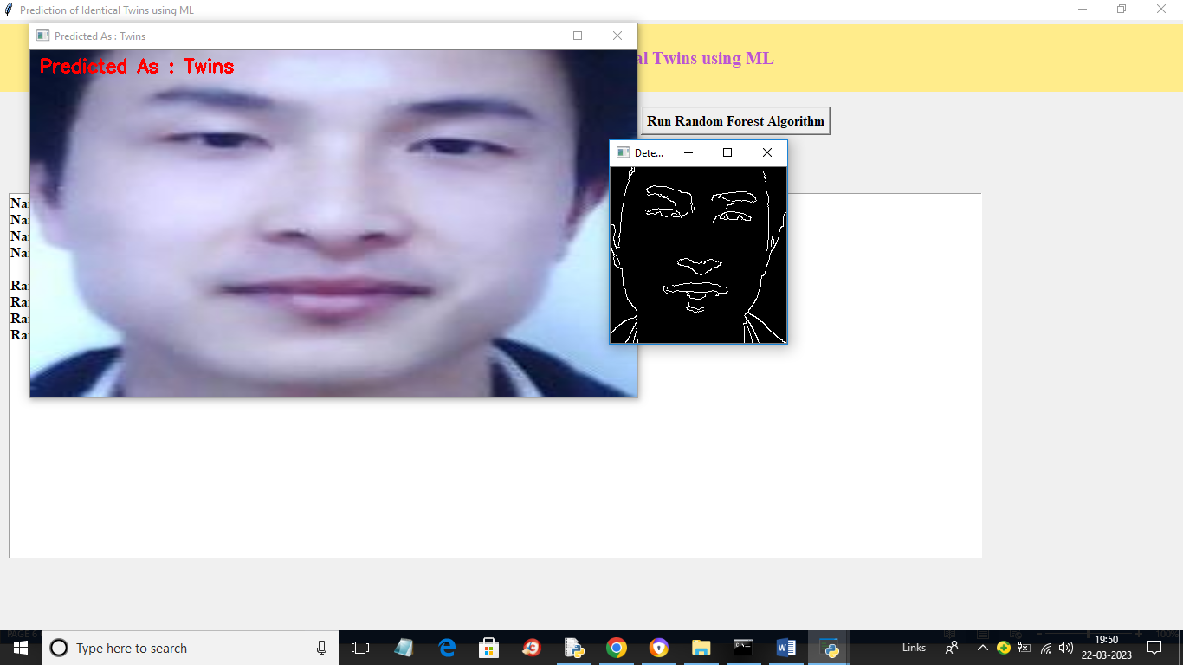

In above screen in red colour text we can see image predicted as Twins and we can see detected object in face in black and white colour and similarly you can upload and test other images

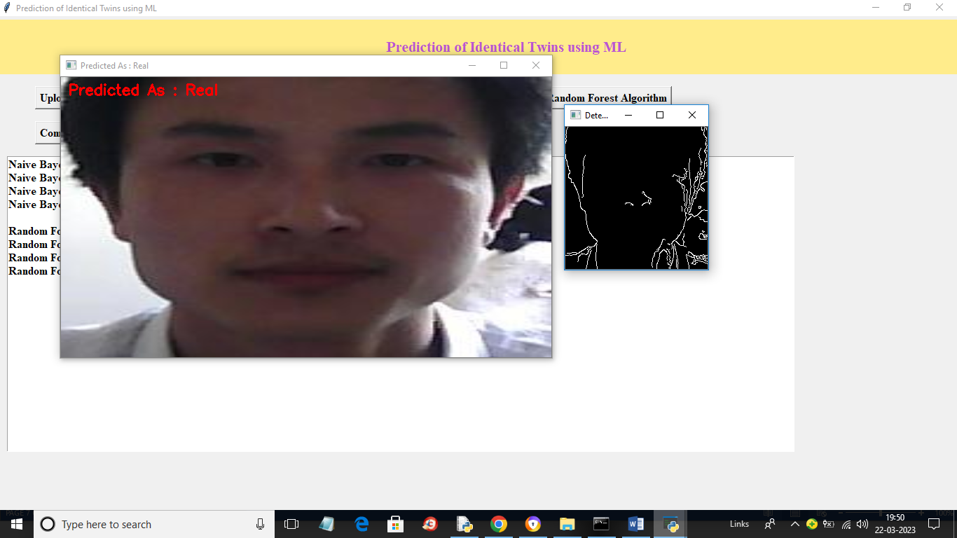

In above screen image predicted as real.