**INNOVATE. CREATE. SOLVE**

**Bengaluru, Karnataka, India**

AN INTERNSHIP REPORT

ON

**“MADE4YOU”**

Bachelor of Engineering

In

Computer Science

SUBMITTED BY: VIGNESH.M CHANDAN N HEGDE

 ISIRI TALAWAR

OMSHREE S N

Proudadevaraya Institute of tecnology, Hosapete

# ABOUT THE COMPANY

**IC Solution (ICS)** is a digital service provider that aims to provide software, designing and marketing solutions to individuals and businesses. At ICS, we believe that service and quality is the key to success

We provide all kinds of technological and designing solutions from Billing Software to Web Designs or any custom demand that you may have. Experience the service like none other!

Some of our services include:

**Development** - We develop responsive, functional and super-fast websites.

We keep User Experience in mind while creating websites. A website should load quickly and should be accessible even on a small view-port and slow internet connection.

**Mobile Application** - We offer a wide range of professional Android, iOS & Hybrid app development services for our global clients, from a start up to a large enterprise.

**Design** - We offer professional Graphic design, Brochure design & Logo design. We are experts in crafting visual content to convey the right message to the customers.

**Consultancy** - We are here to provide you with expert advice on your design and development requirement.

**Videos** - We create a polished professional video that impresses your audience.

# TABLE OF CONTENTS:

|  |  |  |
| --- | --- | --- |
| **SL.NO** | **TITLE** | **PAGE.NO** |
| 1 | Overview of the project | 01 |
| 2 | About made4you | 02 |
| 3 | Made4you services and benefits | 03-04 |
| 4 | Tools used | 05 |
| 5 | Implementation | 06- |
| 6 | Snapshots | 08- |
| 7 | Bibliography | 10 |

**OVERVIEW OF THE PROJECT:**

**Project Name:** Made4you

**Team Members:** Vignesh. M

Chandan hedge Isiri Talawar

Omshree S N

This project is based on Web Development And its Applications. The main objective of this project is to learn the implementation of HTML, CSS, and JavaScript. The basic webpage of this project is created using HTML and styling of the webpage is done using CSS.

M4Y is a digital service provider that aims to provide software, designing and marketing solutions to individuals and businesses. At M4Y, it is believed that service and quality is the key to success. Founded and Funded by Graphic designers from Jahirathu Junction, M4Y has now set a new path towards Digital Solutions.

**About made4you:**

A website refers to a central location with more than one web page or a series of web pages. For example, Computer Hope is considered a website, which contains thousands of different web pages, including the page you're reading now.

M4Y is a digital service provider that aims to provide software, designing and marketing solutions to individuals and businesses. At M4Y, it is believed that service and quality is the key to success. Founded and Funded by Graphic designers from Jahirathu Junction, M4Y has now set a new path towards Digital Solutions.

Development - We develop responsive, functional and super-fast websites.

We keep User Experience in mind while creating websites. A website should load quickly and should be accessible even on a small view-port and slow internet connection.

Consultancy - We are here to provide you with expert advice on your design and development requirements.

Videos - We create a polished professional video that impresses your audience.

# Made4you services and benefits:

### Hardware Services

**Flexibly responding to your needs and wishes**

We know that you sometimes need a very special configuration for your specific environment.

By choosing M4Y group as your IT supplier, you have the option of choosing modules that are not part of our portfolio, e.g. a customer-specific component, for integration into your new customized websites.

Of course, your customized websites are produced and tested according to the same high-quality requirements as the products of our standard product portfolio.

However, as stated above, hardware services are not only restricted to the website itself. It is also possible to customize the accessory pack, to include for example an additional leaflet or an additional manual of your own choosing.

### Software Services

**Individual software configurations and more**

According to your requirements we deliver all systems as "ready to run" websites.

The scope of our Software services includes the replication of a master hard disk drive ex-factory and the customized preinstallation of the CMOS settings.

Your advantage is that the installation of the systems at location is extremely simplified: Simply plug in, switch on and start working !

Moreover, specific requirements, such as the use of predefined passwords or a consistent software across the whole network, will be no problem with our software services.

**BENEFITS**

* Customizing service & solutions ensures process optimization to save valuable resources
* Modern factory processes ensure highest flexibility to satisfy your individual needs
* Desk View load to personalize your systems and to cut your rollout costs by up to 45%
* Count on a single point of contact – we take care

# TOOLS USED:

## Software Requirements

* Text editor (VS code recommended)
* Front End: HTML, CSS, JS (optional)
* Linux 7.1 or Windows XP/7/8/10 OS or Mac OS

## Hardware Requirements

* Pentium 200-MHz computer with a minimum of 64 MB of RAM (128 MB of RAM recommended).

# IMPLEMENTATION:

**Source Code (P2.HTML+P2.CSS)**

**Landing Page Code:**

<!DOCTYPE html>

<html lang="en" dir="ltr">

<head>

<meta charset="utf-8">

<title>Made4you</title>

<meta name="viewport" content="width=device-width, initial-scale=1.0">

<link rel="stylesheet" href="css/styles.css">

<link rel="icon" href="our-official-logo.png">

<link rel="preconnect" href="https://fonts.googleapis.com">

<link rel="preconnect" href="https://fonts.gstatic.com" crossorigin>

<link href="https://fonts.googleapis.com/css2?family=Merienda&display=swap" rel="stylesheet">

</head>

<body class="body1">

<nav>

<input type="checkbox" id="check">

<label for="check" class="checkbtn">

<i class="fas fa-bars"></i>

</label>

<label class="logo"></label>

<ul>

<li><a class="active" href="index.html">Home</a></li>

<li><a href="about.html">About</a></li>

<li><a href="services.html">Services</a></li>

<li><a href="ContactUs.html">ContactUs</a></li>

</ul>

</nav>

<table cellspacing=40; >

<tr>

<td><img src="our-official-logo.png" height="250px" width="250px" alt="logo"></td>

<td><h1 class="hhh">Made4you private limited</h1>

<p class="para"> M4Y is a digital service provider that aims to provide software, designing and marketing solutions to individuals andbusinesses.

<br> At M4Y, it is believed that service and quality is the

key to success.<br> Founded and Funded by Graphic designers

from Jahirathu Junction, M4Y has now set a new path towards

Digital Solutions.</p></td>

</tr>

</table>

<img class="limg"src="https://dcassetcdn.com/design_img/2439524/590045/590045_12780810_2439524_ae9e1515_image.jpg" alt="">

<p class="quote">“Measuring programming progress by lines of code is like measuring aircraft building progress by weight.”</p>

<div class="footer">

<a class="footer-link" href="https://www.linkedin.com/">LinkedIn</a>

<a class="footer-link" href="https://twitter.com/">Twitter</a>

<a class="footer-link" href="https://compsofttechnologies.com/">Website</a>

<p>© 2021 Made4you Pvt Ltd.</p>

</div>

</body>

</html>

**About us**

<!DOCTYPE html>

<html>

<head>

<title>About Us Section</title>

<meta charset="utf-8">

<meta name="viewport" content="width=device-width, initial-scale=1.0">

<link rel="stylesheet" href="https://pro.fontawesome.com/releases/v5.10.0/css/all.css">

<link rel="stylesheet" type="text/css" href="css/styles.css">

<link rel="icon" href="man.png">

</head>

<body>

<nav>

<input type="checkbox" id="check">

<label for="check" class="checkbtn">

<i class="fas fa-bars"></i>

</label>

<label class="logo">Made4you</label>

<ul>

<li><a href="index.html">Home</a></li>

<li><a class="active" href="about.html">About</a></li>

<li><a href="services.html">Services</a></li>

<li><a href="ContactUs.html">ContactUs</a></li>

</ul>

</nav>

<div class="section">

<div class="content-section">

<div class="content">

<h1 class="bob">About Us</h1><br><br>

<hr>

<h3>Made4you Private Limited.</h3>

<p>We are a young company always looking for new and creative ideas to help you with our products in your everyday work.We make sure to help you in every way possible to get the right solutions.<br><br>

Every business worldwide is building event-driven, real-time applications - from financial services, transportation, and energy, to retail, healthcare, and Gaming companies.<br><br>

Our endeavour is to make it easy to develop innovative real-time applications and efficient to operate them in production.<br><br>

​

We have a proven record of building highly scalable, world-class consulting processes that offer tremendous business advantages to our clients in the form of huge cost-benefits, definitive results and consistent project deliveries across the globe.<br><br>

​

We prominently strive to improve your business by delivering the full range of competencies including operational performance, developing and applying business strategies to improve financial reports, defining strategic goals and measure and manage those goals along with measuring and managing them.<br><br>

</p>

<div class="button">

<a href="">Read More</a>

</div>

</div>

<div class="social">

<a href=""><i class="fab fa-facebook-f"></i></a>

<a href=""><i class="fab fa-twitter"></i></a>

<a href=""><i class="fab fa-instagram"></i></a>

</div>

</div>

</div>

</div>

</body>

</html>

**Services**

<!DOCTYPE html>

<html lang="en" dir="ltr">

<head>

<meta charset="utf-8">

<title>Services</title>

<link rel="icon" href="global-services.png">

<link rel="stylesheet" href="css/styles.css">

<link rel="icon" href="customer-service.png">

</head>

<body style="background-color: #87DFD6">

<nav>

<input type="checkbox" id="check">

<label for="check" class="checkbtn">

<i class="fas fa-bars"></i>

</label>

<label class="logo">Made4you</label>

<ul>

<li><a href="index.html">Home</a></li>

<li><a href="about.html">About</a></li>

<li><a class="active" href="services.html">Services</a></li>

<li><a href="ContactUs.html">ContactUs</a></li>

</ul>

</nav>

<img class="global"src="services.jpg" width="100%" height="90%" alt=""><br><br>

<h1 class="srvs">Services</h1>

<hr class="shr">

<p class="spara">It is believed that service and quality is the key to success, Enabling business success driven by technology

Harnessing the power of technology, we create a measurable difference for our clients across various industries & multiple geographies.</p>

<h1 class="deva">Development</h1>

<img class="dev" src="deva.jpg" width="40%" height="40%" alt="">

<p class="pdev">

We develop responsive, functional and super-fast websites. We keep User Experience in mind while creating websites. A website should load quickly and should be accessible even on a small view-port and slow internet connection

</p>

<br>

<hr class="hdev">

<br>

<h1 class="cdev">Consultancy</h1>

<img class="cons" src="consult.jpg" alt="">

<p class="pcdev">

We are here to provide you with expert advice on your design and

development requirements.

</p>

<br>

<hr class="sdev">

<br>

<h1 class="vdev">Videos</h1>

<img class="video" src="video.jpg" alt="">

<p class="pvdev">We create a polished professional video that will impresses your audience.We work on building quality videos that are upto to the user requirements.</p>

<div class="footer">

<a class="footer-link" href="https://www.linkedin.com/">LinkedIn</a>

<a class="footer-link" href="https://twitter.com/">Twitter</a>

<a class="footer-link" href="https://www.appbrewery.co/">Website</a>

<p>© 2021 Made4you Pvt Ltd.</p>

</div>

</body>

</html>

**ContactUS**

<!DOCTYPE html>

<html lang="en">

<head>

<meta charset="UTF-8">

<title>Contact Us</title>

<link rel="stylesheet" href="css/styles.css">

<link rel="icon" href="contact.png">

</head>

<body style="background: url('bg.jpg')">

<nav>

<input type="checkbox" id="check">

<label for="check" class="checkbtn">

<i class="fas fa-bars"></i>

</label>

<label class="logo">Made4you</label>

<ul>

<li><a href="index.html">Home</a></li>

<li><a href="about.html">About</a></li>

<li><a href="services.html">Services</a></li>

<li><a class="active" href="ContactUs.html">ContactUs</a></li>

</ul>

</nav>

<div class="wrapper">

<div class="title">

<h1>Contact us Now.</h1>

</div>

<form method="post" action="connect.php">

<div class="contact-form">

<div class="input-fields">

<input type="text" class="input" placeholder="Name" name="name">

<input type="text" class="input" placeholder="Email Address" name="email">

<input type="text" class="input" placeholder="Phone" name="phone">

<input type="text" class="input" placeholder="Subject" name="subject">

</div>

<div class="msg">

<textarea placeholder="Message" name="message"></textarea>

<button class="btn">Send</button>

</div>

</div>

</div>

</form>

<div class="footer">

<a class="footer-link" href="https://www.linkedin.com/">LinkedIn</a>

<a class="footer-link" href="https://twitter.com/">Twitter</a>

<a class="footer-link" href="https://compsofttechnologies.com/">Website</a>

<p>© 2021 Made4you Pvt Ltd.</p>

</div>

</body>

</html>

**Styles.css**

@import url('https://fonts.googleapis.com/css2?family=Poppins:wght@200;300;400&display=swap');

*{

padding: 0;

margin: 0;

text-decoration: none;

list-style: none;

box-sizing: border-box;

font-family: 'Poppins', sans-serif;

}

.tnx{

margin-top: 300px;

}

.tpara{

font-size: 28px;

}

.body1{

font-family: montserrat;

background-color: #BFD8B8;

background-size: cover;

background-image: url(https://dm0qx8t0i9gc9.cloudfront.net/thumbnails/video/GTYSdDW/videoblocks-technology-network-background_bp3k3q70x_thumbnail-1080_01.png)

}

.limg{

position: relative;

width: 50%;

height: 40%;

top: 100px;

left: 30%;

}

.quote{

text-align: center;

position: relative;

top: 250px;

width: 30%;

left: 50%;

font-family: 'Merienda', cursive;

font-size: 30px;

}

.about-section {

padding: 50px;

text-align: center;

background-color: #474e5d;

color: white;

}

.table{

font-style: italic;

font-weight: bold;

font-family: fantasy;

}

.para{

position: relative;

left: 5%;

font-size: 20px;

}

.web{

position: relative;

left: 150px;

top: 50px;

}

h1{

font-size: 40px;

position:relative;

bottom: 40px;

color: #0A1931;

}

.global{

left: 16%;

}

.srvs{

position: relative;

top:20px;

}

.shr{

border-style: solid;

border-width: 1px;

color: grey;

position: relative;

margin-top: 20px;

}

.spara{

position: relative;

top: 30px;

font-size: 20px;

}

.footer{

position: relative;

top: 680px;

bottom: 0;

text-align: center;

height: 80px;

}

.deva{

position: relative;

top:100px;

text-align: center;

}

.dev{

font-family: fantasy;

position: relative;

top: 150px;

left: 30%;

}

.pdev{

font-size: 25px;

text-align: center;

width: 30%;

position: relative;

top: 190px;

left: 35%;

}

.hdev{

border-style: solid;

border-width: 1px;

color: grey;

position: relative;

top: 200px;

}

.cdev{

position: relative;

top: 220px;

left: 41%;

}

.pcdev{

position: relative;

top: 350px;

left: 500px;

font-size: 25px;

text-align: center;

width: 30%;

}

.sdev{

position: relative;

top:400px;

}

.vdev{

position: relative;

text-align: center;

top: 440px;

}

.pvdev{

text-align: center;

position: relative;

left: 35%;

top: 600px;

font-size: 30px;

width: 30%;

}

.video{

position: relative;

top: 500px;

left: 34%;

width: 500px;

height: 300px;

}

.cons{

position: relative;

top: 290px;

left: 500px;

width: 500px;

height: 300px;

}

.hhh{

position: relative;

left: 20%;

}

nav{

height: 80px;

width: 100%;

}

label.logo{

color: #0A1931;

font-size: 35px;

line-height: 80px;

padding: 0 100px;

font-weight: bold;

}

nav ul{

float: right;

margin-right: 20px;

}

nav ul li{

display: inline-block;

line-height: 80px;

margin: 0 5px;

}

nav ul li a{

color: #0A1931;

font-size: 17px;

padding: 7px 13px;

border-radius: 3px;

text-transform: uppercase;

}

a.active,a:hover{

background: #3DB2FF ;

transition: .5s;

}

.checkbtn{

font-size: 30px;

color: #0A1931;

float: right;

line-height: 80px;

margin-right: 40px;

cursor: pointer;

display: none;

}

#check{

display: none;

}

@media (max-width: 952px){

label.logo{

font-size: 30px;

padding-left: 50px;

}

nav ul li a{

font-size: 16px;

}

}

@media (max-width: 858px){

.checkbtn{

display: block;

}

ul{

position: fixed;

width: 100%;

height: 100vh;

background: #2c3e50;

top: 80px;

left: -100%;

text-align: center;

transition: all .5s;

}

nav ul li{

display: block;

margin: 50px 0;

line-height: 30px;

}

nav ul li a{

font-size: 20px;

}

a:hover,a.active{

background: none;

color: #0082e6;

}

#check:checked ~ ul{

left: 0;

}

}

section{

background: url(bg1.jpg) no-repeat;

background-size: cover;

height: calc(100vh - 80px);

}

/*About page styling code starts here*/

@import url('https://fonts.googleapis.com/css2?family=Poppins:wght@200;300;400&display=swap');

*{

margin:0px;

padding:0px;

box-sizing: border-box;

font-family: 'Poppins', sans-serif;

}

.section{

width: 100%;

min-height: 100vh;

background-color: #ddd;

}

.container{

width: 80%;

display: block;

margin:auto;

padding-top: 100px;

}

.content-section{

float: left;

width: 55%;

}

.image-section{

float: right;

width: 40%;

}

.image-section img{

width: 100%;

height: auto;

}

.bob{

position: relative;

top: 20px;

}

.content-section .title{

text-transform: uppercase;

font-size: 28px;

}

.content-section .content h3{

margin-top: 20px;

color:#5d5d5d;

font-size: 21px;

}

.content-section .content p{

margin-top: 10px;

font-family: sans-serif;

font-size: 18px;

line-height: 1.5;

}

.content-section .content .button{

margin-top: 30px;

}

.content-section .content .button a{

background-color: #3d3d3d;

padding:12px 40px;

text-decoration: none;

color:#fff;

font-size: 25px;

letter-spacing: 1.5px;

}

.content-section .content .button a:hover{

background-color: #a52a2a;

color:#fff;

}

.content-section .social{

margin: 40px 40px;

}

.content-section .social i{

color:#a52a2a;

font-size: 30px;

padding:0px 10px;

}

.content-section .social i:hover{

color:#3d3d3d;

}

@media screen and (max-width: 768px){

.container{

width: 80%;

display: block;

margin:auto;

padding-top:50px;

}

.content-section{

float:none;

width:100%;

display: block;

margin:auto;

}

.image-section{

float:none;

width:100%;

}

.image-section img{

width: 100%;

height: auto;

display: block;

margin:auto;

}

.content-section .title{

text-align: center;

font-size: 19px;

}

.content-section .content .button{

text-align: center;

}

.content-section .content .button a{

padding:9px 30px;

}

.content-section .social{

text-align: center;

}

}

}

/*about pagestyling ends here*/

/* contact page styling starts here */

.formm{

display: flex;

align-items: center;

justify-content: center;

min-height: 100vh;

padding: 40px;

background: linear-gradient(115deg, #56d8e4 10%, #9f01ea 90%);

}

.container{

max-width: 800px;

background: #fff;

width: 800px;

padding: 25px 40px 10px 40px;

box-shadow: 0px 0px 10px rgba(0,0,0,0.1);

}

.container .text{

text-align: center;

font-size: 35px;

font-weight: 600;

background: -webkit-linear-gradient(right, #56d8e4, #9f01ea, #56d8e4, #9f01ea);

-webkit-background-clip: text;

-webkit-text-fill-color: transparent;

}

.container form{

padding: 30px 0 0 0;

}

.container form .form-row{

display: flex;

margin: 32px 0;

}

form .form-row .input-data{

width: 100%;

height: 40px;

margin: 0 20px;

position: relative;

}

form .form-row .textarea{

height: 70px;

}

.input-data input,

.textarea textarea{

display: block;

width: 100%;

height: 100%;

border: none;

font-size: 17px;

border-bottom: 2px solid rgba(0,0,0, 0.12);

}

.input-data input:focus ~ label, .textarea textarea:focus ~ label,

.input-data input:valid ~ label, .textarea textarea:valid ~ label{

transform: translateY(-20px);

font-size: 14px;

color: #3498db;

}

.textarea textarea{

resize: none;

padding-top: 10px;

}

.input-data label{

position: absolute;

pointer-events: none;

bottom: 10px;

font-size: 16px;

transition: all 0.3s ease;

}

.textarea label{

width: 100%;

bottom: 40px;

background: #fff;

}

.input-data .underline{

position: absolute;

bottom: 0;

height: 2px;

width: 100%;

}

.input-data .underline:before{

position: absolute;

content: "";

height: 2px;

width: 100%;

background: #3498db;

transform: scaleX(0);

transform-origin: center;

transition: transform 0.3s ease;

}

.input-data input:focus ~ .underline:before,

.input-data input:valid ~ .underline:before,

.textarea textarea:focus ~ .underline:before,

.textarea textarea:valid ~ .underline:before{

transform: scale(1);

}

.submit-btn .input-data{

overflow: hidden;

height: 45px!important;

width: 25%!important;

}

.submit-btn .input-data .inner{

height: 100%;

width: 300%;

position: absolute;

left: -100%;

background: -webkit-linear-gradient(right, #56d8e4, #9f01ea, #56d8e4, #9f01ea);

transition: all 0.4s;

}

.submit-btn .input-data:hover .inner{

left: 0;

}

.submit-btn .input-data input{

background: none;

border: none;

color: #fff;

font-size: 17px;

font-weight: 500;

text-transform: uppercase;

letter-spacing: 1px;

cursor: pointer;

position: relative;

z-index: 2;

}

@media (max-width: 700px) {

.container .text{

font-size: 30px;

}

.container form{

padding: 10px 0 0 0;

}

.container form .form-row{

display: block;

}

form .form-row .input-data{

margin: 35px 0!important;

}

.submit-btn .input-data{

width: 40%!important;

}

}

/*end of conatct styling*/

@import url('https://fonts.googleapis.com/css?family=Roboto');

*{

margin: 0;

padding: 0;

box-sizing: border-box;

outline: none;

font-family: 'Roboto', sans-serif;

}

body{

background: url('bg.jpg');

background-size: cover;

}

.wrapper{

position: absolute;

top: 50%;

left: 50%;

transform: translate(-50%, -50%);

width: 100%;

max-width: 550px;

background: rgba(0,0,0,0.8);

padding: 30px;

border-radius: 5px;

box-shadow: 0 0 10px rgba(0,0,0,0.3);

}

.wrapper .title h1{

color: #c5ecfd;

text-align: center;

margin-bottom: 25px;

}

.contact-form{

display: flex;

}

.input-fields{

display: flex;

flex-direction: column;

margin-right: 4%;

}

.input-fields,

.msg{

width: 48%;

}

.input-fields .input,

.msg textarea{

margin: 10px 0;

background: transparent;

border: 0px;

border-bottom: 2px solid #c5ecfd;

padding: 10px;

color: #c5ecfd;

width: 100%;

}

.msg textarea{

height: 212px;

}

::-webkit-input-placeholder {

/* Chrome/Opera/Safari */

color: #c5ecfd;

}

::-moz-placeholder {

/* Firefox 19+ */

color: #c5ecfd;

}

:-ms-input-placeholder {

/* IE 10+ */

color: #c5ecfd;

}

.btn {

background: #39b7dd;

text-align: center;

padding: 15px;

border-radius: 3px;

color: #fff;

cursor: pointer;

text-transform: uppercase;

}

@media screen and (max-width: 600px){

.contact-form{

flex-direction: column;

}

.msg textarea{

height: 80px;

}

.input-fields,

.msg{

width: 100%;

}

}

# SNAPSHOTS:

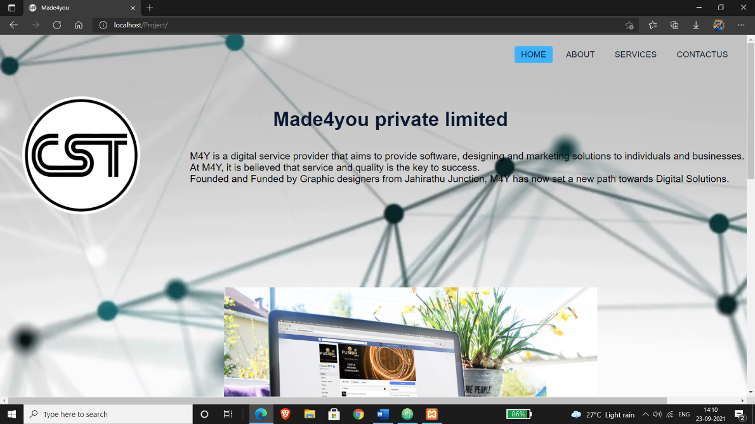

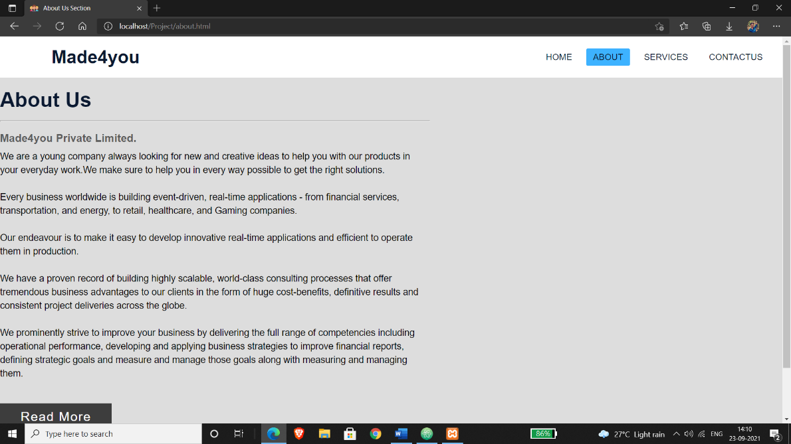

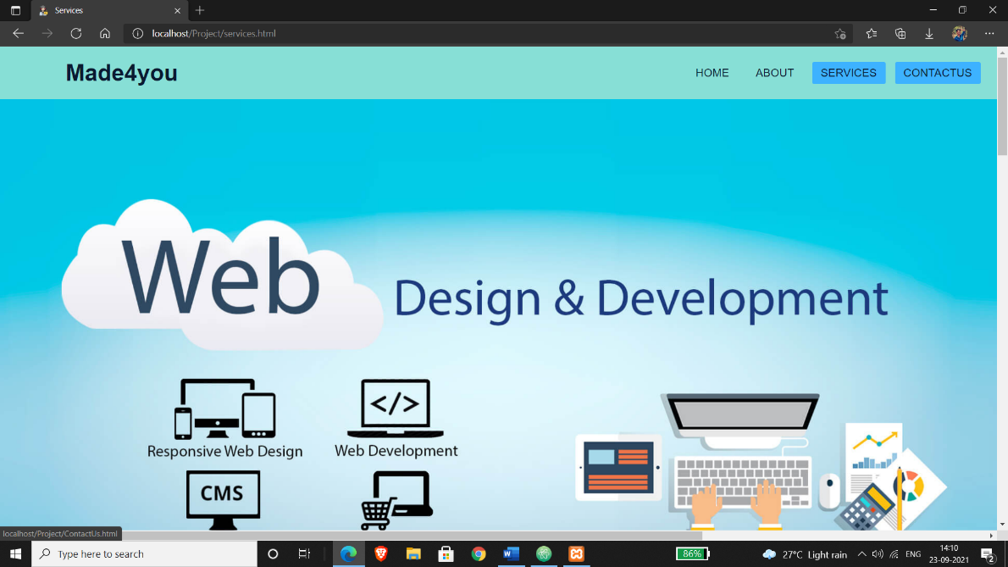

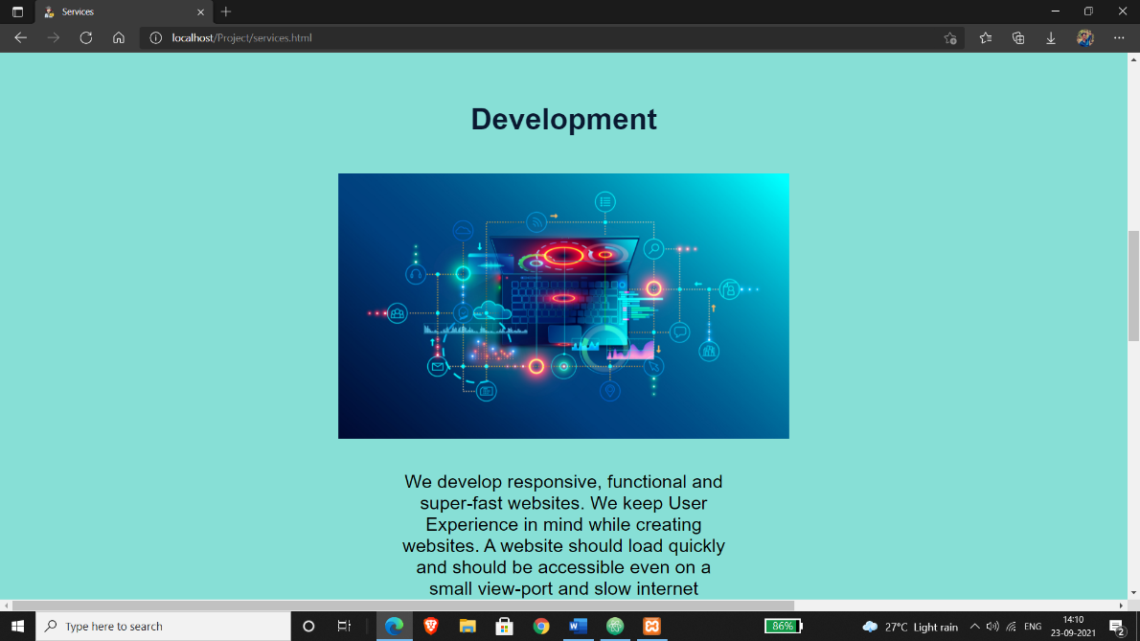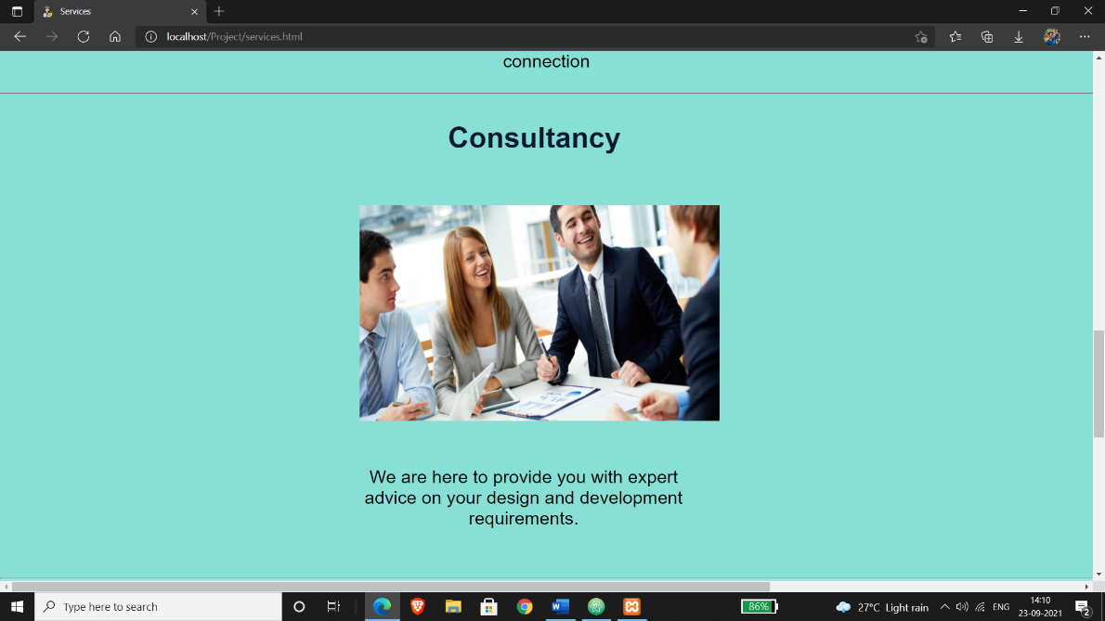

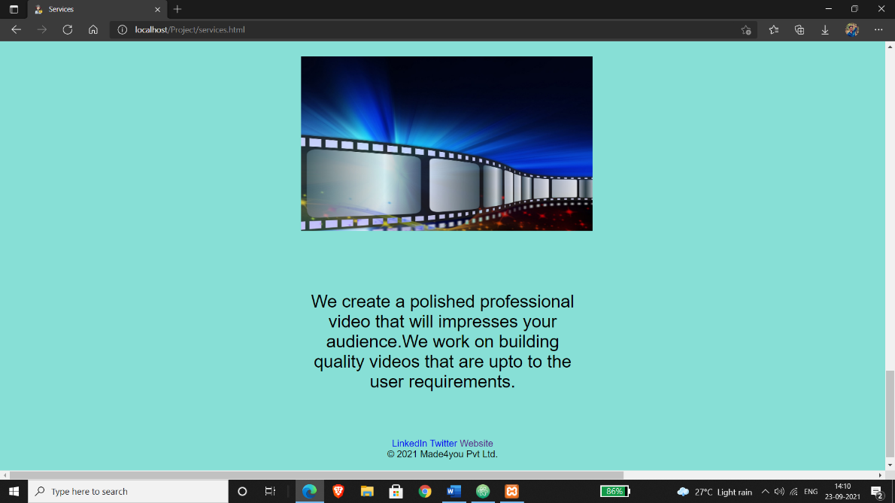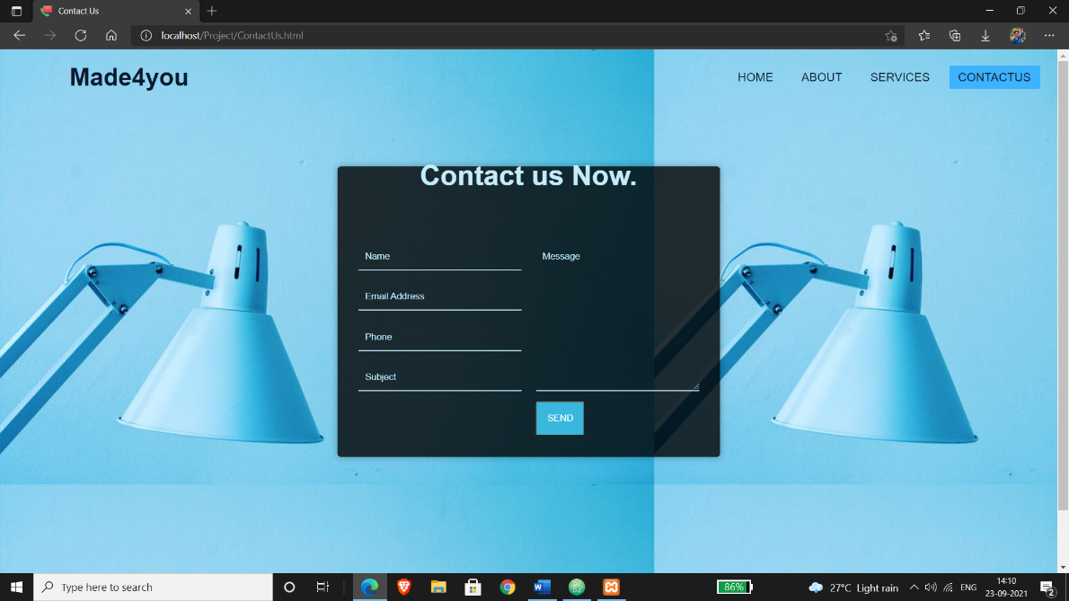

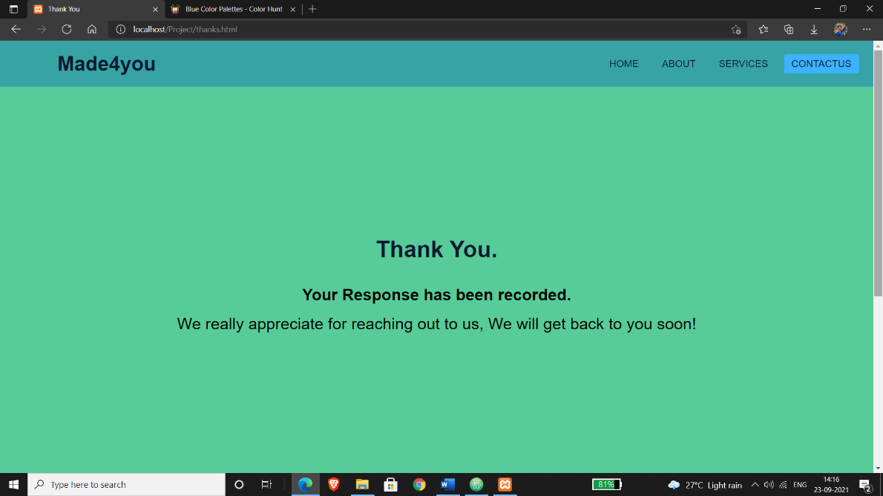

**Bibliography:**

* <https://www.w3schools.com/>
* [https://www.geeksforgeeks.org](https://www.geeksforgeeks.org/)