**44-460/660 Database Systems Name: Gopichand Bandarupalli**

**Spring 2020 Exam 2 Take Home S#: 538305**

**65 Points ☑ 8am □ 9:30 □ 2pm**

Transform the ER model below into a set of 3NF relations. Use the format shown here for relations:

FACULTY (FacID, LastName, FirstName, Rank, DeptID)

FK DeptID 🡪 DEPT

DEPT (DeptID, DeptName, DeptPhone)

You must underline all components of each primary key. Denote each foreign key directly beneath the relation that contains the foreign key, as shown above. Do *not* use the graphical notation from the textbook. The notation shown above is the notation you are required to use. Be sure that all relations are in 3NF.

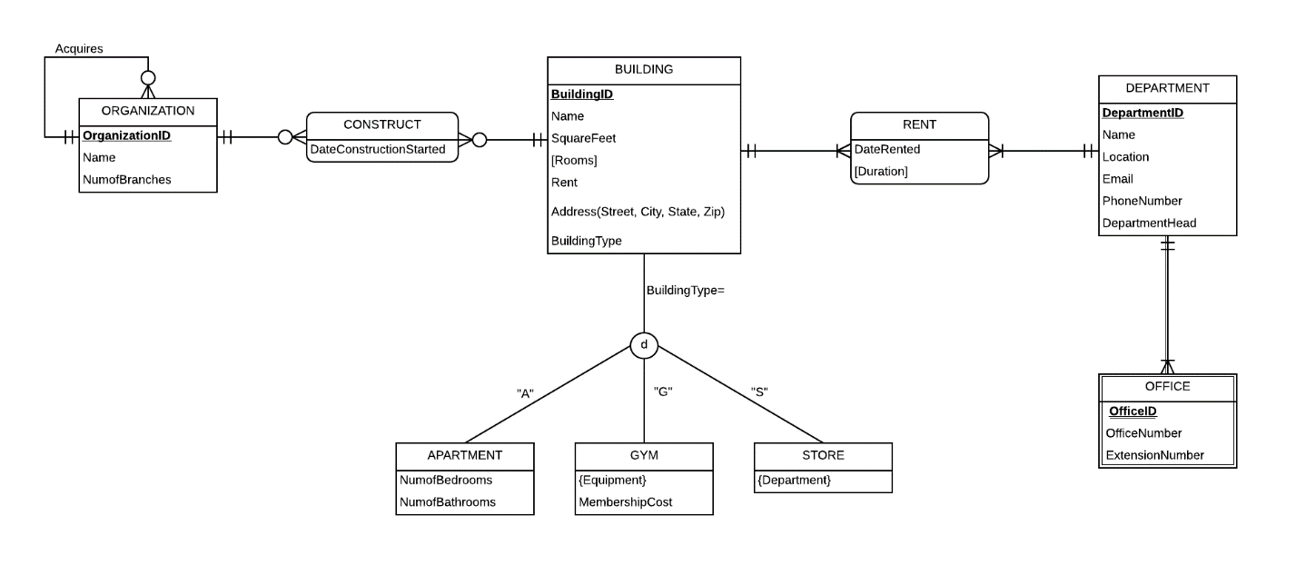

has

[Type answer on next page]

BUILDING(BuildingID,Name,Squarefeet,Rent,Street,City,State,Zip,BuildingType)

ORGANIZATION(OrganizationID,Name,NumofBranches,Acquire-ID)

FK: Acquire-ID 🡪ORGANIZATION

CONSTRUCT(OrganizationID, BuildingID,DateofConstruction)

FK: OrganizationID 🡪 ORGANIZATION

FK: BuildingID 🡪 BUILDING

DEPARTMENT(DepartmentID,Name,Location,Email,phoneNumber,DepartmentHead)

OFFICE(OfficeID, DepartmentID,officeNumber,ExtentionNumber)

FK:DepartmentID🡪 DEPARTMENT

RENT(BuildingID, DepartmentID,DateRented)

FK: BuildingID 🡪BUILDING

FK:DepartmentID🡪DEPATMENT

Apartment(ApartmentID,NumofBedrooms,NumofBathrooms)

FK: ApartmentID 🡪BUILDING

STORE(SB-ID)

FK:SB-ID🡪BUILDING

STOREDEPARTMENT(SB-ID,Department)

FK:SB-ID🡪STORE

GYM(GB-ID,MembershipCost)

FK:GB-ID🡪BUILDING

GYMEQUIPMENT(GB-ID, Equipment)

FK:GB-ID🡪GYM