44-563 Developing Web Applications and Services Spring 2012

Exam 1

*Questions 1-10 refer to the web page shown below.*

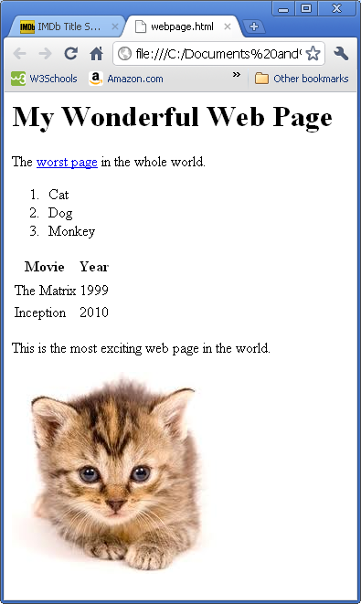

1. (6 pts) Write the HTML code (including the necessary tags) for including the link worst page to another web page. Assume the URL of the other page is

http://nerd.com/badpage.html

2. (6 pts) Write the HTML code (including the necessary tags) for the heading "My Wonderful Web Page".

3. (6 pts) Write the HTML code (including the necessary tags) for the list containing the three items Cat, Dog, and Monkey.

4. (6 pts) Write the HTML code (including the necessary tags) for the paragraph containing the text "This is the most exciting web page in the world".

5. (6 pts) Write the HTML code (including the necessary tags) for including the picture of a cat in the web page. Assume the name of the picture file is cat.jpg and the file is located in the same directory as the .html file for the web page.

6. (10 pts) Write the HTML code (including the necessary tags) for the table containing information about movies and years. Be sure to include the headings for the columns.

7. (5 pts) Write CSS code to set the background color of the page to orange.

8. (5 pts) Write CSS code to display the text in the heading in italics.

9. (5 pts) Write CSS code to put a green border around the paragraph.

10. (5 pts) Write CSS code to display all text in the table (including the column headings) in the color brown.

11. (a) (2 pts) Each namespace has a unique prefix that must be used in all documents that use the namespace.

TRUE FALSE

(b) (2 pts) Each namespace has a unique URI.

TRUE FALSE

(c) (2 pts) In the namespace declaration below

**xmlns:ape="http://www.animals.org/hominidae"**

the namespace URI is ____________________________________

and the namespace prefix is ______________________________________

12. (10 pts) The faculty language is defined by this DTD file, named faculty.dtd.

**<?xml version="1.0" encoding="UTF-8"?>**

**<!ELEMENT faculty (name, adviseeList)>**

**<!ATTLIST faculty facultyNumber ID #REQUIRED>**

**<!ELEMENT name (first, last)>**

**<!ELEMENT first (#PCDATA)>**

**<!ELEMENT last (#PCDATA)>**

**<!ELEMENT adviseeList (advisee+)>**

**<!ELEMENT advisee (studentNumber, classification)>**

**<!ELEMENT studentNumber (#PCDATA)>**

**<!ELEMENT classification (#PCDATA)>**

Write an XML file faculty.xml that uses the faculty language to represent the data described below. Your file must validate against the DTD file.

Donald Knuth is a faculty member with faculty number F849. He has two advisees: Student S456 who is a junior, and student S789 who is a senior.

13. (12 pts) Answer the questions below concerning this definition from a schema:

**<xsd:complexType name="Items">**

**<xsd:sequence>**

**<xsd:element name="item" minOccurs="0" maxOccurs="7">**

**<xsd:complexType>**

**<xsd:sequence>**

**<xsd:element name="productName" type="xsd:string"/>**

**<xsd:element name="quantity">**

**<xsd:simpleType>**

**<xsd:restriction base="xsd:positiveInteger">**

**<xsd:maxExclusive value="10"/>**

**</xsd:restriction>**

**</xsd:simpleType>**

**</xsd:element>**

**<xsd:element name="USPrice" type="xsd:decimal"/>**

**<xsd:element ref="comment" minOccurs="0"/>**

**<xsd:element name="shipDate" type="xsd:date" minOccurs="0"/>**

**</xsd:sequence>**

**<xsd:attribute name="partNum" type="SKU" use="required"/>**

**</xsd:complexType>**

**</xsd:element>**

**</xsd:sequence>**

**</xsd:complexType>**

**<xsd:simpleType name="SKU">**

**<xsd:restriction base="xsd:string">**

**<xsd:pattern value="[A-Z]{3}\d{2}"/>**

**</xsd:restriction>**

**</xsd:simpleType>**

(a) The **item** element can be omitted.

TRUE FALSE

(b) The **item** element can occur 5 times.

TRUE FALSE

(c) The **shipDate** element is required.

TRUE FALSE

(d) The value of **quantity** can be 10.

TRUE FALSE

(e) The minimum legal value of **quantity** is __________.

(f) Give an example of a legal value for **partNum**.

14. (12 pts) Assume an XML file has the following format:

**<dogList>**

**<dog>**

**<dogName>Tex</dogName>**

**<breed>Standard Poodle</breed>**

**<age>6</age>**

**<owner>**

**<ownerName>**

**<first>Mary</first>**

**<last>Smith</last>**

**</ownerName>**

**<address>**

**<city>Dallas</city>**

**<state>Texas</state>**

**</address>**

**</owner>**

**</dog>**

**REMAINING dog ELEMENTS NOT SHOWN TO SAVE SPACE**

**</dogList>**

We want to use XSL to transform this data into a table in HTML. The table will contain the dog name and owner's city for each dog with an age less than 8. Write XSL code that produces this table from the data file. **Write ONLY the code that goes between the <table> and </table> tags. Everything else can be omitted.**

NOTE: THERE IS MORE SPACE AVAILABLE ON THE NEXT PAGE

ADDITIONAL SPACE

**DO NOT REMOVE THIS PAGE**

ADDITIONAL SPACE

**DO NOT REMOVE THIS PAGE**