**Micro-service For Product and Orders**

This project is deals with two services with api gateway service which is registered with eureka-server by through which we access the services.

Project Components:

1. API –Gateway – Spring boot, Netflix Zuul
2. Service Discovery – Spring boot ,Netflix Eureka
3. Order-service – Spring boot , JPA, Hibernate
4. Order-details-service – Spring boot , JPA , Hibernate

**First service -** Order-Service which is take specific format of JSON object with respect to Customer_ID & placed the order. Customers have been already registered with respective database.

In first Service placed the order with url: <http://localhost:8400/orderservice/1/placeOrde>r with

We get response successfully created with Order id :1

The bellow image show the example

**Second Service** as getting order based on customer id provided in URI. Below is output of service.

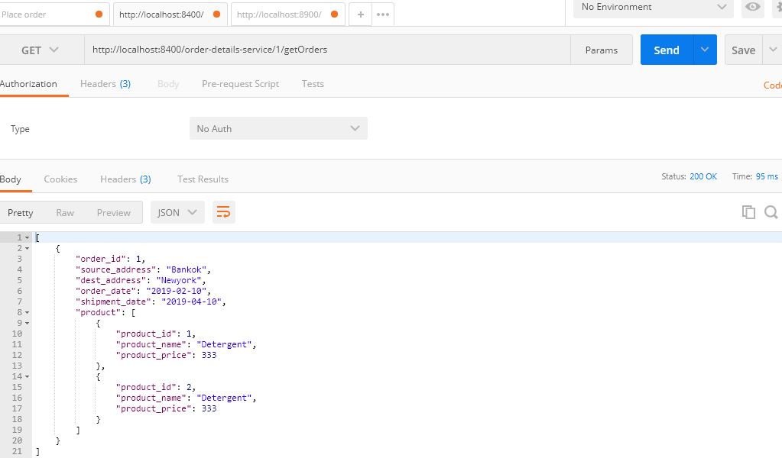

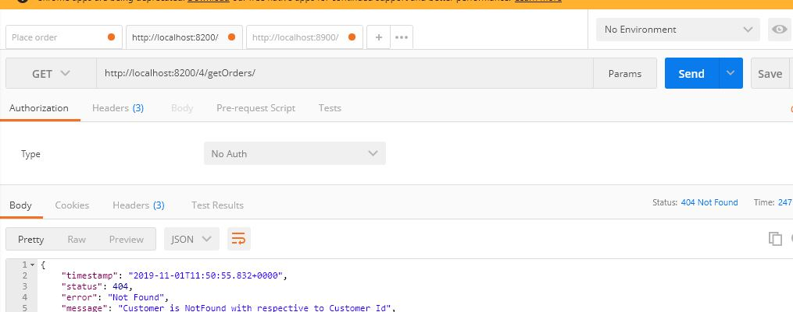

Below is the Eureka Sever Dashboard:

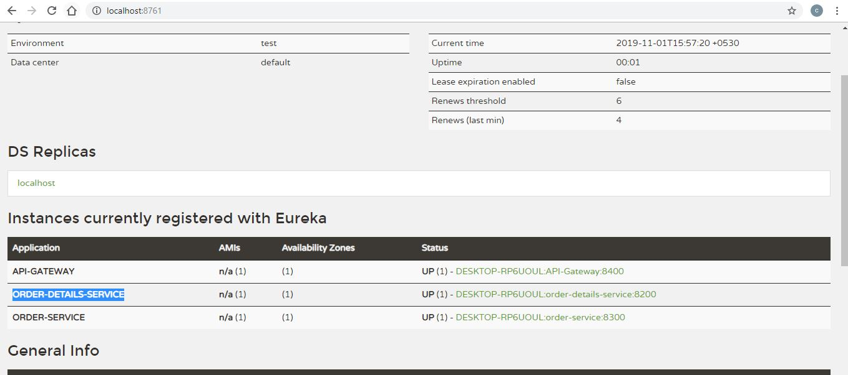

**How to run all things**

**Before you start**

* Need to modify MySQL connection details.

**Important Endpoint \***

* [http://localhost:8300/{cust_id}/placeOrder](http://localhost:8300/%7bcust_id%7d/placeOrder) - Order Service - Placing Order
* [http://localhost:8200/{cust_id}/getOrders/](http://localhost:8200/%7bcust_id%7d/getOrders/) -Order-Details-Service –to get Order details
* [http://localhost:8761](http://localhost:8761/) – Eureka Dashboard

## URI Endpoints from API Gateway

|  |  |  |  |
| --- | --- | --- | --- |
| **Method** | **API** | **Required Parameter /Request Body** | **Description** |
| GET | http://localhost:8400/order-details-service/{cust_ID}/getOrders | Cust_id – provide customer id | Get the orders for provided customer id. |
| POST | http://localhost:8400/order-service/{cust_id}/placeOrder | Cust_id – provide customer id  Body :-  {  "source_address": "Bankok",  "dest_address": "Newyork",  "order_date": "2019-02-11",  "shipment_date": "2019-04-11",  "product": [  {  "product_id":"5",  "product_name": "Detergent",  "product_price": "333.0"  },  {  "product_id":"6",  "product_name": "Detergent",  "product_price": "333.0"  }  ]  } | To add order to the customer ID |

E.g. URI:

<http://localhost:8400/order-service/1/placeOrder> - POST

<http://localhost:8400/order-details-service/1/getOrders> -GET