Html123456712346

HTML is the standard markup language for Web pages.

With HTML you can create your own Website.

<!DOCTYPE html>  
<html>  
<head>  
<title>Page Title</title>  
</head>  
<body>  
  
<h1>This is a Heading</h1>  
<p>This is a paragraph.</p>  
  
</body>  
</html>

HTML is an acronym which stands for **Hyper Text Markup Language** which is used for creating web pages and web applications. Let's see what is meant by Hypertext Markup Language, and Web page.

**Hyper Text:** HyperText simply means "Text within Text." A text has a link within it, is a hypertext. Whenever you click on a link which brings you to a new webpage, you have clicked on a hypertext. HyperText is a way to link two or more web pages (HTML documents) with each other.

**Markup language:** A markup language is a computer language that is used to apply layout and formatting conventions to a text document. Markup language makes text more interactive and dynamic. It can turn text into images, tables, links, etc.

**Web Page:** A web page is a document which is commonly written in HTML and translated by a web browser. A web page can be identified by entering an URL. A Web page can be of the static or dynamic type. **With the help of HTML only, we can create static web pages**.

Description of HTML Example

**<!DOCTYPE>:** It defines the document type or it instruct the browser about the version of HTML.

**<html >** :This tag informs the browser that it is an HTML document. Text between html tag describes the web document. It is a container for all other elements of HTML except <!DOCTYPE>

**<head>:** It should be the first element inside the <html> element, which contains the metadata(information about the document). It must be closed before the body tag opens.

**<title>:** As its name suggested, it is used to add title of that HTML page which appears at the top of the browser window. It must be placed inside the head tag and should close immediately. (Optional)

**<body>**: Text between body tag describes the body content of the page that is visible to the end user. This tag contains the main content of the HTML document.

**<h1>** : Text between <h1> tag describes the first level heading of the webpage.

# **HTML text Editors**

* After learning the basics, you can easily use other professional text editors which are, **Notepad++, Sublime Text, Vim, etc**.

# **Building blocks of HTML**

An HTML document consist of its basic building blocks which are:

* **Tags:** An HTML tag surrounds the content and apply meaning to it. It is written between < and > brackets.
* **Attribute:** An attribute in HTML provides extra information about the element, and it is applied within the start tag. An HTML attribute contains two fields: name & value.

## Syntax

1. **<tag** name  attribute_name= " attr_value"**>** content **</** **tag** name**>**

* **Elements:** An HTML element is an individual component of an HTML file. In an HTML file, everything written within tags are termed as HTML elements.

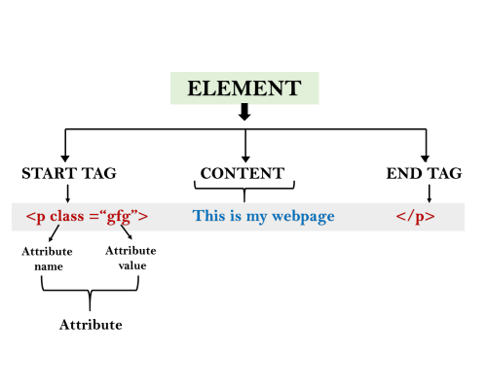

1. <!DOCTYPE html**>**
2. **<html>**
3. **<head>**
4. **<title>**The basic building blocks of HTML**</title>**
5. **</head>**
6. **<body>**
7. **<h2>**The building blocks**</h2>**
8. **<p>**This is a paragraph tag**</p>**
9. **<p** style="color: red"**>**The style is attribute of paragraph tag**</p>**
10. **<span>**The element contains tag, attribute and content**</span>**
11. **</body>**
12. **</html>**

# **HTML Tags**

HTML tags are like keywords which defines that how web browser will format and display the content. With the help of tags, a web browser can distinguish between an HTML content and a simple content. HTML tags contain three main parts: opening tag, content and closing tag. But some HTML tags are unclosed tags.

When a web browser reads an HTML document, browser reads it from top to bottom and left to right. HTML tags are used to create HTML documents and render their properties. Each HTML tags have different properties.

An HTML file must have some essential tags so that web browser can differentiate between a simple text and HTML text. You can use as many tags you want as per your code requirement.

* All HTML tags must enclosed within <> these brackets.
* Every tag in HTML perform different tasks.
* If you have used an open tag <tag>, then you must use a close tag </tag> (except some tags)

## Syntax

<tag> content </tag>

## HTML Tag Examples

<p> Paragraph Tag </p>

## <h2> Heading Tag </h2>

<b> **Bold Tag** </b>

<i> *Italic Tag* </i>

<u> Underline Tag</u>

## Unclosed HTML Tags

Some HTML tags are not closed, for example br and hr.

**<br> Tag**: br stands for break line, it breaks the line of the code.

**<hr> Tag**: hr stands for Horizontal Rule. This tag is used to put a line across the webpage.

## HTML Meta Tags

DOCTYPE, title, link, meta and style

## HTML Text Tags

<p>, <h1>, <h2>, <h3>, <h4>, <h5>, <h6>, <strong>, <em>, <abbr>, <acronym>, <address>, <bdo>, <blockquote>, <cite>, <q>, <code>, <ins>, <del>, <dfn>, <kbd>, <pre>, <samp>, <var> and <br>

## HTML Link Tags

<a> and <base>

## HTML Image and Object Tags

<img>, <area>, <map>, <param> and <object>

## HTML List Tags

<ul>, <ol>, <li>, <dl>, <dt> and <dd>

## HTML Table Tags

table, tr, td, th, tbody, thead, tfoot, col, colgroup and caption

## HTML Form Tags

form, input, textarea, select, option, optgroup, button, label, fieldset and legend

## HTML Scripting Tags

script and noscript

# **HTML Attribute**

* HTML attributes are special words which provide additional information about the elements or attributes are the modifier of the HTML element.
* Each element or tag can have attributes, which defines the behaviour of that element.
* Attributes should always be applied with start tag.
* The Attribute should always be applied with its name and value pair.
* The Attributes name and values are case sensitive, and it is recommended by W3C that it should be written in Lowercase only.
* You can add multiple attributes in one HTML element, but need to give space between two attributes.

## Syntax

1. **<element** attribute_name="value"**>**content**</element>**

## Example

1. <!DOCTYPE html**>**
2. **<html>**
3. **<head>**
4. **</head>**
5. **<body>**
6. **<h1>** This is Style attribute**</h1>**
7. **<p** style="height: 50px; color: blue"**>**It will add style property in element**</p>**
8. **<p** style="color: red"**>**It will change the color of content**</p>**
9. **</body>**
10. **</html>**

# **HTML Elements**

An HTML file is made of elements. These elements are responsible for creating web pages and define content in that webpage. An element in HTML usually consist of a start tag <tag name>, close tag </tag name> and content inserted between them. **Technically, an element is a collection of start tag, attributes, end tag, content between them**.

Example

1. <!DOCTYPE html**>**
2. **<html>**
3. **<head>**
4. **<title>**WebPage**</title>**
5. **</head>**
6. **<body>**
7. **<h1>**This is my first web page**</h1>**
8. **<h2>** How it looks?**</h2>**
9. **<p>**It looks Nice!!!!!**</p>**
10. **</body>**
11. **</html>**

# **HTML Formatting**

**HTML Formatting** is a process of formatting text for better look and feel. HTML provides us ability to format text without using CSS. There are many formatting tags in HTML. These tags are used to make text bold, italicized, or underlined.

In HTML the formatting tags are divided into two categories:

* Physical tag: These tags are used to provide the visual appearance to the text.
* Logical tag: These tags are used to add some logical or semantic value to the text.

|  |  |
| --- | --- |
| * **Element name** | **Description** |
| <b> | This is a physical tag, which is used to bold the text written between it. |
| <strong> | This is a logical tag, which tells the browser that the text is important. |
| <i> | This is a physical tag which is used to make text italic. |
| <em> | This is a logical tag which is used to display content in italic. |
| <mark> | This tag is used to highlight text. |
| <u> | This tag is used to underline text written between it. |
| <tt> | This tag is used to appear a text in teletype. (not supported in HTML5) |
| <strike> | This tag is used to draw a strikethrough on a section of text. (Not supported in HTML5) |
| <sup> | It displays the content slightly above the normal line. |
| <sub> | It displays the content slightly below the normal line. |
| <del> | This tag is used to display the deleted content. |
| <ins> | This tag displays the content which is added |
| <big> | This tag is used to increase the font size by one conventional unit. |
| <small> | This tag is used to decrease the font size by one unit from base font size. |

## 1) Bold Text

HTML<b> and <strong> formatting elements

See this example:

1. **<p>** **<b>**Write Your First Paragraph in bold text.**</b></p>**

# **HTML Heading**

A HTML heading or HTML h tag can be defined as a title or a subtitle which you want to display on the webpage. When you place the text within the heading tags <h1>.........</h1>, it is displayed on the browser in the bold format and size of the text depends on the number of heading.

There are six different HTML headings which are defined with the <h1> to <h6> tags, from highest level h1 (main heading) to the least level h6 (least important heading).

h1 is the largest heading tag and h6 is the smallest one. So h1 is used for most important heading and h6 is used for least important.

**Headings in HTML helps the search engine to understand and index the structure of web page.**

1. **<h1>**Heading no. 1**</h1>**
2. **<h2>**Heading no. 2**</h2>**
3. **<h3>**Heading no. 3**</h3>**
4. **<h4>**Heading no. 4**</h4>**
5. **<h5>**Heading no. 5**</h5>**
6. **<h6>**Heading no. 6**</h6>**

# **HTML Paragraph**

HTML paragraph or HTML p tag is used to define a paragraph in a webpage. Let's take a simple example to see how it work. It is a notable point that a browser itself add an empty line before and after a paragraph. An HTML <p> tag indicates starting of new paragraph.

1. **<p>**This is first paragraph.**</p>**
2. **<p>**This is second paragraph.**</p>**
3. **<p>**This is third paragraph.**</p>**

# **HTML Phrase tag**

The HTML phrase tags are special purpose tags, which defines the structural meaning of a block of text or semantics of text. Following is the list of phrase tags, some of which we have already discussed in HTML formatting.

* Abbreviation tag :<abbr>
* Acronym tag: <acronym> (not supported in HTML5)
* Marked tag: <mark>
* Strong tag: <strong>

1. Text Abbreviation tag

This tag is used to abbreviate a text. To abbreviate a text, write text between <abbr> and </abbr> tag.

Example

1. **<p>**An **<abbr** title = "Hypertext Markup language"**>**HTML **</abbr>**language is used to create web pages. **</p>**

[**Test it Now**](https://www.javatpoint.com/oprweb/test.jsp?filename=htmlphrasetag1)

**Output:**

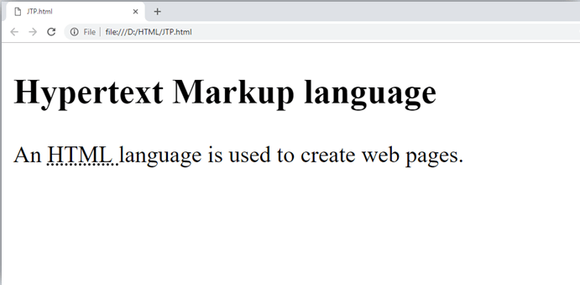

# **HTML Anchor**

The **HTML anchor tag** defines *a hyperlink that links one page to another page*. It can create hyperlink to other web page as well as files, location, or any URL. The "href" attribute is the most important attribute of the HTML a tag. and which links to destination page or URL.

## href attribute of HTML anchor tag

The href attribute is used to define the address of the file to be linked. In other words, it points out the destination page.

The syntax of HTML anchor tag is given below.

<a href = "..........."> Link Text </a>

Let's see an example of HTML anchor tag.

## Example:

1. <!DOCTYPE html**>**
2. **<html>**
3. **<head>**
4. **<title></title>**
5. **</head>**
6. **<body>**
7. **<p>**Click on **<a** href="https://www.google.com/" target="_blank"**>** this-link **</a>**to go on home page of JavaTpoint.**</p>**
8. **</body>**
9. **</html>**

# **HTML Image**

**HTML img tag** is used to display image on the web page. HTML img tag is an empty tag that contains attributes only, closing tags are not used in HTML image element.

Let's see an example of HTML image.

1. **<h2>**HTML Image Example**</h2>**
2. **<img** src="good_morning.jpg" alt="Good Morning Friends"**/>**