Gourab Das
(M)+91 8697327875
email- rohondas12@gmail.com

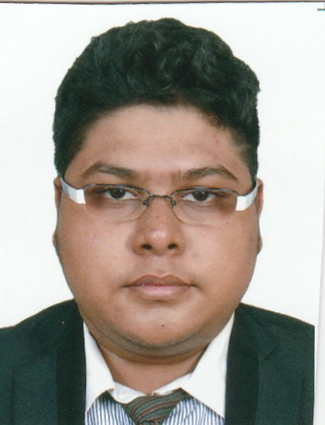
Master of Business Administration
Present Assignment
Graduated in Masters in Business Administration-General from London South Bank University, Singapore

Past Assignment
Completed Bachelor of Technology in Electronics and Communication from Manav Bharti University, Himachal Pradesh

Introduction
A student with knowledge of Masters in Business management student and Bachelor of technology in Electronics and Communication. Dynamic in working enthusiastically in managing assignments, friendly by nature, possessing the nature to try to be a leader in a group, having positive nature and thinking in every aspect, having strong understanding of management skills such as convincing, marketing and successful completion of tasks on time.

Areas of expertise
Convincing Skills- I was able to convince my group people to take up Huawei case study for our group assignment case study in a fair manner.

Engineering Skills- I was able to communicate properly the exact components required in our research work and calibrated the machines in the most efficient way.

On Time- During my M.B.A course, I was able to successfully complete my dissertation and presentations on time.

Good communication skills- Appeared for the IELTS exam and got a score of 7.0 out of 9.0

Professional Experiences
GNS Nirman Pvt. Ltd (a real estate company)
As a Administration Executive from July -16 to till date
Responsibilities:
Tally ERP – Purchase entry, Sales booking, Adjustment entry, Stock maintain and other regular accounts work.
Office skills – tracking for Flat booking and follow-up with clients. MIS report submits to management etc.
Engineering skills-Duty as site-in-charge supervision of electronic equipments installation and maintenance

Marketing skills- Marketing of building projects under development and also completed ones

Internship and Research Projects

Topic: Design and Development of Induction Generators and motors
Collaboration: Under internship of Rajdhani Service Solutions, Delhi, India

Skills
Software Based Skills | Presentation – MS Office, MS Word, MS Excel  Language Based –Java  Tally ERP
Experimental Skills | Basic Experiments - Basic Electronics

Academics

London South Bank University, Singapore Batch – 2015 - 16
Masters of Business Administration (General)

Manav Bharti University, Himachal Pradesh Batch – 2010 - 14
Bachelor of Technology - Electronics and Communication

St. Francis Xavier School Batch – 2009 - 10
Subjects - Physics, Chemistry, Mathematics, Computer, English and Bengali

Assembly of God Church School Batch – 2007 - 08
Subjects - Science, Mathematics, English, Computer, Social Science and Bengali

Extra Curriculum achievements
Joined the cricket club in school and represented the school for the inter cricket sport championship.
Gained first position for elocution representing the School in class four.
Participated in the event Power Logistics Asia 2015 PL

Subject Based Academic Projects

Topic: Auto wheelchair
Course: Project for 7th Semester Seminar
Topic: Robot Designing
Course: 6th Semester Project
Topic: Design Drone and its controlling
Course: 4thSemester Project.
Topic: Dissertation on Optimizing transport facility in BlueDartIndia
Course: Final semester MBA project.

Personal Detail

Date of birth : 2nd Dec, 1991
Passport : J3284391
Nationality : Indian
Address : 132 A/1D, Raja Rajendra Lal Mitra Road Kolkata, India-700085

I hereby declare that the information given above is true and correct to the best of my knowledge and belief.

Date : -----------------------------
Place: Kolkata GOURAB DAS

