CLASS PROGRAMS
PROGRAMS FOR VARIOUS GRAPHS :
1.LINE GRAPH
import matplotlib.pyplot as plt
x = [1,2,3]
y = [2,4,1]
plt.plot(x,y)
plt.xlabel('x - axis')
plt.ylabel('y - axis')
plt.title('My first graph!')
plt.show()

OUTPUT:
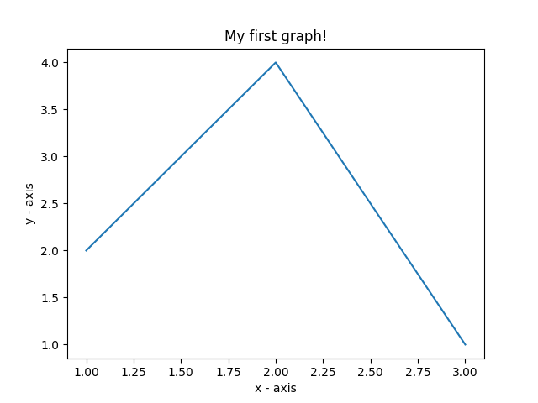

2.BAR GRAPH:
import matplotlib.pyplot as plt
left=[1,2,3,4,5]
height=[16,25,36,49,2]
tick_label = ['one','two','three','four','five']
plt.bar(left,height,tick_label = tick_label,
width = 0.6,color = ['red','blue'])
plt.xlabel('x-Axis')
plt.ylabel('y-Axis')
plt.title('MY BAR GRAPH')
plt.show()

OUTPUT:
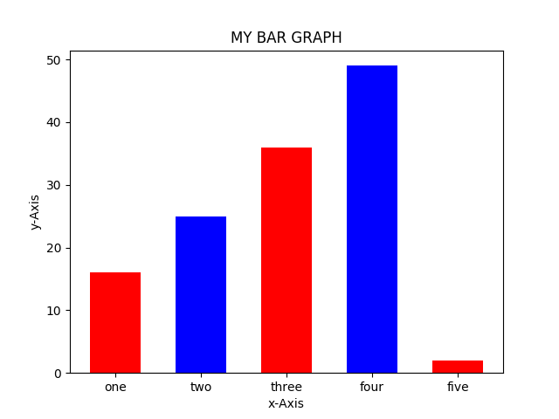

3.SCATERING CHART:
import matplotlib.pyplot as plt

x = [1,2,3,4,5,6,7,8,9,10]

y = [2,4,5,7,6,8,9,11,12,12]

plt.scatter(x, y, label= "stars", color= "blue",
marker= "*", s=30)
plt.xlabel('x - axis')
plt.ylabel('y - axis')
plt.title('My scatter plot!')
plt.legend()
plt.show()

OUTPUT:

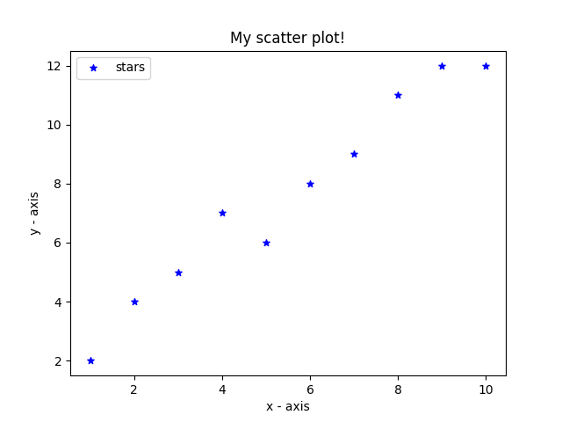

4. PIE GRAPH:
import matplotlib.pyplot as plt

activities = ['sleep', 'study', 'work', 'gamming']

slices = [3, 7, 8, 6]

colors = ['r', 'y', 'g', 'b']
plt.pie(slices, labels = activities, colors=colors,
startangle=90, shadow = True, explode = (0, 0, 0.1, 0),
radius = 1.2, autopct = '%1.1f%%')
plt.legend()
plt.show()

OUTPUT:
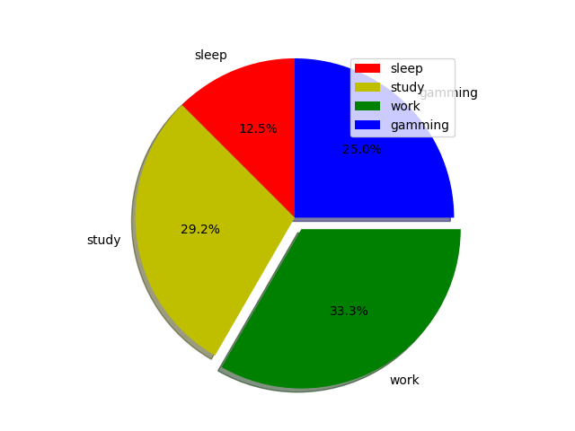

5.WAVE GRAPH:
import matplotlib.pyplot as plt
import numpy as np

x = np.arange(0, 2*(np.pi), 0.1)
y = np.sin(x)
plt.plot(x, y)
plt.show()

OUT PUT:
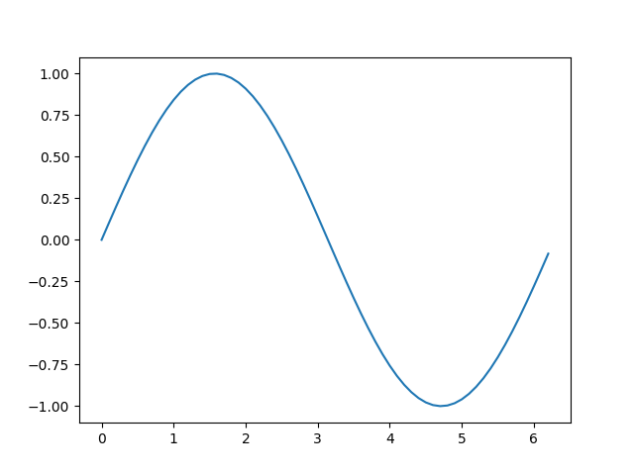

6.3D GRAPH:
from mpl_toolkits.mplot3d import axes3d
import matplotlib.pyplot as plt
from matplotlib import style
import numpy as np

style.use('ggplot')

fig = plt.figure()

ax1 = fig.add_subplot(111, projection='3d')

x = np.random.randint(0, 10, size = 20)
y = np.random.randint(0, 10, size = 20)
z = np.random.randint(0, 10, size = 20)

ax1.set_xlabel('x-axis')
ax1.set_ylabel('y-axis')
ax1.set_zlabel('z-axis')
plt.show()

OUTPUT:
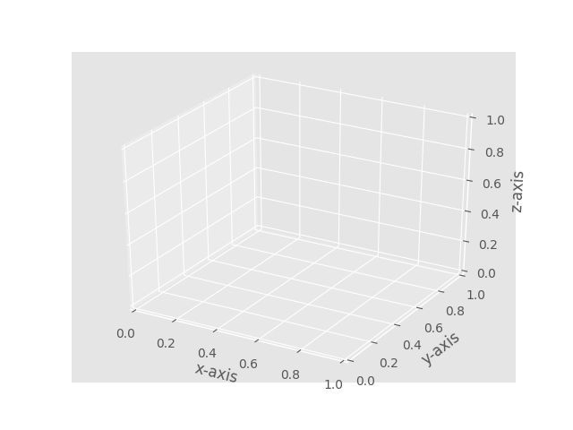

7.NO. OF WAVES:
import matplotlib.pyplot as plt
import numpy as np

def create_plot(ptype):

x = np.arange(0, 5, 0.01)

if ptype == 'sin':

y = np.sin(2*np.pi*x)
elif ptype == 'exp':

y = np.exp(-x)
elif ptype == 'hybrid':

y = (np.sin(2*np.pi*x))*(np.exp(-x))

return(x, y)

plt.style.use('ggplot')

plt1 = plt.subplot2grid((11,1), (0,0), rowspan = 3, colspan = 1)
plt2 = plt.subplot2grid((11,1), (4,0), rowspan = 3, colspan = 1)
plt3 = plt.subplot2grid((11,1), (8,0), rowspan = 3, colspan = 1)

x, y = create_plot('sin')
plt1.plot(x, y, label = 'sine wave', color ='b')
x, y = create_plot('exp')
plt2.plot(x, y, label = 'negative exponential', color = 'r')
x, y = create_plot('hybrid')
plt3.plot(x, y, label = 'damped sine wave', color = 'g')

plt1.legend()
plt2.legend()
plt3.legend()

plt.show()

OUTPUT:
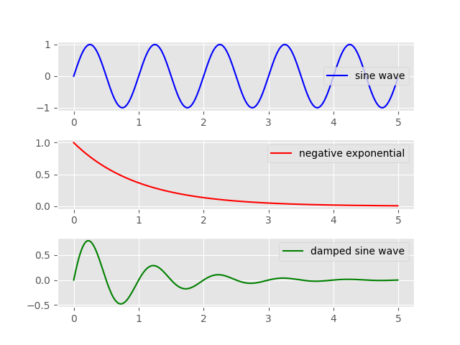

8.DOTTED LINE GRAPH:
import matplotlib.pyplot as plt
x = [1,2,3,4,5,6]
y = [2,4,1,5,2,6]
plt.plot(x, y, color='green', linestyle='dashed', linewidth = 3,
marker='o', markerfacecolor='blue', markersize=12)
plt.ylim(1,8)
plt.xlim(1,8)
plt.xlabel('x - axis')
plt.ylabel('y - axis')
plt.title('Some cool customizations!')
plt.show()

OUTPUT:
