

DATA STRUCTURES & ALGORITHMS
23CSE203
LAB MANUAL
Submitted By
Name | CHANDRA SEKHAR MATCHA
Roll No. | AV.SC.U4CSE25035
Year/Sem/Section | 2nd year /Sem-3/CSE-A
Credits | 05

S.No. | Title | Page No.
1) | Week-1:  1A) Rocket launch systems display the countdown of before launch instead of using a loop implement the countdown using the recursion write a recursion Python program to display the countdown from n to 1 followed by launch.  1B) Banks calculate the growth of an investment using compound interest. The formula requires calculating powers, which can be implemented recursively. Write a recursive Python program to calculate P^n (power), where P = Principal growth factor, n = number of years.  1C) An HR department stores employee IDs in a list. Develop a recursive program to search for a given employee ID. Write a recursive function to search for an employee ID in a list.  1D) In a logistics company, the number of possible ways to arrange n different parcels is calculated using the factorial formula. Develop a recursive program to calculate the factorial of a given number.  1E) Write a recursive Python program to print the first n terms of a Fibonacci series. | 3-12
INDEX

WEEK-1

1A) Aim: Rocket launch systems display the countdown of before launch instead of using a loop implement the countdown using the recursion write a recursion Python program to display the countdown from n to 1 followed by launch.

Program:
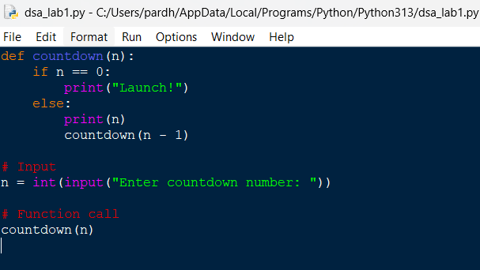
Output:
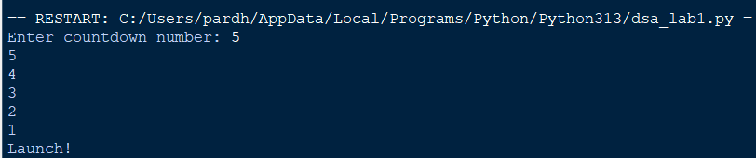

Explanation:
- def defines the countdown() function.
- input() accepts the countdown value from the user.
- int() converts the input into an integer.
- countdown() starts the recursive countdown process.
- if checks the base case (n == 0).
- else executes when the condition is False.
- print(n) displays the current countdown number.
- countdown(n - 1) recursively calls the function with the value decreased by 1.
- print("Launch!") displays the launch message when the countdown reaches 0.
- The program demonstrates the use of functions, recursion, conditional statements, input, and output to perform the countdown.
Error Table:
S.No. | Errors Observed | Rectification
1) | Invalid (non-numeric) input entered by the user. | Enter a valid integer as input.
2) | Missing base case (if n == 0) causing infinite recursion. | Include the base case to stop recursion .l
3) | incorrect indentation leading to an Indentation Error | Maintain proper Python indentation.
4) | Missing colon (:) after def, if, or else. | Add the required colon (:) after statements.
5) | Calling countdown(n) instead of countdown (n - 1), causing infinite recursion. | Decrease the value by 1 in each recursive call using countdown (n - 1).

1B) Aim: Banks calculate the growth of an investment using compound interest. The formula requires calculating powers, which can be implemented recursively. Write a recursive Python program to calculate P^n (power), where P = Principal growth factor, n = number of years.

Program:
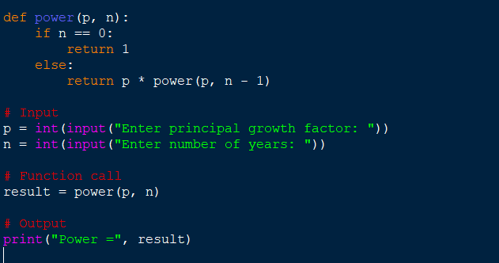
Output:
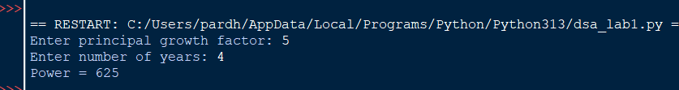

Explanation:
- power() is the recursive function that computes P raised to n.
- The base case is n == 0, which returns 1 (any number to the power 0 is 1).
- The recursive case multiplies p with power(p, n - 1), reducing n by 1 on each call.
- float() allows the principal growth factor to be a decimal value.
- input() collects the values of P and n from the user.
- Each recursive call is stacked until the base case is reached, then the results are multiplied back up the call stack.
- print() displays the final computed value of P^n.
Error Table:
S.No. | Errors Observed | Rectification
1) | Missing base case (n == 0) causing infinite recursion. | Include the base case to stop recursion.
2) | Entering a negative value for n causes the recursion to never reach 0. | Restrict input to non-negative integers or handle negative n separately.
3) | Using int() for P truncates decimal growth factors. | Use float() to accept decimal values for P.
4) | Incorrect indentation leading to an IndentationError. | Maintain proper Python indentation.
5) | Calling power(p, n) instead of power(p, n - 1), causing infinite recursion. | Decrease n by 1 in each recursive call using power(p, n - 1).

1C) Aim: An HR department stores employee IDs in a list. Develop a recursive program to search for a given employee ID. Write a recursive function to search for an employee ID in a list.
Program:
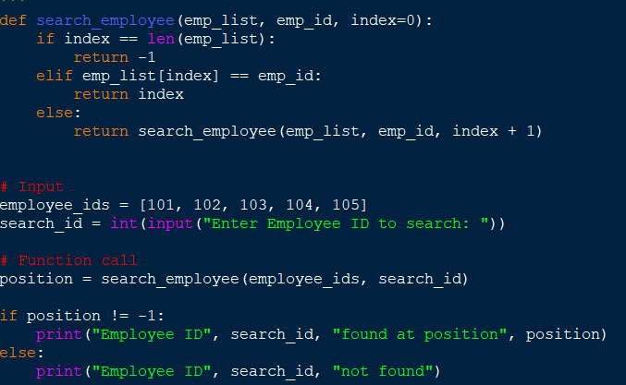
Output:

Explanation:
- search_employee() is the recursive function that searches the list one index at a time.
- The base case index == len(emp_list) means every element was checked and the ID was not found, so it returns -1.
- The second condition checks if the current element matches the employee ID being searched.
- If not matched, the function calls itself with index + 1, moving to the next employee in the list.
- employee_ids is the list of employee IDs stored by the HR department.
- input() and int() collect the employee ID to search for from the user.
- The if-else block reports whether the employee ID was found and at which position.
Error Table:
S.No. | Errors Observed | Rectification
1) | Missing base case (index == len(emp_list)) causing infinite recursion. | Include the base case to stop recursion when the list is exhausted.
2) | Invalid (non-numeric) input entered by the user. | Enter a valid integer as input.
3) | Calling search_employee(emp_list, emp_id, index) without incrementing index, causing infinite recursion. | Increase index by 1 in each recursive call using index + 1.
4) | Incorrect indentation leading to an IndentationError. | Maintain proper Python indentation.
5) | Searching an empty list without handling it, giving a confusing result. | Add a check for an empty list before searching.

1D) Aim:In a logistics company, the number of possible ways to arrange n different parcels is calculated using the factorial formula. Develop a recursive program to calculate the factorial of a given number.
Program:
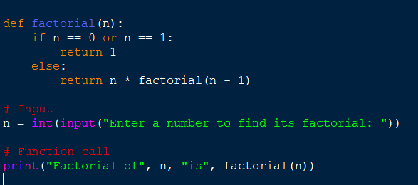
Output:

Explanation:
- factorial() is the recursive function that computes n! (n factorial).
- The base case is n == 0 or n == 1, both of which return 1.
- The recursive case multiplies n with factorial(n - 1), reducing n by 1 on each call.
- input() and int() collect the number whose factorial is to be found.
- Each recursive call is stacked until the base case is reached, then the results are multiplied back up the call stack.
- print() displays the number of possible arrangements (the factorial value).
Error Table:
S.No. | Errors Observed | Rectification
1) | Missing base case (n == 0 or n == 1) causing infinite recursion. | Include the base case to stop recursion.
2) | Entering a negative number, for which factorial is undefined. | Restrict input to non-negative integers.
3) | Invalid (non-numeric) input entered by the user. | Enter a valid integer as input.
4) | Incorrect indentation leading to an IndentationError. | Maintain proper Python indentation.
5) | Calling factorial(n) instead of factorial(n - 1), causing infinite recursion. | Decrease n by 1 in each recursive call using factorial(n - 1).

1E) Aim:Write a recursive Python program to print the first n terms of a Fibonacci series.

Program:
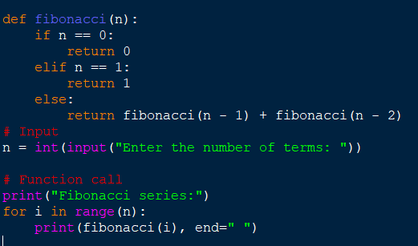

Output:
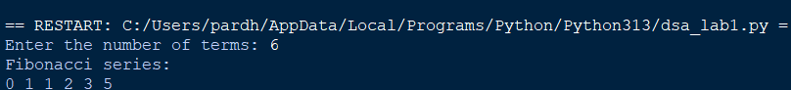

Explanation:
- fibonacci() is the recursive function that returns the nth Fibonacci term.
- The base cases are n == 0 (returns 0) and n == 1 (returns 1).
- The recursive case adds fibonacci(n - 1) and fibonacci(n - 2), following the Fibonacci rule.
- input() and int() collect the number of terms to be printed.
- The for loop calls fibonacci(i) for each index from 0 to n - 1.
- print(..., end=" ") displays each term on the same line, separated by a space.
Error Table:
S.No. | Errors Observed | Rectification
1) | Missing base cases (n == 0 and n == 1) causing infinite recursion. | Include both base cases to stop recursion.
2) | Entering a negative number of terms. | Restrict input to non-negative integers.
3) | Invalid (non-numeric) input entered by the user. | Enter a valid integer as input.
4) | Incorrect indentation leading to an IndentationError. | Maintain proper Python indentation.
5) | Using fibonacci(n - 1) - fibonacci(n - 2) instead of addition, giving wrong terms. | Use addition, fibonacci(n - 1) + fibonacci(n - 2), as per the Fibonacci rule.

WEEK-2

2A) Aim: Write a python program to perform linear search on the given input.
Program:

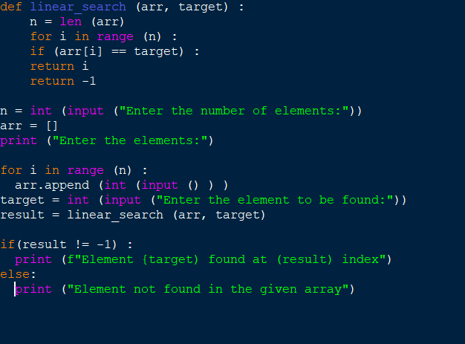
Output:

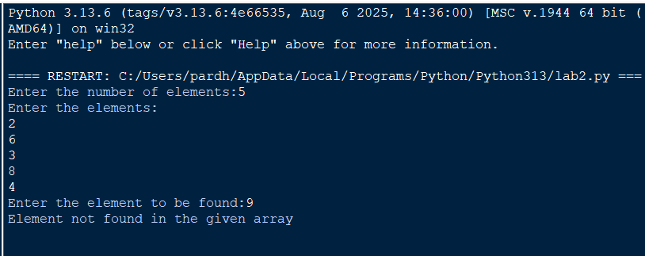

Explanation:
- linear_search(arr, target) sequentially iterates through arr to check each element against target.
- for i in range(n): iterates through array indices from 0 to n-1 sequentially.
- if arr[i] == target: checks for a match and returns index i if found.
- return -1 executes when the target element is absent from the array.
- arr.append(int(input())) converts user input to integers and builds the array.
- if (result != -1): displays the index where the element is found or prints a "not found" message.
Error Table:
S.No. | Errors Observed | Rectification
1) | Invalid (non-numeric) input entered by the user. | Entered a valid integer as input.
2) | Incorrect indentation leading to an Indentation Error | Maintained proper Python indentation.
3) | Missing colon (:) after def, for, if, or else. | Added the required colon (:) after statements.
4) | ValueError when passing non-integer strings to int(input()). | Ensure user input consists of valid integer characters.
5) | IndexError caused by accessing an array index out of bounds. | Ensure loop bounds do not exceed len(arr) - 1.

2B) Aim: Write a python program to perform binary search on the given input.Verify by taking sorted array and unsorted array as input.
Program:
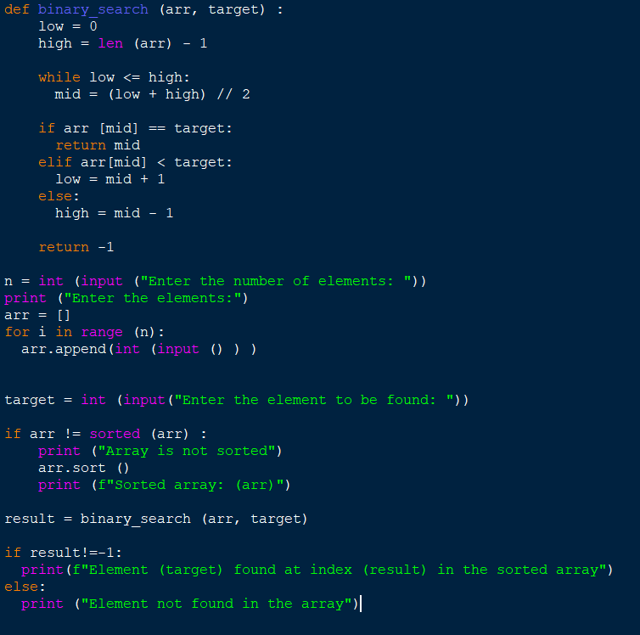
Output:
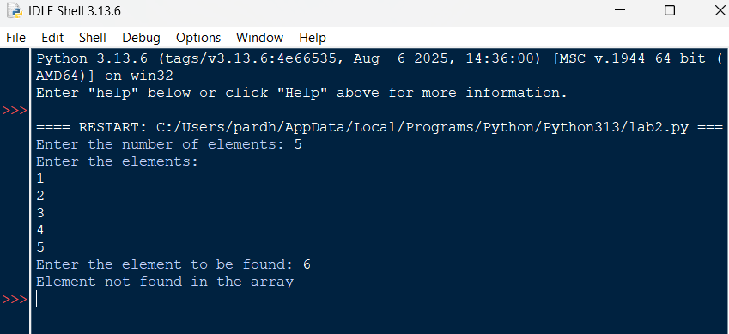
Explanation:
- binary_search(arr, target) uses a divide-and-conquer strategy on a sorted array.
- while low <= high: runs as long as the search boundary contains valid elements.
- mid = (low + high) // 2 computes the middle index using integer division.
- if arr[mid] == target: returns mid if the target is found at the middle index.
- elif arr[mid] < target: updates low = mid + 1, otherwise sets high = mid - 1.
- arr.sort() ensures the input array is sorted before executing binary search.
Error Table:
S.No. | Errors Observed | Rectification
1) | Performing binary search on an unsorted array leading to incorrect results. | Sort the array using arr.sort() before applying binary search.
2) | Using floating-point division / instead of integer division // for calculating mid, causing a TypeError. | Use mid = (low + high) // 2 for integer index calculation.
3) | Incorrect loop condition (low < high instead of low <= high), missing target when low == high. | Change the condition to while low <= high:.
4) | Incorrectly updating pointers like low = mid or high = mid causing an infinite loop. | Use low = mid + 1 and high = mid - 1.
5) | Invalid (non-numeric) input entered by the user. | Enter a valid integer as input.

WEEK-3
3A) Aim: Write a python program to sort an array using selection sort and take the elements as input from user;
Program:
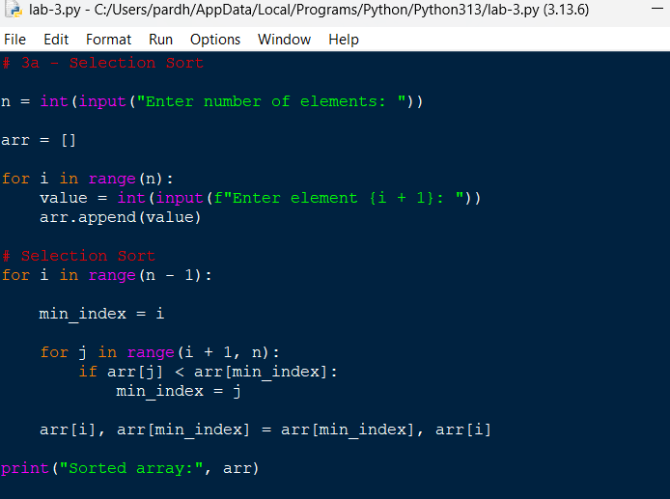
Output:
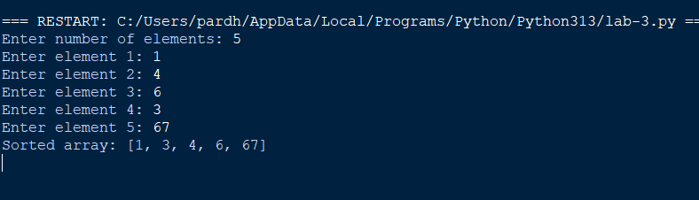

Explanation;
Took the number of elements from the user.
• Created an empty list arr.
• Used a for loop to take each element individually.
• min_index stores the position of the smallest element.
• The inner loop searches for the smallest element in the unsorted portion.
• Swapped the smallest element with the first unsorted element.
• Repeated this until the array was sorted

Error Table:
S.No. | Errors Observed | Rectification
1) | Incorrect initialization of min_index, causing the minimum element to be identified incorrectly. | Initialize min_index = i before searching for the minimum element.
2) | Starting the inner loop from 0, causing already sorted elements to be checked again. | Start the inner loop from i + 1.
3) | Forgetting to update min_index when a smaller element is found. | Use min_index = j inside the if condition.
4) | Incorrect swapping of elements, resulting in an unsorted array. | Use arr[i], arr[min_index] = arr[min_index], arr[i].
5) | Invalid (non-numeric) input entered by the user. | Enter a valid integer for each array element.
6) | Incorrect indentation causing an IndentationError. | Maintain proper indentation inside for loops and if statements.

3B) Aim: Write a python program to sort an array using Insertion sort and take the elements as input from user;
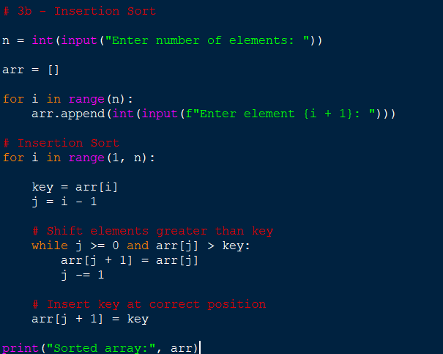
Output:
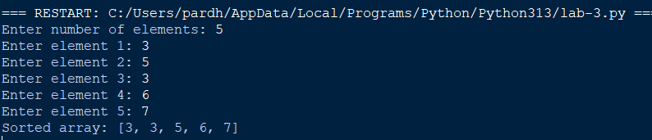

Explanation:
• Took the number of elements from the user.
• Used a loop to input every element.
• Started sorting from index 1.
• Stored the current element in key.
• Compared key with the elements before it.
• Shifted larger elements one position to the right.
• Inserted key into its correct position.
• Repeated until the array was sorted.

Error Table:
S.No. | Errors Observed | Rectification
1) | Starting the outer loop from 0, unnecessarily processing the first element. | Start the loop from 1 because the first element is already considered sorted.
2) | Forgetting to store the current element in key. | Use key = arr[i] before shifting elements.
3) | Forgetting j -= 1, causing the while loop to run indefinitely. | Decrease j by using j -= 1 after shifting an element.
4) | Placing the key at arr[j] instead of arr[j + 1]. | Insert the key using arr[j + 1] = key.
5) | Incorrect condition in the while loop. | Use j >= 0 and arr[j] > key to shift larger elements.

3C) Aim: Write a python program to sort an array using Bubble sort and take the elements as input from user
Program:
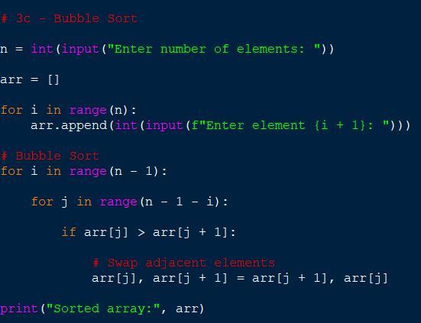
Output:
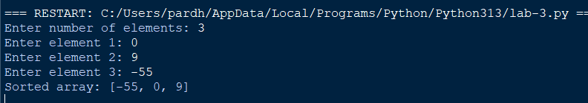

Explanation:
• Took the number of elements.
• Input each element using a loop.
• Compared two adjacent elements.
• If the left element was greater, we swapped them.
• After every pass, the largest remaining element moved to the end.
• Reduced the comparison range after every pass.
• Repeated until the array became sorted.

Error Table:
S.No. | Errors Observed | Rectification
1) | Comparing non-adjacent elements instead of neighboring elements. | Compare arr[j] with arr[j + 1].
2) | Using an incorrect inner loop range. | Use range(n - 1 - i) so that already sorted elements are not checked
3) | Forgetting to swap elements when they are in the wrong order. | Use arr[j], arr[j + 1] = arr[j + 1], arr[j].
4) | Using < instead of > for ascending order. | Use if arr[j] > arr[j + 1] for ascending sorting.
5) | Using an incorrect outer loop range. | Use range(n - 1) to perform the required passes.
6) | Entering non-numeric values as array elements. | Enter valid integer values using int(input()).

3A) Aim: Write a python program to sort an array using Merge sort and take the elements as input from user; 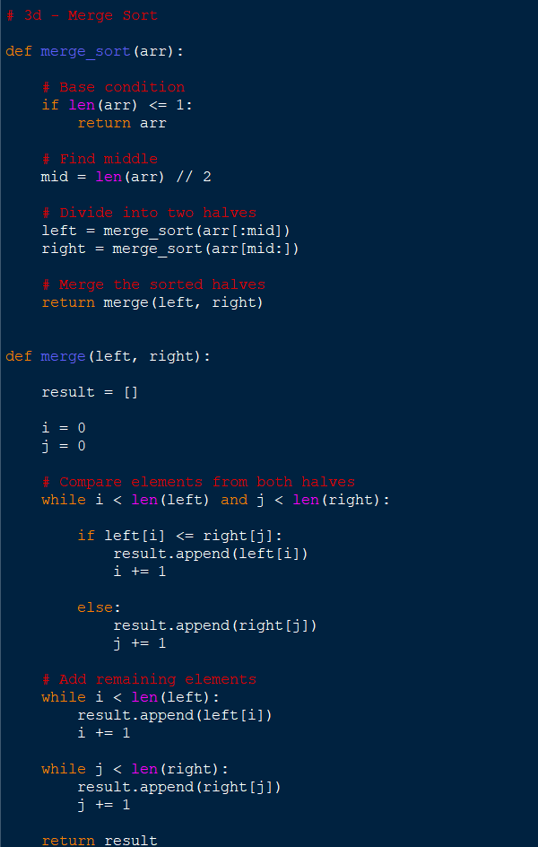

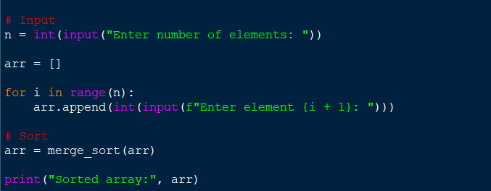

Output:
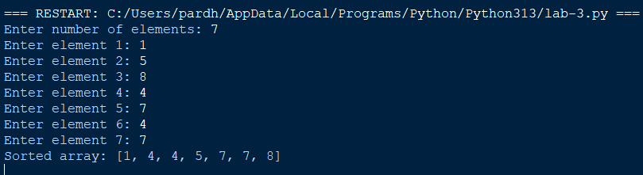

Explanation:
• Took the number of elements from the user.
• Used a loop to input the array.
• Used recursion to divide the array.
• Divided the array into two halves.
• Continued dividing until each part contained one element.
• Used the merge() function to combine the smaller arrays.
• Compared elements from the left and right halves.
• Added the smaller element to result.
• Added remaining elements.
• Returned the sorted array.

S.No. | Errors Observed | Rectification
1) | Missing base case causing infinite recursion. | Include if len(arr) <= 1: return arr to stop recursion.
2) | Incorrect calculation of the middle position. | Use mid = len(arr) // 2 to divide the array correctly.
3) | Incorrectly dividing the array into left and right parts. | Use arr[:mid] for the left half and arr[mid:] for the right half.
4) | Forgetting to increment i or j while merging. | Increment the corresponding index after adding an element to result.
5) | Forgetting to add the remaining elements from either half. | Add the remaining elements using result.extend(left[i:]) and result.extend(right[j:]).
6) | Forgetting to return the merged result. | Use return result at the end of the merge() function.
7) | Incorrect indentation in recursive functions. | Maintain proper indentation for all function statements, loops, and conditions.
3A) Aim: Write a python program to sort an array using Quick sort and take the elements as input from user;
Program:
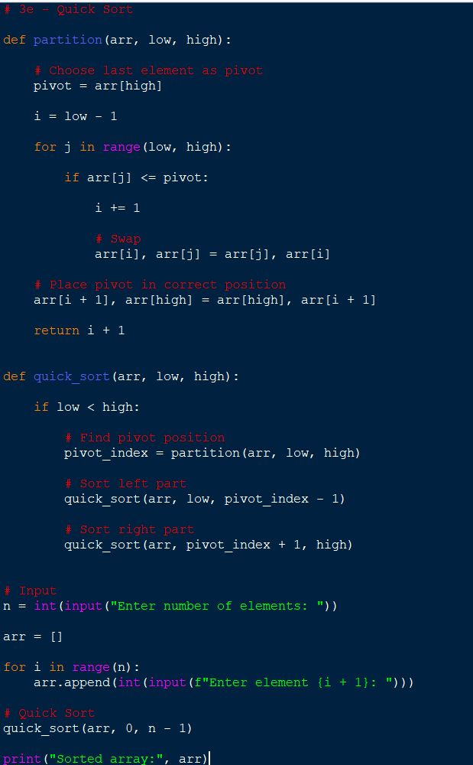
Output:
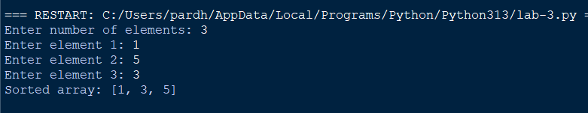

Explanation:
• Took the number of elements.
• Used a loop to input every element.
• Selected the last element as the pivot.
• Compared every element with the pivot.
• Elements smaller than or equal to the pivot were moved to the left.
• Elements greater than the pivot remained on the right.
• Placed the pivot in its correct position.
• Recursively sorted the left and right portions.
• Continued until the entire array was sorted.

S.No. | Errors Observed | Rectification
1) | Missing base condition causing infinite recursion. | Use if low < high: to continue recursion only when elements remain to be sorted.
2) | Incorrectly selecting or accessing the pivot element. | Select the last element using pivot = arr[high].
3) | Forgetting to return the pivot index from the partition function. | Use return i + 1 after placing the pivot.
4) | Incorrect recursive boundaries causing the pivot to be processed again. | Use quick_sort(arr, low, pivot_index - 1) and quick_sort(arr, pivot_index + 1, high).
5) | Incorrect initial function call. | Call quick_sort(arr, 0, n - 1) to sort the complete array.
6) | Incorrect partition condition resulting in improper ordering. | Use if arr[j] <= pivot for ascending order.
7) | Forgetting to swap the pivot into its correct position. | Use arr[i + 1], arr[high] = arr[high], arr[i + 1].
8) | Incorrect indentation causing an IndentationError. | Maintain proper Python indentation inside functions, loops, and conditions.

WEEK – 4
4a. AIM: Write a python program to implement a single linked list which would perform the below operations, by taking an input from the user.
a. Create a linked list. b. Insert at beginning. c. Insert at end.
d. Insert at a specific index. e. Delete by value. f. Delete 1st node.
g. Delete last node. h. Count no. of nodes i. Display.
j. Exit.
PROGRAM:
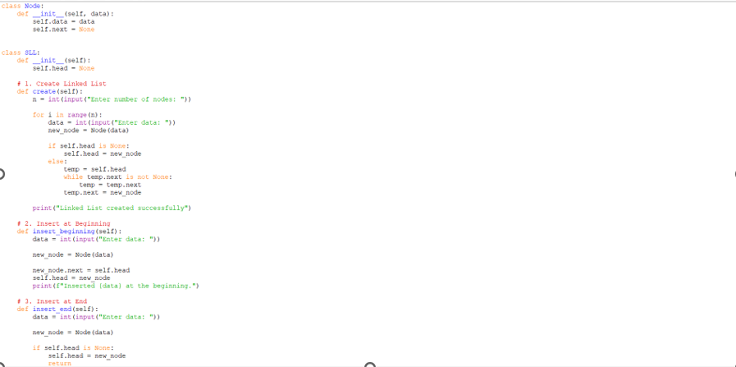
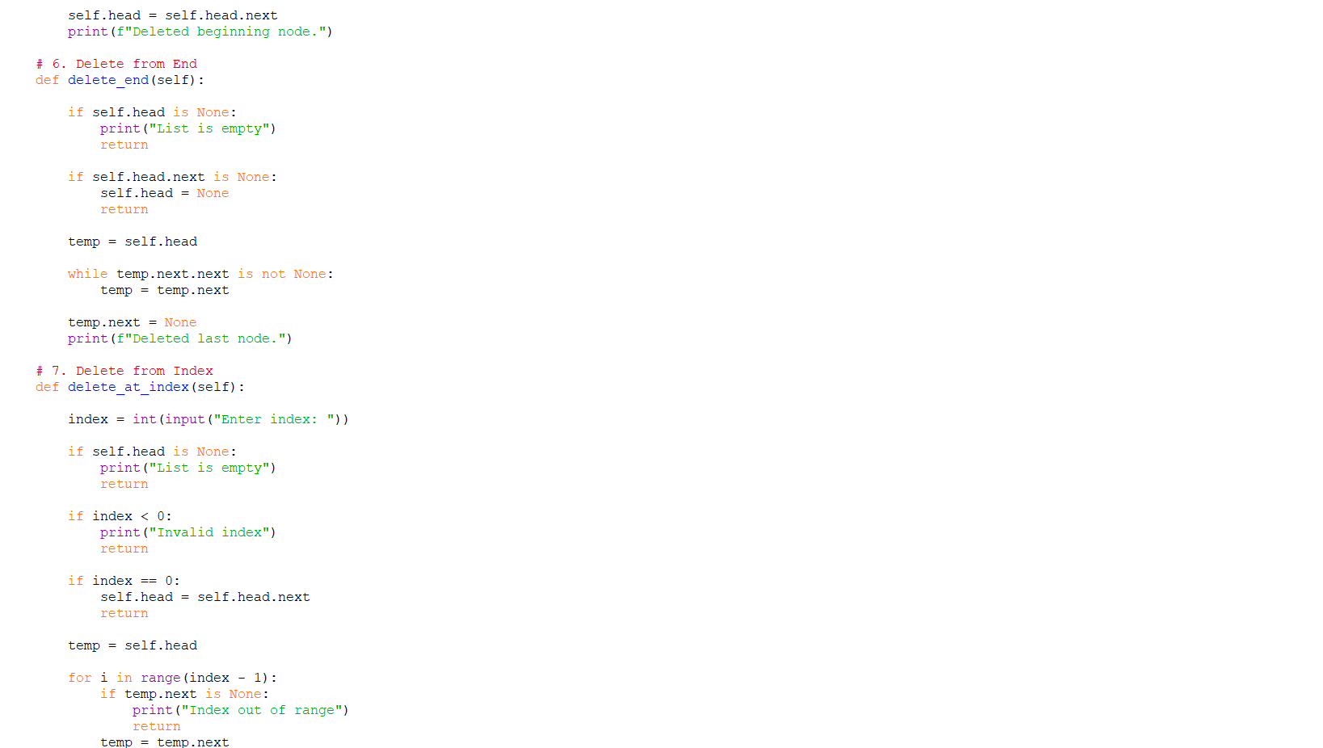
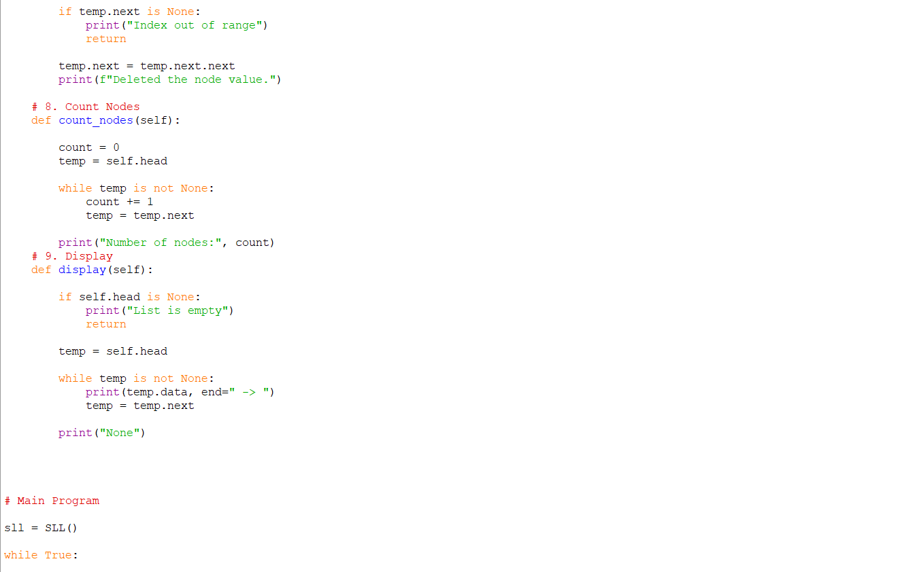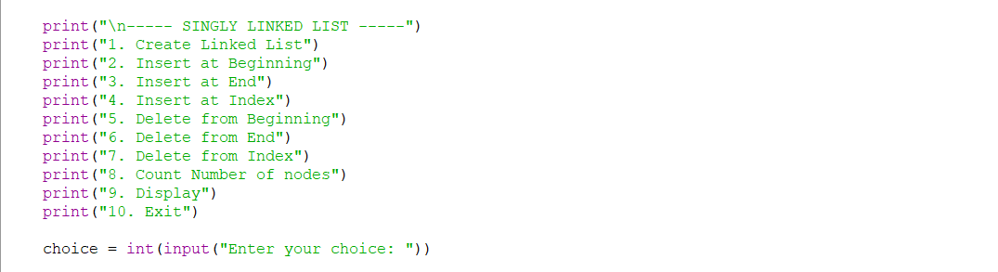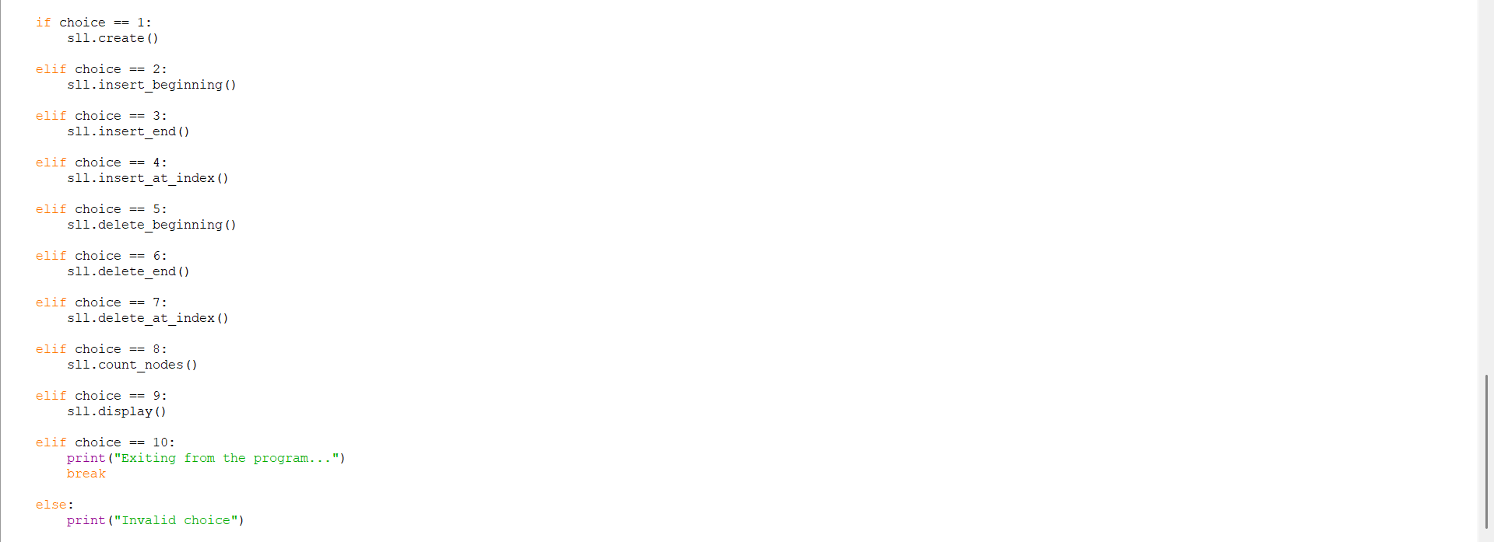
OUTPUT:
Positive Case;
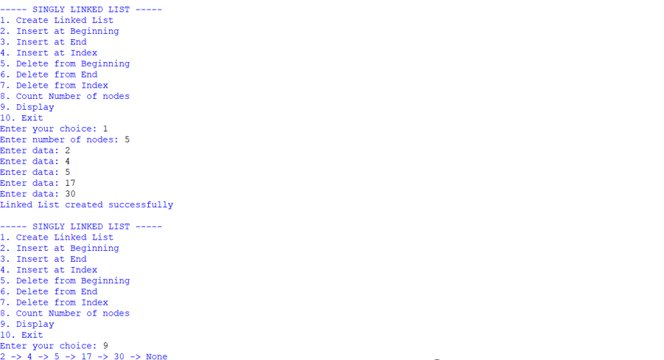
Negative Case;
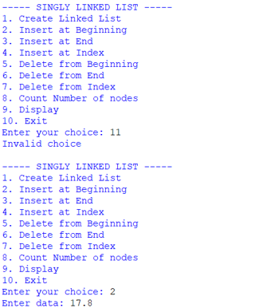
EXPLANATION:
🔹 Class Definitions
- Node class
  - Represents a single node in the linked list.
  - Each node has:
    - data → stores the value.
    - next → pointer to the next node (initially None).
- SLL class
  - Manages the linked list operations.
  - Has a head pointer (initially None) that points to the first node.
🔹 Operations in SLL
1. Create Linked List
- Asks user for number of nodes.
- For each node:
  - Creates a new Node.
  - If list is empty → new node becomes head.
  - Otherwise → traverses to the end and attaches the new node.
2. Insert at Beginning
- Creates a new node.
- Points its next to current head.
- Updates head to new node.
3. Insert at End
- Creates a new node.
- If list is empty → new node becomes head.
- Otherwise → traverses to last node and attaches new node.
4. Insert at Index
- Asks for index and data.
- If index = 0 → behaves like "insert at beginning".
- Otherwise → traverses to (index-1) node and inserts new node in between.
5. Delete from Beginning
- Moves head to head.next.
- Effectively removes the first node.
6. Delete from End
- If list empty → prints "List is empty".
- If only one node → sets head = None.
- Otherwise → traverses to second-last node and sets its next = None.
7. Delete from Index
- Asks for index.
- If index = 0 → removes head.
- Otherwise → traverses to (index-1) node and skips the next node.
8. Count Nodes
- Traverses through list.
- Counts nodes until None.
9. Display
- Traverses from head to end.
- Prints each node’s data in data -> data -> None format.
🔹 Main Program
- Runs an infinite loop with a menu:
  - Options 1–9 → perform linked list operations.
  - Option 10 → exits program.
- Uses if-elif to call respective methods.

ERROR TABLE:

S.NO | Error Obtained | Rectification
1. | Index out of range  When inserting/deleting at an index greater than the number of nodes. | Traverse carefully;  if temp becomes None before reaching index, print "Index out of range" and stop.
2. | Logical error in insertion  if index is negative. | Validate index: if index < 0: print ("Invalid index").
3. | Wrong output format  In display (missing None at end). | After traversal, always print "None" to mark end of list.
4. | Indentation Error  In the Count node part | It was rectified later,  By maintaining proper indentation.

4b. AIM: Write a python program to implement a double linked list which would perform the below operations, by taking an input from the user.
a. Create a linked list. b. Insert at beginning. c. Insert at end.
d. Insert at a specific index. e. Delete by value. f. Delete 1st node.
g. Delete last node. h. Count no. of nodes i. Display.
j. Exit.
PROGRAM:
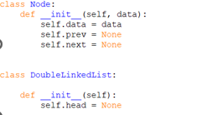
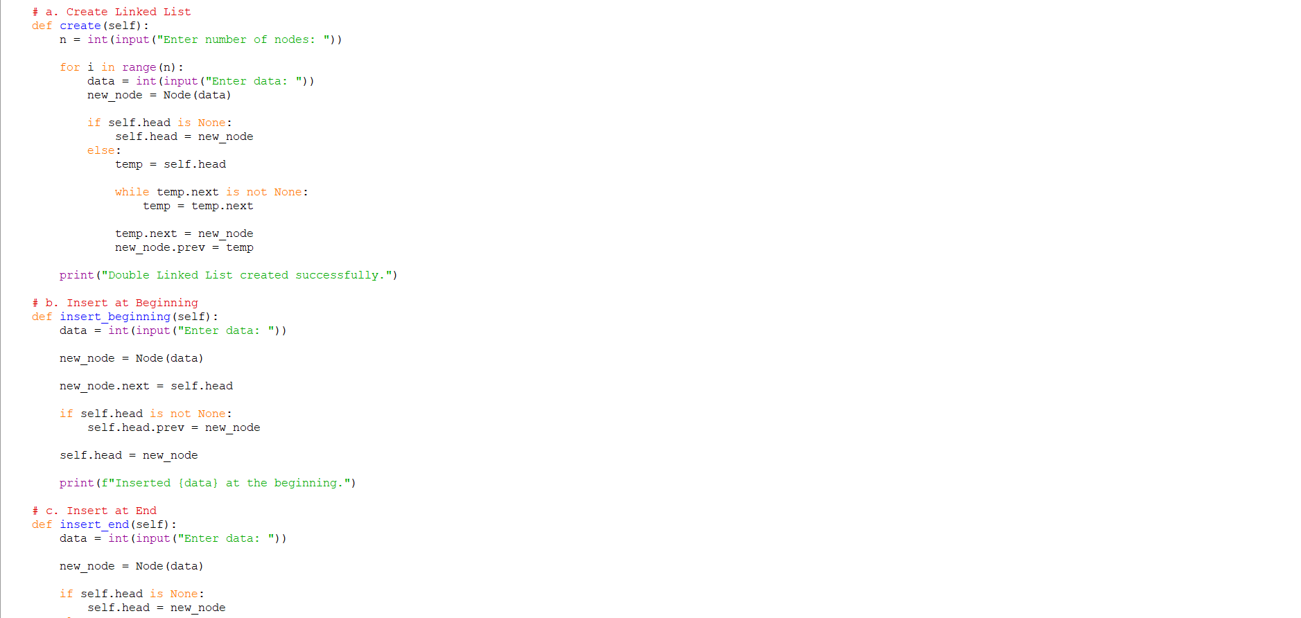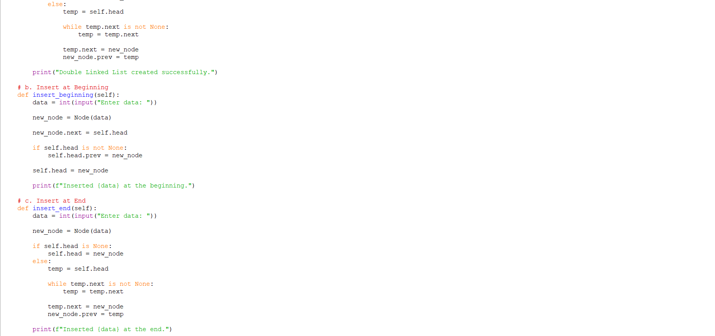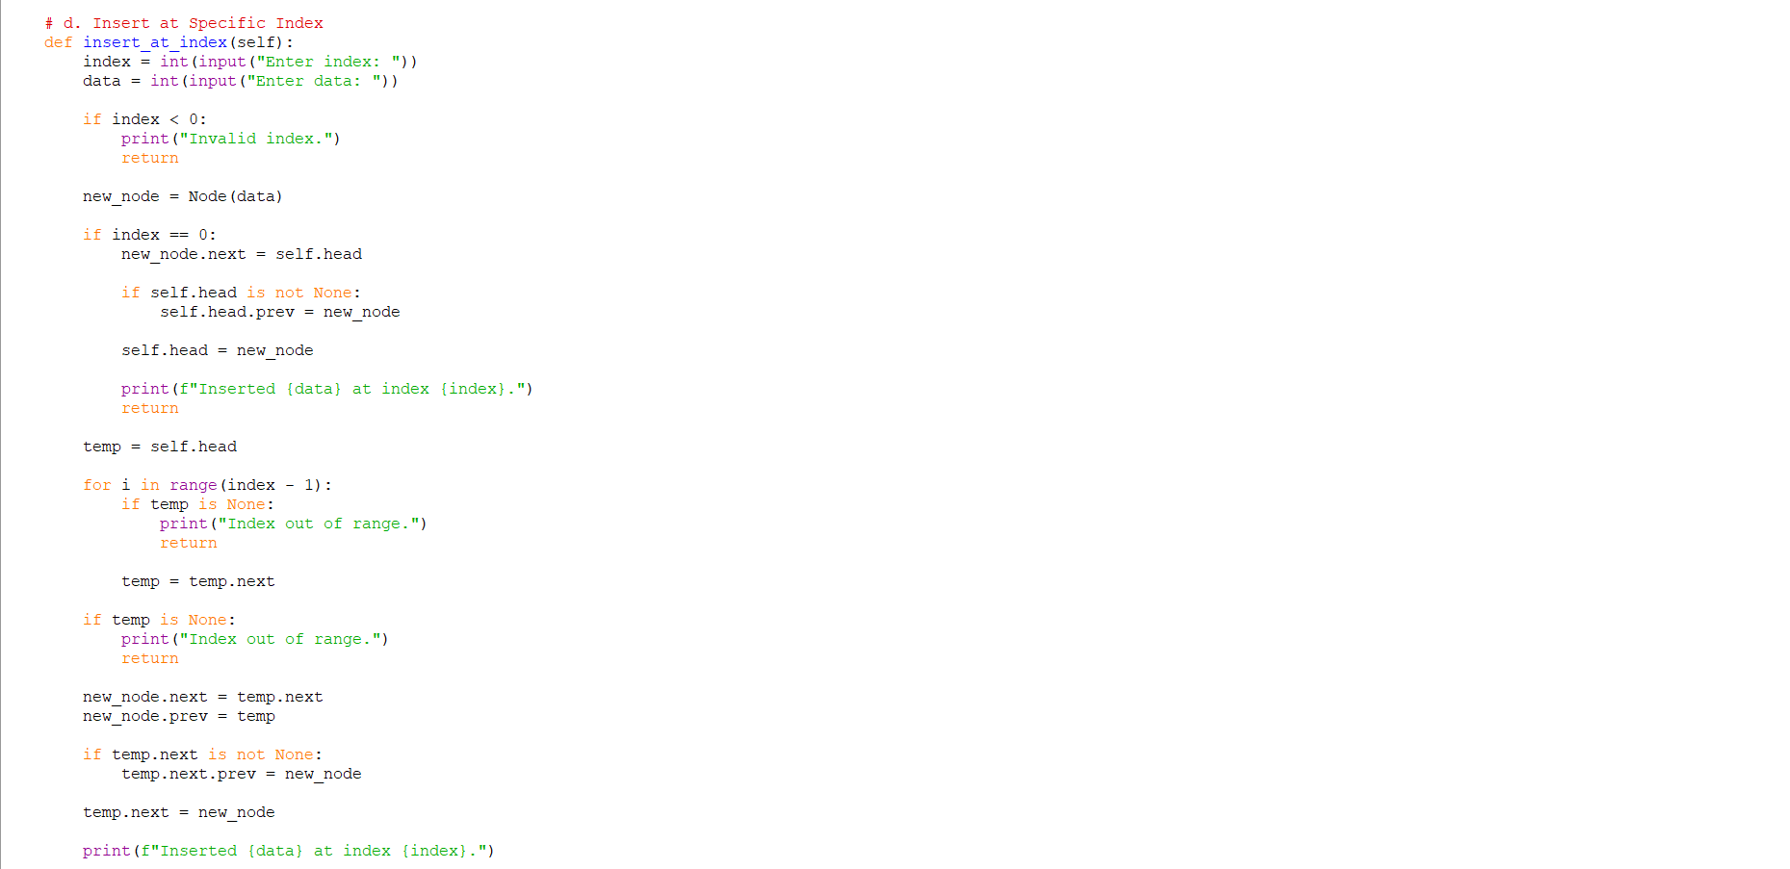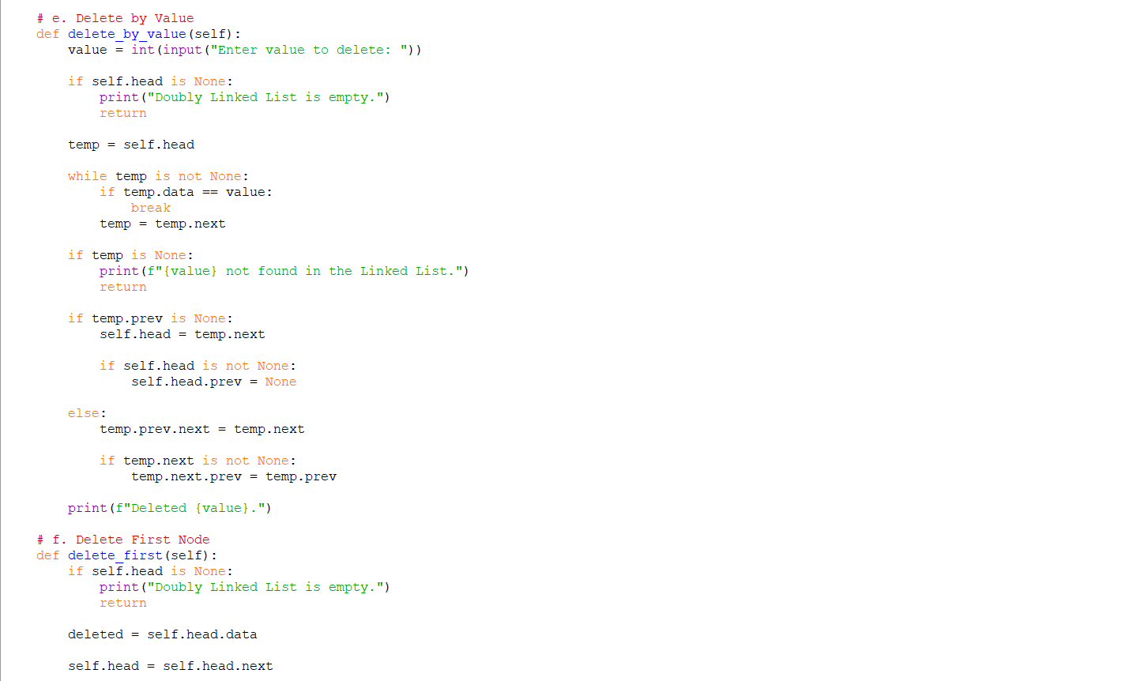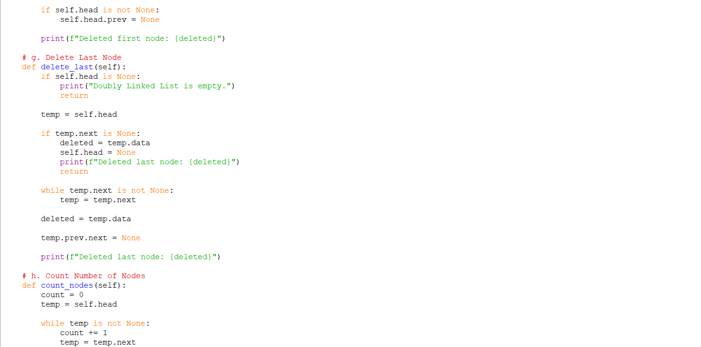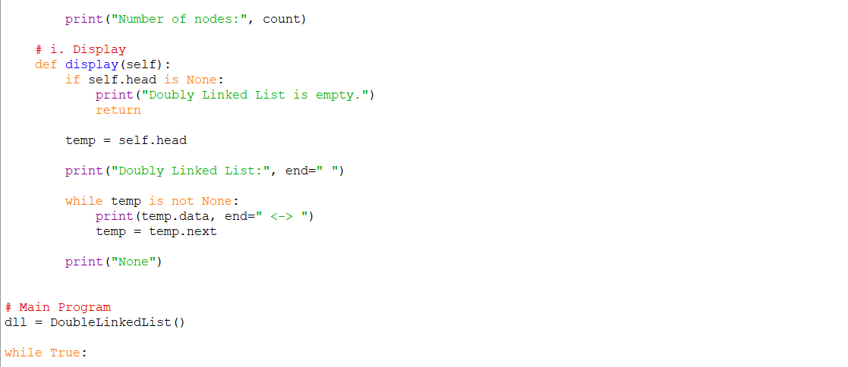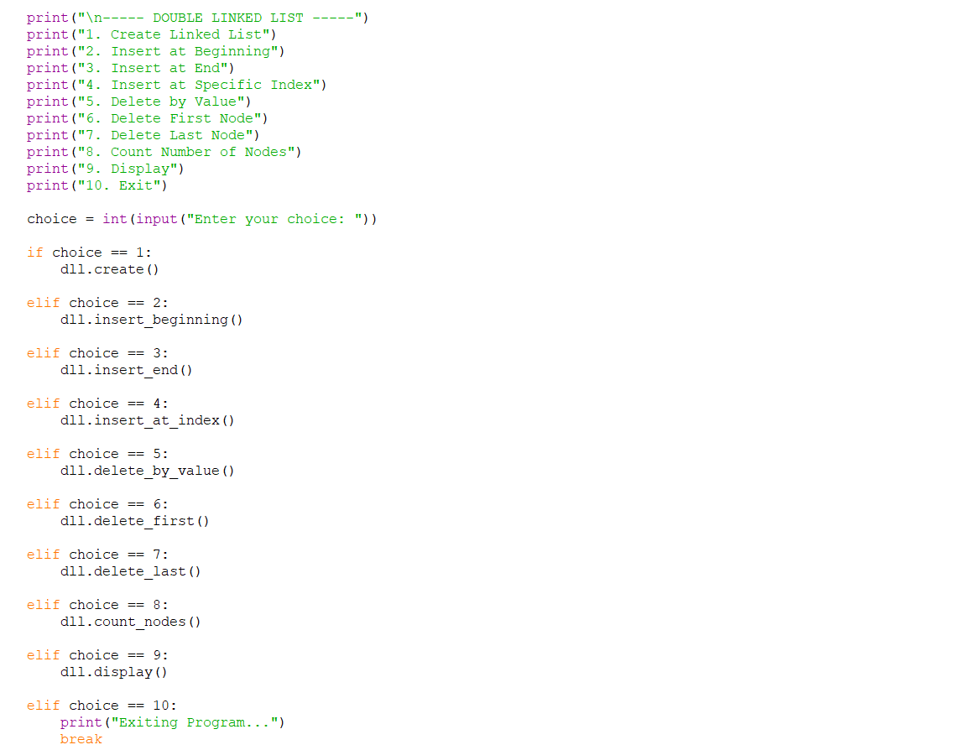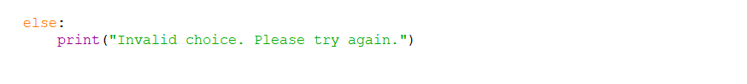
OUTPUT:
Positive Case;
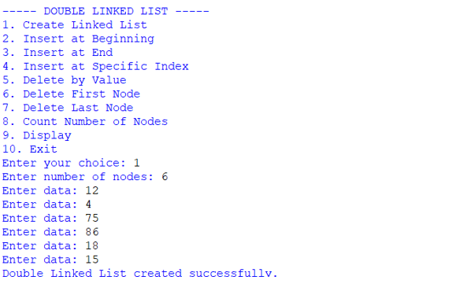
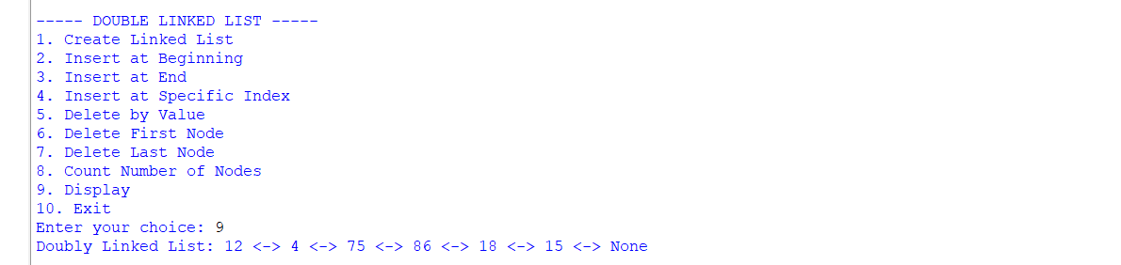 Negative Case;
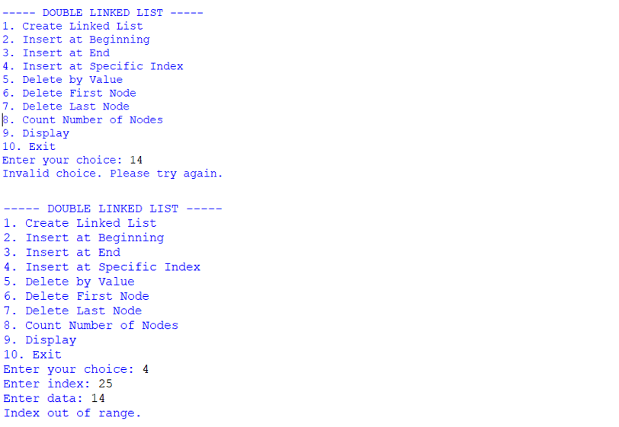
EXPLANATION:
1. Node Class
- Each node stores:
  - data: the actual value.
  - prev: pointer to the previous node.
  - next: pointer to the next node.
- This structure allows traversal in both directions (forward and backward).
2. Double Linked List Class
This class manages the linked list. It starts with self.head = None (empty list). It provides several operations:
a. Create Linked List
- User specifies how many nodes to create.
- Each new node is linked at the end.
- prev pointer connects the new node to the previous one.
b. Insert at Beginning
- A new node is created.
- Its next points to the current head.
- The old head’s prev points back to the new node.
- The new node becomes the head.
c. Insert at End
- Traverse to the last node.
- Attach the new node at the end.
- Update prev of the new node to point to the last node.
d. Insert at Specific Index
- Traverse until the given index.
- Insert the new node between two nodes.
- Adjust both next and prev pointers to maintain the chain.
e. Delete by Value
- Search for the node with the given value.
- If found:
  - If it’s the head, move head to the next node.
  - Otherwise, adjust prev.next and next.prev to bypass the node.
- This removes the node from the chain.
f. Delete First Node
- Move head to the second node.
- Set its prev to None.
g. Delete Last Node
- Traverse to the last node.
- Remove it by setting its previous node’s next to None.
h. Count Nodes
- Traverse the list, incrementing a counter.
- Prints the total number of nodes.
i. Display
- Traverse from head to end.
- Print each node’s data in the format: data <-> data <-> ... None
3. Main Program (Menu-Driven)
- Runs an infinite loop with options:
  - Create Linked List
  - Insert at Beginning
  - Insert at End
  - Insert at Specific Index
  - Delete by Value
  - Delete First Node
  - Delete Last Node
  - Count Nodes
  - Display
10.Exit
- Based on user choice, the corresponding method is executed.

ERROR TABLE:

S.NO | Error Obtained | Rectification
1. | Invalid index entered (negative or too large). | Add a check: if index < 0 → print "Invalid index"; if traversal reaches None before index → print "Index out of range".
2. | Deleting from an empty list. | Before deletion, check if self.head is None: → print "Doubly Linked List is empty."
3. | Value not found during deletion by value. | Traverse list; if node not found → print "value not found in the Linked List."
4. | Insertion at index when list is empty but index > 0. | Handle separately: if self.head is None and index! = 0 → print "Index out of range."

4c. AIM: Write a python program to implement a circular linked list which would perform the below operations, by taking an input from the user.
a. Create a linked list. b. Insert at beginning. c. Insert at end.
d. Insert at a specific index. e. Delete by value. f. Delete 1st node.
g. Delete last node. h. Count no. of nodes i. Display.
j. Display head and tail. k. Print data from tail to head. l. Exit.
PROGRAM:
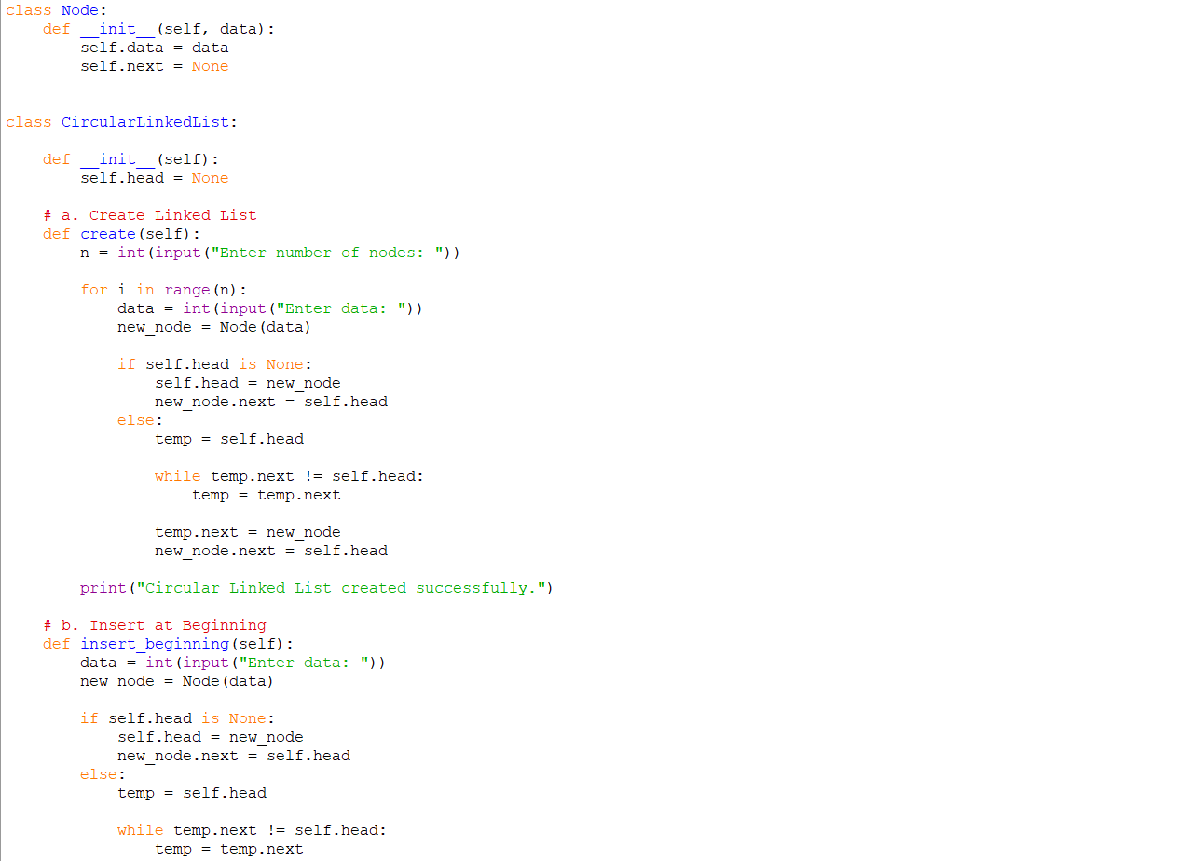
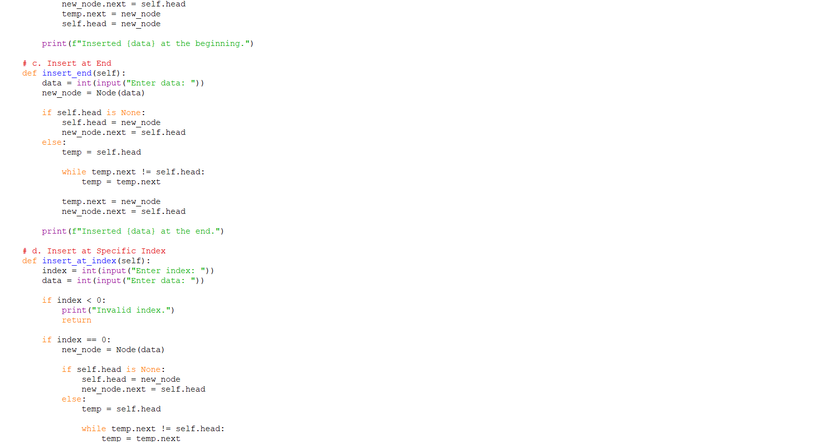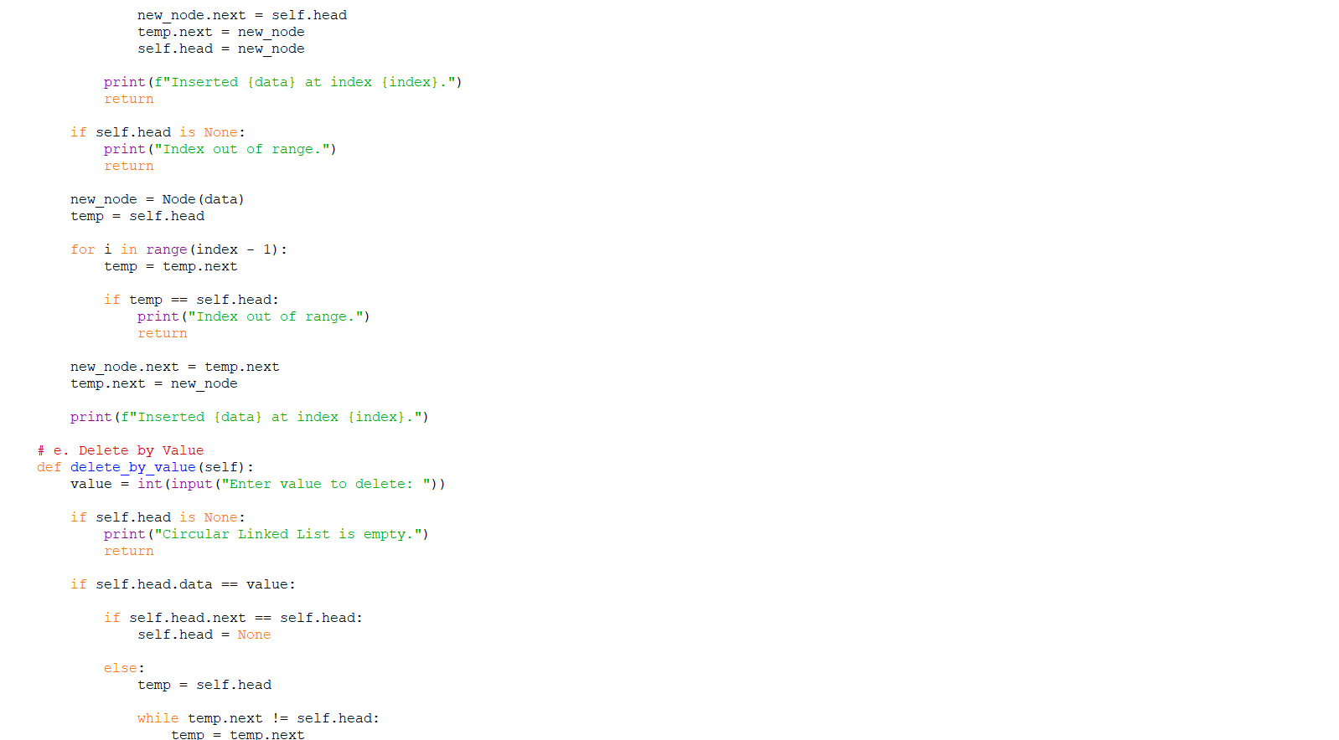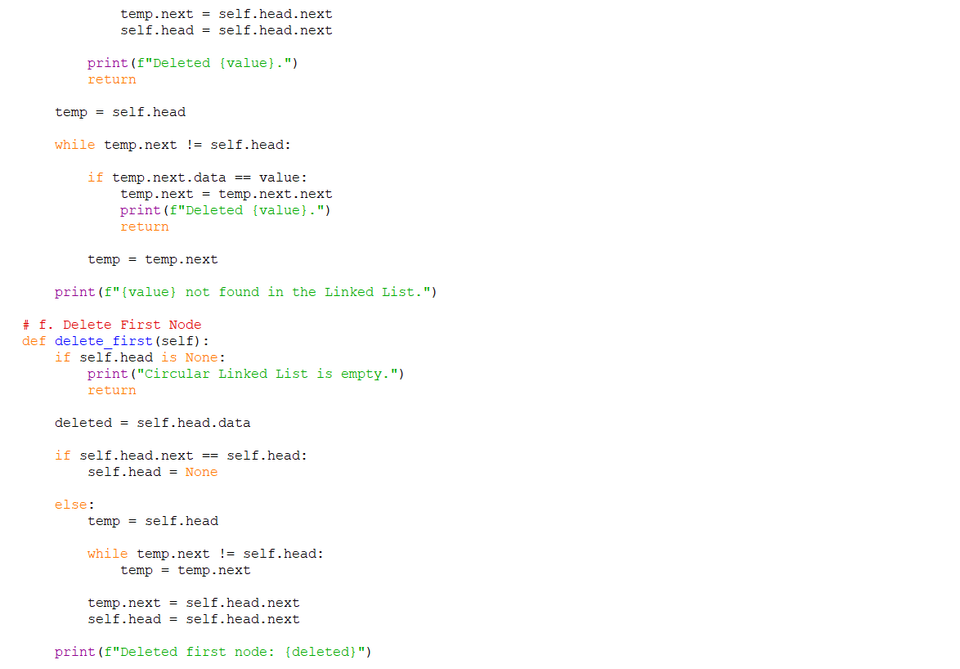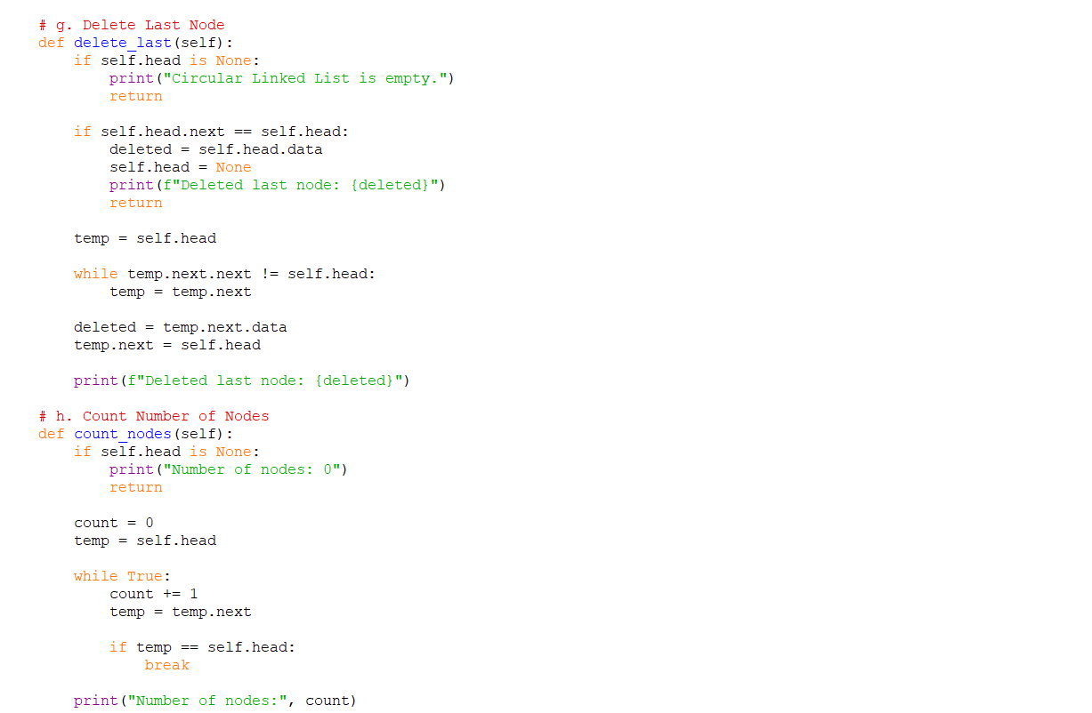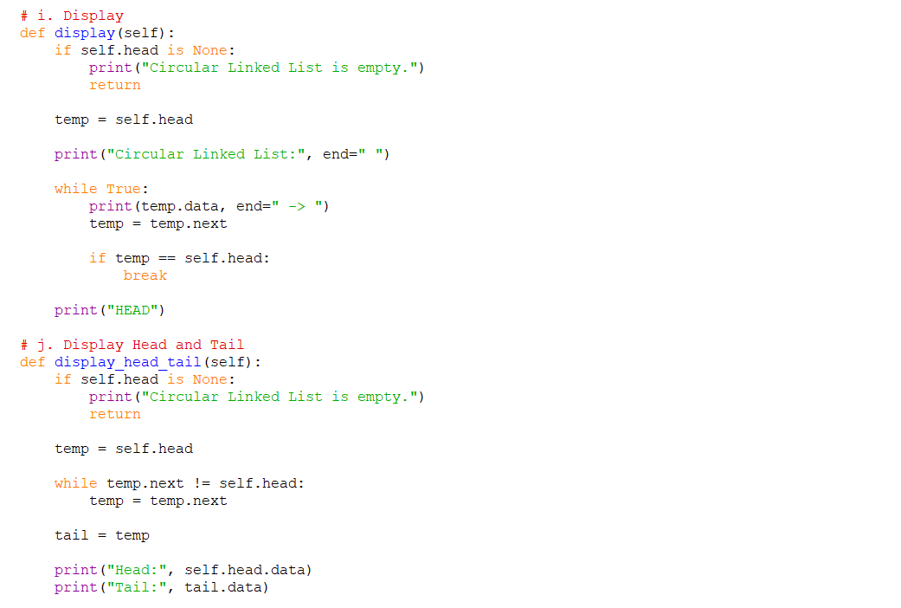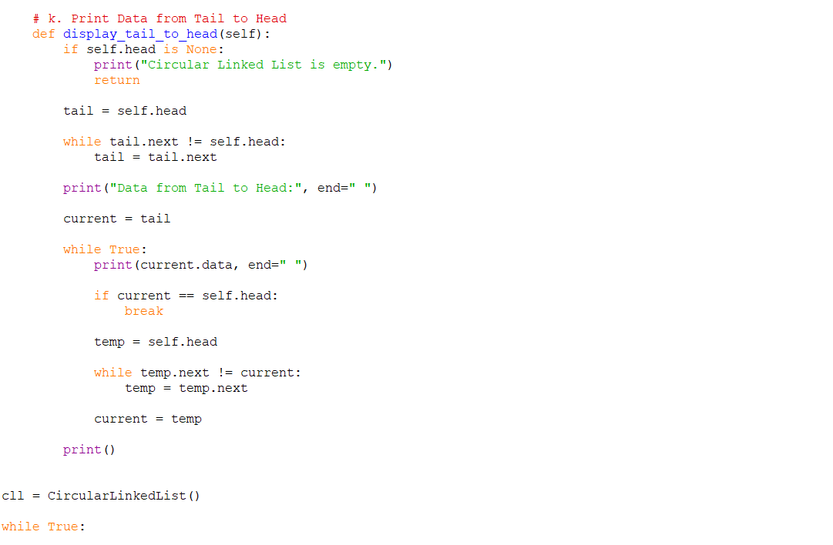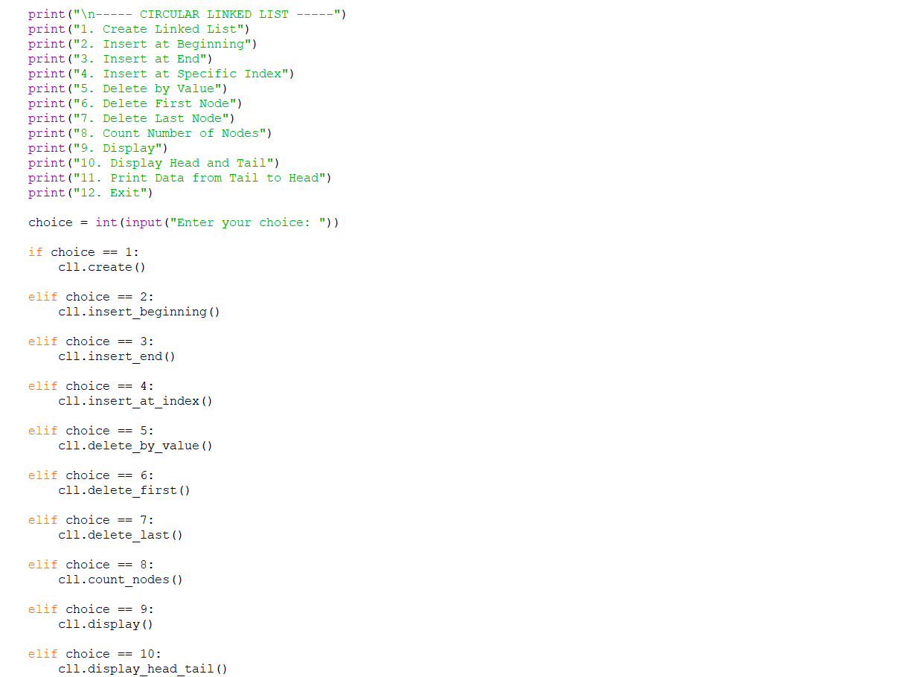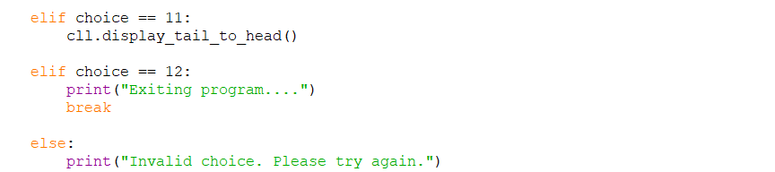

OUTPUT:
Positive Case;
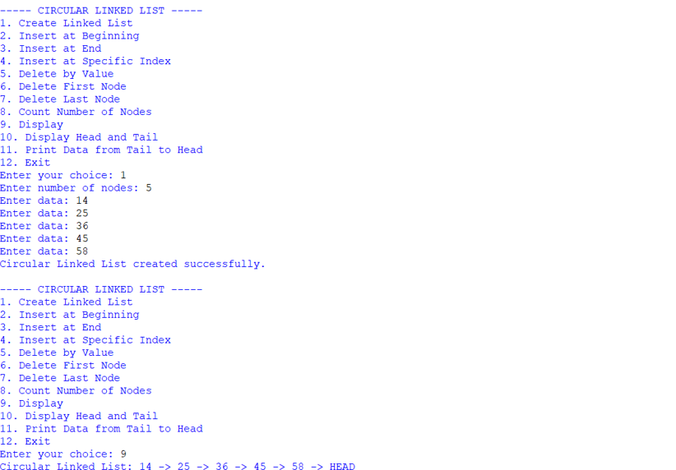
Negative Case;
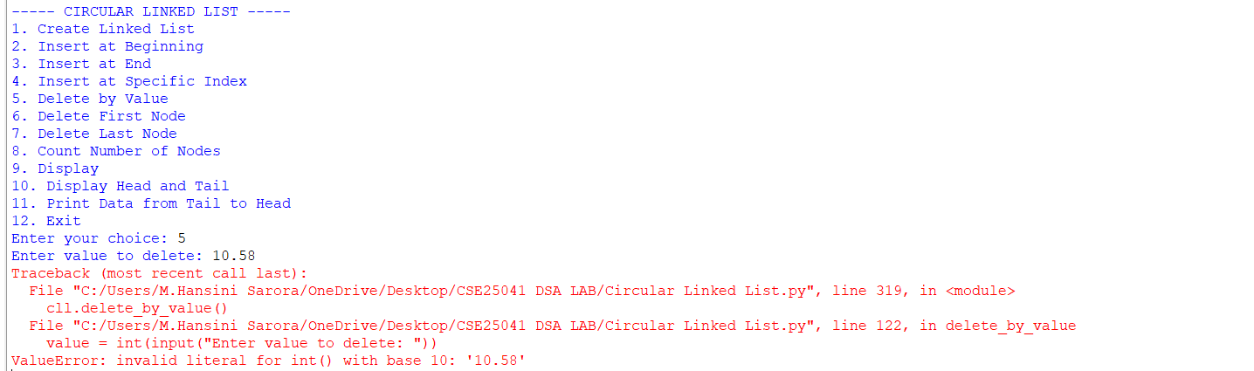

EXPLANATION:
1. Node Class
- Each node stores:
  - data: the value.
  - next: pointer to the next node.
- In a circular linked list, the last node’s next points back to the head, forming a circle.
2. Circular Linked List Class
This class manages the linked list. It starts with self.head = None (empty list). It provides several operations:
a. Create Linked List
- User specifies number of nodes.
- Each new node is linked at the end.
- The last node’s next points back to the head, ensuring circularity.

b. Insert at Beginning
- A new node is created.
- It becomes the new head.
- The last node’s next is updated to point to this new head.
c. Insert at End
- Traverse to the last node.
- Attach the new node after it.
- New node’s next points back to head.
d. Insert at Specific Index
- If index = 0 → same as inserting at beginning.
- Otherwise, traverse to the given position.
- Insert the new node between two nodes.
- Maintain circularity by adjusting next pointers.
e. Delete by Value
- Search for the node with the given value.
- If it’s the head:
- If only one node exists → set head to None.
Otherwise, adjust last node’s next to point to new head.
- If it’s in the middle → bypass the node by linking previous node’s next to the next node.
f. Delete First Node
- If only one node → set head to None.
- Otherwise, move head to the second node and update last node’s next.

g. Delete Last Node
- Traverse to the second-last node.
- Make its next point to head.
- Removes the last node.
h. Count Nodes
- Traverse until you return to head.
- Count nodes during traversal.
i. Display
- Print nodes starting from head.
- Stop when traversal returns to head.
- Shows circularity by ending with "HEAD".
j. Display Head and Tail
- Head = first node.
- Tail = last node (whose next points to head).
- Prints both values.
k. Print Data from Tail to Head
- Find tail.
- Traverse backward by repeatedly searching for the node whose next points to the current node.
- Prints values in reverse order until reaching head.
3. Main Program (Menu-Driven)
- Runs an infinite loop with give options.
- Based on user choice, the corresponding method is executed.

ERROR TABLE:

S.NO | Error Obtained | Rectification
1. | Display on empty list. | Add condition:  if self.head is None: → print "Circular Linked List is empty."
2. | Deleting from an empty list. | Before deletion, check if self.head is None: → print "Circular Linked List is empty."
3. |  | Ensure every insertion/deletion maintains circularity: last node’s next must always point to self.head.
  Infinite loop in traversal
  (if circularity broken).
4. | Reverse traversal  (Tail to Head) inefficient. | Current implementation repeatedly searches for predecessor. Rectify by using a doubly circular linked list if reverse traversal is frequent.

WEEK – 5
5. AIM: Write a python program to implement a stack using an Array, Linked list. Implement the stack operations such as push, pop, peak and also display the stack elements.
PROGRAM:

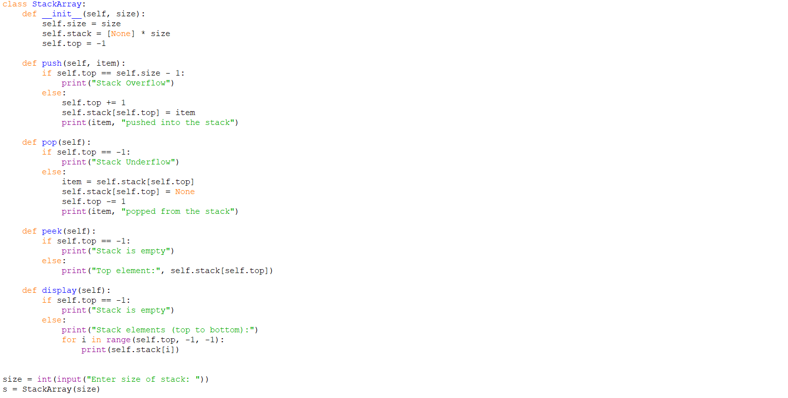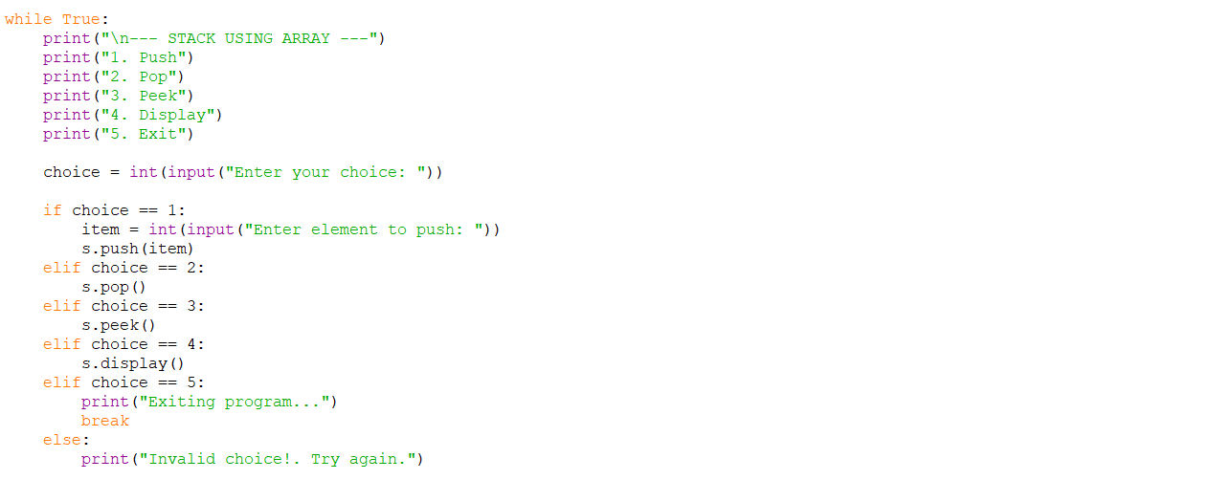 OUTPUT:
Positive Case;
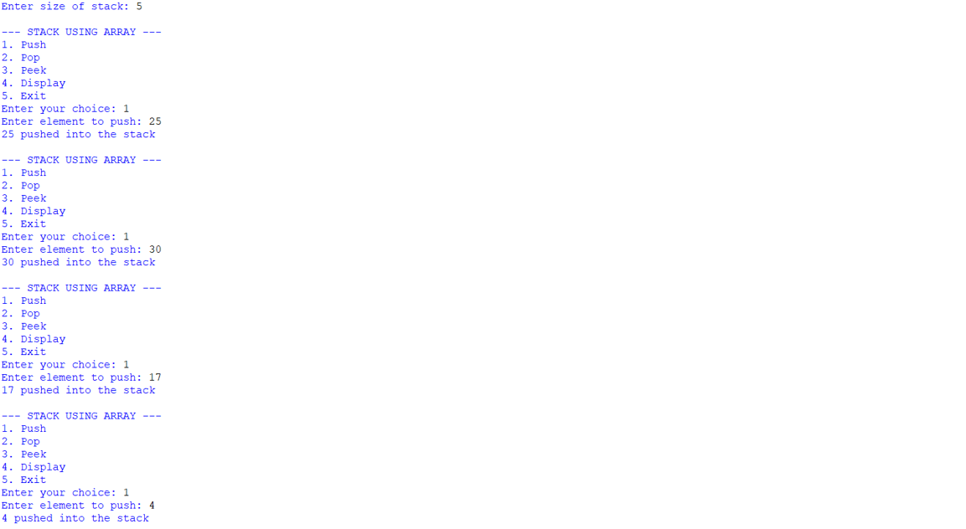
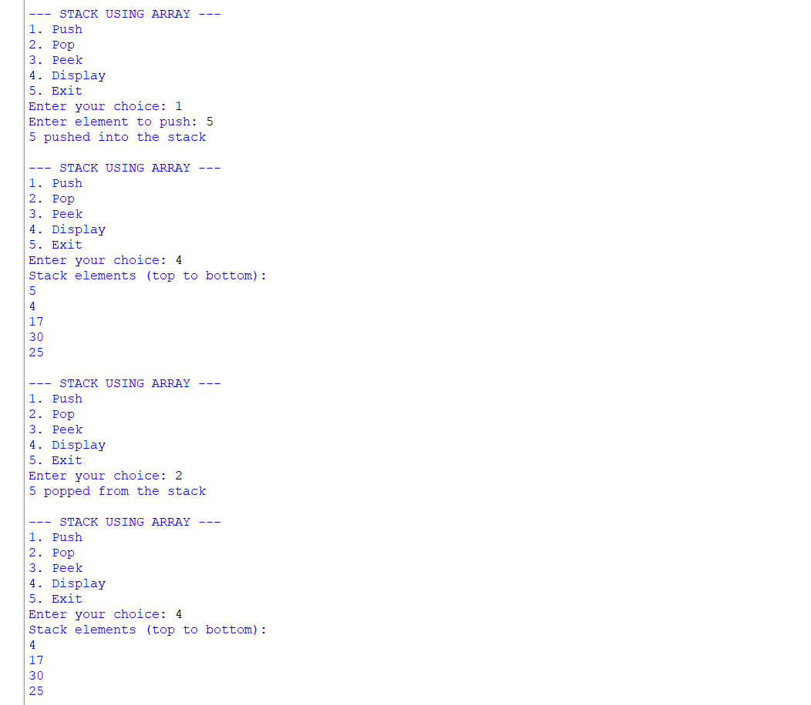 Negative Case;
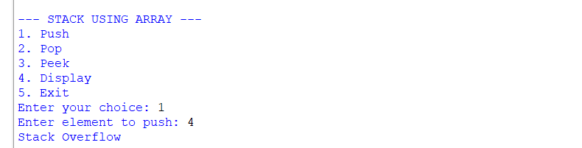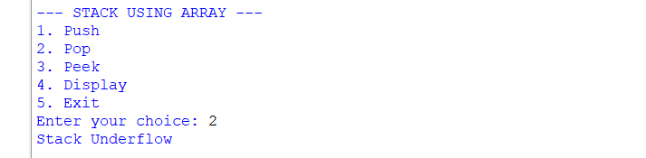

Stack Using Linked List;
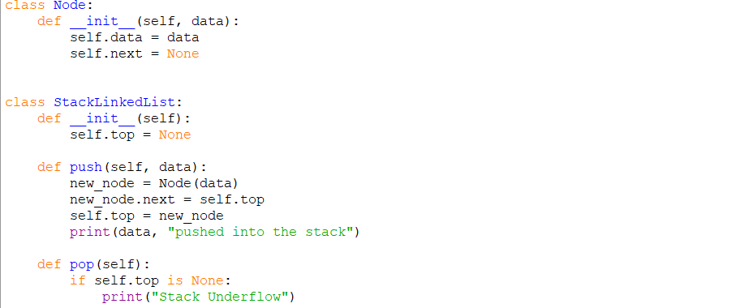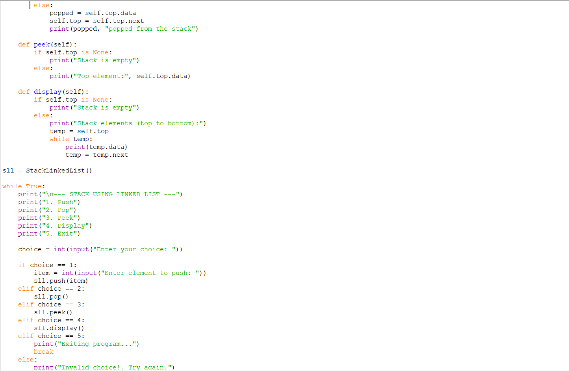 OUTPUT:
Positive Case;
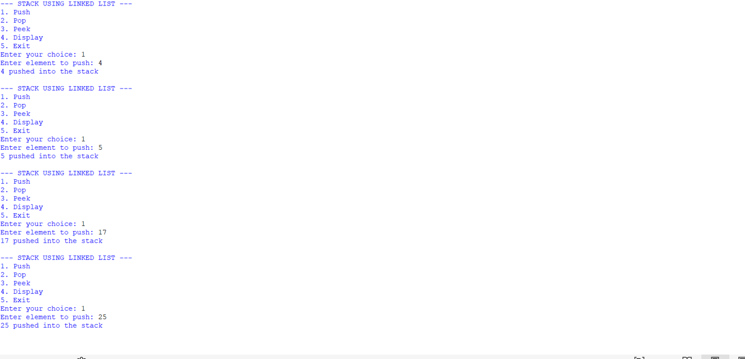
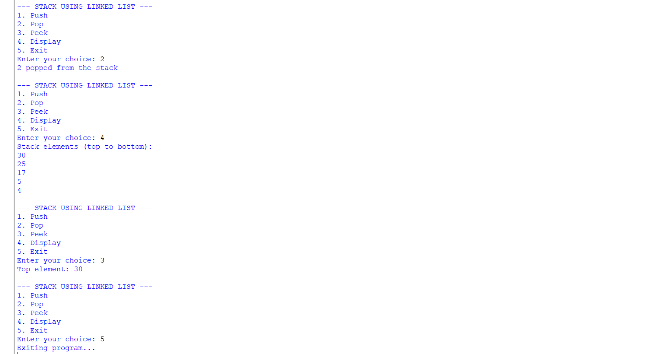 Negative Case;
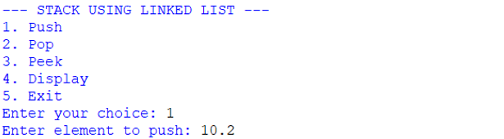
EXPLANATION:
🧩 Stack Using Array
Structure:
- Uses a Python list (self.stack) to store elements.
- self.top keeps track of the index of the last pushed element.
- self.size defines the maximum capacity.
Operations:
- Push
  - Check if top == size - 1 → Overflow.
  - Otherwise, increment top and insert the element at that position.
- Pop
  - Check if top == -1 → Underflow (empty stack).
  - Otherwise, remove the element at top, decrement top.
- Peek
  - Shows the element at top without removing it.
- Display
  - Prints elements from top down to 0 (top to bottom order).
🧩 Stack Using Linked List
Structure:
- Each element is a Node with:
  - data (value)
  - next (pointer to the next node).
- self.top points to the most recently pushed node.
Operations:
- Push
  - Create a new node.
  - Link its next to the current top.
  - Update top to this new node.
- Pop
  - If top is None → Underflow.
  - Otherwise, remove the node at top and update top to top.next.
- Peek
  - Shows the data at top.
- Display
  - Traverse from top downwards, printing each node’s data.

ERROR TABLE:
S.NO | Error Obtained | Rectification
1. | def _init_(self, size): | Python expects two underscores before and after init.
2. | Display on empty stack. | Add condition: if self.top is None: → print  "Stack is empty".
3. |  | Add a check: if self.top == self.size - 1: → print "Stack Overflow".
  Stack Overflow
  when pushing beyond the defined size
4. | Stack Underflow  when popping from empty stack | Add a check: if self.top is None: → print "Stack Underflow".
5. | Syntax error | Later it was rectified in the for loop of display section.

WEEK – 6
6. AIM: To implement Queue and its operations such as Enqueue, Dequeue, Peek, Display with a menu driven approach.
6a. Using Array, Linked list, Data structures.
6b. Circular Queue.
PROGRAM:
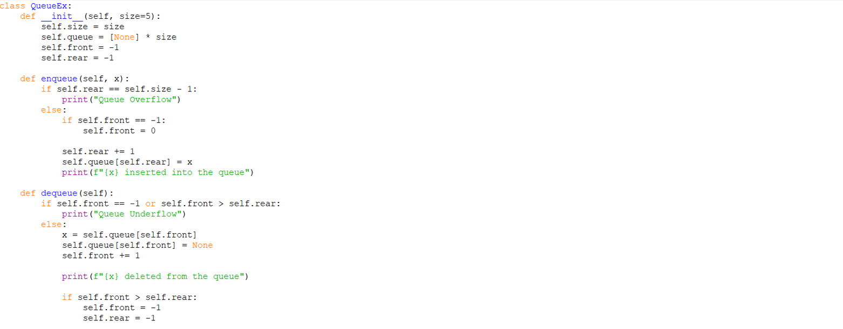
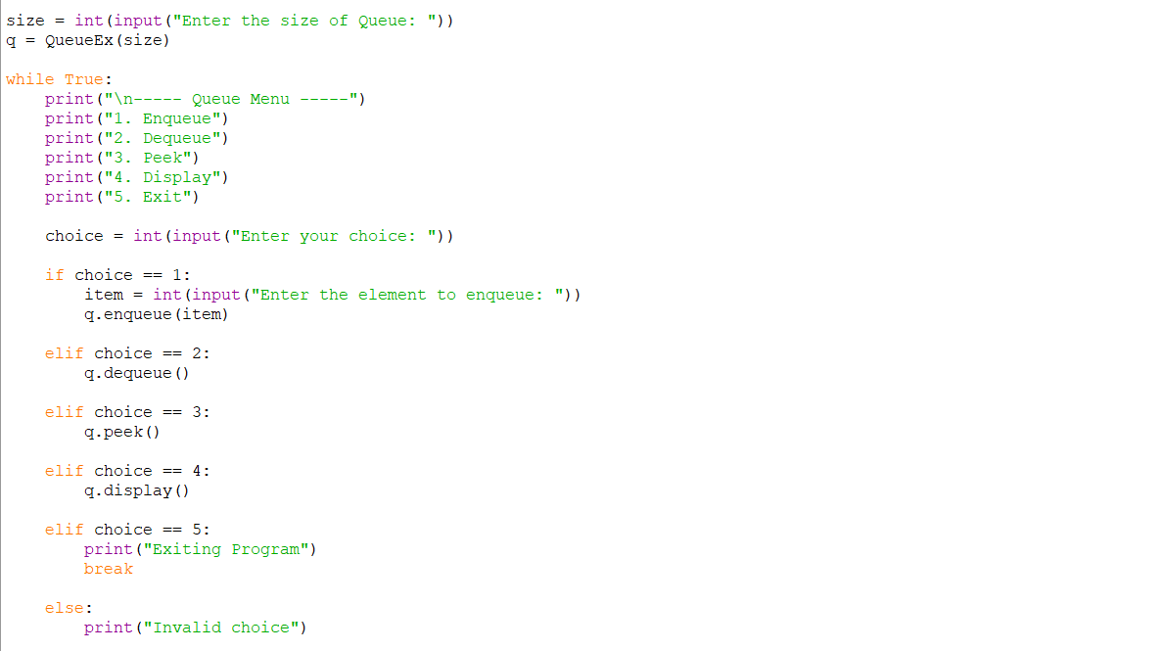
OUTPUT:
Positive Case;
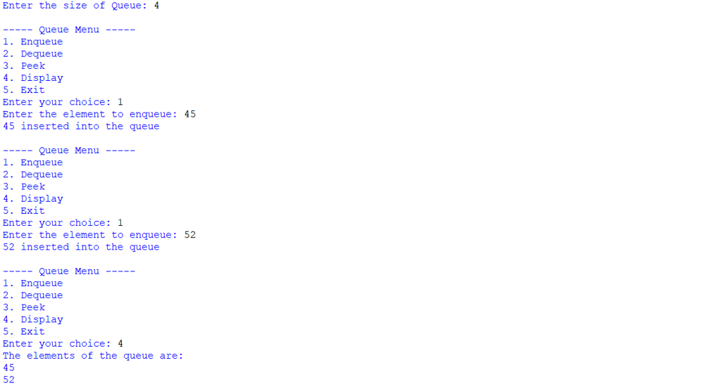
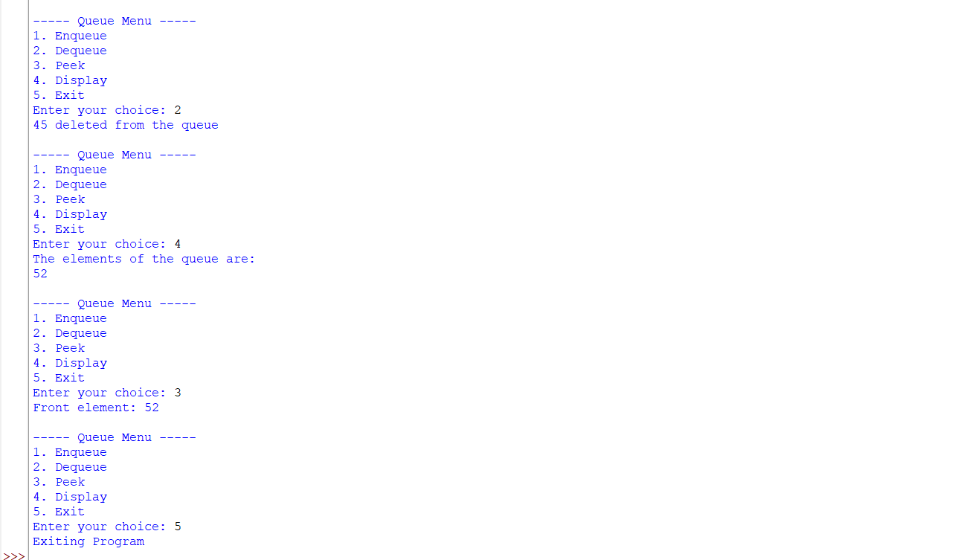
Negative Case;
Linked List.,
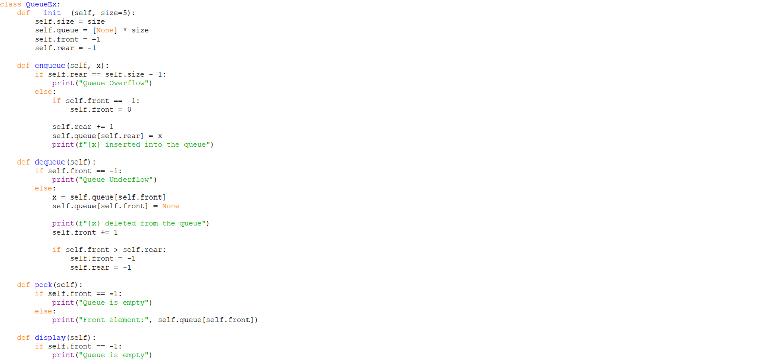
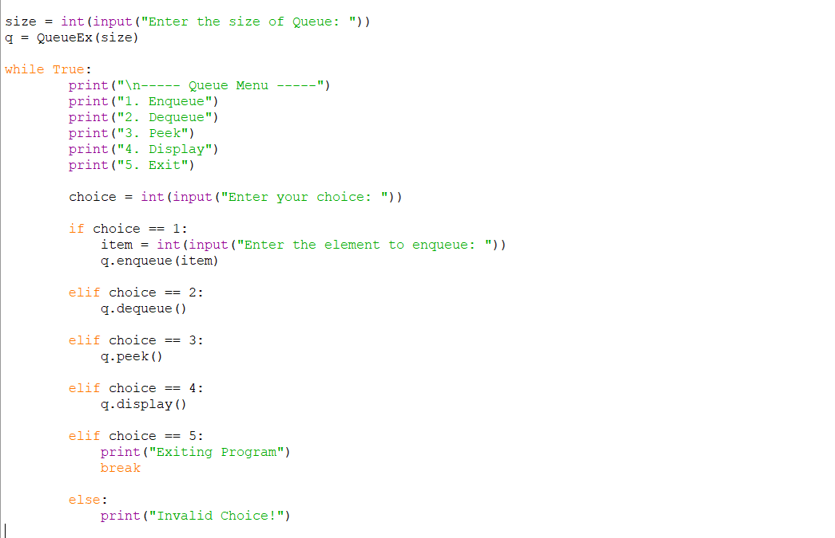
OUTPUT:
Positive Case;
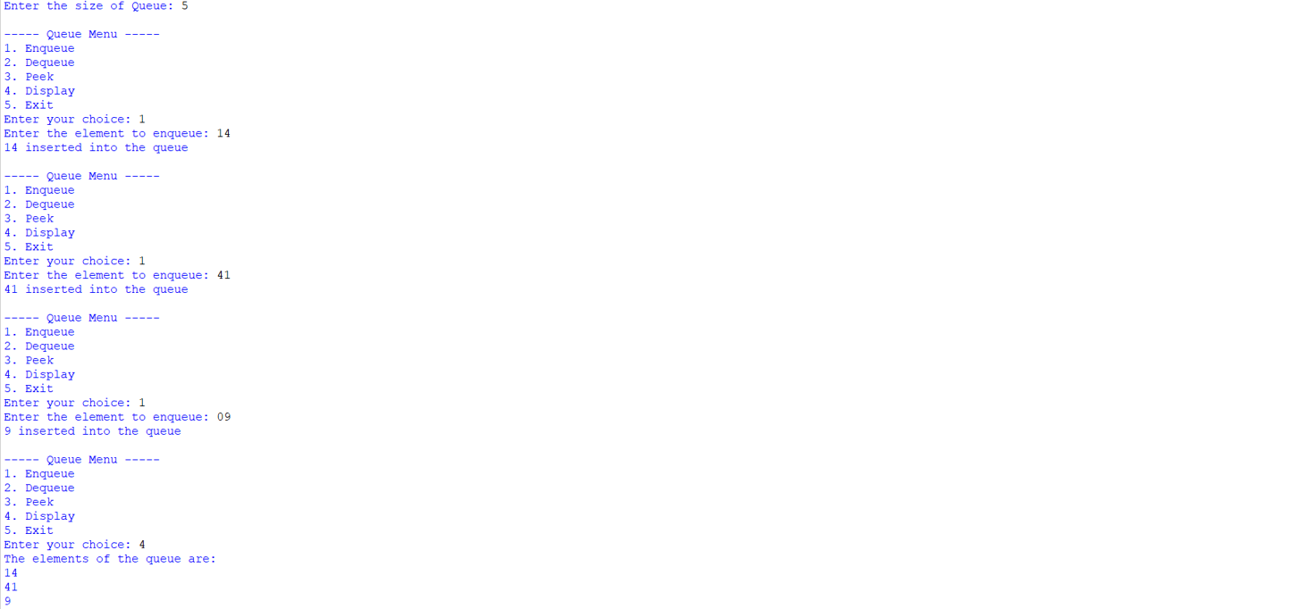
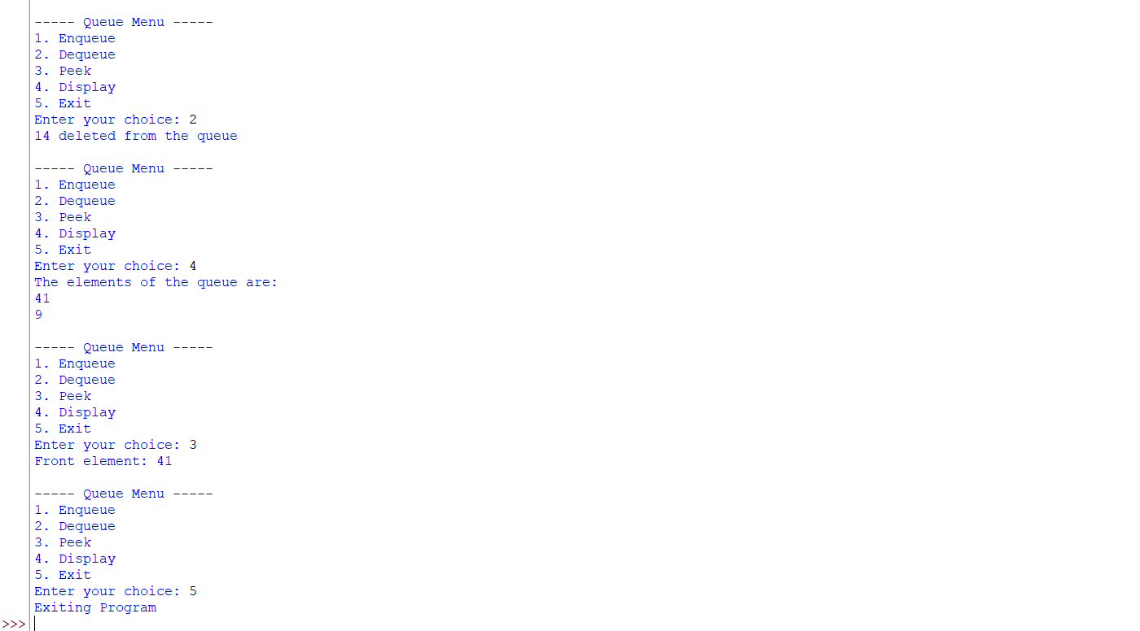
Negative Case;
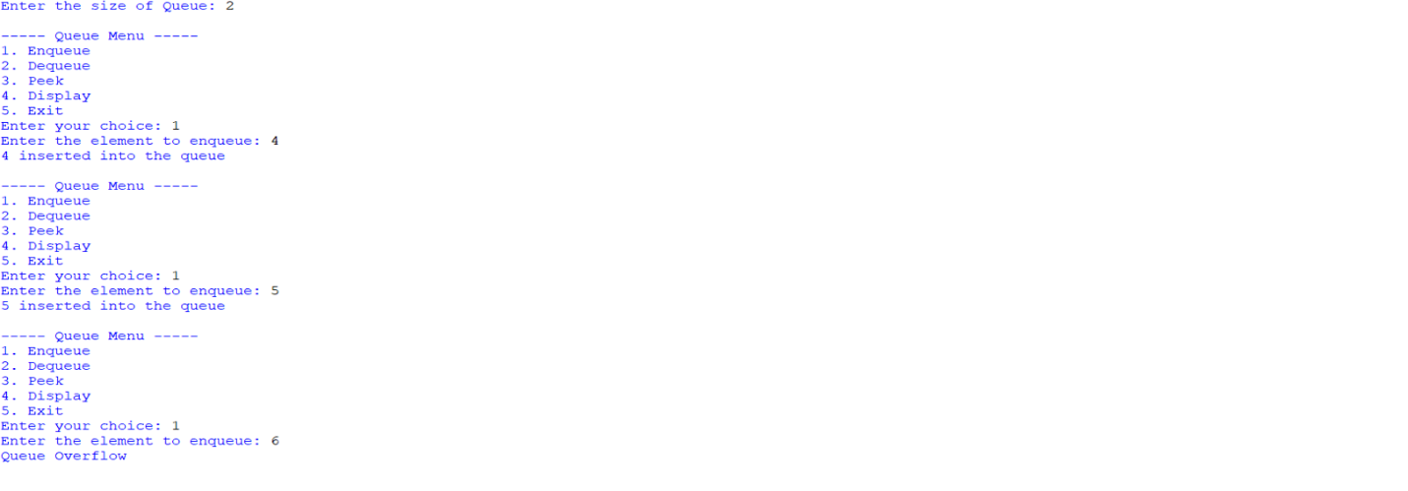
EXPLANATION:
🔹 What is a Queue?
- A Queue is a linear data structure that follows the FIFO (First In First Out) principle.
- Elements are inserted at the rear and removed from the front.
Arrays:
🔹 Components in the Code
- Initialization (__init__)
  - Creates a queue of fixed size.
  - Uses an array (self.queue) to store elements.
  - front and rear pointers track the first and last elements.
  - Both start at -1 (empty queue).
- Enqueue (Insertion)
  - Adds an element at the rear.
  - If rear == size - 1, → Overflow (queue full).
  - If queue is empty (front == -1), set front = 0.
  - Increment rear and insert the element.
- Dequeue (Deletion)
- Removes an element from the front.
- If queue is empty (front == -1 or front > rear), → Underflow.
- Deletes the element at front, increments front.
- If all elements are deleted (front > rear), reset both pointers to -1.
4. Peek
- Shows the element at the front without removing it.
- If empty, prints "Queue is empty".
5. Display
- Prints all elements between front and rear.
- If empty, prints "Queue is empty".
🔹 Menu-Driven Program
- User chooses operations from a menu:
  - Enqueue → Insert element.
  - Dequeue → Remove element.
  - Peek → Show front element.
  - Display → Show all elements.
  - Exit → End program.
- The loop continues until the user selects Exit.
🔹 Characteristics of This Queue
- It is a Linear Queue (not circular).
- Overflow occurs when rear == size - 1.
- Underflow occurs when queue is empty.
- Once rear reaches the end, no more insertions are possible even if earlier slots are freed (limitation of linear queue).
Linked List:
🔹 Structure in the Code
- Initialization (__init__)
  - Creates a queue of fixed size (default = 5).
  - Uses an array (self.queue) to store elements.
  - front and rear pointers track the first and last elements.
  - Both start at -1 (empty queue).
- Enqueue (Insertion)
  - Adds an element at the rear.
  - If rear == size - 1, → Overflow (queue full).
  - If queue is empty (front == -1), set front = 0.
  - Increment rear and insert the element.
- Dequeue (Deletion)
  - Removes an element from the front.
  - If queue is empty (front == -1), → Underflow.
  - Deletes the element at front, increments front.
  - If all elements are deleted (front > rear), reset both pointers to -1.
- Peek
  - Shows the element at the front without removing it.
  - If empty, prints "Queue is empty".
- Display
  - Prints all elements between front and rear.
  - If empty, prints "Queue is empty".
🔹 Characteristics of This Queue
- It is a Linear Queue (not circular).
- Overflow occurs when rear == size - 1.
- Underflow occurs when queue is empty (front == -1).
- Once rear reaches the end, no more insertions are possible even if earlier slots are freed (limitation of linear queue).

6b. To implement Circular Queue and its operation.
PROGRAM:
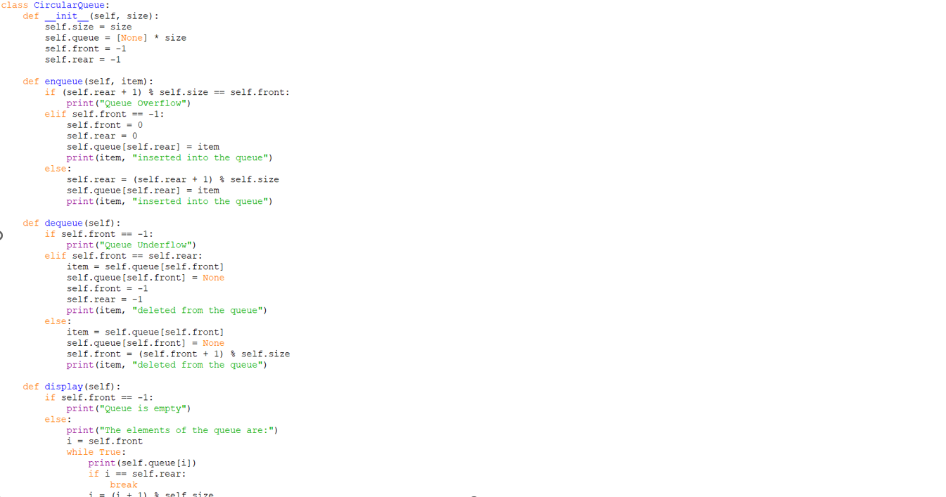
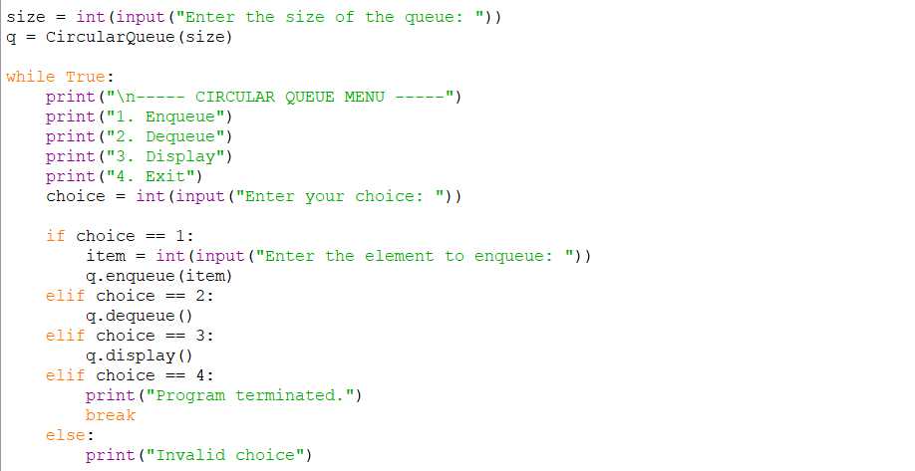
OUTPUT:
Positive Case;
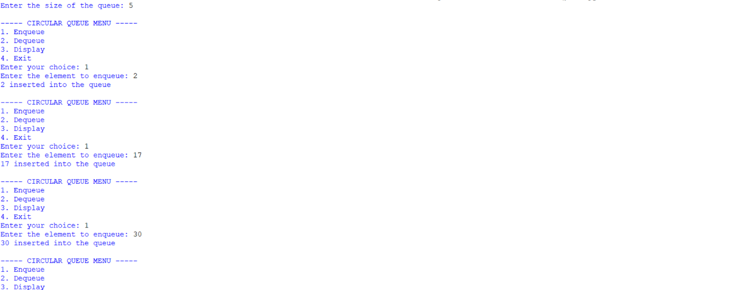
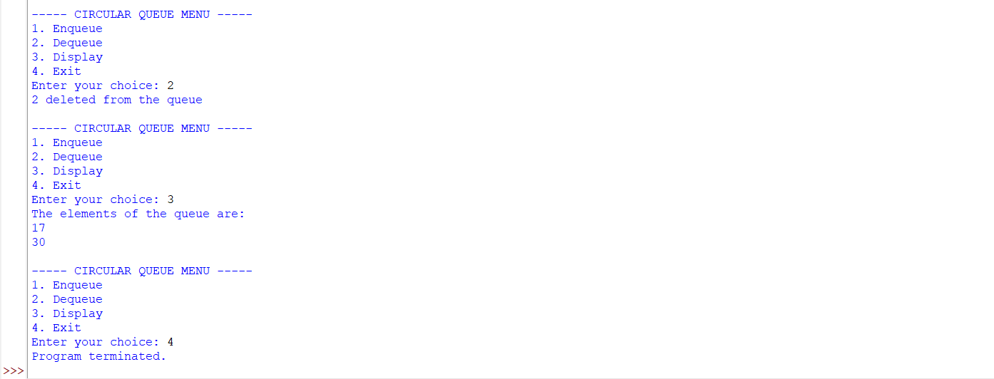
Negative Case;
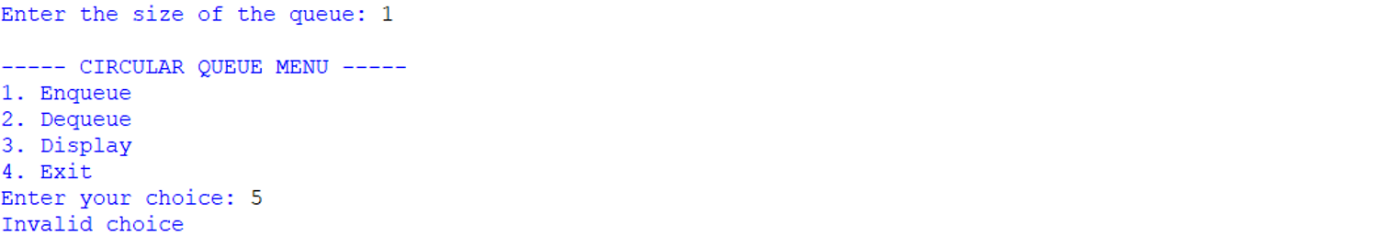
EXPLANATION:
🔹 Concept of Circular Queue
- A Circular Queue is a linear data structure that follows the FIFO (First In First Out) principle.
- Unlike a simple linear queue, the last position connects back to the first position, forming a circle.
- This design solves the problem of wasted space in a linear queue when elements are deleted from the front.
🔹 Structure in the Code
- Initialization (__init__)
  - Creates a queue of fixed size.
  - Uses an array (self.queue) to store elements.
  - front and rear pointers track the first and last elements.
  - Both start at -1 (empty queue).
- Enqueue (Insertion)
  - Adds an element at the rear.
  - Overflow occurs if (rear + 1) % size == front (queue full).
  - If queue is empty (front == -1), both front and rear are set to 0.
  - Otherwise, rear moves forward using modulo arithmetic: (rear + 1) % size.
3. Dequeue (Deletion)
- Removes an element from the front.
- Underflow occurs if front == -1 (queue empty).
- If only one element is left (front == rear), both pointers reset to -1.
- Otherwise, front moves forward using (front + 1) % size.
4.Display
- Prints all elements from front to rear using modulo arithmetic.
- Traverses circularly until it reaches the rear.
🔹 Menu-Driven Program
- User chooses operations from a menu:
  - Enqueue → Insert element.
  - Dequeue → Remove element.
  - Display → Show all elements.
  - Exit → End program.
- The loop continues until the user selects Exit.
🔹 Characteristics of Circular Queue
- Efficient use of memory: Freed spaces are reused.
- FIFO principle maintained.
- Overflow condition: (rear + 1) % size == front.
- Underflow condition: front == -1.

ERROR TABLE:
S.NO | Error Obtained | Rectification
1. | Redundant underflow check → Condition if self.front == -1 or self.front > self.rear: is slightly redundant because resetting pointers already handles empty state. | Simplify to if self.front == -1.
2. | Missing underflow condition → In dequeue, only checks if self.front == -1. If multiple deletions occur, front > rear is not handled, leading to incorrect behavior. | Add condition: if self.front == -1 or self.front > self.rear.
3. | Circular Queue: Display traversal limitation → Display prints values but not indices, making debugging harder. | Optional improvement: print both index and value.

