Mutchumari Chandrasekhar Reddy AP25110010976
1.Converting recursive programs to non-recursive programs. Towers of Hanoi Problem example.
a. Implement using Recursion:
Program:
#include<stdio.h>
void hanoi(int n,char a,char b,char c){
if(n==1){
printf("Move disk 1 from %c to %c\n",a,c);
return;
}
hanoi(n-1,a,c,b);
printf("Move disk %d from %c to %c\n",n,a,c);
hanoi(n-1,b,a,c);
}
int main(){
int n;
scanf("%d",&n);
hanoi(n,'A','B','C');
return 0;
}
Terminal process:
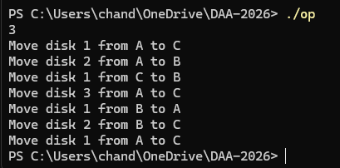
b. Implement without Recursion:
#include<stdio.h>
#include<math.h>
void move(int n,char a,char c){
printf("Move disk %d from %c to %c\n",n,a,c);
}
void hanoi(int n,char a,char b,char c){
int i;
char x,y,z,temp;
x=a;
y=b;
z=c;
if(n%2==0){
temp=y;
y=z;
z=temp;
}
for(i=1;i<=pow(2,n)-1;i++){
if(i%3==1){
move((int)log2(i)+1,x,z);
}else if(i%3==2){
move((int)log2(i)+1,x,y);
}else{
move((int)log2(i)+1,y,z);
}
}
}
int main(){
int n;
scanf("%d",&n);
hanoi(n,'A','B','C');
return 0;
}
Terminal process:
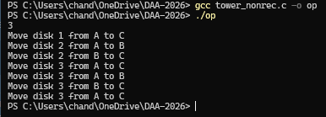
2.Write a program to implement Stack operations using Linked List.
Program:
#include<stdio.h>
#include<stdlib.h>
struct node{
int data; struct nodenext;
};
struct nodetop=NULL;
void push(int x){
struct nodenewnode=(struct node)malloc(sizeof(struct node));
newnode->data=x;
newnode->next=top;
top=newnode;
}
void pop(){
struct nodetemp;
if(top==NULL){
printf("Stack Underflow\n");
return;
}
temp=top;
printf("Deleted: %d\n",top->data);
top=top->next; free(temp);
}
void display(){
struct nodetemp=top;
if(top==NULL){
printf("Stack is empty\n");
return;
}
while(temp!=NULL){
printf("%d ",temp->data);
temp=temp->next;
}
printf("\n");
}
int main(){
int ch,x;
while(1){
printf("1.Push 2.Pop 3.Display 4.Exit\n");
scanf("%d",&ch);
switch(ch){
case 1: scanf("%d",&x);
push(x);
break;
case 2:
pop();
break;
case 3:
display();
break;
case 4:
return 0;
}
}
}
Terminal process:
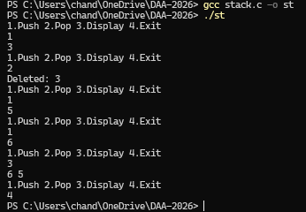

3.Write a program to implement Queue operations using Linked List.
Program:
#include<stdio.h>
#include<stdlib.h>
struct node{
int data;
struct nodenext;
};
struct nodefront=NULL;
struct noderear=NULL;
void enqueue(int x){
struct nodenewnode=(struct node*)malloc(sizeof(struct node));
newnode->data=x;
newnode->next=NULL;
if(rear==NULL){
front=rear=newnode;
}else{
rear->next=newnode;
rear=newnode;
}
}
void dequeue(){
struct nodetemp;
if(front==NULL){
printf("Queue Underflow\n");
return;
}
temp=front;
printf("Deleted: %d\n",front->data);
front=front->next;
if(front==NULL)
rear=NULL;
free(temp);
}
void display(){
struct nodetemp=front;
if(front==NULL){
printf("Queue is empty\n");
return;
}
while(temp!=NULL){
printf("%d ",temp->data);
temp=temp->next;
}
printf("\n");
}
int main(){
int ch,x;
while(1){
printf("1.Enqueue 2.Dequeue 3.Display 4.Exit\n");
scanf("%d",&ch);
switch(ch)
{
case 1:
enqueue(x);
break;
case 2:
dequeue();
break;
case 3:
display();
break;
case 4:
return 0;
}
}
}
Terminal process:
