Mutchumari Chandrasekhar Reddy AP25110010976

1.write Programs for summation of series 1+X+X^2+X^3+…with different time complexities.
Method 1:
#include<stdio.h>
#include<math.h>
int main(){
int x,n,sum;
printf("Enter the values of x and n: ");
scanf("%d %d",&x,&n);
if(x==1){
sum=n+1;
}else{
sum=(pow(x,n+1)-1)/(x-1);
}
printf("The sum of the series is: %d",sum);
return 0;
}
//time complexity O(1).
Method 2:
#include<stdio.h>
#include<math.h>
int main(){
int x,n,i;
double sum=0;
printf("Enter the values of x and n: ");
scanf("%d %d",&x,&n);
for(i=0;i<=n;i++){
sum+=pow(x,i);
}
printf("The sum of the series is: %lf",sum);
return 0;
}
//time complexity O(n).

Terminal process:
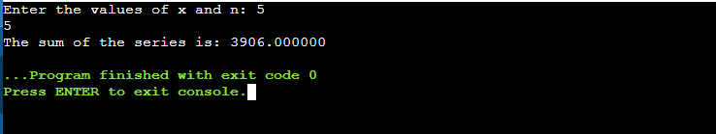
2.Write a program to find the Kth smallest element in the array.
#include<stdio.h>
int main(){
int a[100],i,j,k,temp,n;
printf("Enter the size of the array: ");
scanf("%d",&n);
printf("Enter the elements of the array: ");
for(i=0;i<n;i++){
scanf("%d",&a[i]);
}
printf("Enter the value of k: ");
scanf("%d",&k);
for(i=0;i<n-1;i++){
for(j=i+1;j<n;j++){
if(a[i]>a[j]){
temp=a[i];
a[i]=a[j];
a[j]=temp;
}
}
}
printf("The %dth smallest element is: %d",k,a[k-1]);
return 0;
}
//time complexity is O(n^2)
Terminal Process:
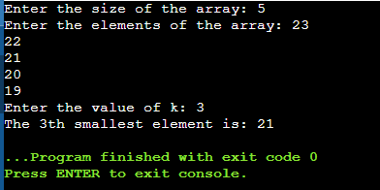

3. Create a Binary Search Tree and perform the insertion, deletion operations.
Program:
#include <stdio.h>
#include <stdlib.h>
struct node {
int data;
struct node *left;
struct node *right;
};
struct node* createNode(int data) {
struct node* newNode = (struct node*)malloc(sizeof(struct node));
newNode->data = data;
newNode->left = NULL;
newNode->right = NULL;
return newNode;
}
struct node* insert(struct node* root, int data)
{ if (root == NULL)
return createNode(data);
if (data < root->data)
root->left = insert(root->left, data);
else if (data > root->data)
root->right = insert(root->right, data);
return root;
}
struct node* findMin(struct node* root)
{ while (root->left != NULL)
root = root->left;
return root;
}
struct node* deleteNode(struct node* root, int data) {
struct node* temp;
if (root == NULL)
return root;
if (data < root->data)
root->left = deleteNode(root->left, data);
else if (data > root->data)
root->right = deleteNode(root->right, data);
else {
if (root->left == NULL) {
temp = root->right;
free(root);
return temp;
}
else if (root->right == NULL) {
temp = root->left;
free(root);
return temp;
}
temp = findMin(root->right);
root->data = temp->data;
root->right = deleteNode(root->right, temp->data);
}
return root;
}
void inorder(struct node* root) {
if (root != NULL) {
inorder(root->left);
printf("%d ", root->data);
inorder(root->right);
}
}
int main() {
struct node* root = NULL;
int n, i, data, del;
printf("Enter number of nodes: ");
scanf("%d", &n);
printf("Enter elements: ");
for (i = 0; i < n; i++) {
scanf("%d", &data);
root = insert(root, data);
}
printf("Inorder traversal: ");
inorder(root);
printf("\nEnter element to delete: ");
scanf("%d", &del);
root = deleteNode(root, del);
printf("After deletion: ");
inorder(root);
return 0;
}

Terminal Process:
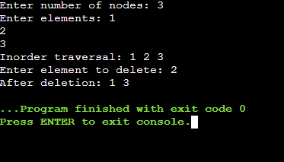
KJJR

