Attention-Based Transformer Models for Cloud Malware Detection Using Network Traffic Data

Abstract
With the increasing reliance on cloud computing, ensuring security against cyber threats such as malware and Distributed Denial-of-Service (DDoS) attacks has become a critical challenge. This paper introduces a holistic method of detecting cloud-based attacks with machine learning, deep learning, and transformer-based networks based on a high-dimensional network traffic dataset. The data has been preprocessed in a systematic manner to remove duplicates, perform a correlation analysis, and multicollinearity, and finally, exploratory data analysis has been performed to determine the key traffic patterns and influential features. Several models were used, such as Decision Tree and Random Forest as control models, Deep Neural Network (DNN) and Multilayer Perceptron (MLP) as deep learning, and more complex models like FT-Transformer and TabNet as attention-based learning. Standard classification metrics such as the accuracy, precision, recall and F1-score were used to evaluate the models. The FT-Transformer model showed good results of 96.18% percent accuracy and 96.18% percent F1-score, showing that it is effective to capture the interactions of complex features. On the whole, the transformer-based models were much more effective than the traditional models, and TabNet was the most effective, whereas FT-Transformer also gave quite similar results being relatively lightweight. These results underscore the usefulness of attention-based architectures in discovering intricate feature interactions in tabular cloud data and their ultimate use as scalable and resilient solutions to state-of-the-art cloud security applications.

Introduction
As cloud computing has gained widespread usage, organizations are now more dependent on an Infrastructure-as-a-Service (IaaS) platform to store, process, and manage large amounts of data. Nevertheless, this has changed and has made cloud systems susceptible to numerous cybersecurity issues with one of the most serious being Distributed Denial-of-Service (DDoS) attacks. DDoS attacks are designed to overload the cloud resources with voluminous amounts of malicious traffic that causes service failure and considerable financial losses. It is especially difficult to detect such attacks in cloud environments because of their high dimensionality, dynamic and significant volume of network traffic data [1], [2]. These complexities cannot usually be addressed by traditional rule-based and signature-based detection mechanisms and require intelligent data-driven approaches.
Machine learning and deep learning practices have been extensively studied in recent years to be used in intrusion detection and cloud security. Random Forest machine learning models and ensemble machine learning have shown good baseline performance in the detection of anomalies in network traffic [3], [4]. Deep learning techniques, such as Deep Neural Networks, have also enhanced the performance of detection, recognizing nonlinear patterns in the data [10], [12]. Transformer-based architectures have recently become a promising direction because of their capability to represent complex relationships with the help of attention mechanisms [14], [15]. Regardless of all these developments, the current methods continue to have problems with a successful capture of feature interactions in tabular data which is one of the main features of cloud traffic data.
With these constraints in mind, this research paper seeks to design a successful cloud-based DDoS detection system through a combination of conventional machine learning models, deep learning, and transformer-based models. The main aim is to compare and contrast performances of various modelling methods, and attention-based architectures (FT-Transformer, TabNet among others) to learn better feature interactions. Using the example of a real-world cloud DDoS dataset and an automated pre-processing and modelling pipeline, this study aims to determine which method has the highest success when it comes to the accurate and scalable detection of attacks. Finally, the research will lead to promoting cloud security by revealing the possibility of transformer-based models to process high-dimensional traffic data of network traffic.
Main Objectives
- To construct and assess an FT-Transformer model to detect malware on clouds, emphasising on acquiring complex feature interactions by attention mechanisms.
- To apply and compare machine learning and deep learning models in detecting malicious network traffic patterns in the cloud environment.
- To use effective data pre-processing and feature analysis methods, such as cleaning, correlation analysis and multicollinearity, to enhance model performance.
- To evaluate and compare the performance of the models based on standard evaluation parameters to identify the most efficient method of malware detection that is accurate and scalable.

Related Work

Machine Learning-Based Cloud DDoS Detection
Machine learning algorithms have found wide use in the detection of Distributed Denial-of-Service (DDoS) attacks in cloud environments because they are effective in processing structured network traffic data. The use of supervised learning models has been shown to be applicable in detecting malicious traffic patterns in Infrastructure-as-a-Service (IaaS) environments in several studies. As an example, evidence classification with machine learning-based methods has been applied to cloud forensics, which allows detecting cyber-attacks by analyzing traffic behavior [1]. Likewise, machine learning classifiers such as data fusion methods have been used to improve the accuracy of detection in cloud-based DDoS attacks by combining various traffic features [2].
Random Forest is a tree-based ensemble model, which has been of great interest in detecting anomalies in the cloud computing environment because of its strength and capacity to capture nonlinear connections [4], [5]. The models are also extensively used in intrusion detection systems and real-time cloud security systems, where they ensure consistent performance with regard to different attack patterns [3], [7]. Moreover, scaling and distributed intrusion detection in cloud and IoT-integrated systems has been considered using lightweight models, including LightGBM and KNN, which has shown great potential due to their computing efficiency and scalability [7]– [9]. Machine learning models can still be effectively used as a good baseline method in larger applications that utilize cloud-connected systems because of their simplicity and interpretability [6].
Nevertheless, there are significant weaknesses when it comes to machine learning-based solutions to cloud DDoS detection. The majority of models rely heavily on feature engineering performed by hand and statistical preprocessing, which might limit their extrapolation to changing attack patterns [2], [4]. Additionally, the classical models tend to look at features in isolation or apply superficial decision boundaries, restricting their ability to reflect the rich interdependencies of network traffic characteristics [3], [8]. These constraints encourage more sophisticated representation learning methods as the data in cloud traffic grows to be higher-more dimensional and dynamic.

Deep Learning-Based Cloud Attack Detection
The deep learning models are currently being actively researched to detect intrusion and DDoS attacks in clouds because of their enhanced ability to learn hierarchical representations of complex data. Deep neural networks (DNNs) have been popularly used to detect intrusion activities in clouds and have proven to perform better than conventional machine learning models by attempting to understand nonlinear correlations among traffic information [10]. Deep learning methods based on optimization have also improved the accuracy of detecting DDoS in clouds through tuning strategies that are combined with neural architectures to detect cloud DDoS [11]. In the same way, DNN-based models have been tailor-made to enhance the performance of classification of cloud attack detection systems and this demonstrates their effectiveness in the process of differentiating between malicious and benign traffic [12].
Besides standalone deep learning models, hybrid systems that integrate neural networks with other systems have been suggested. Indicatively, the capability of detecting intrusions in cloud-fog has been enhanced by the use of layered intrusion detection systems which combine KNN and multilayer perceptron (MLP) [9]. Deep convolutional neural networks coupled with the traditional algorithms like Random Forest have also shown to be effective in identifying several types of intrusion in real-time cloud data [5]. More so, deep learning models have been used in detecting the malicious host in cloud forensics and it is important to highlight that deep learning models are used in sophisticated cybersecurity analytics [13].
Though deep learning models perform better in predictive detection, they still have a number of challenges in cloud DDoS detection. Typical DNN and MLP models do not naturally support tabular data, which constrains their capability to easily capture the interactions between features [9] 12]. These models can be highly hyperparameter tuned and need large-scale training data to optimize their performance and can still rely on front-end feature engineering. Moreover, deep learning methods can lack interpretability, which is hard to comprehend the feature contribution of security-sensitive tasks. Such restrictions make it clear that more data-oriented architectures are required to work with structured tabular data in a better manner.

Transformer-Based Models for Cloud Intrusion Detection
Recent developments in deep learning have brought transformer-based systems to network intrusion detection to provide a new direction to model rich dependencies in cloud traffic data. Transformer models make use of self-attention mechanisms to dynamically learn feature-level relationships that can better represent high-dimensional data. Transformer-based intrusion detection systems have been shown to have better performance in the context of cloud security by prioritizing the most meaningful traffic properties when classifying traffic [14]. Likewise, transformer architectures have been implemented in the detection of DDoS attacks with encouraging outcomes in the ability to detect complex patterns of information in network traffic data [15].
Transformer models are of special interest in the context of cloud DDoS detection because network traffic dataset are structured and feature-rich. Transformers can explicitly model the interaction between two or more features, unlike traditional machine learning models and other standard deep learning models, and thus capture subtle changes in traffic behavior that are indicative of attacks [14], [15]. This renders them highly applicable to environments, which have the attack patterns distributed among several correlated features as opposed to solitary indicators.
Nevertheless, there is a relative lack of transformer-based models in cloud-based DDoS detection in comparison to traditional methods. A significant number of the available literature are on general intrusion detection as opposed to specifically addressing tabular cloud traffic data using attention-based architectures. Moreover, not much is done to explore transformer models which have been developed with tabular data in mind, where learning to interact with features is essential. This provides a chance to explore dedicated transformer architectures that are structured cloud security data.

Research Gap and Motivation for FT-Transformer
The literature available on cloud-based DDoS detection illustrates that considerable advances have been made using machine learning methods, but there are major shortcomings. Conventional machine learning models, though interpretable and efficient, are highly dependent on manual feature engineering and statistical pre-processing and therefore limited in their ability to adapt to the changing cloud conditions [1]–[4], [7], [8]. These models tend to take quite simplistic decision boundaries and cannot be used to represent more complex nonlinear relationships between various traffic features. Such techniques find it hard to generalise to changing patterns of DDoS attacks, as the data in cloud networks continue to be highly-dimensional and heterogeneous, with malicious behaviour typically spread across many correlated attributes, and not just a single indicator.
Deep learning models have tried to overcome these shortcomings by allowing the automatic learning of features and learning nonlinear relationships among traffic data of a network. Despite the demonstrated improved performance of models like DNN and MLP, they are not naturally suited to the tabular datasets, which dominate in the cloud traffic analysis [9] -[13]. Consequently, they tend not to explicitly represent the relationship between features and they can consider input variables as independent, which restricts their capability to identify attack signatures that are driven by interactions. Moreover, these models often need much tuning and large training data, and rely on pre-processing and feature selection steps. Transformer-based methods are a relatively recent solution of the problem, as it is only recently that they have been discovered to be a promising alternative, given their ability to self-pay attention; however, their usage in structured cloud DDoS datasets is under-explored and uncharted [14], [15].
To fill in these gaps, the current study will utilize the FT-Transformer model that is tailored to work with tabular data and focuses on learning feature interactions via attention. In contrast to traditional methods, FT-Transformer models define each feature as a token and use self-attention to identify dependencies across all the variables in the inputs, as well as dynamically identify the most important combination of features to classify. This is especially critical with cloud DDoS detection, where the behaviour of attacks is described by multifaceted interactions between traffic characteristics, including flow statistics, packet rate, and timing characteristics. FT-Transformer is a more robust and scalable solution as it minimizes the usage of manual feature engineering and improves representation learning. Thus, the purpose of the study is to fill the research gap identified by assessing the performance of attention-based tabular learning to enhance the performance of classification towards detecting DDoS attacks in the cloud.

Methodology

Data Collection and Dataset Description
The dataset that was utilized in this research is a cloud-based network traffic dataset to detect Distributed Denial-of-Service (DDoS) attack and was retrieved in an open-access repository (https://zenodo.org/records/14681803).This test is explicitly created to model actual cloud environments, in which extensive network traffic is created and tracked in order to find out malevolent activities. It snacks both normal (benign) and attack traffic, and it can be used to develop supervised learning models to classify binary. The dataset can be of specific interest to researchers of cloud security because it represents the behavior of traffic streams in Infrastructure-as-a-Service (IaaS) contexts, in which DDoS attacks are one of the most severe issues of concern.
The sample is a high dimensional feature space of about 80 attributes which introduce various features of network traffic. These features will comprise flow based, packet based, and statistical metrics which will give detailed information about the behavior of traffic. As an example, Flow Duration is the sum of all the time of a communication session, while Fwd Packets/s is the number of packets sent forward every second. In the same way, one such property, such as Packet Length Mean, represents the mean size of packets within a flow which can be quite different between benign and attack traffic. Other attributes such as inter-arrival times, header lengths and packets numbers also provide an added benefit to the dataset, which would otherwise capture the finer differences between normal and malicious behavior.
All the instances in the dataset are network flows and have a target label that is used to refer to the type of traffic. The target variable is two classes, namely, BENIGN, which is normal network activity, and DDOS, which is malicious attack traffic. This binary classification model is quite appropriate to test intrusion detection systems because it permits models to be trained on discriminative patterns between legitimate and attack traffic. The data has a relatively balanced distribution of classes, which is a positive aspect to train powerful models that do not have a huge bias to a specific class.
In general, the dataset represents a realistic and holistic depiction of traffic in cloud networks, and it is appropriate to test not only the conventional machine learning models but also the sophisticated deep learning models. It has a rich feature set, allowing exploration of complex relationships between traffic attributes, necessary to detect DDoS correctly. Moreover, a wide range of traffic measures makes it possible to study the patterns of interaction between features, which is the foundation of the implementation of the more sophisticated architectures examined in this work, including transformer-based models.

Data Loading and Initial Preprocessing
The analysis was loaded into the analysis environment with the help of the Pandas library which offers effective data processing of structured tabular data. A constant random seed was initialized to provide the same result given the same libraries, NumPy and the random module of Python. The dataset was then imported in a CSV file into Data Frame structure, which can be easily manipulated and analyzed. The loading was followed by a preliminary check to become familiar with the dataset organization, such as its shape, the names of features, and sample entries. It was determined that the dataset consisted of 52,318 instances and 80 features, meaning that cloud network traffic was highly-dimensional zed.
An initial investigation of the data has shown that every record corresponds to a network flow and has several statistical and traffic-specific characteristics. The characteristics used are variables like Flow Duration, Total Forward Packets, Mean Packet Length and Fwd Packets/s that are used collectively to define the network traffic behavior. The categorical values of the target variable, which are labeled as label, are the values of BENIGN and DDOS traffic. Also, to ensure consistent column names, all leading and trailing spaces were eliminated. Types of data were also confirmed, as most of the characteristics are numerical, and the target characteristic is numerical.
One of the important preprocessing phases was to investigate data quality. The dataset was screened against missing or null values, and the data were found to have no missing values, which means that the dataset is clean and can be analyzed directly. Nonetheless, there were found duplicate records and 761 duplicate records were found. Duplicates may cause bias and have a negative effect on the performance of the model, which is particularly true in the case of classification. Thus, such duplicates were eliminated so that the integrity of the data would be maintained and the learning process would be enhanced.
The dataset was brought down to 51,557 records after eliminating the duplicate records, retaining all 80 features hence offering a balanced and clean dataset to analyze it. This preprocessing work is necessary to make sure that the dataset is a true reflection of the unique instances of network flows which would enhance the quality of insights gained in further stages of the process, e.g., exploratory data analysis and training of the models. Altogether, the data loading and preprocessing stage provided a solid base of creating trustworthy and sturdy cloud DDoS detection models.
C. EDA
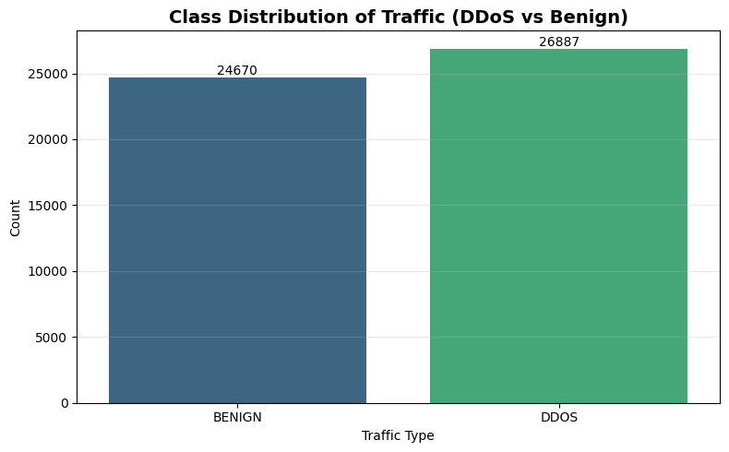
Figure 1. Class Distribution of Network Traffic
The analysis of class distribution presented in Figure 1 will give the preliminary idea of the proportion between benign and malicious traffic in the dataset. The dataset consists of 26,887 DDoS and 24,670 benign cases as shown in the figure having a fairly balanced proportion of the two classes. This minor prevalence of DDoS traffic indicates that the data set is adequately configured to apply the supervised learning since it does not pose any significant problems of class imbalance that would be biased in the performance of the model. Balanced data is especially necessary in cloud attack detection where it is important to make sure that models are able to capture patterns of normal and malicious traffic and not overfit into one of the majority classes. On the whole, this distribution allows building up to reliable classification models and also allows the application of standard evaluation metrics, including accuracy, precision, recall, and F1-score, without the need to resort to any extensive resampling.
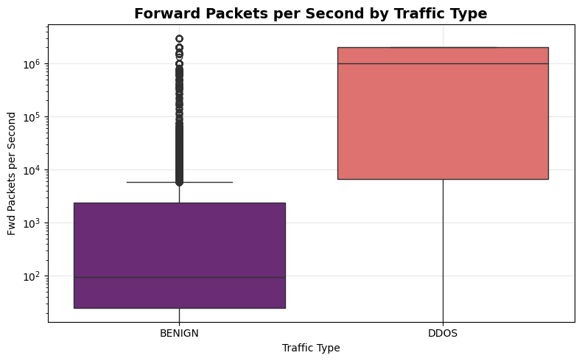
Figure 2. Forward Packets per Second by Traffic Type
The bar chart in Figure 2 shows how the rates of forward packets (Fwd Packets/s) are distributed between benign and DDoS traffic on a logarithmic scale. It can be seen that the DDoS traffic has much higher values of packet transmission rates than that of benign traffic which are several orders of magnitude above. Benign traffic is usually clustered around lower packet rates with a narrower distribution, but DDoS traffic is far more widely spread, and its behavior is highly variable and bursts, as would be usual in an attack situation. The existence of extreme values and high-density upper ranges in DDoS traffic indicates the basic nature of DDoS attacks wherein a high number of packets is produced over a relatively small period of time and clog network resources. This apparent distinction between the two types of schemas implies that such features as the packet rate is a very discriminative attribute of malicious activity detection in cloud environments.
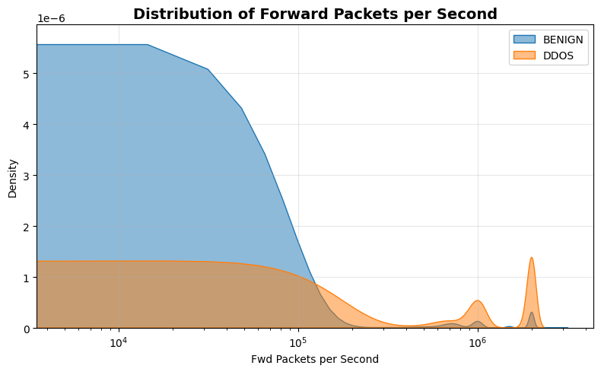

Figure 3. Distribution of Forward Packets per Second
Figure 3 is a density plot that shows the frequency distribution of forward packet rates (Fwd Packets/s) of benign and DDoS traffic on a logarithmic scale. This visualization contrasts with the boxplot, showing the frequency of various rates of packets in each class. It is seen that in normal traffic, benign traffic is clumped at the lower region of the packet rate with the density quickly decreasing with increasing packet rates. Conversely, DDoS traffic distribution is more peaked with visible peaks at higher packet rates, which implies the existence of intense traffic bursts that are typical of attack behavior. The small intersection of the two distributions implies forward packet rate is a highly discriminative feature, and can help effectively distinguish normal and malicious traffic in clouds.
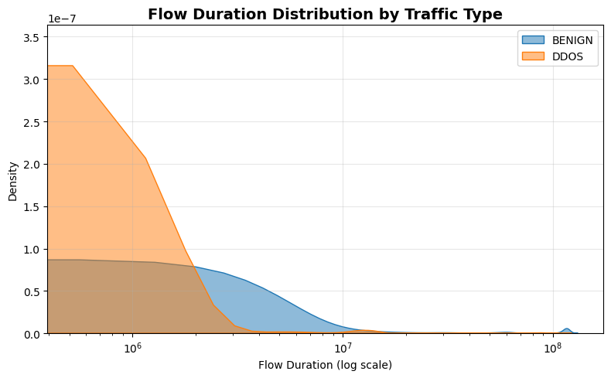Figure 4. Flow Duration Distribution by Traffic Type
Figure 4 is a density plot that shows the distribution of Flow Duration of benign and DDoS traffic on a logarithmic scale, which gives insights into the temporal behavior of the network flows. One can notice that the DDoS traffic can be observed to have a large concentration in shorter flow times which in turn shows that the attack patterns tend to create small and short connections with a high number of requests in a small-time frame. Conversely, benign traffic is found to be more widely spread over longer periods of time indicating more consistent and maintained communication sessions during normal network activity. The evident differences in the distributional characteristics of the two classes underline the duration of flows as a significant characteristic to distinguish between malicious and legitimate traffic in the cloud environment.

D. Correlation Analysis and Multicollinearity Handling
The correlation analysis was performed to determine the strongest features that contributed to the detection of DDoS attacks. The findings suggest that there are some features which have strong, positive relationships with the target variable. It is important to note that Inbound has the highest correlation which implies that it has a big role to play in differentiating attack traffic and benign traffic. Min Packet Length, Fwd Packet Length Min, Avg Fwd Segment Size, and Fwd Packet Length Mean are other significant features, which show good associations with the target. These properties add up to be more of a packet size and flow nature, meaning that abnormal behavior at the packet-level can be successfully used to detect DDoS attacks. Also, other characteristics like Fwd Packets/s and URG Flag Count can be useful, which helps to highlight the significance of traffic intensity and protocol-level indicators in identifying malicious behavior.
Further examination demonstrated that there was a high level of multicollinearity between a number of features and that there were a lot of pairs of features with very high correlation values. E.g. Total Fwd Packets and Subflow Fwd Packets, Fwd Packet Length Mean and Avg Fwd Segment Size features were found to be very redundant. Multicollinearity of this kind can adversely affect the performance of the model by introducing redundancy, computational complexity and even instability of the learning algorithms. To deal with this problem, all features that have a high correlation with each other were eliminated systematically, and other redundant or less informative columns were eliminated as well. The outcome of this process was a cleaner and efficient dataset which provided accuracy in the models as they concentrated on the most relevant features, the ones that are not redundant to detect DDoS.
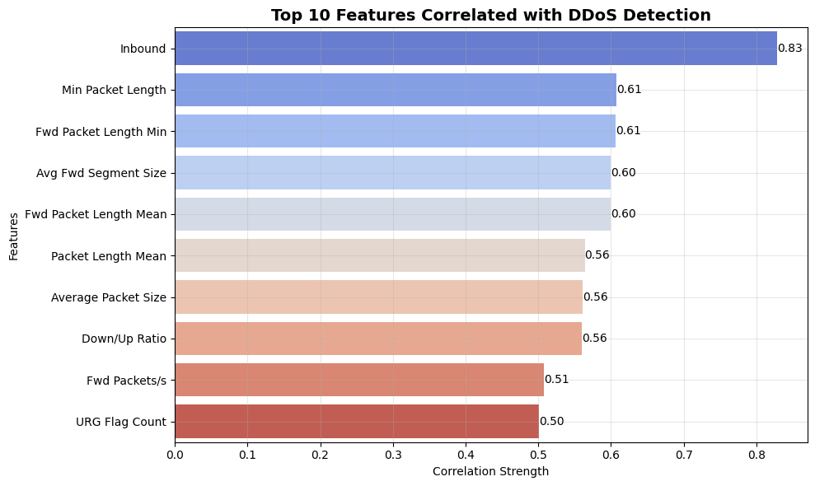
Figure 5. Correlation Analysis Plot
Figure 5 provides a plot of the top features which are most correlated with the detection of a DDoS attack; this implies that these features are important in identifying malicious traffic and benign traffic. The greatest correlation is with the feature Inbound, indicating the importance of the direction of traffic in detection of attack behavior. Certain features in packets including Min Packet Length, Fwd Packet Length Min, Avg Fwd Segment Size and Fwd Packet Length Mean also show strong correlations indicating that DDoS are defined in characteristics of unique packets. Also, functions such as Fwd Packets/s and URG Flag Count show that traffic intensity, as well as protocol-level behavior are key in detection. Generally, the plot illustrates that both the packet structure and features of flows can be used as important indicators to find the real DDoS attacks in cloud environments.

E. Label Encoding, Data Splitting and Feature Scaling
The target variable was first converted to numerical before model training so that it could be used in classification algorithms. The labels of the classes were coded in such a way that BENIGN traffic is represented by 0 and DDOS traffic is represented by 1. This binary coding made sure that the target variable could be directly interpreted using machine learning and deep learning models. The correlation analysis temporarily created an encoded column was removed to prevent repetition and ensure a clean structure of the dataset was retained.
After label encoding, the data was separated into input features and the target variable, with the set of features consisting of the chosen traffic attributes, and the target, which took the form of the type of attack. This data was then divided into training and testing subsets using 80:20 ratio whereby a greater part of the data was utilized in learning the model and an independent unseen part was used in assessing the model. In the split, a stratified sampling strategy was used so that the distribution of classes of benign and DDoS traffic in training and testing set was similar. It is especially crucial when classifying, and it helps avoid bias in the testing procedure, as well as making the test set representative of the total dataset.
The data was split and then to standardize the numeric input variables feature scaling was used with StandardScaler. This is used to convert every feature to have a mean of 0 and a standard deviation of 1 thus bringing all the variables into a similar scale. Models like deep neural networks, transformer-based or other models particularly, are sensitive to the magnitude of features, and scaling is especially important in these models. The modelling process can be made more stable, efficient, and less susceptible to disproportionately large feature values by standardizing the training data, and using the same transformation to the test data, so that the transformation can be applied to the test data. The step thus allows the subsequent models to learn normalized and well-structured input data.
F. Modelling

i. Machine Learning Models for DDoS Detection
In order to determine baseline performance of cloud-based DDoS detection, one of two classical machine learning models, i.e., Decision Tree and Random Forest were applied. The Decision Tree model was also set to use the entropy criterion, in determining the information gain, which enabled the model to divide features according to their contribution to decrease the uncertainty. The constraints used to avoid overfitting and enhance generalization were limited tree depth, minimum splitting samples, and leaf size. Moreover, class balancing has been included to deal with minimal differences in class distribution to provide equal learning opportunities in both benign and DDoS classes. The working principle of the Decision Tree model is to divide the feature space into decision regions by using recursive collection, rendering it very interpretable and applicable in explaining decision trends of features in network traffic data.
Random Forest model is based on the Decision Tree and involves building an ensemble of a number of trees and combining their projections to enhance stability and robustness. The model used in this research was set to control the depth and use more stringent splitting guidelines to prevent overly complex trees and limit the number of features the model would take into account during a split to increase the diversity of trees. Random Forest averts variance and enhances predictive accuracy more than a single decision tree due to the combination of multiple weak learners. It is especially effective when dealing with high dimensional and noisy cloud traffic data. Both models were tested according to classification measures like accuracy, precision, recall as well as F1-score, and the confusion matrices were used to determine how the models could differentiate between DDoS and benign traffic patterns.

ii. Deep Learning Approaches
Deep learning models which comprise of Deep Neural Network (DNN) and 3-layer Multilayer Perceptron (MLP) were used to model complex nonlinear patterns in cloud network traffic. The DNN model is a series of fully connected layers that learns successively the hierarchical feature representations of the input data. The model has an input layer, then dense layers of 128, 64 and 32 neurons, each layer will have the ReLU activation function to add nonlinearity. After every dense layer, Batch Normalization layer is added to stabilize the learning process and increase the convergence and Dropout layers with a relatively high dropout rate are added to prevent overfitting by deactivating the neurons at random during the training process. The last output layer employs a sigmoid activation function to generate a probability value that classifies binary (DDoS vs benign traffic).
The DNN model was trained with the Adam optimizer which is popular due to its ability to adapt learning rate, and binary cross-entropy loss, befitting binary classification tasks. The training was conducted several times throughout an epoch and Early Stopping mechanism was used to keep a check on the validation loss and overfitting by halting training once no more progress was being made. Training was done with a validation split to test the generalization capacity of the model. With this setup, the DNN can extract meaningful patterns out of high-dimensional tabular data without compromising stability and preventing the complexity of the model.
On the same note, the 3-layer MLP model is based on structured deep learning architecture but enhances stronger regularization by increasing dropout rates at all the hidden layers. The architecture includes three connected hidden layers 128, 64, and 32 neurons, each has a Batch Normalization and Dropout layer to facilitate generalization. The MLP model is more robust, with dropouts being aggressive in reducing overfitting, in comparison to the DNN. It is also trained with Adam optimizer and binary cross-entropy loss, and Early Stopping is used to ensure the best performance. The two models build on the input scaling feature and are measured in classification metrics to allow an overall evaluation of the deep learning performance in detecting DDoS attacks in the cloud environment.

iii. FT-Transformer-Based Approach
To further enhance the interaction of features in detecting cloud DDoS, a model named FT-Transformer was deployed on PyTorch. To allow the ability to execute the models efficiently, the scaled training and testing dataset was now converted into PyTorch tensors and loaded onto the available computation device, which was either a GPU or a CPU, prior to training. Because structured tabular data is particularly the focus of the FT-Transformer architecture, it is quite relevant to the present study, as every traffic record, in this case, comprises several numerical features. In contrast to standard deep learning architecture designs that perform feature processing primarily by stacking dense layers, FT-Transformer assumes the input features are tokens and learns how these tokens relate to each other, by using attention mechanisms. This enables the model to model complicated dependencies among traffic properties, which is of significant value in cloud DDoS identification in which attack behavior is frequently manifested by means of interactions among a number of attributes, instead of a variable.
The architecture is initialized with a linear feature embedding layer, in which the individual numerical features are sequentially mapped (projected) to a representation space of size 64 (d64) or in 64 dimensions. An embarked CLS token is then integrated to the feature sequence to allow the model to pool all information encompassed in all features to a single representation to make classification. The model is based on a 3-layer Transformer Encoder (layers = 3) and 4 attention heads (heads = 4). Every encoder layer consists of self-attention to learn dependencies between input features and then a feedforward subnetwork with dimensionality 128 (dim feedforward = 128). The GELU activation function was chosen in the encoder to have more comfortable nonlinear transformations, and dropout = 0.2 was taken to avoid overfitting. Moreover, the encoder was set with batch first=True, which permits batch-major formatting of input, and norm first=True, which executes normalization ahead of attention and feedforward functions to empower the training to be more stable.
Once through the transformer encoder the output of the CLS token is removed as the global feature representation and enters the classification head. This head comprises a Layer Norm and two fully connected layers with 128 and 64 neurons respectively with ReLU activation and dropout rates of 0.3 and 0.2 respectively and the final output layer generates predictions of the two traffic classes. The model output was transformed to the predicted class labels based on the maximum score of the two output nodes to take the evaluation. The evaluation of performance was then conducted with the help of accuracy, precision, recall, F1-score, classification report, and confusion matrix. On the whole, this architecture was chosen due to the combination of the benefits of attention-based representation learning with the tabular-data-oriented framework that renders it an excellent way of accounting for more intricate feature interactions in cloud-based DDoS attack detection.

iv. TabNet Architecture
Besides the transformer-based design, a TabNet model was used as a deep learning model that operates on tabular data. TabNet uses sequential attention to enable the model to concentrate on the most important features in each decision-making step, enhancing interpretability and feature selection. The model used here was set with a decision and attention dimension (n_d = 16, n a = 16) which determines the size of feature representations and attention masks, and steps = 4, which means the number of sequential stages of decisions to be applied to narrow the feature selection and representation learning. In contrast to the traditional neural networks which handle all features at once, TabNet selectively and dynamically selects and transforms features via attention masks, which allows TabNet to learn dynamically, feature importance.
A batch-based training method with a very large batch size of 1024 was used to train the model and provided its ability to process large-dimensional data in a relatively faster way. A maximum of 20 epochs of training were done with a mechanism of early stopping (patience = 2) to prevent overfitting when the validation performance ceased to improve. Throughout training, the model was tested on a validation set based on the use of the accuracy as the main package. The architecture of TabNet inherently integrates feature selection and representation learning and is thus especially effective with structured data, e.g., the traffic on a cloud network. The masking of sparse features and the emphasis on the the most informative features allow the model to improve classification results and minimize the effects of redundant or irrelevant features in detecting DDoS.

Evaluation and Results
This section includes a comparative analysis of the performance of all the implemented models of cloud-based DDoS attacks detection. To determine the effectiveness of each approach, key classification metrics, such as accuracy, precision, recall, and F1-score are evaluated. This comparison and contrast of traditional machine learning, deep learning and transformer-based models identify the advantages and disadvantages of each approach to represent unrestrained complex traffic patterns and accurately differentiate between normal and malicious network behavior.

Table 1. Model Performance Summary Table

Model | Accuracy (%) | Precision (%) | Recall (%) | F1 Score (%)
Decision Tree | 81.85 | 92.78 | 70.70 | 80.24
Random Forest | 91.73 | 87.76 | 97.77 | 92.50
Deep Neural Network | 95.35 | 99.70 | 91.37 | 95.35
3-Layer MLP | 95.40 | 99.58 | 91.58 | 95.41
TabNet | 97.68 | 97.75 | 97.68 | 97.68
FT-Transformer | 96.18 | 96.35 | 96.18 | 96.18

Table 1 provides a comparative overview of all the applied models in terms of the most important evaluation measures such as accuracy, precision, recall and F1-score. It vividly depicts the gradual upgrading of performance of old machine learning models to new deep learning and transformer-based methods. Though Decision Tree indicates a relatively lower performance, ensemble models and deep learning models indicate significant improvements. Interestingly, FT-

Transformer and TabNet models most effectively predict malicious traffic in cloud environments based on all metrics, which emphasizes the usefulness of transformer-based models in detecting malicious traffic.

Decision Tree Results
The Decision Tree model scored moderate with an accuracy of 81.85% and a reasonably high precision of 92.78%. The recall value is, however, much lower at 70.70%, meaning that the model is not effective at identifying a high number of DDoS attacks. This implies that although the model is good at reducing false positives it does not identify a lot of true attacks meaning that it cannot be utilized with much confidence in real life cloud security implementation as it is important that high detection rates be achieved.

Random Forest Results
The Random Forest model is a significant improvement of the Decision Tree, with an accuracy of 91.73% and a very high recall of 97.77%. This shows that it is a very useful model in detecting DDoS attacks with a very low false negativity. Nonetheless, it is a little less accurate (87.76) indicating that there are more false positives than with the Decision Tree. Generally, the ensemble characteristic of Random Forest enhances robustness and detection ability thus it is an excellent baseline model.

Deep Neural Network Results
The Deep Neural Network (DNN) model is highly performing with the accuracy of 95.35% and a very high precision of 99.70. This means that the model is very predictive of DDoS attacks with the lowest false positives. Nevertheless, the recall equals 91.37%, a little bit lower, indicating that there are still some attack cases that are missed. The data is largely nonlinear, which the model is useful in capturing, which results in better classification performance than the conventional machine learning models.

3-Layer MLP Results
The 3-layer MLP model is not significantly different in its performance than the DNN, as its accuracy is somewhat higher, (95.40%) and its precision is high (99.58%). The recall of the DNN is slightly lower than the 91.58% of the recall compared to the DNN, and this leads to a balanced F1 score of 95.41%. Stronger regularization with the dropout assists in enhancing generalization, which enhances the MLP as a reliable and stable deep learning model in cloud DDoS detection.

FT-Transformer Results
The FT-Transformer model also offers better performance by being able to effectively capture feature interactions using attention mechanisms. Its accuracy is at 96.18%, and the precision and recall are balanced, about 96% and 96% respectively. This balance shows that the model achieves a good performance in terms of reducing false positives, as well as in terms of reducing false negatives. Dependence between features modeling capabilities of the transformer also help to enhance its better detection performance over the traditional deep learning models.

TabNet Results
The TabNet model has the highest overall performance, highest accuracy of 97.68% and high accuracy, precision, and recall, and F1 values. This means that the model is very effective in both maintaining benign and DDoS traffic correctly and with minimum errors. TabNet is a sequential attention mechanism that enables it to pay attention to the most significant features in each decision step and hence perform better. The fact that it integrates feature selection and representation learning renders it especially good with tabular cloud traffic data.

7) Comparative Discussion
The performance of all models is comparatively analysed, revealing a direct performance improvement sequence beginning with the traditional machine learning models to the advanced deep learning and transformer-based models. The Decision Tree model performs poorly, especially in terms of low recall, meaning that it is not able to represent complicated attack patterns in cloud traffic data. Random Forest model is much better in detecting especially regarding the recall because it is an ensemble model. Nevertheless, it has a trade-off between precision and recall. DNN and MLP models of deep learning go further to increase performance as they are able to capture nonlinear relationships in the data leading to high accuracy and precision. Although improved in these aspects, both models have a somewhat poorer recall than more sophisticated architectures, indicating they are not quite able to capture higher-order interactions between features within high-dimensional network traffic.
The FT-Transformer model represents a significant improvement over the conventional machine learning and the typical deep learning model. It is able to exploit self-attention mechanisms to easily extract intricate inter-feature interactions that are decisive in detecting DDoS attacks in clouds. In contrast to DNN and MLP, the FT-Transformer also dynamically learns feature-to-feature relations causing a balanced performance in terms of accuracy, precision, and recall. The fact that it has similar performance measured by all evaluation metrics implies that it is well-generalized and has strong strength. The FT-Transformer, compared to Random Forest, does not only gain accuracy but also removes the variance between the precision and recall making it more applicable in the real-life scenario.
The FT-Transformer conducts comparably with TabNet, albeit, being simplistic and easy to compute. The ability to select features explicitly in every step of the decision contributes to the high accuracy and the overall performance of TabNet as it focuses on the feature selection process sequentially. Nonetheless, the FT-Transformer scores similarly to TabNet, showing that attention-based transformer models can be successful competitors to specialized tabular models. Interestingly, the FT-Transformer attains this performance by using a lighter and more flexible architecture, which emphasizes the efficiency and scalability. This is indicative of the fact that, not only can transformer-based models offer a high degree of predictive performance, but also offer a potential balance between complexity and effectiveness that is very well suited to cloud-based DDoS detection tasks.

Conclusion
The present research was dedicated to the identification of the Distributed Denial-of-Service (DDoS) attacks within the cloud environment with the help of machine learning and deep learning combined with transformer-based models. An elaborate methodology has been followed and it began with data preprocessing and exploratory analysis up to the advanced modelling and evaluation. The data offered a good representation of the cloud network traffic, which made it possible to determine the major patterns related to malicious activity. It was found through systematic analysis that traffic-based characteristics like packet length, duration of flow and packet rates are important in the separation of DDoS attacks and legitimate traffic.
Experimental findings indicate that classical machine learning algorithms, i.e. Decision Tree and Random Forest, are a good starting point to classification problems. Although Random Forest is much better than Decision Tree in terms of detection, capability, both models are limited when it comes to the ability to capture complex interactions between features as seen in high-dimensional cloud traffic data. DNN and MLP models can also be further optimized to deep learning with greater accuracy and precision, as nonlinear associations are learned. Nevertheless, these models have some drawbacks in complete representation of the feature’s dependencies, which are essential in precise DDoS detection.
The biggest performance improvements were caused by the introduction of transformer-based and attention-driven models, especially FT-Transformer and TabNet. The FT-Transformer model proved to be efficient in the interactions of features through self-attention mechanisms, which led to balanced and strong overall performance in all metrics. TabNet had the best overall results because of its sequential attention-based feature selection as it showed that it is effective in dealing with structured tabular data. It is important to note that the performance of the FT-Transformer was almost equivalent to TabNet, which is relatively lightweight, with the efficiency and potential of transformer-based architecture in cloud security applications.
In general, this paper has shown that attention-based models can be a great benefit compared to the existing and classical deep learning methods in detecting cloud DDoS attacks. These models provide a more scalable and effective solution to recent cybersecurity issues by removing the need to use manual feature engineering and enhancing the ability to learn complex feature relationships. Findings of this study will play a role to add to the existing literature on transformer-based learning of tabular data and emphasize its validity in the context of the real-world cloud.
Future Work
Future research can be aimed at increasing the strength and scalability of the developed cloud attack detection framework through the addition of real-time streaming information and the implementation of the models in dynamic cloud applications. Moreover, the merge of both hybrid architectures consisting of attention-based model and a temporal learning mechanism can also enhance the ability to detect changing patterns of attacks. It will be useful to investigate automated feature selection, explainable AI methods, and lightweight model optimization as well, to enhance interpretability and computation performance to make them applicable to large-scale cloud systems.

References

- Abuowaida, S., Owida, H.A., Mohammad, S.I.S., Alshdaifat, N., Elsoud, E.A., Alazaidah, R., Vasudevan, A. and Alshurideh, M.T., 2025. Evidence detection in cloud forensics: Classifying cyber-attacks in iaas environments using machine learning. Data and Metadata, 4, p.699.

- Pattnaik, L.M., Swain, P.K., Satpathy, S. and Panda, A.N., 2023. Cloud DDoS attack detection model with data fusion & machine learning classifiers. EAI endorsed transactions on scalable information systems, 10(6).

- Mehmood, M., Amin, R., Muslam, M.M.A., Xie, J. and Aldabbas, H., 2023. Privilege escalation attack detection and mitigation in cloud using machine learning. IEEe Access, 11, pp.46561-46576.

- Gupta, A. and Simon, R., 2024, March. Enhancing security in cloud computing with anomaly detection using random forest. In 2024 11th International Conference on Reliability, Infocom Technologies and Optimization (Trends and Future Directions)(ICRITO) (pp. 1-6). IEEE.

- Khan, M. and Haroon, M., 2024. Ensemble random forest and deep convolutional neural networks in detecting and classifying the multiple intrusions from near real‐time cloud datasets. Security and Privacy, 7(5), p.e408.

- Singh, K. and Malhotra, J., 2023. IoT and cloud computing based automatic epileptic seizure detection using HOS features based random forest classification. Journal of Ambient Intelligence and Humanized Computing, 14(11), pp.15497-15512.

- Dhabliya, D., Vijay, S.A.A., Minhas, D. and Marwaha, S., 2024, December. Secure Anomaly Detection with Light GBM and Enhanced Privacy Preservation. In 2024 IEEE 4th International Conference on ICT in Business Industry & Government (ICTBIG) (pp. 1-6). IEEE.

- Vidhubala, J. and Kayalvizhi, R., 2026, February. LightGBM-Based Multi-Class Botnet Detection Framework for IoT Networks. In 2026 IEEE 5th International Conference on AI in Cybersecurity (ICAIC) (pp. 1-6). IEEE.

- Kaffash, A., Kamel, S.R. and Kheirabadi, M., 2024. A two-layer cloud-fog intrusion detection system usingenhanced KNN and MLP neural networks. Majlesi Journal of Electrical Engineering, 18(3), pp.1-14.

- Alzughaibi, S. and El Khediri, S., 2023. A cloud intrusion detection systems based on dnn using backpropagation and pso on the cse-cic-ids2018 dataset. Applied Sciences, 13(4), p.2276.

- Balasubramaniam, S., Vijesh Joe, C., Sivakumar, T.A., Prasanth, A., Satheesh Kumar, K., Kavitha, V. and Dhanaraj, R.K., 2023. Optimization enabled deep learning‐based ddos attack detection in cloud computing. International Journal of Intelligent Systems, 2023(1), p.2039217.

- Verma, R., Jailia, M., Kumar, M. and Kaliraman, B., 2024, May. Deep neural network model for improved DDoS attack detection in cloud environments. In 2024 5th International Conference for Emerging Technology (INCET) (pp. 1-6). IEEE.

- Nandita, G. and Munesh Chandra, T., 2024. Malicious host detection and classification in cloud forensics with DNN and SFLO approaches. International Journal of System Assurance Engineering and Management, 15(2), pp.578-590.

- Long, Z., Yan, H., Shen, G., Zhang, X., He, H. and Cheng, L., 2024. A Transformer-based network intrusion detection approach for cloud security. Journal of Cloud Computing, 13(1), p.5.

- Liang, B., 2024, November. Research on DDoS Attack Detection Model Based on Transformer Architecture. In International Conference on Networks, Communications and Intelligent Computing (pp. 123-132). Singapore: Springer Nature Singapore.

