# Background

In a Stroop task, participants are presented with a list of words, with each word displayed in a color of ink. The participant’s task is to say out loud the color of the ink in which the word is printed. The task has two conditions: a congruent words condition, and an incongruent words condition. In the congruent words condition, the words being displayed are color words whose names match the colors in which they are printed: for example RED, BLUE. In the incongruent words condition, the words displayed are color words whose names do not match the colors in which they are printed: for example PURPLE, ORANGE. In each case, we measure the time it takes to name the ink colors in equally-sized lists. Each participant will go through and record a time from each condition.

## Word set used in congruent task (Word Set#1) and incongruent task (Word Set#2) are depicted below:

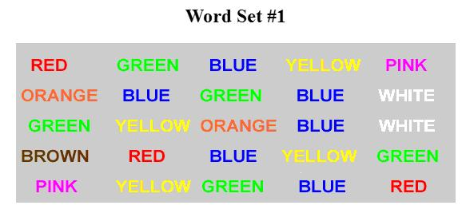

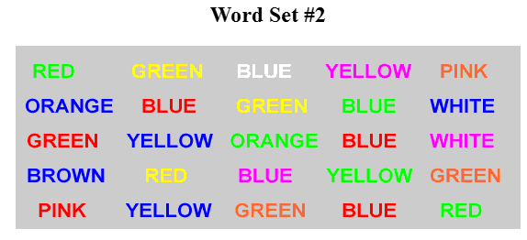

# Problem

# Problem Description

In this project, investigation of a classic phenomenon from experimental psychology called the [Stroop Effect](https://en.wikipedia.org/wiki/Stroop_effect) is carried out. Following tasks are performed during the course of the project, to determine Mean time for color recognition for congruent words Set is equals to mean time for incongruent words Set.

* 1. Study and Learn about the experiment
  2. Perform [Stroop Effect](https://en.wikipedia.org/wiki/Stroop_effect) experimental and record results
  3. Create a hypothesis regarding the outcome of the task
  4. Look at some data collected from others who have performed the same task and will compute some statistics describing the results.
  5. Interpret recorded results in terms of hypothesis created earlier

# Data Collection

## Data collection steps are listed below:

## Navigate to [Interactive Stroop Effect Experiment](https://faculty.washington.edu/chudler/java/ready.html) (which has a Java-based applet for performing the Stroop task) and follow the instructions to perform Stroop task.

## Recorded the time duration observed on the Stroop task for both congruent words condition, and an incongruent words.

## Downloaded the [dataset](https://drive.google.com/file/d/0B9Yf01UaIbUgQXpYb2NhZ29yX1U/view), which contains results from a number of participants who participated earlier in the Stroop task. Each row of the dataset contains the performance for one participant; with the first number their results on the congruent task and the second number their performance on the incongruent task.

# Solution Approach

Based on quick observation of data set, each subject or entity is measured twice, resulting in pairs of observations for congruent task, and incongruent task. Here sample size is 24. Population parameters such as standard deviation are not available. Based on this observation, statistical procedure named Paired sample (dependent sample) t-test shall be used to determine whether the mean difference between two sets of observations is zero.

# Identify variables in the experiment

Independent variable: words Set Type (either congruent or incongruent words)

Dependent variable: Time takes for reader to name the ink colors

Note: Number of words in congruent or incongruent list is fixed. Same subject is exposed to two conditions

# Establish hypothesis

**H0** (null hypothesis): There is no difference in population means of response time under incongruent and congruent scenarios, which can be mathematically represented as **H0: μC - μI = 0**

**HA**(alternative hypothesis): The population mean of the response time under congruent and incongruent conditions are different, which can be mathematically represented as **HA: μC - μI** ≠ **0**

Wherein,

μC : mean of congruent words Set

μI: mean of incongruent words Set

# Establish a statistical test

The available data is sample data and population parameter such as standard deviation is not available and total samples are < 30, hence t-test is suitable here.

Based on the Null hypothesis 1-tailed test is suitable. Since same subject is exposed to two conditions, t-test is of type for dependent samples (statistical test for "same subjects" or "repeated-measures") shall be carried out.

So overall, 1-tailed t-test statistical test for dependent samples to be carried

*Note: A typical guideline to determine whether the dependent sample t-test is the right test is to answer the following three questions:*

* *Is there a direct relationship between each pair of observations (e.g., before vs.  after scores on the same subject)?*
* *Are the observations of the data points definitely not random (e.g., they must not be randomly selected specimen of the same population)?*
* *Do both samples have to have the same number of data points?*

# Statistical Test Assumptions

* 1. Population standard deviation available? - No
  2. Is this a paired sample? - Yes
  3. Is this a small sample (<=30)? – Yes
  4. Any idea of mean increase or decrease of congruent test vs. incongruent test?: unknown
  5. Dependent Sample T-Test with 2 tailed test to be considered? - Yes
  6. Significant Level (Alpha) = 0.05 ( 95% confidence Level)
  7. Degree of Freedom : 23
  8. T Critical = **t 0.05**  *= +/-*2.069
  9. Rejection Region t < *-*2.069 or t > *+*2.069

# Report descriptive statistics

Calculated Descriptive statistics are depicted in the below table for measure of centrality (Mean, Median, and Mode) and measure of variability (Range, IQR, SD).

|  |  |  |  |
| --- | --- | --- | --- |
| **Sample Statistics** | **Congruent** | **Incongruent** | **Diff (Cong-InCong)** |
| **n** | 24 | 24 |  |
| **Sum** | 337.227 | 528.382 | -191.155 |
| **Mean(x̄)** | 14.051125 | 22.01591667 | -7.964791667 |
| **Median** | 14.3565 | 21.0175 | -6.661 |
| **Mode** | 14.3565 | 21.0175 | -6.661 |
| **Range** | 13.698 | 19.568 | -5.87 |
| **IQR** | 4.686 | 5.5165 | -0.8305 |
| **Variance(s2)** | 12.669029 | 23.01175704 | -10.34272797 |
| **s** | 3.559358 | 4.797057122 | -1.237699165 |
| **SE** | 0.7265509 | 0.979195185 | -0.252644284 |
| Degree of freedom | 23 | 23 |  |

# Plot the data

Comparative plot of data for both samples is depicted in this section.

Below Comparative Bar graph indicates incongruent read time is more than congruent read time for each of the subjects considered.

Scatter plot for Congruent words timing is depicted in the below diagram:

Scatter plot for incongruent words timing is depicted in the below diagram:

Box plot for Congruent words timing, incongruent words timing is depicted in the below diagram:

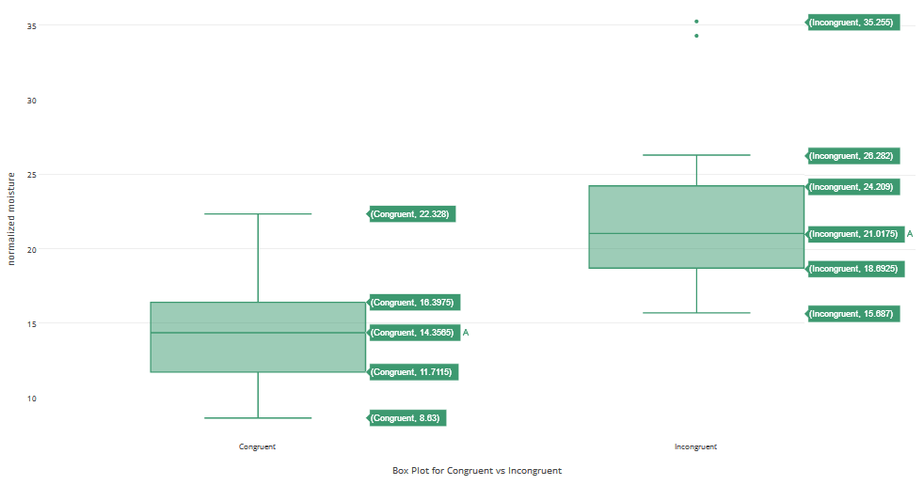

# Perform the statistical test and interpreting results

Statistical test has been performed at 95% confident level and results are depicted in below table, tests includes test statistic, p-value.

|  |  |  |
| --- | --- | --- |
| **degree of freedom** | 23 |  |
| **significance level(Alpha)** | 0.05 | 95% |
| **t Critical** | 2.069 |  |
| **Mean of X D** | -7.9647917 |  |
| **SXD (standard deviation of the diff)** | 4.8648269 |  |
| **mean difference SE** | 0.9930286 |  |
| **T Statistic** | -8.0207069 |  |
| **P Value** | < 0.002 |  |
| **CI** | -10.019368 | -5.91021542 |

T Statistic does not falls within t Critical range i.e. [-2.069, +2.069] and test statistic is extremely less than -2.069 or greater than 2.069, Null hypothesis is rejected in favor of the alternative hypothesis. Mean time for color recognition for congruent words Set vs. incongruent words Set are not same and are different.

P-value, < 0.002, is less than α = 0.05, we reject the null hypothesis (H0: μC - μI = 0) in favor of the alternative hypothesis (HA: μC ≠ μI ).

We are 95% confident that the mean difference between "before" and "after" is between [-10.019368,-5.91021542]

Since mean difference between samples is –ve, there is significant increase in real time to read incongruent words set when compared with congruent words set.

# Digging deeper and extending the investigation

Detecting words and reading is easier for brain when compared with color of the words.

# References

1. <https://en.wikipedia.org/wiki/Stroop_effect>
2. <https://faculty.washington.edu/chudler/java/ready.html>
3. <https://docs.google.com/document/d/1-OkpZLjG_kX9J6LIQ5IltsqMzVWjh36QpnP2RYpVdPU/pub?embedded=True>
4. <http://www2.le.ac.uk/offices/ld/resources/numerical-data/variability>
5. <http://www2.le.ac.uk/offices/ld/resources/numerical-data/variability>
6. <http://www.sjsu.edu/faculty/gerstman/StatPrimer/t-table.pdf>
7. <http://www.mathportal.org/calculators/statistics-calculator/t-test-calculator.php>
8. <http://www.statisticssolutions.com/dependent-sample-t-test/>
9. <https://plot.ly/create/box-plot/>

# Revision History:

1. 0.1 – initial revision
2. 0.2 – updated to consider for 2 tail t-test
3. 0.3 – updated for additional visual representations