Experiment No 1 Area Of Triangle

<!DOCTYPE html>

<html lang="en">

<head>

    <meta charset="UTF-8">

    <meta name="viewport" content="width=device-width, initial-scale=1.0">

    <title>Document</title>

</head>

<body>

    <script>

        var base = parseInt(prompt("Enter the base: "));

        var height = parseInt(prompt("Enter the height: "));

        //Calculating the area

        var area = (base * height) / 2;

        //Display Output

        document.writeln("Base: " + base);

        document.writeln("<br>");

        document.writeln("Height: " + height);

        document.writeln("<br>");

        document.writeln("The area of the triangle is " + area);

    </script>

</body>

</html>

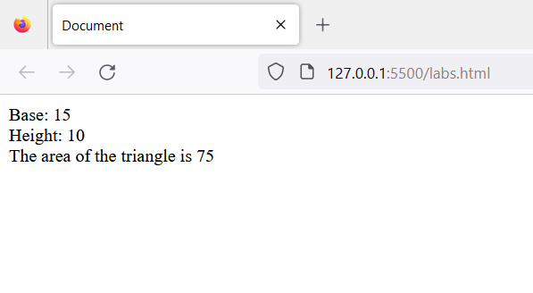

Experiment 2 Tabel

<!DOCTYPE html>

<html lang="en">

<head>

    <meta charset="UTF-8">

    <meta name="viewport" content="width=device-width, initial-scale=1.0">

    <title>Document</title>

</head>

<body>

    <script>

        // program to generate a multiplication table

        // take input from the user

        const number = parseInt(prompt('Enter an integer: '));

        //creating a multiplication table

        for (let i = 1; i <= 10; i++) {

            // multiply i with number

            const result = i * number;

            // display the result

            document.write(`${number} * ${i} = ${result} <br>`);

        }

    </script>

</body>

</html>

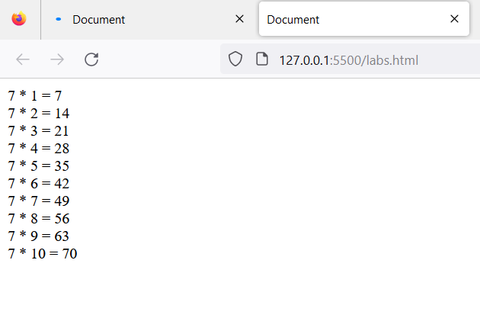

Experiment 3a Reverse string

<!DOCTYPE html>

<html lang="en">

<head>

    <meta charset="UTF-8">

    <meta name="viewport" content="width=device-width, initial-scale=1.0">

    <title>Document</title>

</head>

<body>

    <script>

        function reverseString(str) {

            // empty string

            let newString = "";

            for (let i = str.length - 1; i >= 0; i--) {

                newString += str[i];

            }

            return newString;

        }

        // take input from the user

        const string = prompt('Enter a string: ');

        const result = reverseString(string);

        document.write(result);

    </script>

</body>

</html>

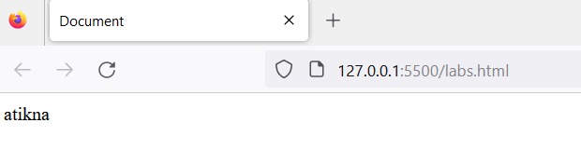

Experiment 3b Replace String

<!DOCTYPE html>

<html lang="en">

<head>

    <meta charset="UTF-8">

    <meta name="viewport" content="width=device-width, initial-scale=1.0">

    <title>Document</title>

</head>

<body>

    <script>

        const string = 'Mr Red has a red house and a red car';

        // replace the characters

        const newText = string.replace('red', 'blue');

        // display the result

        document.write(newText);

    </script>

</body>

</html>

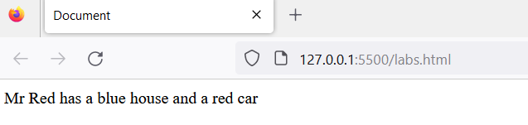

Experiment 3c Palindrome

<!DOCTYPE html>

<html lang="en">

<head>

    <meta charset="UTF-8">

    <meta name="viewport" content="width=device-width, initial-scale=1.0">

    <title>Document</title>

</head>

<body>

    <script>

        // function that check str is palindrome or not

        function check_palindrome(str) {

            let j = str.length - 1;

            for (let i = 0; i < j / 2; i++) {

                let x = str[i];//forward character

                let y = str[j - i];//backward character

                if (x != y) {

                    // return false if string not match

                    return false;

                }

            }

            /// return true if string is palindrome

            return true;

        }

        //function that print output is string is palindrome

        function is_palindrome(str) {

            let ans = check_palindrome(str);

            //condition checking ans is true or not

            if (ans == true) {

                document.write("passed string is palindrome <br>");

            }

            else {

                document.write("passed string not a palindrome");

            }

        }

        // test variable

        let test = "racecar";

        is_palindrome(test);

    </script>

</body>

</html>

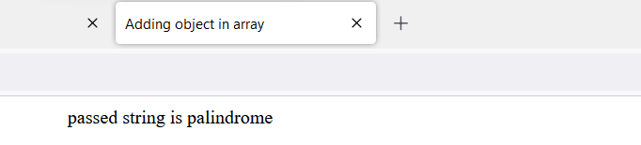

Experiment 4a Compare Two Strings

<!DOCTYPE html>

<html lang="en">

<head>

    <meta charset="UTF-8">

    <meta name="viewport" content="width=device-width, initial-scale=1.0">

    <title>Document</title>

</head>

<body>

    <script>

        const string1 = 'JavaScript Program';

        const string2 = 'javascript program';

        // compare both strings

        const result = string1.toUpperCase() === string2.toUpperCase();

        if (result) {

            document.write('The strings are similar.');

        } else {

            document.write('The strings are not similar.');

        }

    </script>

</body>

</html>

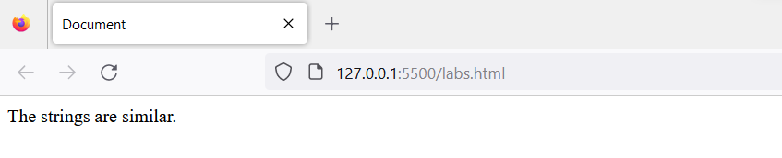

Experiment 4b

<!DOCTYPE html>

<html lang="en">

<head>

    <meta charset="UTF-8">

    <meta name="viewport" content="width=device-width, initial-scale=1.0">

    <title>Document</title>

</head>

<body>

    <script>

        // Method 2: JS String Comparison Using RegEx

        const string1 = 'JavaScript Program';

        const string2 = 'javascript program';

        // create regex

        const pattern = new RegExp(string1, "gi");

        // compare the stings

        const result = pattern.test(string2)

        if (result) {

            document.write('The strings are similar.');

        } else {

            document.write('The strings are not similar.');

        }

    </script>

</body>

</html>



Experiment 4c

<!DOCTYPE html>

<html lang="en">

<head>

    <meta charset="UTF-8">

    <meta name="viewport" content="width=device-width, initial-scale=1.0">

    <title>Document</title>

</head>

<body>

    <script>

        // Method 3: Using localeCompare() [Recommended Method]

        // program to perform case insensitive string comparison

        const string1 = 'JavaScript Program';

        const string2 = 'javascript program';

        const result = string1.localeCompare(string2, undefined, { sensitivity: 'base' });

        if (result == 0) {

            document.write('The strings are similar.');

        } else {

            document.write('The strings are not similar.');

        }

    </script>

</body>

</html>



Experiment 5 Count Down Timer

<!DOCTYPE html>

<html lang="en">

<head>

    <meta charset="UTF-8">

    <meta name="viewport" content="width=device-width, initial-scale=1.0">

    <title>Document</title>

</head>

<body>

    <script>

        // Experiment 5: Program to create a countdown timer

        // time to countdown from (in milliseconds)

        let countDownDate = new Date().getTime() + 24 * 60 * 60 * 1000;

        // countdown timer

        let x = setInterval(function () {

            // get today's date and time in milliseconds

            let now = new Date().getTime();

            // find the interval between now and the countdown time

            let timeLeft = countDownDate - now;

            // time calculations for days, hours, minutes and seconds

            const days = Math.floor(timeLeft / (1000 * 60 * 60 * 24));

            const hours = Math.floor((timeLeft / (1000 * 60 * 60)) % 24);

            const minutes = Math.floor((timeLeft / 1000 / 60) % 60);

            const seconds = Math.floor((timeLeft / 1000) % 60);

            // display the result in the element with id="demo"

            document.write(days + "d " + hours + "h " + minutes + "m " + seconds + "s <br>");

            // clearing countdown when complete

            if (timeLeft < 0) {

                clearInterval(x);

                document.write('CountDown Finished');

            }

        }, 2000);

    </script>

</body>

</html>

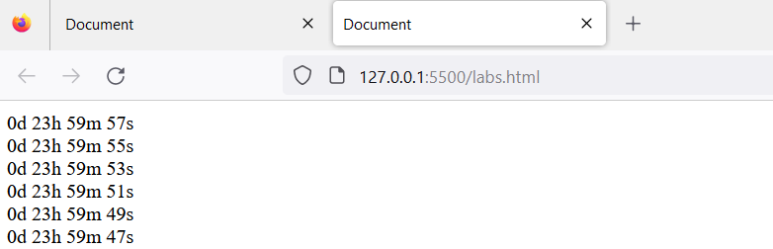

Experiment 6a Remove Array element

<!DOCTYPE html>

<html lang="en">

<head>

    <meta charset="UTF-8">

    <meta name="viewport" content="width=device-width, initial-scale=1.0">

    <title>Document</title>

</head>

<body>

    <script>

        //Program 6a: Program to remove specific element from Array Object

        function remove_array_element(array, n) {

            var index = array.indexOf(n);

            if (index > -1) {

                array.splice(index, 1);

            }

            return array;

        }

        document.write(remove_array_element([2, 5, 9, 6], 5));

    </script>

</body>

</html>

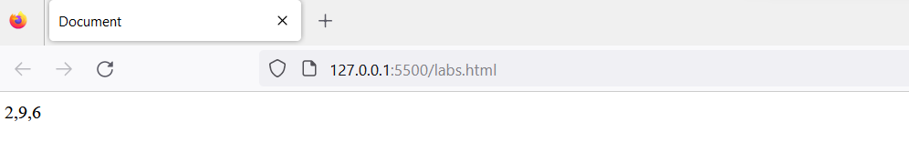

Experiment 6b Contained Specified Value

<!DOCTYPE html>

<html lang="en">

<head>

    <meta charset="UTF-8">

    <meta name="viewport" content="width=device-width, initial-scale=1.0">

    <title>Document</title>

</head>

<body>

    <script>

        // Exp 6 b: program to check if an array contains a specified value

        const array = ['you', 'will', 'learn', 'javascript'];

        const hasValue = array.includes('javascript');

        // check the condition

        if (hasValue) {

            document.write('Array contains a value.');

        } else {

            document.write('Array does not contain a value.');

        }

    </script>

</body>

</html>

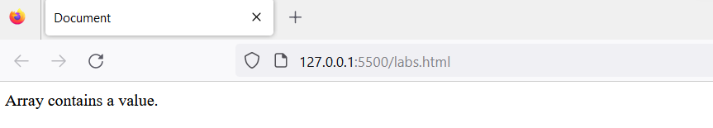

Experiment 6c Empty Array

<!DOCTYPE html>

<html lang="en">

<head>

    <meta charset="UTF-8">

    <meta name="viewport" content="width=device-width, initial-scale=1.0">

    <title>Document</title>

</head>

<body>

    <script>

        //Exp 6c: Program to empty an array

        //Method 1

        function emptyArray(arr) {

            // substituting new array

            arr = [];

            return arr;

        }

        const array = [1, 2, 3];

        document.write(array);

        // call the function

        const result = emptyArray(array);

        document.write(result);

    </script>

</body>

</html>

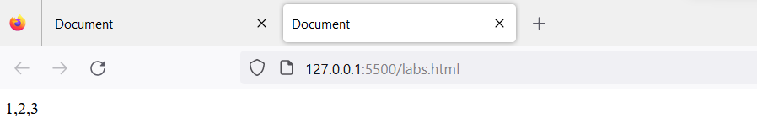

Experiment 7a Object is an array

<!DOCTYPE html>

<html lang="en">

<head>

    <meta charset="UTF-8">

    <meta name="viewport" content="width=device-width, initial-scale=1.0">

    <title>Document</title>

</head>

<body>

    <script>

        let myArray = [1, 2, 3];

        document.write("myArray "+myArray+ '<br>');

        let myObject = { name:"omkar" };

        document.write("myObject "+myObject+ '<br>');

        myArray.push(myObject);

        document.write("New Array "+myArray+ '<br>');

        if (Array.isArray(myObject)) {

            document.write('The object is an array. <br>');

        } else {

            document.write('The object is not an array. <br>');

        }

        if (myArray.includes(myObject)) {

            document.write('The array contains the object. <br>');

        } else {

            document.write('The array does not contain the object. <br>');

        }

        if (Array.isArray(myArray)) {

            document.write('myArray is an array. <br>');

        } else {

            document.write('myArray is not an array. <br>');

        }

    </script>

</body>

</html>

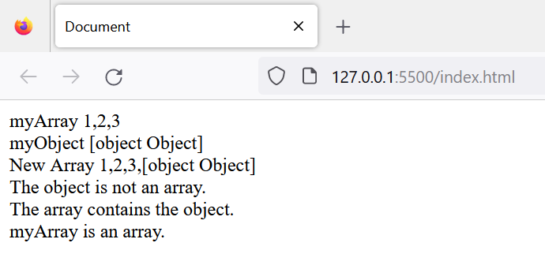

Experiment 7b Adding object in array

<!DOCTYPE html>

<html>

<head>

    <title>Adding object in array</title>

    <style>

        body {

            text-align: center;

        }

    </style>

</head>

<body>

    <h1 style="color: green">Geeksforgeeks</h1>

    <p>Click the button to add new elements to the array.</p>

    <button onclick="spliceFunction()">Add elements</button>

    <p id="geeks"></p>

    <script>

        var list = ["HTML", "CSS", "JavaScript"];

        document.getElementById("geeks").innerHTML = list;

        function spliceFunction() {

            list.splice(2,0,"Angular", "SQL", );

            document.getElementById("geeks").innerHTML = list;

        }

    </script>

</body>

</html>

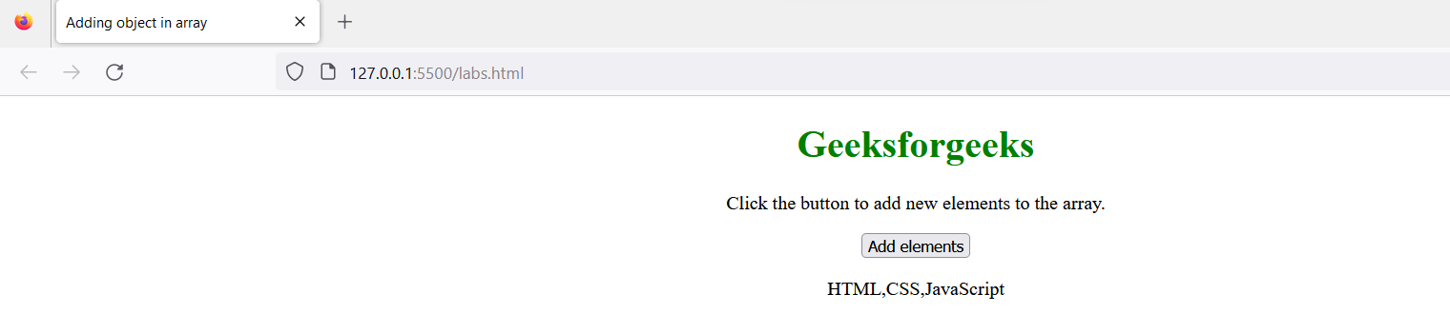

Experiment No 8a Set operations

<!DOCTYPE html>

<html>

<head>

    <title>Set Union Operation</title>

</head>

<body>

    <h1>Set Union Operation</h1>

    <p id="output"></p>

    <script>

        // Define two sets as arrays

        var set1 = [1, 2, 3, 4];

        var set2 = [3, 4, 5, 6];

        // Function to perform the union operation on two sets

        function union(setA, setB) {

            var result = [...new Set([...setA, ...setB])];

            return result;

        }

        // Perform the union operation

        var unionResult = union(set1, set2);

        // Display the results on the webpage

        var outputElement = document.getElementById("output");

        outputElement.innerHTML = "Union of set1 and set2: " + JSON.stringify(unionResult);

    </script>

</body>

</html>

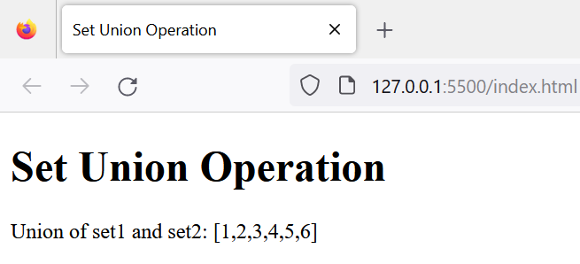

Experiment 8b Set Intersection

<!DOCTYPE html>

<html>

<head>

    <title>Set Intersection</title>

</head>

<body>

    <h1>Set Intersection</h1>

    <p id="output"></p>

    <script>

        // Function to perform set intersection

        function intersection(setA, setB) {

            return new Set([...setA].filter(x => setB.has(x)));

        }

        // Define two sets

        var setA = new Set([1, 2, 3, 4, 5]);

        var setB = new Set([3, 4, 5, 6, 7]);

        // Perform intersection

        var resultSet = intersection(setA, setB);

        // Display the results on the webpage

        var outputElement = document.getElementById("output");

        outputElement.innerHTML = "Set A: " + [...setA] + "<br>";

        outputElement.innerHTML += "Set B: " + [...setB] + "<br>";

        outputElement.innerHTML += "Intersection: " + [...resultSet];

    </script>

</body>

</html>

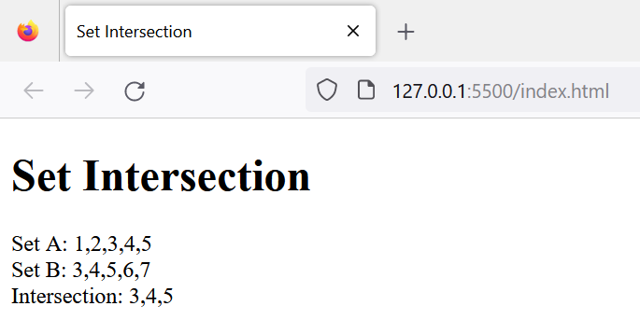

Experiment 8c Set Difference

<!DOCTYPE html>

<html>

<head>

    <title>Set Difference Operation</title>

</head>

<body>

    <h1>Set Difference Operation</h1>

    <p id="output"></p>

    <script>

        // Define two sets (arrays) a and b

        var setA = [1, 2, 3, 4, 5];

        var setB = [3, 4, 6, 7, 8];

        // Function to perform set difference operation

        function setDifference(setA, setB) {

            return setA.filter(item => !setB.includes(item));

        }

        // Perform the set difference operation

        var differenceResult = setDifference(setA, setB);

        // Display the results on the webpage

        var outputElement = document.getElementById("output");

        outputElement.innerHTML = "Set A: " + JSON.stringify(setA) + "<br>";

        outputElement.innerHTML += "Set B: " + JSON.stringify(setB) + "<br>";

        outputElement.innerHTML += "Set Difference (A - B): " + JSON.stringify(differenceResult);

    </script>

</body>

</html>

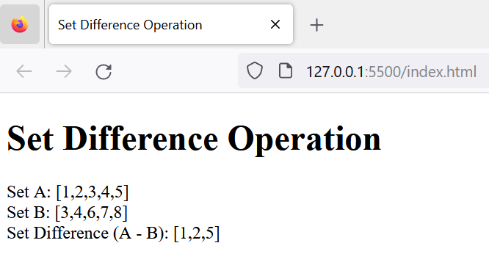

Experiment 9 Change Background color

HTML File

<!DOCTYPE html>

<html lang="en">

<head>

    <meta charset="UTF-8">

    <meta http-equiv="X-UA-Compatible" content="IE=edge">

    <meta name="viewport" content="width=device-width, initial-scale=1.0">

    <title>Experiment-9</title>

    <script src="Exp9.js">

    </script>

</head>

<body>

    <h1 id="head1" onmouseover="changeColor1()" onmouseout="changeColor2()"> Experiment-9</h1>

    <h2> JavaScript program to change background color of Webpage On mouse over event</h2>

    <p>We are using mousever Event to Change the Background Color</p>

</body>

</html>

JavaScript File

function changeColor1() {

    document.body.style.backgroundColor = "red";

}

function changeColor2() {

    document.body.style.backgroundColor = "yellow";

}

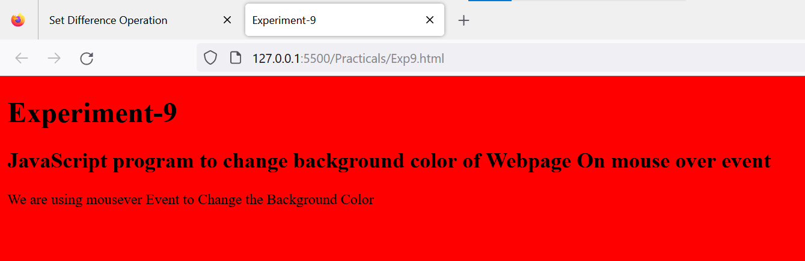

Experiment 10

HTML File

<!DOCTYPE html>

<html lang="en">

<head>

    <meta charset="UTF-8">

    <meta http-equiv="X-UA-Compatible" content="IE=edge">

    <meta name="viewport" content="width=device-width, initial-scale=1.0">

    <title>Document</title>

    <script src="/Exp10a.js"></script>

</head>

<body>

    <h1>Experiment-10</h1>

    <h2>Form Validation Example</h2>

    <br>

    <h1>Sign Up Form</h1>

    <form name="myForm"  action="/thankyou.html" onsubmit="return validate()" >

        <label for="fname"> First name</label>

        <input type="text" id="fname" name="fname" placeholder="Enter First Name" required>

        <label for="lname">Last Name</label>

        <input type="text" id="lname" name="lname" placeholder="Enter Last Name" >

        <br>

        <br>

        <label for="usremail">Email</label>

        <input type="email" id="usremail" name="usremail" placeholder="Enter Email here" >

        <label for="usrpassword">Password</label>

        <input type="password" id="usrpassword" name="usrpassword" placeholder="Enter Password" >

        <br>

        <br>

        <p>Gender ?</p>

        <label for="male"> Male</label>

        <input type="radio" id="male" name="option">

        <label for="female"> Female </label>

        <input type="radio" id="female" name="option">

        <p></p>

        <label for="usrmobile">Mobile Number</label>

        <input type="text" id="usrmobile" name="usrmobile" placeholder="Mobile Number" required>

        <p></p>

        <input type="submit" name="" id="" value="submit">

    </form>

</body>

</html>

JavaScript File

function validate() {

    var firstName = document.myForm.fname.value;

    var lastName = document.myForm.lname.value;

    var userpassword = document.myForm.usrpassword.value;

    var usrmobile = document.myForm.usrmobile.value;

    console.log(firstName);

    console.log(lastName);

    console.log(userpassword);

    console.log(usrmobile);

    if (firstName == null || firstName == "" || firstName.length<3 ) {

        alert("First Name can't be blank or Less than 3 Charecter");

        document.myForm.fname.focus();

        return false;

    }

    if (lastName == null || lastName == "") {

        alert("Last Name can't be blank");

        document.myForm.lname.focus();

        return false;

    }

    if (userpassword.length < 6) {

        alert("Password must be at least 6 characters long.");

        document.myForm.usrpassword.focus();

        return false;

    }

    if (isNaN(usrmobile)) {

        alert("Enter Numeric value only");

        document.myForm.usrmobile.focus();

        return false;

    }

    return true;

}

**HTML file**

<!DOCTYPE html>

<html lang="en">

<head>

<meta charset="UTF-8">

<meta http-equiv="X-UA-Compatible" content="IE=edge">

<meta name="viewport" content="width=device-width, initial-scale=1.0">

<title>Acknowledge</title>

</head>

<body>

<h1>Thank you..! </h1>

<h2> Your Registration is Completed</h2>

</body></html>

