Mittheilungen Data New
Table of contents

Mittheilungen Data : Databases of sunspot counts collected from multiple observers by Professor Rudolf Wolf. It’s the primary source of sunspot data.
Importing functions from scripts file. All the data used is in the folder data
Observers are grouped by FK_OBSERVERS.
Number of Observers by FK_OBSERVERS: 148
Number of observers by ALIAS: 144
Number of observes by ALIAS(144) is different from
number of observers by FK_OBSERVERS(148).
One of the ALIAS has multiple FK_OBSERVERS IDs.
Checking ALIAS'es with multiple FK_OBSERVERS IDs.
Broger has multiple FK_OBSERVERS IDs.
FK_OBSERVERS IDs associated with Broger are [104 117]
==================================================
OBSERVER STATISTICS
==================================================
Total unique observers: 148
Observation period: 1849-01-01 00:00:00 to 1944-12-31 00:00:00
Total observation span: 96.0 years

1 Timeline of the observers
TODO: Plot only top 10 to 20 observers
Figure 1 is a timeline plot showing actual observation days for all observers in Mittheilungen data. X-axis is time in years, and in Y-axis we have observers sorted by start date, and number of observations for each observer is shown in the parantheses.
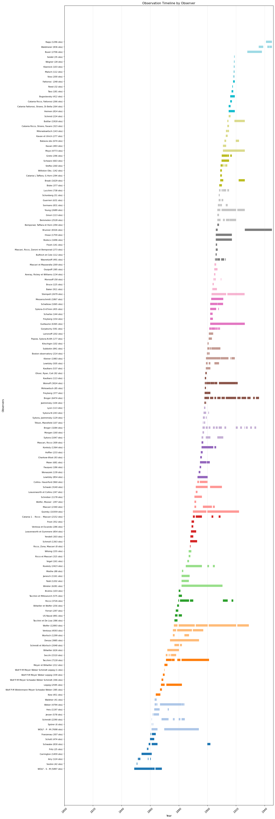
Figure 1: Plot showing actual observation days for all observers in Mittheilungen data

2 Bubble plot of the observers
Figure 2 is a bubble plot showing all observers in Mittheilungen data. X-axis is start date, Y-axis is end date, size of the bubble is the number of observations, color is the number of observation years, hover name is the alias, and text is the alias.
Unable to display output for mime type(s): text/html
(a) Bubble plot showing all observers in Mittheilungen data

Unable to display output for mime type(s): text/html
(b)
Figure 2

3 Animated bubble plot of the observers
Figure 3 is similar to Figure 2 but with animation over the start year.
Unable to display output for mime type(s): text/html
Figure 3: Animated bubble plot showing all observers in Mittheilungen data.

