Project Overview
Developed a full-stack message storage application using HTML, CSS, JavaScript, Python Flask, and MySQL. The project follows a 3-tier architecture with clear separation between frontend, backend, and database layers.
Development (using AI)
Built an interactive frontend using HTML, CSS to handle user interactions and UI design.
Implemented backend logic using Python Flask to manage APIs, requests, and business logic.
Used MySQL as the database to store and manage application data efficiently.
Version Control
Managed the entire source code using Git and GitHub.
Tracked changes, maintained repository history, and enabled collaborative development practices.
CI/CD Automation
Integrated Jenkins to build a CI/CD pipeline for automated workflow.
Automated code build, testing, and deployment whenever changes were pushed to GitHub.
Containerization
Used Docker and Docker Compose to containerize the application.
Managed frontend, backend, and database as separate services for consistent deployment across environments.
DevOps Implementation
Automated the complete deployment process to reduce manual effort and improve efficiency.
Ensured faster delivery and reliable application deployment using DevOps best practices.
Conclusion
This project helped in understanding real-world full-stack development along with DevOps tools and automation. It improved practical knowledge of CI/CD pipelines, containerization, and production-level deployment workflows.

A 3-Tier Full Stack Application with frontend, backend, and database architecture integrated using DevOps CI/CD automation.
Used technologies:
1.Github
2.Jenkins(CICD)
3.Docker
4.Python-flask(Backend)
5.HTML and CSS(Frontend)
6.Mysql(Database)

First, clone the project repository from https://github.com/chandusaigari/project and open it in VS Code.

After making changes, push the code to your GitHub repository using the following

Git commands:
git init
git clone https://github.com/chandusaigari/project.git
git branch -M main
git status
git remote add origin https://github.com/your_username/project
git add .
git commit -m "code committed"
git push origin main

Now the code will be available in your GitHub repository.
If your repository already contains files, use `git pull origin main` before pushing the code, because the files in github may not contain in your local vscode folder.
Make sure you downloaded Jenkins and docker for this project without those , this project would not happen .
what to do next after pushing to github?

After installing successfully Jenkins and docker do these below steps,
Open any distro of linux like Ubuntu latest version.
Type the command for starting Jenkins as shown in below picture

After this your Jenkins will start and you can access Jenkins from browser with
localhost://8080.

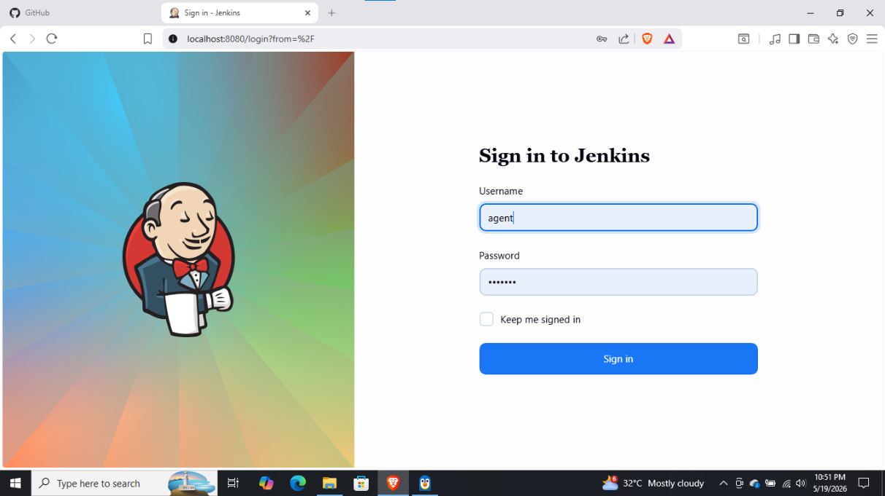

You need to sign in with your Jenkins username and password
After sign in you will get the Jenkins dashboard like this below one.
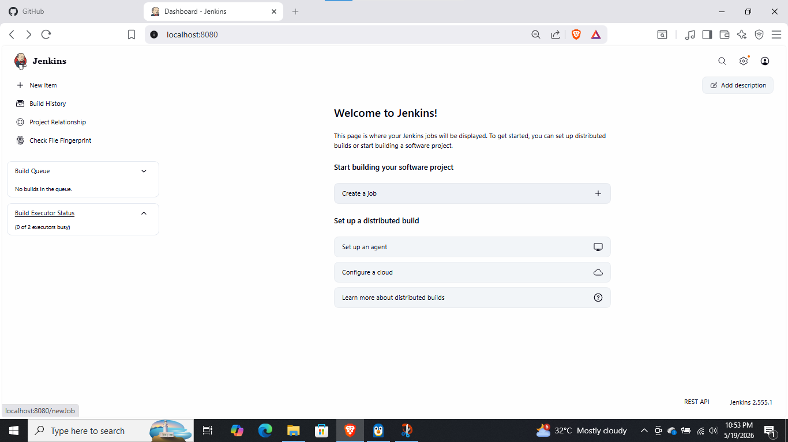
Build your First Job by clicking the above mentioned button
The Outcome will be :
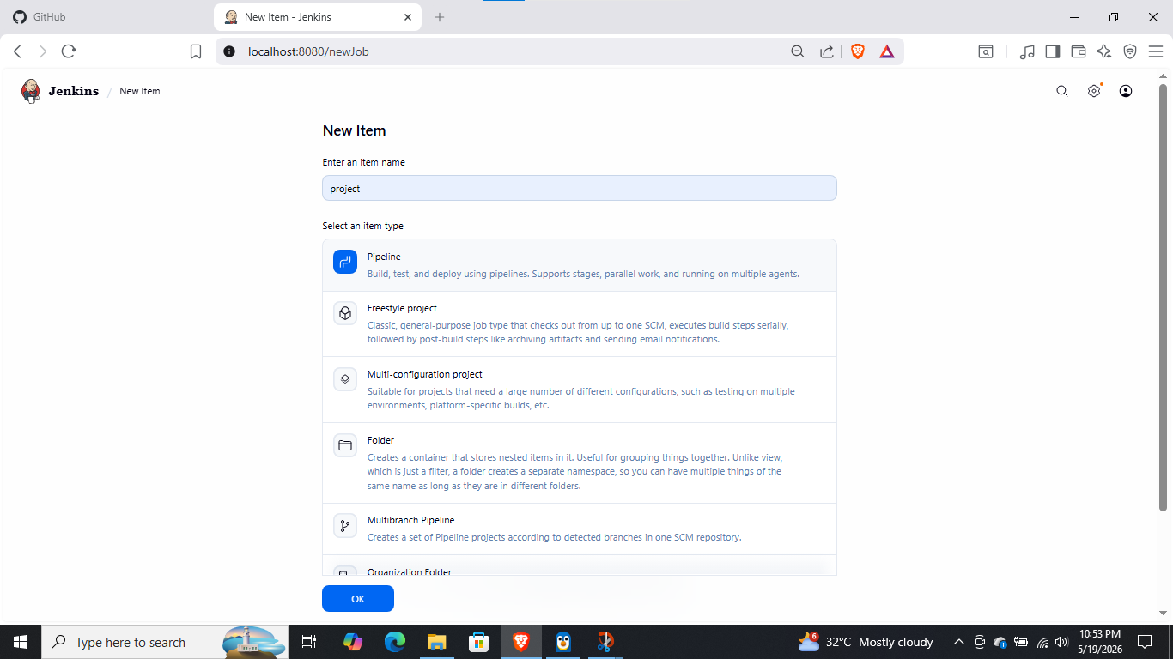
Make sure that your repository name & Job name should be same , select the pipeline
After saving ,you will be redirect to configure page then you need to choose the pipeline script from scm .
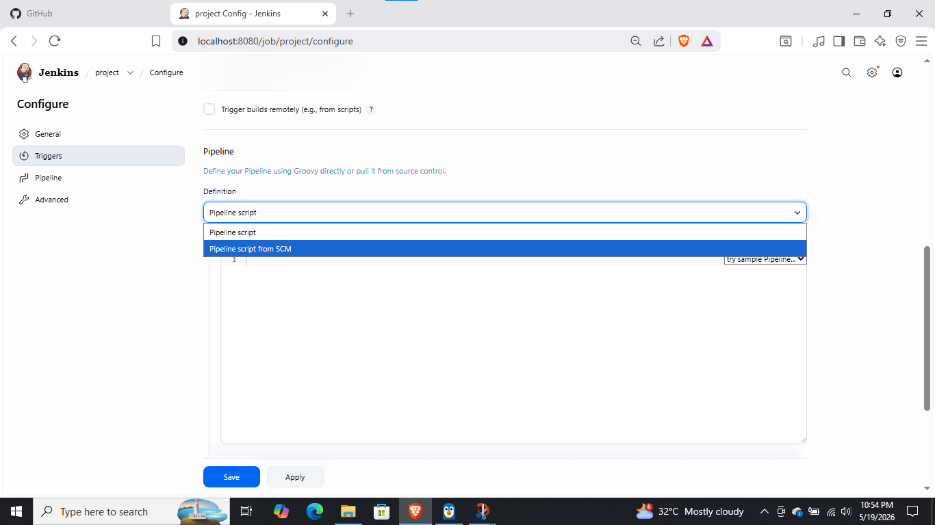

Now select the scm- source code management as Git

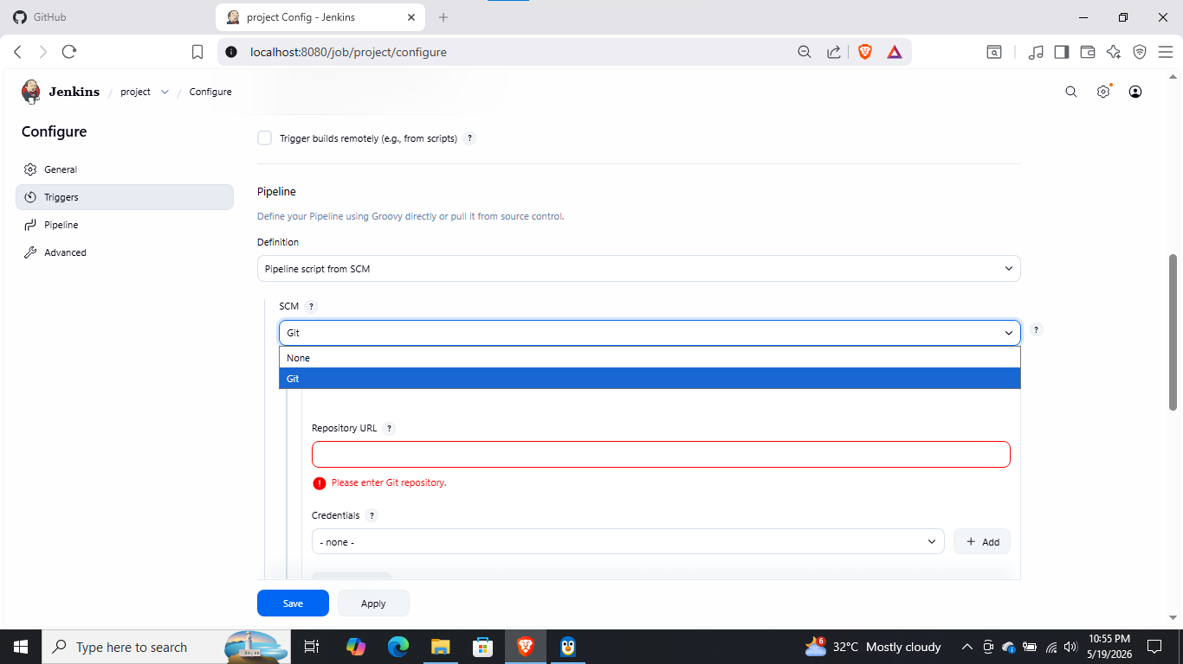
Now add the URL of your project in the Repository URL
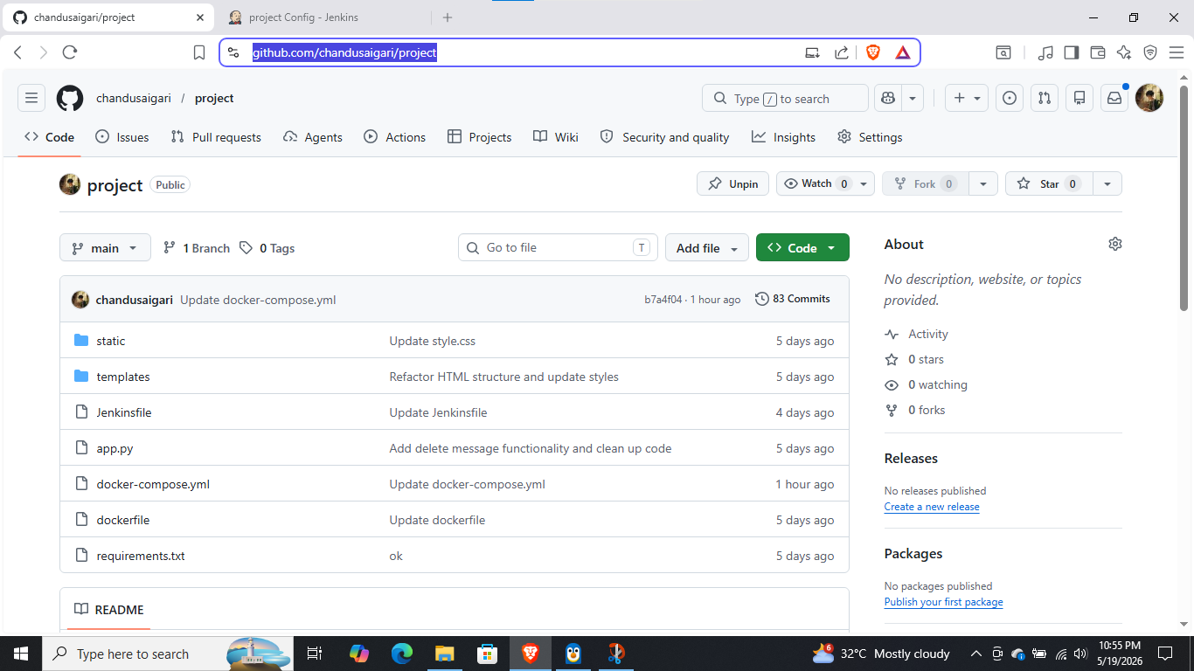
If your project repo is not private no need to add credentials if it is private make sure you need to add github credentials.
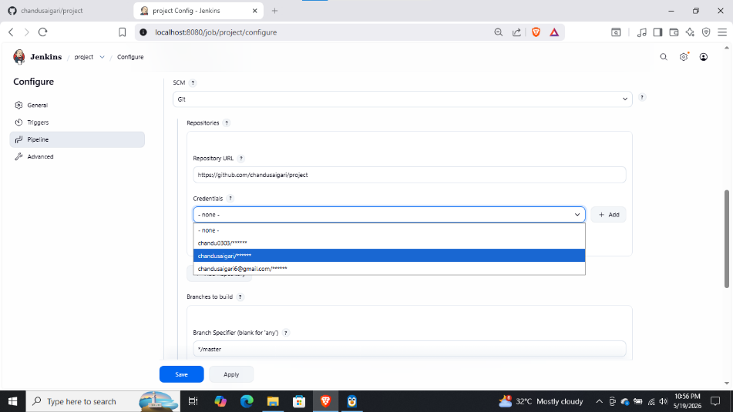

Select the branch of your repo based on your project either it is main or master branch.
After applying and save , you can build the Job by pressing the button
BUILD NOW
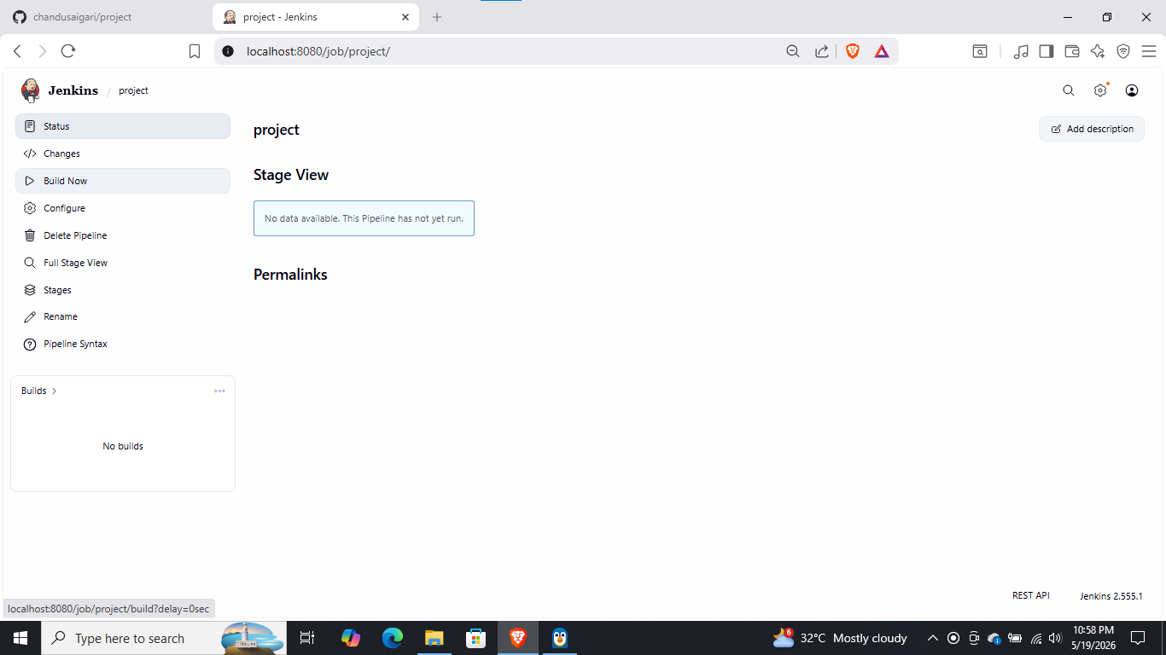

As you can see, by clicking BUILD NOW your job will get started..

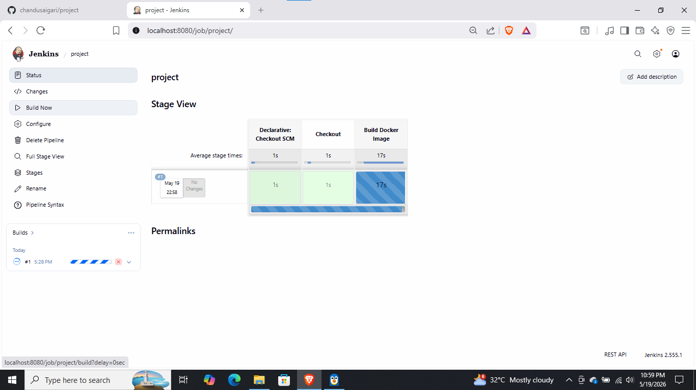
To visualize the pipeline like above, install Blue ocean plugin from manag Jenkins & plugins installation page.
Also you can see the pipeline flow from console output to view the process
Benefits of viewing console is to know the failure at what point it is happened
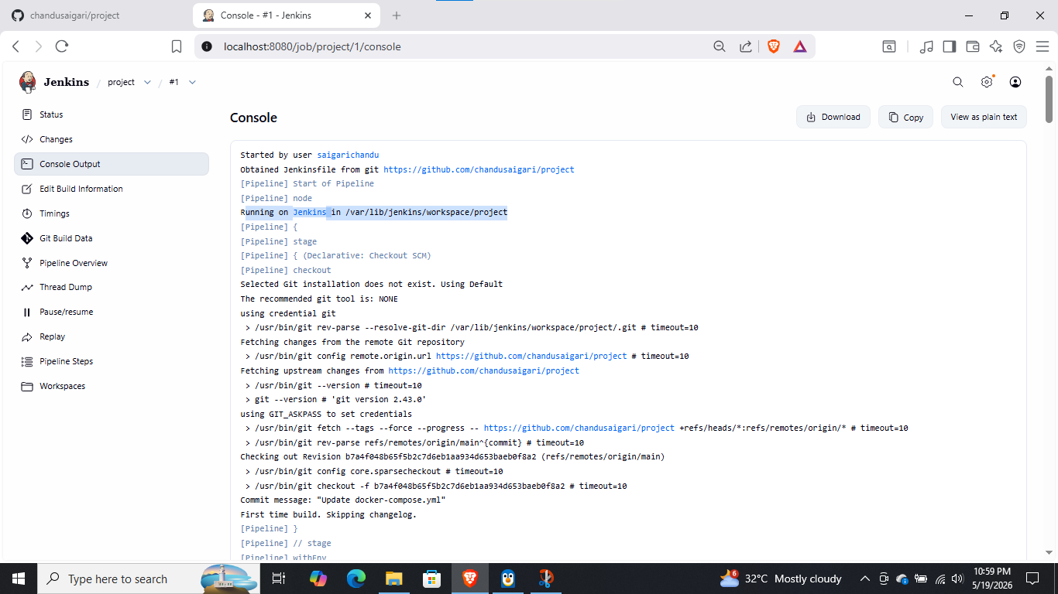

Make sure the docker is also running in background if not run the command in your terminal as shown below.
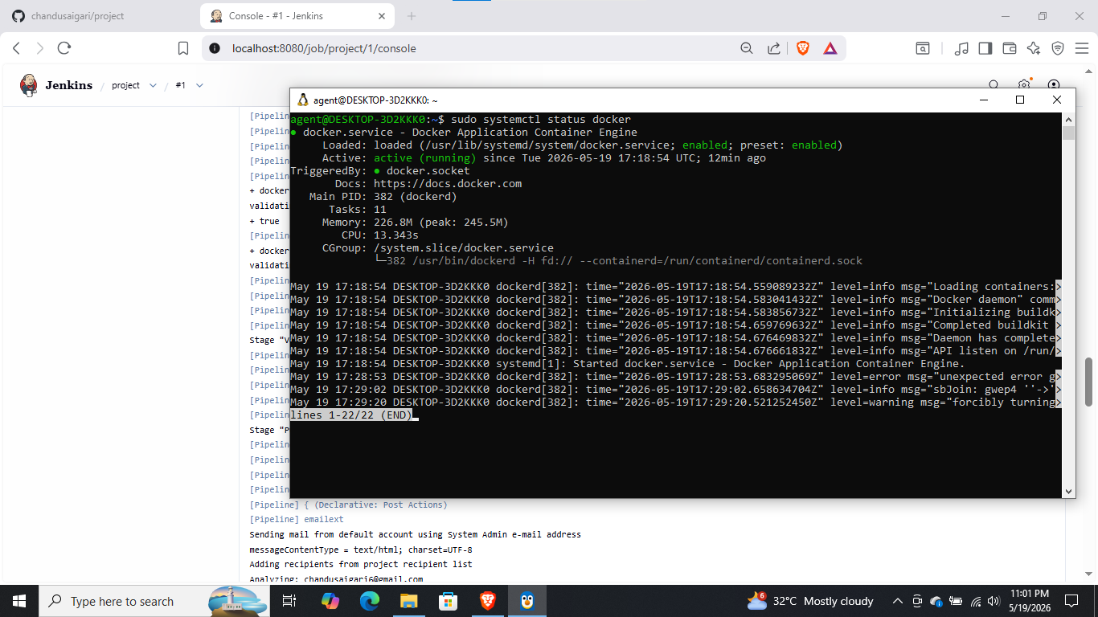
Without docker running we canot containerize the application of what we building
After docker run ,check the console for on going process
You can see we got a failure in pipeline
We need to check it in console output for knowing what is the actual error is
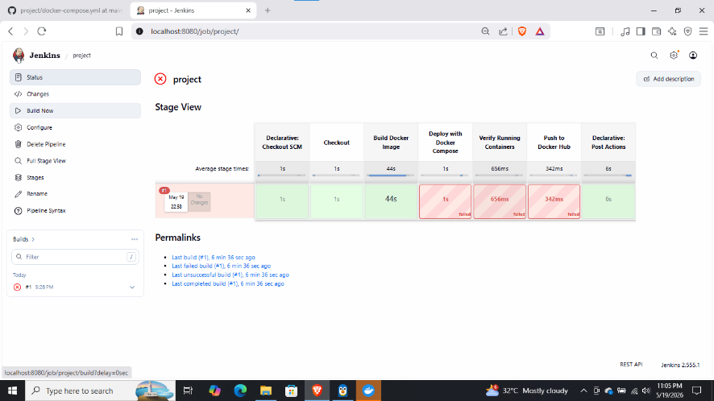

In console output
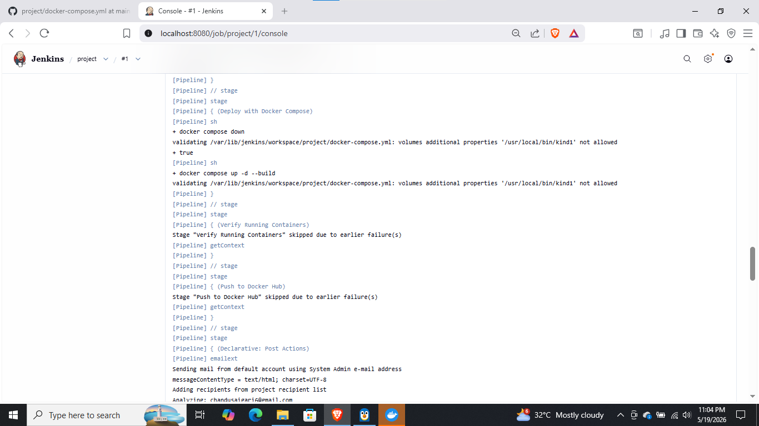
It was saying that we did not allowed the Jenkins to access docker
Solution is in terminal ,run the command :sudo usermode -aG docker Jenkins
By this we will give the access Jenkins from docker
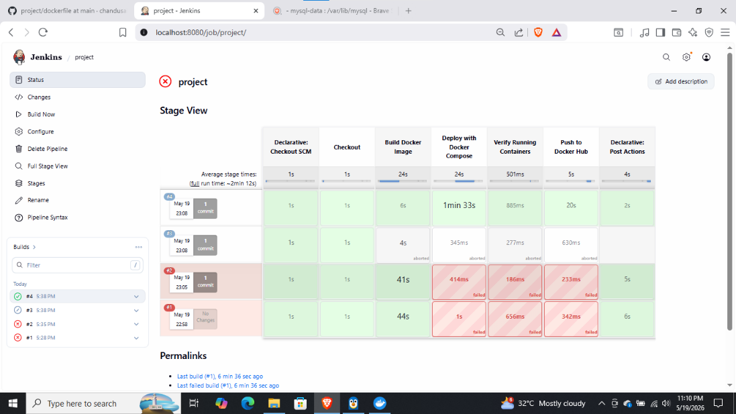
As you can see our Job as successfully done.
To check the Job done correctly or not we need to check the docker containers running and open your application from browser
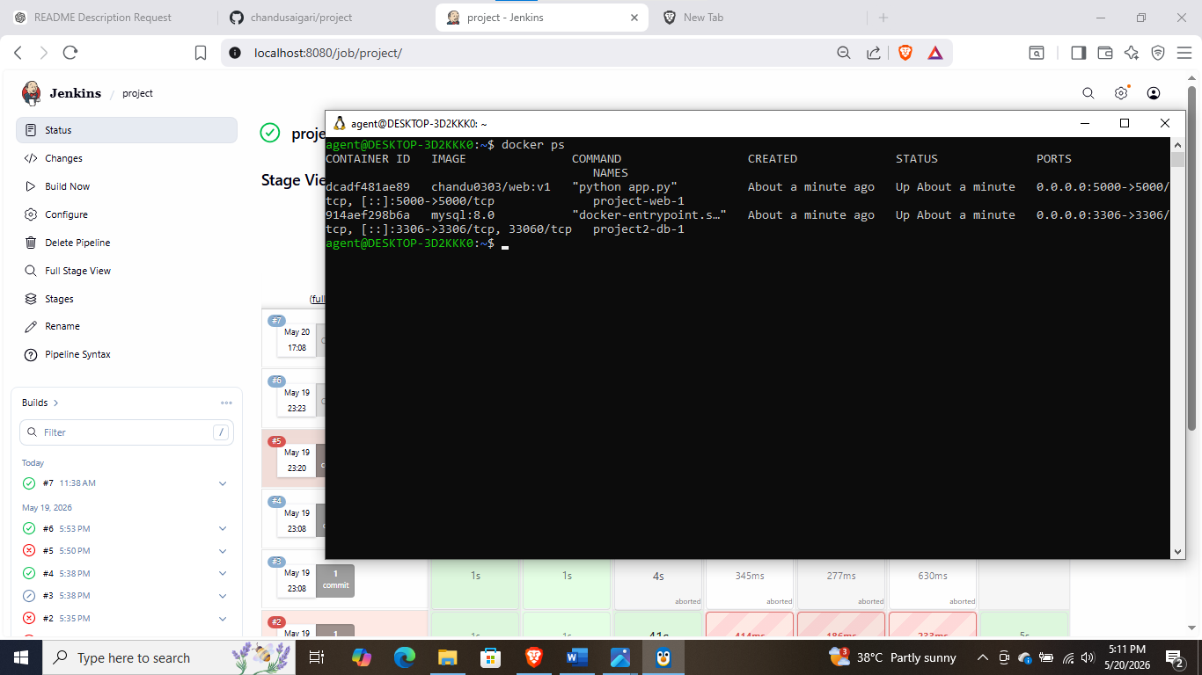
Using docker ps command, you can check the running containers and also see at what port your application running
Mine is localhost://5000. Run this in web browser
you will get final running application like this
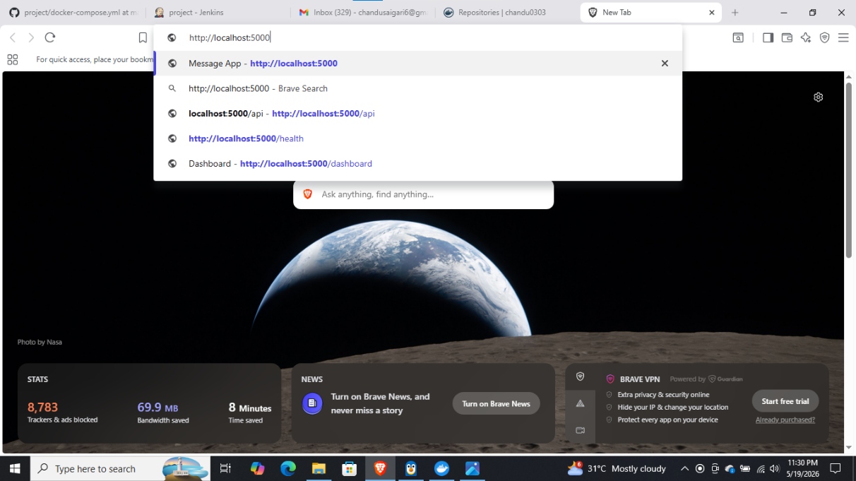
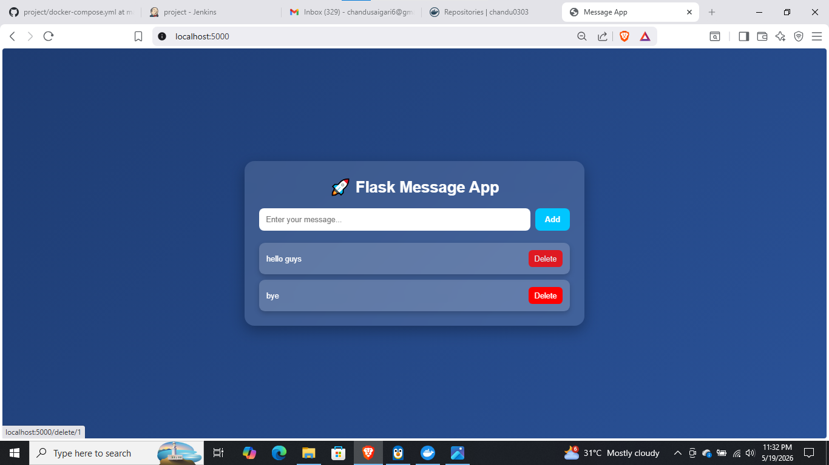
Click on this link for step by step process from an end to end picture flow:

Check the YOUTUBE VIDEO for clear explanation:

Future Scope:
This project can be enhanced by migrating from Docker Compose to Kubernetes for better scalability, load balancing, auto-scaling, and self-healing capabilities. Kubernetes will help manage the application more efficiently in production environments.
For monitoring, Prometheus can be used to collect real-time metrics like CPU, memory, and request performance, while Grafana can visualize these metrics through dashboards for better system insights.
These improvements will make the application more scalable, reliable, and suitable for cloud-native production deployment.

Contact
I am actively seeking opportunities to apply my skills in DevOps & realated fields .
If you find my project interesting, I would be grateful for an opportunity to contribute and prove my abilities in a professional environment.
You can reach me at:
Email: chandusaigari6@gmail.com
Phone: +91-7396618269

