E-COMMERCE SALES ANALYSIS
ANALYST INSIGHTS REPORT

📅 Reporting Period : 01-01-2026 – 31-03-2026
👤 Prepared By : CHANDU
📌 Department : Data Analytics / BI Team
🎯 Prepared For : Stakeholder Name/Team

STAKEHOLDERS QUESTION?
Q1.Which products are driving the highest revenue?
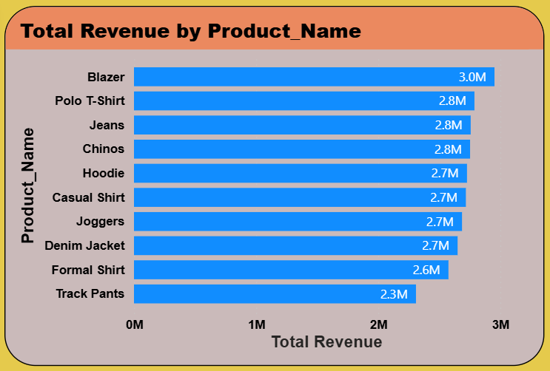

KEY OBSERVATIONS:
. Top 3 products account for 31.57M of total revenue
• Track Pants sells 1069 units but generates only 2.3M due to customer not satisfied
.37.98% of products are high-volume but low-revenue
WHAT I FOUND:
• Revenue is concentrated in 3 products
• WEAK correlation between volume and revenue
• Average revenue per unit: 2250
RECOMMENDATIONS:
- Bundle Polo T-shirt with Jeans to increase Revenue
- Focus 5% marketing budget on top 3 revenue products

Q2. Which cities are performing best, and how does delivery time affect customer satisfaction there?
KEY OBSERVATIONS:
- Top-performing cities Mumbai, Pune, Hyderabad generate the highest revenue but don’t always deliver the best customer experience.
- For example, Pune shows the highest sales contribution, but it also has longer average delivery times, which slightly reduces customer satisfaction.
- In contrast, mid-performing or smaller cities Delhi, Mumbai often have:
  - Faster delivery times
  - Higher customer ratings
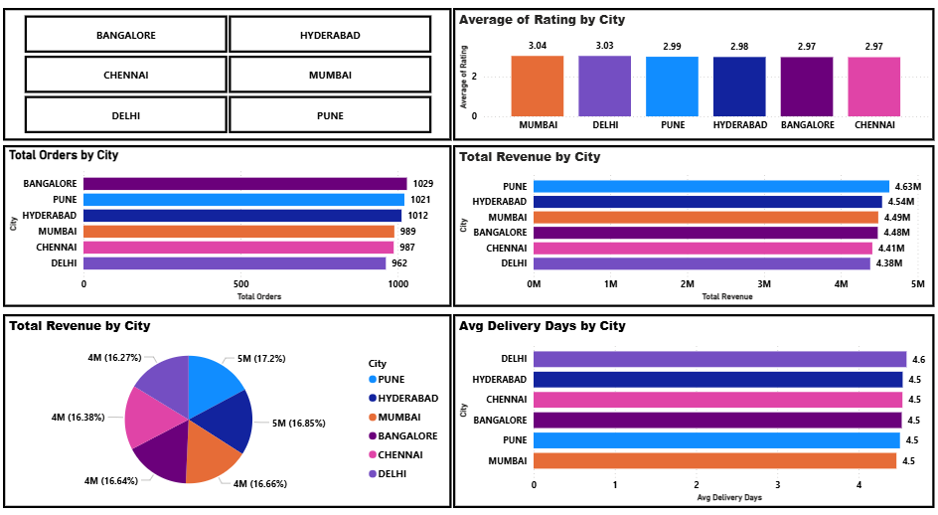
WHAT I FOUND:
- There is a negative relationship between delivery time and customer satisfaction (ratings)
- High-demand cities face operational delays, impacting delivery speed
- Mid/low-sales cities often perform better in customer experience (ratings)
- Customer satisfaction is more consistent in cities with efficient logistics
RECOMMENDATIONS:
- Improve logistics and supply chain efficiency in high-sales cities
- Set up regional warehouses / fulfillment centers to reduce delivery time

Q3.Which payment methods are most preferred, and do they influence sales or order value?

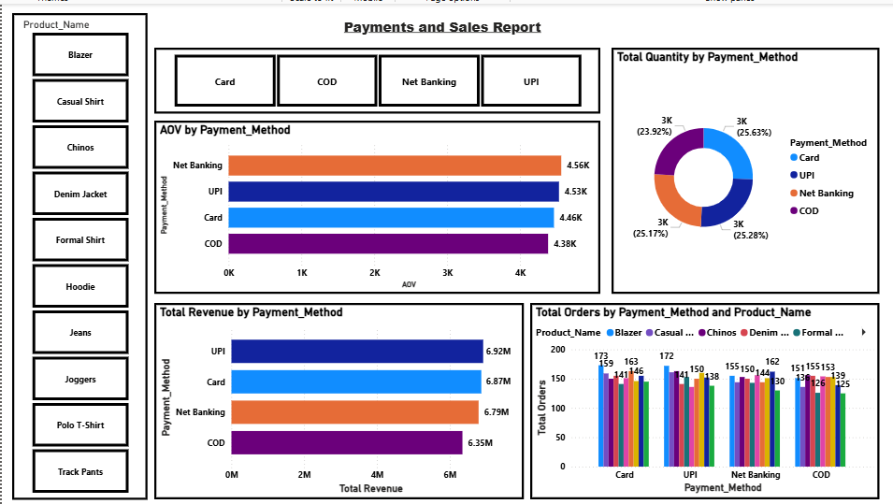
As per
KEY OBSERVATIONS:
- UPI / Net Banking are the most frequently used payment method
- UPI contributes the highest number of orders
- UPI payments generate higher revenue per order compared to others
- COD has high Revenue but relatively lower average order value
WHAT I FOUND:
- Payment method usage varies by customer convenience and trust
- Digital payments (UPI/Card) dominate overall transactions
- Average Order Value (AOV) is higher for Net banking/UPI , indicating premium purchases
- COD users tend to place smaller-value orders
RECOMMENDATIONS:
- Encourage UPI & Net Banking payments through discounts or cashback offers
- Promote card-based offers to increase high-value transactions
- Reduce dependency on COD by improving trust in prepaid methods
- Introduce incentives for digital payments to improve revenue quality

Q4. Which product attributes (size/colour) perform best, and are they linked to customer satisfaction?
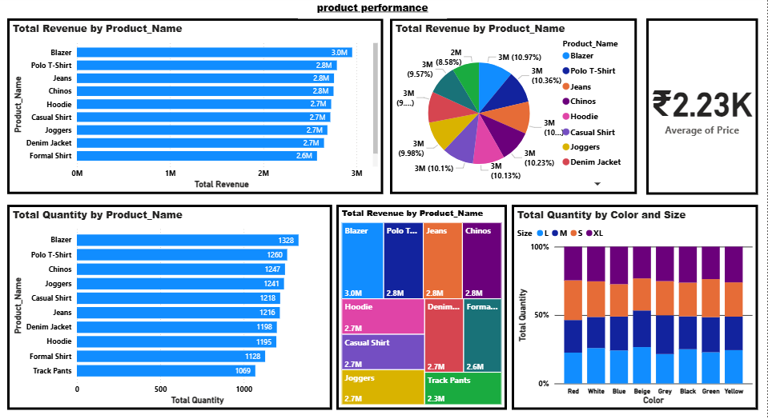
KEY OBSERVATIONS:
- Red and Blue are the top-selling colours across products
- Medium (M) and short(S) sizes contribute the highest sales volume
- Certain size-colour combinations (e.g., Red-S, XL–Blue) dominate overall quantity sold
WHAT I FOUND:
- Customer preference is strongly aligned with standard sizes (M/L) and neutral colours
- There is a link between size and customer satisfaction:
- Common sizes (M/S) → higher ratings
RECOMMENDATIONS:
- Maintain higher inventory for M & S sizes and top colours (Red, Blue)
- Improve fit consistency and sizing guides for low-rated sizes (L/XL)
- Use customer feedback to improve product

