 | MINISTRY OF EDUCATION AND TRAINING

FPT UNIVERSITY
Capstone Project Document
World data visualization – Report 03
LKPD group
Group Members | Ngo Quang Khanh 00575  Vo Dang Phat 00537  Nguyen Hoang Long 00371  Pham Vu Duc 00491
Supervisor | Phan Truong Lam
Ext Supervisor
Capstone Project code | CP2011_Spr_WDV

Hanoi, 01/2011

Table of Contents

3. Report 3 4
3.1. User Requirement Specification (general requirement) 4
3.2. System Requirement Specification (Specific Requirements) 4
3.2.1. External Interface Requirements 4
3.2.2. System Features 5
3.2.2.1. Feature 01 – View & compare statistics 5
3.2.2.1.1. Use-case 01 – View statistic of a country/region 5
3.2.2.1.2. Use-case 02 – Comparing statistics between countries/regions 7
3.2.2.1.3. Use-case 03 – Show color representation on world map 9
3.2.2.1.4. Use-case 04 – View basic information of a country 10
3.2.2.1.5. Use-case 05 – Change graph style 11
3.2.2.1.6. Use-case 06 – View trade data 13
3.2.2.2. System feature 02 – Manage personal info & workspace 15
3.2.2.2.1. Use-case 01 – Register new account 15
3.2.2.2.2. Use-case 02 – Logging in 17
3.2.2.2.3. Use-case 03 – Modify personal information 18
3.2.2.2.4. Use-case 04 – Manage Feeds 20
3.2.2.2.4.1. Use-case 04-01 – Get default feeds 21
3.2.2.2.4.2. Use-case 04-02 – Manage Custom Feeds 22
3.2.2.2.4.3. Use-case 04-03 – Categorize Feeds 24
3.2.2.2.4.4. Use-case 04-04 – View feeds 25
3.2.2.2.5. Use-case 05 – View world bank project 26
3.2.2.2.5.1. Use-case 05-01 – List world bank project 26
3.2.2.2.5.2. Use-case 05-02 – Add favorite project 27
3.2.2.2.5.3. Use-case 05-03 – View detail project data 29
3.2.2.2.6. Use-case 06 – Manage Local Project 30
3.2.2.2.6.1. Use-case 06-01 – Manage custom project 30
3.2.2.2.6.2. Use-case 06-02 – View custom project 32
3.2.2.2.6.3. Use-case 06-03 – Vote custom project 33
3.2.2.2.7. Use-case 07 – View Country Reports 34
3.2.2.2.7.1. Use-case 07-01 – View country data about indicators 34
3.2.2.2.7.2. Use-case 07-02 – Export country data 36
3.2.2.2.8. Use-case 08 – Manage Data Template 37
3.2.2.2.8.1. Use-case 08-01 – Create shortcut for viewing data 37
3.2.2.3. System Feature 03 – Link to social networks 38
3.2.2.3.1. Use-case 01 – Register Account 38
3.2.2.3.2. Use-case 02 – Login in 40
3.2.2.3.3. Use-case 03 – Modify personal Information 41
3.2.2.3.4. Use-case 04 – Notify to Facebook 43
3.2.2.3.5. Use-case 05 – Get Contact From Window Live 45
3.2.2.3.6. Use-case 06 – Send email to friend in Window Live 47
3.2.2.4. System feature 04 – Map navigation 50
3.2.2.4.1. Use-case 01 – Zoom in/out 50
3.2.2.4.2. Use-case 02 – Customize navigation panel 52
3.2.2.4.3. Use-case 03 – Panning map 53
3.2.2.4.4. Use-case 04 – Change map type 55
3.2.2.5. System feature 05 – Manage country shortlist 56
3.2.2.5.1. Use-case 01 – Add/Remove countries to/from shortlist 56
3.2.2.5.2. Use-case 02 – Mark/Unmark countries in shortlist 58
3.2.3. Software System Attributes 59
3.2.3.1. Reliability 59
3.2.3.2. Availability 59
3.2.3.3. Security 59
3.2.3.4. Maintainability 59
3.2.3.5. Portability 59
3.2.3.6. Performance 60
3.3. Entity relationship diagram: 61
3.4. Other material (if any) 62

Report 3

User Requirement Specification (general requirement)

From developer team suggestions and surveys, discussions with users, we have got a list of requirements as following:
- An online statistics visualization system so that users can use a variety of statistics in visual form to work with.
- The system provides information about the whole world, so it should have a selection mechanism using world map for ease in selecting countries.
- The world map selection mechanism mentioned above should support all basic features of an online mapping system such as zooming, panning, changing display type…
- The system should provide linking feature to social networks to help users post the graph, information… to their friend in that social network.
- The system should be deployed online and access from anywhere with an internet connection.
- The system should provide an ID system that accepts ID from other providers and preferably single sign on with popular social networks as well.
- The system should provide a wide range of indicator/statistics to be applicable for a wide range of researchers and subjects.
- The system should be able to provide graphical presentation of trading data between countries.
- The system should allow users to create their own workspace so that they can optimize the working environment to the best.
- The system should provides ways to compare statistics between regions
- The system should be able to give predictions of next year’s statistics at least.
- To optimize user experience, the information the system provides to users should best be stationed at local server side and periodic updated from the original source.

System Requirement Specification (Specific Requirements)

External Interface Requirements
      - User interfaces
- User interface should be intuitive and include a world map for graphical selection of regions because the system’s aim is to provide information of all countries in the world, thus selecting by list is too tedious compare to selecting by map.
- User interface should have graphical representations of statistics such as graphs, and if possible, color representation on the map.

      - Hardware interfaces
- The system should be deployed online and available to a wide range of hardware devices. Specifically, the system should be accessible on any computer using Windows© and if possible, other OS as well.

      - Software interfaces
- The system should be able to run on any browser support Silver light © technology and have had Silver light © installed.
- Any service exposed by the system should be accessible using HTTP protocol.

      - Communications protocol
- Communication between server system and client should be maintained using HTTP protocol or HTTPS protocol for more security if needed be.
- - The communication between client and ID service providers should be in HTTPS for securities reasons.

System Features
This section will describe the system being built through a list of Use cases. First, we will have an over-view of the whole system and what it will do through a use case diagram:
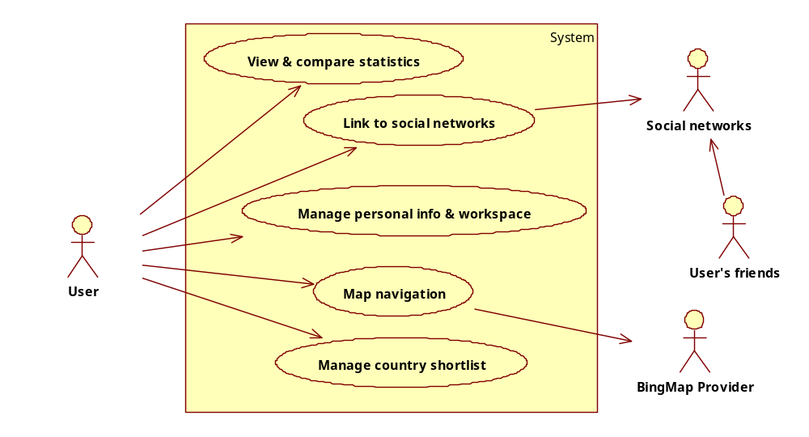

      - Feature 01 – View & compare statistics
This is the use case diagram showing all the use case in this feature
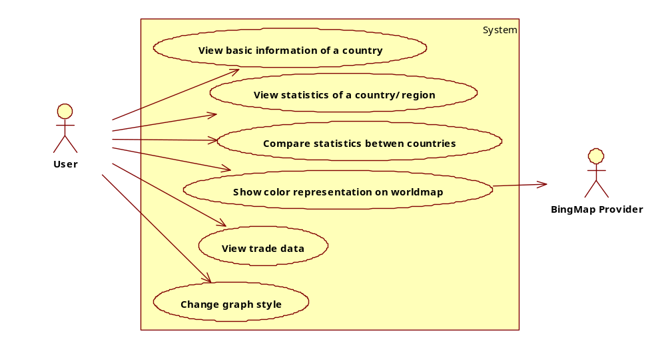
        - Use-case 01 – View statistic of a country/region
Use-case diagram:
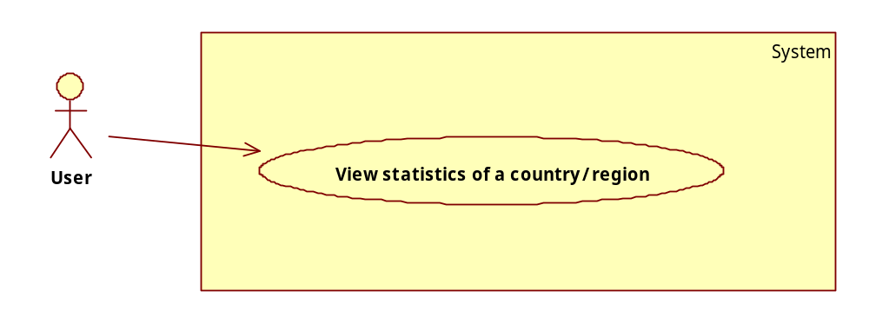
Use-case specification:
USE CASE-01 SPECIFICATION
Use-case No. | 001 | Use-case Version |  | 1.0
Use-case Name | View statistic of a country/region
Author | KhanhNQ
Date | 23/01/2011 | Priority | High
Actor:
User
Summary:
User selects the region (country) they want to view statistics, then the statistics that they want to view. After that, they can view the graphs and other visualization possible for that country and those statistics. The graph and/or visual representation should include predicted future number of at least next year and more if possible.
Goal:
To present users with a visual representation of a region’s/nation’s statistics.
Triggers
User click on a button for that country.
Preconditions:
User must have selected countries and statistics.
Post Conditions:
The graphs and/or other visual representations of the statistic are shown.
Main Success Scenario:
- User chooses the countries by dragging pin onto that country on the world map.
- User chooses statistics (indicators) from the list.
- User click on the pin of a country
- The diagram and/or visualization of selected statistics are shown.
Alternative Scenario:
N/A
Exceptions:
- User clicks on the pin of a country without selecting any statistics beforehand.
Relationships:
N/A
Business Rules:
N/A

        - Use-case 02 – Comparing statistics between countries/regions
Use-case diagram:
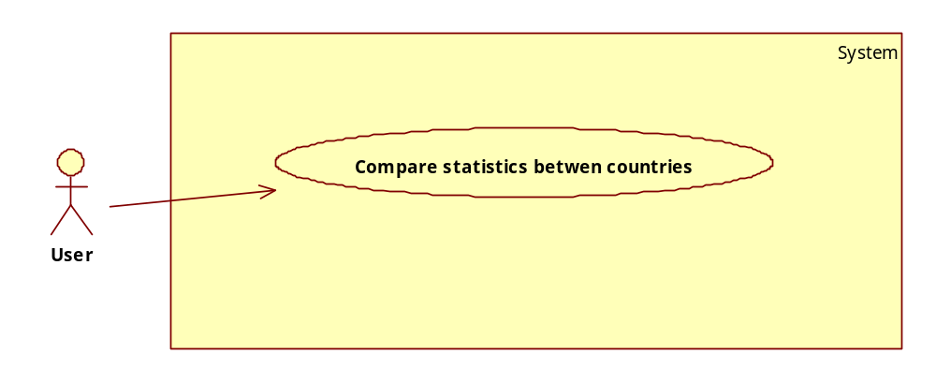
Use-case specification:
USE CASE-2 SPECIFICATION
Use-case No. | 002 | Use-case Version |  | 1.0
Use-case Name | Comparing statistics between countries/regions
Author | KhanhNQ
Date | 23/01/2011 | Priority | High
Actor:
User
Summary:
User selects the region (country) they want to view statistics, then the statistics that they want to view. Finally, they should select countries from the shortlist of selected countries. After that, they can view the graphs and other visualization possible for those countries and those statistics. The graph and/or visual representation should include predicted future number of at least next year and more if possible.
Goal:
To compare the status of a region/nation to others
Triggers
Click on the “Compare button” in countries shortlist.
Preconditions:
- More than 1 countries is selected on the world map
- At least 1 statistics/indicator is selected
- At least 2 countries selected on the countries shortlist.
Post Conditions:
- Graphs and other visual representation are shown is ways that best aid users in comparing statistics.
Main Success Scenario:
- User chooses the countries by dragging pin onto that country on the world map.
- User chooses statistics (indicators) from the list.
- User clicks on checkboxes in countries shortlist to choose countries.
- User clicks on “Compare” button.
- The comparison diagram and/or visualization of selected statistics are shown.
Alternative Scenario:
N/A
Exceptions:
- No statistic/indicator selected.
- No countries selected in shortlist.
Relationships:
N/A
Business Rules:
N/A
        - Use-case 03 – Show color representation on world map
Use-case diagram:
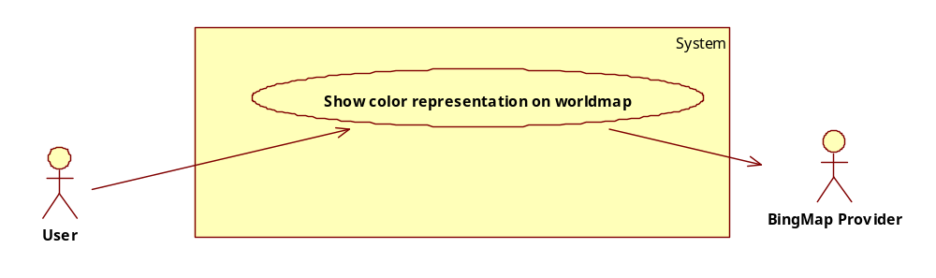
Use-case specification:
USE CASE-3 SPECIFICATION
Use-case No. | 003 | Use-case Version |  | 1.0
Use-case Name | Comparing statistics between regions
Author | KhanhNQ
Date | 20/02/2011 | Priority | Low
Actor:
User, BingMap provider
Summary:
User selects the statistics that they want to view and then click on the “Show world status” button. The world map will then show a color layer on each country/region on world map based on the value of that statistics on each country.
Goal:
To have an overview of the whole world on a selected statistic.
Triggers
Click on the “Show world status” in countries shortlist.
Preconditions:
- Only one statistic/indicator was selected
Post Conditions:
- The world map will show a color layer on each country/region on world map based on the value of that statistics on each country.
Main Success Scenario:
- User selects a statistic/indicator in the list.
- User clicks on the button “Show world status”.
Alternative Scenario:
N/A
Exceptions:
- More than 1 statistic is selected. A popup will show asking user to select one.
- A country with no statistic. The color of that country will be special and noted in the legend.
Relationships:
N/A
Business Rules:
N/A

        - Use-case 04 – View basic information of a country
Use-case diagram:
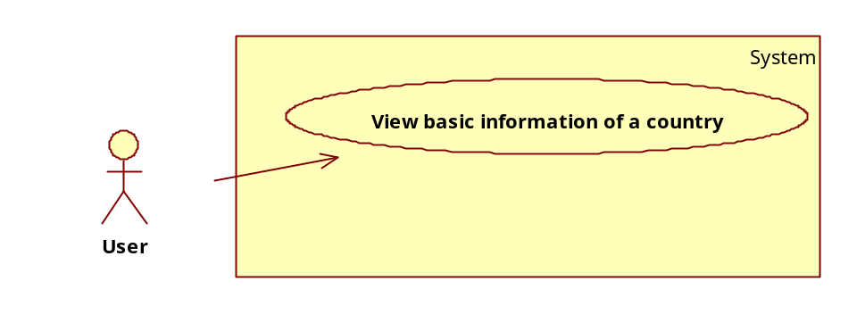
Use-case specification:
USE CASE-4 SPECIFICATION
Use-case No. | 004 | Use-case Version |  | 1.0
Use-case Name | View basic information of a country
Author | KhanhNQ
Date | 10/03/2011 | Priority | High
Actor:
User
Summary:
User put a pin on the country they want to view information and then click on that pin to view the information available: flag, country name, income level…
Goal:
View basic information of a country.
Triggers
Left mouse click on a pinned pin.
Preconditions:
- At least one pin is pinned on the world map.
Post Conditions:
- The “Country overview” dialog appears displaying basic information of a country.
Main Success Scenario:
- Drag a pin to the country on the world map.
- Click on the pin.
Alternative Scenario:
N/A
Exceptions:
N/A
Relationships:
N/A
Business Rules:
N/A
        - Use-case 05 – Change graph style
Use-case diagram:
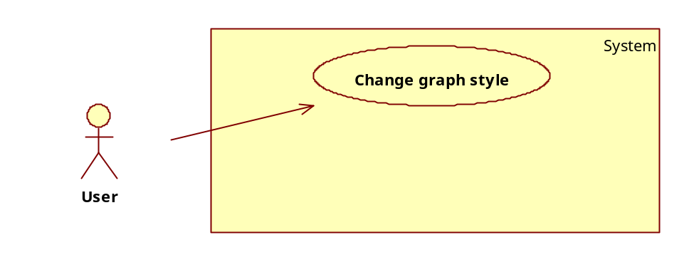
Use-case specification:
USE CASE-5 SPECIFICATION
Use-case No. | 005 | Use-case Version |  | 1.0
Use-case Name | Change graph style
Author | KhanhNQ
Date | 10/03/2011 | Priority | High
Actor:
User
Summary:
User after select countries proceeds with view graphical presentation (graph) of those statistics. Here user will be provided with the option to change the type of graph they want to display.
Goal:
To gave user the option to change graph style based on their preference and characteristics of the statistics he/she is viewing.
Triggers
Click on the “Render” button in graph dialog.
Preconditions:
- One or more indicator was selected.
- The graph dialog is showing.
Post Conditions:
- The selected graph style is showed in place of the old one.
Main Success Scenario:
- User drags a pin to a country on world map.
- User selects one or more indicator from the indicator list.
- User clicks on the pin to show the dialog.
- User change to the “Country data” tag.
- User selects another type of graph from the combo box.
- User clicks on the “Render graph” button.
Alternative Scenario:
- User drags a pin to at least country on world map.
- User chooses at least 2 countries on the country shortlist.
- User selects one or more indicator from the indicator list.
- User clicks on the compare button.
- User selects another type of graph from the combo box.
- User clicks on the “Render graph” button.
Exceptions:
- No statistics was selected.
- No country was selected in country shortlist.
Relationships:
Feature 01 – Use case 01, Feature 01 – Use case 02.
Business Rules:
N/A
        - Use-case 06 – View trade data
Use-case diagram:
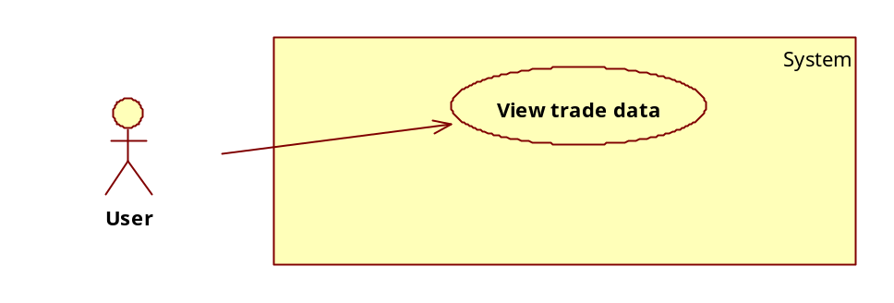
Use-case specification:
USE CASE-6 SPECIFICATION
Use-case No. | 006 | Use-case Version |  | 1.0
Use-case Name | View trade data
Author | KhanhNQ
Date | 10/03/2011 | Priority | High
Actor:
User
Summary:
User selects multiple country and view the trading status from/to a country in selected countries. Numbers shown are based on import/export of those countries.
Goal:
To present users with graphical presentation of import/export trading between countries.
Triggers
Click on the “Trade data” button.
Preconditions:
- More than one country was selected.
Post Conditions:
- Arrow will appear on the world map with the beginning of the arrow is the export country and the end of the arrow is the import country. In the middle of the arrow is a number showing the amount of trade in US Dollar.
Main Success Scenario:
- User drags a pin of world map and repeat to choose more than 1 country.
- User clicks on the “Trade data” button.
- User select year, main country and import/export data.
Alternative Scenario:
N/A
Exceptions:
- Less than 2 countries are selected on the world map.
- There was no trade data for the select countries.
Relationships:
N/A
Business Rules:
N/A

      - System feature 02 – Manage personal info & workspace
This is the use-case diagram of all use case in this feature:
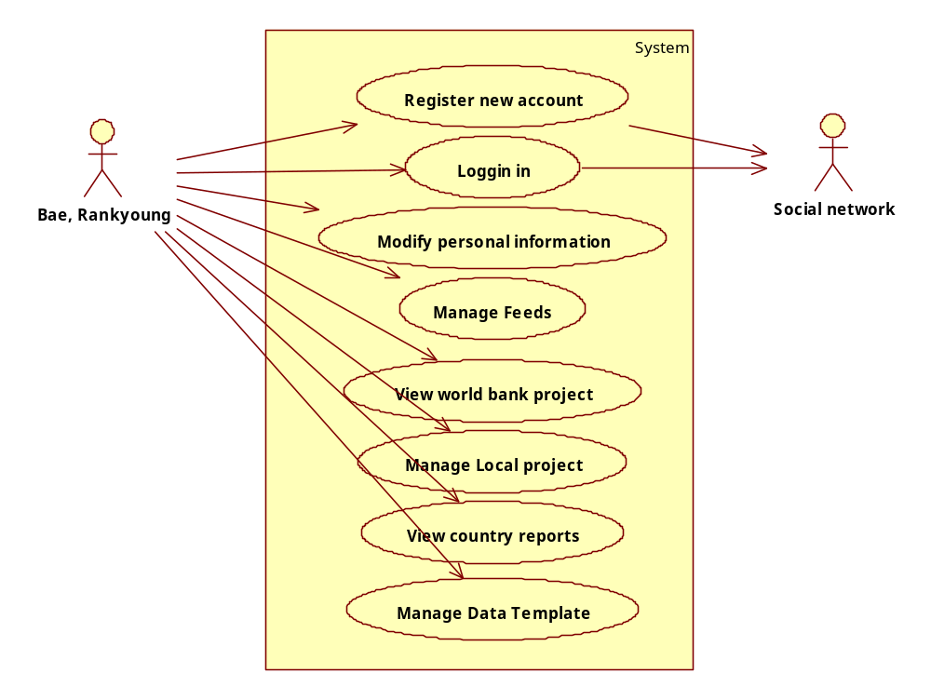
        - Use-case 01 – Register new account
Use-case diagram:
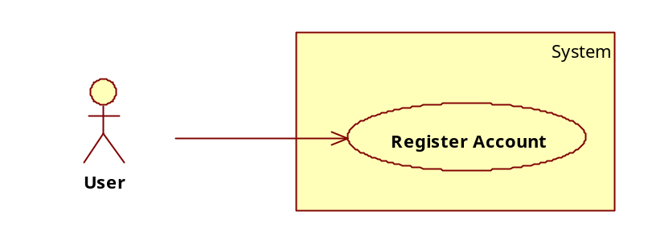
Use-case specification:
USE CASE-1 SPECIFICATION
Use-case No. | 001 | Use-case Version |  | 1.0
Use-case Name | Register account
Author | LongNH
Date | 23/01/2011 | Priority | High
Actor:
User, Social networks
Summary:
User register an account in the system, using an already exist account of a supported social network.
Goal:
Enable user to create account.
Triggers
User click on “Register” button on main interface of the system.
Preconditions:
- User must have an account of a supported social network.
Post Conditions:
A new account is created.
Main Success Scenario:
- User clicks on the Register button in main interface of the system.
- User agrees with the privacy policy and other conditions when using the system.
- User provides username and password of a supported social network.
- User provides personal information such as email, name…
- User click on “Register” button to register new account
- A new account is create and saved to local DB.
Alternative Scenario:
- User clicks on the Register button in main interface of the system.
- User agrees with the privacy policy and other conditions when using the system.
- User provides username and password of a supported social network.
- User provides personal information such as email, name…
- User click on “Cancel” button cancel the registration.
- No new account created.
Exceptions:
- User didn’t fill in required fields.
- Provided username and account couldn’t log into the selected social network.
- User didn’t agree with the policies.
Relationships:
N/A
Business Rules:
N/A
        - Use-case 02 – Logging in
Use-case diagram:
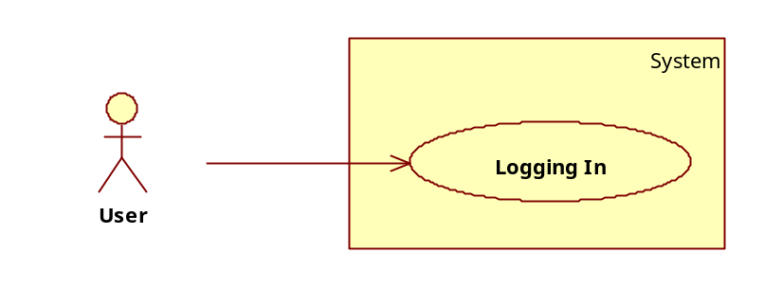
Use-case specification:
USE CASE-2 SPECIFICATION
Use-case No. | 002 | Use-case Version |  | 1.0
Use-case Name | Logging in
Author | KhanhNQ
Date | 23/01/2011 | Priority | Normal
Actor:
User, Social networks
Summary:
User log into the system using accounting from any social network supported.
Goal:
Authenticate user to give user access to his/her workspace and other personal service offered by the system.
Triggers
User click on “Log in” in the main interface of the system.
Preconditions:
- User has created the account beforehand.
Post Conditions:
User is logged in and his/her default workspace is opened.
Main Success Scenario:
- User clicks on the login button in main interface of the system.
- User provides username and password to log in.
- User is logged in and the default workspace is opened.
Alternative Scenario:
- User clicks on the login button in main interface of the system.
- User provides username and password to log in.
- User is denied because of incorrect username or password.
Exceptions:
- User didn’t enter the correct password or username.
Relationships:
N/A
Business Rules:
N/A
        - Use-case 03 – Modify personal information
Use-case diagram:
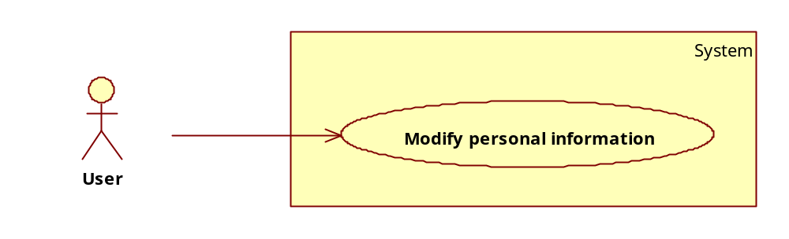
Use-case specification:
USE CASE-3 SPECIFICATION
Use-case No. | 003 | Use-case Version |  | 1.0
Use-case Name | Modify personal information
Author | PhatVD, DucPV
Date | 21/02/2011 | Priority | Normal
Actor:
User, Social networks
Summary:
User log into the system using accounting from any social network supported. After that, user can view and modify their personal information.
Goal:
Enable user to modify their personal information.
Triggers
User click on “Change personal info” in their user control panel.
Preconditions:
- User must have an account.
- User have logged in with above account.
Post Conditions:
Modified information is saved.
Main Success Scenario:
- User clicks on the login button in main interface of the system.
- User provides username and password to log in.
- User clicks on the “Control panel” button.
- User clicks on the “Change personal info”
- User modify their information
- User click “Save”
- Modified information is saved
Alternative Scenario:
- User clicks on the login button in main interface of the system.
- User provides username and password to log in.
- User clicks on the “Control panel” button.
- User clicks on the “Change personal info”
- User click “Cancel”
- Modified information is not saved
Exceptions:
- User didn’t fill in required fields.
Relationships:
N/A
Business Rules:
N/A
        - Use-case 04 – Manage Feeds
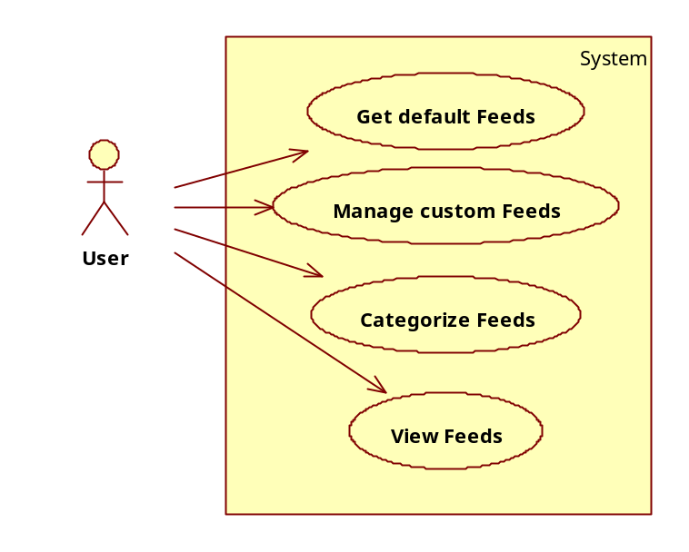

          - Use-case 04-01 – Get default feeds
Use-case specification:
USE CASE-4-01 SPECIFICATION
Use-case No. | 004-01 | Use-case Version |  | 1.0
Use-case Name | Get default feeds
Author | LongNH
Date | 11/03/2011 | Priority | Normal
Actor:
User
Summary:
User log into the system using accounting from any social network supported. After that, user can get Feeds from default source that system provided
Goal:
Display List of Feeds that system get for user
Triggers
User click on “Feeds” icon in their user control panel.
Preconditions:
- User must have an account.
- User have logged in with above account.
Post Conditions:
Display Feeds List in the User’s workspace
Main Success Scenario:
- User clicks on the login button in main interface of the system.
- User provides username and password to log in.
- User clicks on the “Control panel” button.
- User clicks on the “Feeds”
Alternative Scenario:
Exceptions:
Relationships:
N/A
Business Rules:
N/A
          - Use-case 04-02 – Manage Custom Feeds
USE CASE-4-02 SPECIFICATION
Use-case No. | 004-02 | Use-case Version |  | 1.0
Use-case Name | Manage Custom Feeds
Author | LongNH
Date | 21/02/2011 | Priority | Normal
Actor:
User
Summary:
User log into the system using accounting from any social network supported. After that, user can custom the personal source of Feeds
Goal:
Enable user to modify their personal Feeds
Triggers
User click on “Change Feed source” in their user control panel.
Preconditions:
- User must have an account.
- User have logged in with above account.
-User has a feed source that he want to check every day
Post Conditions:
Modified information is saved.
Main Success Scenario:
- User clicks on the login button in main interface of the system.
- User provides username and password to log in.
- User clicks on the “Control panel” button.
- User clicks on the “Change feed source”
- User modify their Feed source
- User click “Save”
- Modified information is saved
Alternative Scenario:
- User clicks on the login button in main interface of the system.
- User provides username and password to log in.
- User clicks on the “Control panel” button.
- User clicks on the “Change Feed source”
- User click “Cancel”
- Modified information is not saved
Exceptions:
N/A
Relationships:
N/A
Business Rules:
N/A
          - Use-case 04-03 – Categorize Feeds
USE CASE-04-03 SPECIFICATION
Use-case No. | 004-03 | Use-case Version |  | 1.0
Use-case Name | Categorize Feeds
Author | LongNH
Date | 21/02/2011 | Priority | Normal
Actor:
User, Social networks
Summary:
User log into the system using accounting from any social network supported. After that, user can select the category that he concern
Goal:
Enable user to view feed by category
Triggers
User click on “Feeds” in their user control panel.
User select category in the category list
Preconditions:
- User must have an account.
- User have logged in with above account.
Post Conditions:
Modified information is saved.
Main Success Scenario:
- User clicks on the “Feeds” button
- System display list of all New Feeds.
- User select the category
- System filter the Feed List base on the Category of Feeds
Alternative Scenario:
Exceptions:
Relationships:
N/A
Business Rules:
N/A
          - Use-case 04-04 – View feeds
Use-case specification:
USE CASE-4-04 SPECIFICATION
Use-case No. | 004-04 | Use-case Version |  | 1.0
Use-case Name | View Feeds
Author | LongNH
Date | 23/01/2011 | Priority | Normal
Actor:
User
Summary:
User log into the system using accounting from any social network supported. After that, user can view the News from the Feed section
Goal:
Enable user to view Feed data
Triggers
User click on the Feed link that provided in the List of Feeds
Preconditions:
- User must have an account of a supported social network
- User have logged in with above account.
Post Conditions:
- Feed detail screen is displayed
Main Success Scenario:
- User clicks on the “Feeds” button
- System displays a list of Feeds sort by date
- User selects a feed.
- Feed detail screen is displayed
Alternative Scenario:
Exceptions:
  - The feed link is broken or has been removed
  - System display the Error notification
Relationships:
N/A
Business Rules:
N/A
        - Use-case 05 – View world bank project
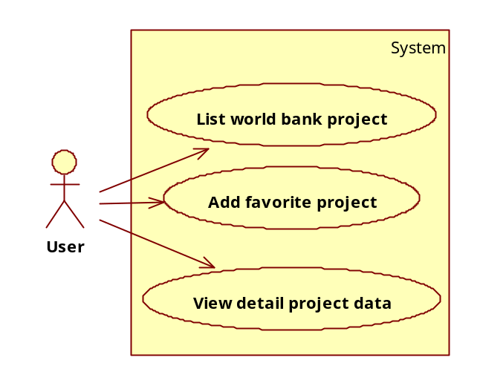
          - Use-case 05-01 – List world bank project
USE CASE-5-01 SPECIFICATION
Use-case No. | 005-01 | Use-case Version |  | 1.0
Use-case Name | List world bank project
Author | LongNH
Date | 21/02/2011 | Priority | Normal
Actor:
User
Summary:
User log into the system using accounting from any social network supported. After that, user can view the list of world bank project in a country.
Goal:
Visualize the list of World bank project in a country.
Triggers
User click on “View World Bank Project” in their user control panel.
Preconditions:
- User must have an account.
- User have logged in with above account.
Post Conditions:
Project viewer screen is displayed
Main Success Scenario:
- User select a country in favorite country list
- User clicks on the “show WB project data”
- System displays the Country shape
- System create pushpin on the map represent for the project in that country
Alternative Scenario:
Exceptions:
N/A
Relationships:
N/A
Business Rules:
N/A
          - Use-case 05-02 – Add favorite project
USE CASE-5-02 SPECIFICATION
Use-case No. | 005-02 | Use-case Version |  | 1.0
Use-case Name | Add favorite project
Author | LongNH
Date | 21/02/2011 | Priority | Normal
Actor:
User
Summary:
User log into the system using accounting from any social network supported. He can go into his workspace, view any project data of a country and mark it as “FAVORITE” to keep update about that project’s information
Goal:
Enable user to mark a project as Favorite.
Triggers
- User view detail about a country project
- User click “Add to favorite” button
Preconditions:
- User must have an account.
- User have logged in with above account.
-Project Detail screen is displayed
Post Conditions:
Modified information is saved.
Main Success Scenario:
- User views the project detail data
- User clicks on the “Add to favorite” button.
- Modified information is saved
Alternative Scenario:
- User views the favorite project detail data
- User clicks on the “Remove from favorite” button.
- Modified information is save
Exceptions:
N/A
Relationships:
N/A
Business Rules:
N/A
          - Use-case 05-03 – View detail project data
Use-case specification:
USE CASE-5-03 SPECIFICATION
Use-case No. | 005-03 | Use-case Version |  | 1.0
Use-case Name | View detail project data
Author | LongNH
Date | 23/01/2011 | Priority | Normal
Actor:
User,
Summary:
User log into the system using accounting from any social network supported. He can select a country, view list of project data and after that view the detail of project data
Goal:
Enable user to view the detail of a project in his country.
Triggers
User click on project link in the Project list
Preconditions:
- User must have an account of a supported social network
- User have logged in with above account.
-Project list screen is displayed
Post Conditions:
-Project detail screen is displayed
Main Success Scenario:
- User select a country in favorite country list
- User clicks on the “show WB project data”
- System displays the Country shape
- System create pushpin on the map represent for the project in that country
- User clicks on a project link.
- Project detail: Money, location, status …. Are displayed in Project detail screen
Alternative Scenario:
Exceptions:
- N/A
Relationships:
N/A
Business Rules:
N/A
        - Use-case 06 – Manage Local Project
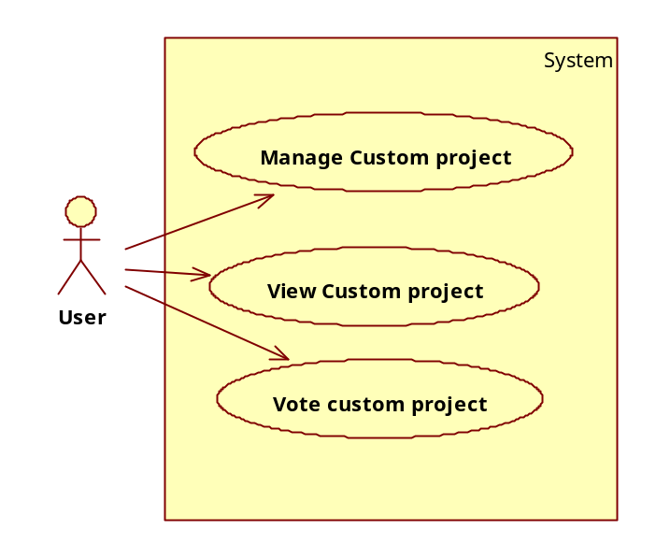
          - Use-case 06-01 – Manage custom project
USE CASE-6 SPECIFICATION
Use-case No. | 006-01 | Use-case Version |  | 1.0
Use-case Name | Manage custom project
Author | LongNH
Date | 21/02/2011 | Priority | Normal
Actor:
User
Summary:
User log into the system using accounting from any social network supported. He can access his workspace, after that, he can manage his own project in his country
Goal:
Enable user to create his own project for the development of his region
Triggers
User click on “Custom Project” button in his workspace
Preconditions:
- User must have an account.
- User have logged in with above account.
Post Conditions:
Main Success Scenario:
- User clicks on the “Custom project” in his workspace
- System display the Custom project management screen with the following functions:
+ Create new project
+ List region’s project
+ Edit my project
+ Delete my project
- User clicks on the “Create new project” button.
- Create new project screen is displayed
Alternative Scenario 1:
- User clicks on the “List region’s project” button.
- Region’s project screen is displayed
Alternative Scenario 2:
- User clicks on the “Edit my project” button.
- User edit information of his project
-Information is saved
Alternative Scenario 3:
- User clicks on the “Delete my project” button.
- Project is deleted
Exceptions:
N/A
Relationships:
N/A
Business Rules:
N/A
          - Use-case 06-02 – View custom project
USE CASE-6-02 SPECIFICATION
Use-case No. | 006-02 | Use-case Version |  | 1.0
Use-case Name | View custom project
Author | LongNH
Date | 21/02/2011 | Priority | Normal
Actor:
User
Summary:
User log into the system using accounting from any social network supported. He can access his workspace, after that, he can view the list of all project in his region
Goal:
Enable user to view and track the status of projects for his region
Triggers
User click on “View Custom Project” button in his workspace
Preconditions:
- User must have an account.
- User have logged in with above account.
Post Conditions:
Main Success Scenario:
- User clicks on the “View Custom project” in his workspace
- System display the Custom project list in user’s region
Alternative Scenario:
Exceptions:
- User didn’t fill in required fields.
Relationships:
N/A
Business Rules:
N/A
          - Use-case 06-03 – Vote custom project
USE CASE-6-03 SPECIFICATION
Use-case No. | 006-03 | Use-case Version |  | 1.0
Use-case Name | Vote custom project
Author | LongNH
Date | 21/02/2011 | Priority | Normal
Actor:
User
Summary:
User log into the system using accounting from any social network supported. He can access his workspace, after that, he can view the detail of a project of his region then he can vote for it to let everyone know that the project is good or not.
Goal:
Enable user to express their feeling about a project
Triggers
User click on “Vote for this Project” button in the project detail screen
Preconditions:
- User must have an account.
- User have logged in with above account.
-Project Detail screen is displayed
Post Conditions:
Main Success Scenario:
- User clicks on the “Vote for this project” in his workspace
- System display that the project is supported by this user.
Alternative Scenario:
Exceptions:
- User didn’t fill in required fields.
Relationships:
N/A
Business Rules:
N/A
        - Use-case 07 – View Country Reports
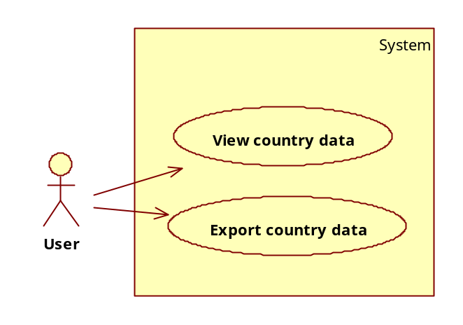
          - Use-case 07-01 – View country data about indicators
USE CASE-7 SPECIFICATION
Use-case No. | 007-01 | Use-case Version |  | 1.0
Use-case Name | View country data about indicators
Author | LongNH
Date | 21/02/2011 | Priority | Normal
Actor:
User
Summary:
User log into the system using accounting from any social network supported. After that, user can view a country data from the past to present about an indicator.
Goal:
Enable user to view indicator data of a country from the past to present.
Triggers
User click on “country data” tab in their user control panel.
Preconditions:
- User must have an account.
- User have logged in with above account.
Post Conditions:
System displays chart and grid about the data.
Main Success Scenario:
- User clicks on “Country data” Tab.
- User selects indicators
- User selects type of chart
- User select the year range
- System displays the Country data as the form of Datagrid and Chart control
Exceptions:
N/A
Relationships:
N/A
Business Rules:
N/A
          - Use-case 07-02 – Export country data
USE CASE-7 SPECIFICATION
Use-case No. | 007-02 | Use-case Version |  | 1.0
Use-case Name | Export country data
Author | LongNH
Date | 21/02/2011 | Priority | Normal
Actor:
User
Summary:
User log into the system using accounting from any social network supported. He can view country data about indicators. After that, he can export this data to PDF or Excel.
Goal:
Enable user to export their data to different form of documents.
Triggers
User click on “Export” in their user control panel.
Preconditions:
- User must have an account.
- User have logged in with above account.
Post Conditions:
User can download a document that system exported
Main Success Scenario:
- User view the indicators data of a country
- User click on “Export” button
- User select the type of export file
- System export a file that contain the country data
Alternative Scenario:
Exceptions:
N/A
Relationships:
N/A
Business Rules:
N/A
        - Use-case 08 – Manage Data Template
          - Use-case 08-01 – Create shortcut for viewing data
USE CASE-8 SPECIFICATION
Use-case No. | 008-01 | Use-case Version |  | 1.0
Use-case Name | Create shortcut for viewing data
Author | LongNH
Date | 21/02/2011 | Priority | Normal
Actor:
User
Summary:
User log into the system using accounting from any social network supported. After that, user can view country data, project data… and after that, he can save that data into shortcut for later use
Goal:
Enable user to create shortcut for his data viewer
Triggers
User click on “Create shortcut” icon in their user control panel.
Preconditions:
- User must have an account.
- User have logged in with above account.
Post Conditions:
A shortcut for the data viewer is saved in user’s shortcut list
Main Success Scenario:
- User view country data or project data
- System displays the data viewer screen.
- User clicks on the “make shortcut” button
- User enters the name and category of shortcut.
- User click “Save”
- Shortcut is saved
Alternative Scenario:
Exceptions:
N/A
Relationships:
N/A
Business Rules:
N/A
      - System Feature 03 – Link to social networks
        - Use-case 01 – Register Social Network Account
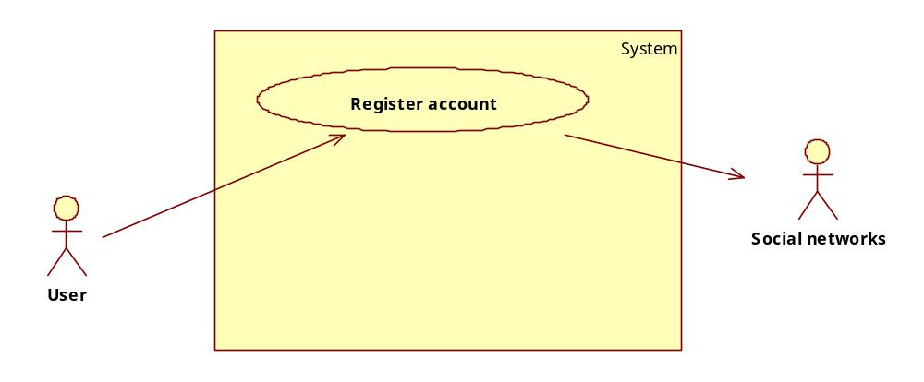
USE CASE-1 SPECIFICATION
Use-case No. | 001 | Use-case Version |  | 1.1
Use-case Name | Register Social Network Account
Author | PhatVD
Date | 11/03/2011 | Priority | High
Actor:
User, Live System
Summary:
User register an account in the system, using an already exist account of a Social Networks
Goal:
Enable user to create account.
Triggers
User click on “Register” button on main interface of the system.
Preconditions:
- User must have an account of a supported Social Networks
PostConditions:
A new account is created.
Main Success Scenario:
- User clicks on the Register button in main interface of the system.
- User agrees with the privacy policy and other conditions when using the system.
- User provides username and password of a supported social network.
- User provides personal information such as email, name…
- User click on “Register” button to register new account
- A new account is create and saved to local DB.
Alternative Scenario:
- User clicks on the Register button in main interface of the system.
- User agrees with the privacy policy and other conditions when using the system.
- User provides username and password of a supported social network.
- User provides personal information such as email, name…
- User click on “Cancel” button cancel the registration.
- No new account created.
Exceptions:
- User didn’t fill in required fields.
- Provided username and account couldn’t log into the selected social network.
- User didn’t agree with the policies.
Relationships:
N/A
Business Rules:
N/A

        - Use-case 02 – Login in with Social networks Account
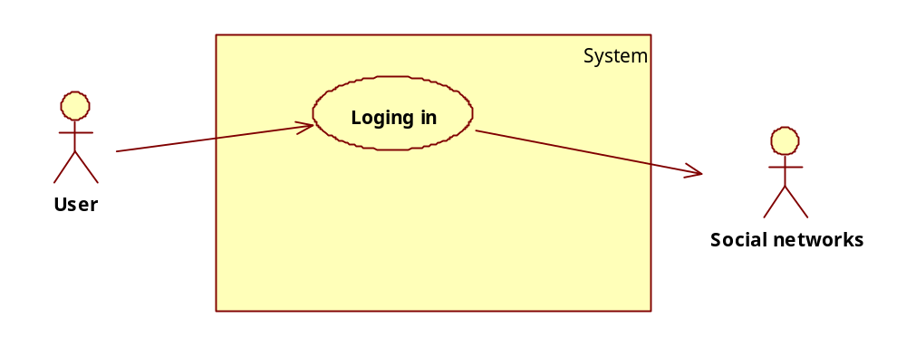
USE CASE-2 SPECIFICATION
Use-case No. | 002 | Use-case Version |  | 1.1
Use-case Name | Login in with Social networks Account
Author | PhatVD
Date | 23/01/2011 | Priority | Normal
Actor:
User, Social networks
Summary:
User log into the system using accounting from any social network supported.
Goal:
Authenticate user to give user access to his/her workspace and other personal service offered by the system.
Triggers
User click on “Log in” in the main interface of the system.
Preconditions:
- User has created the account beforehand.
PostConditions:
User is logged in and his/her default workspace is opened.
Main Success Scenario:
- User clicks on the login button in main interface of the system.
- User provides username and password to log in.
- User is logged in and the default workspace is opened.
Alternative Scenario:
- User clicks on the login button in main interface of the system.
- User provides username and password to log in.
- User is denied because of incorrect username or password.
Exceptions:
- User didn’t enter the correct password or username.
Relationships:
N/A
Business Rules:
N/A

        - Use-case 03 – Modify personal Information
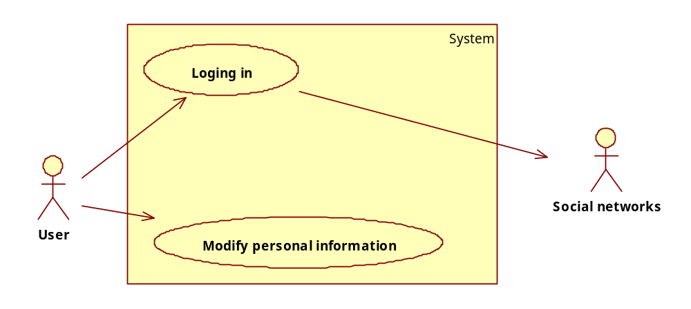
USE CASE-3 SPECIFICATION
Use-case No. | 003 | Use-case Version |  | 1.1
Use-case Name | Modify personal information
Author | PhatVD
Date | 11/03/2011 | Priority | Normal
Actor:
User, Social networks
Summary:
User log into the system using accounting from any social network supported. After that, user can view and modify their personal information.
Goal:
Enable user to modify their personal information.
Triggers
User click on “Change personal info” in their user control panel.
Preconditions:
- User must have an account.
- User have logged in with above account.
PostConditions:
Modified information is saved.
Main Success Scenario:
- User clicks on the login button in main interface of the system.
- User provides username and password to log in.
- User clicks on the “Control panel” button.
- User clicks on the “Change personal info”
- User modify their information
- User click “Save”
- Modified information is saved
Alternative Scenario:
- User clicks on the login button in main interface of the system.
- User provides username and password to log in.
- User clicks on the “Control panel” button.
- User clicks on the “Change personal info”
- User click “Cancel”
- Modified information is not saved
Exceptions:
- User didn’t fill in required fields.
Relationships:
N/A
Business Rules:
N/A
        - Use-case 04 – Notify to Facebook
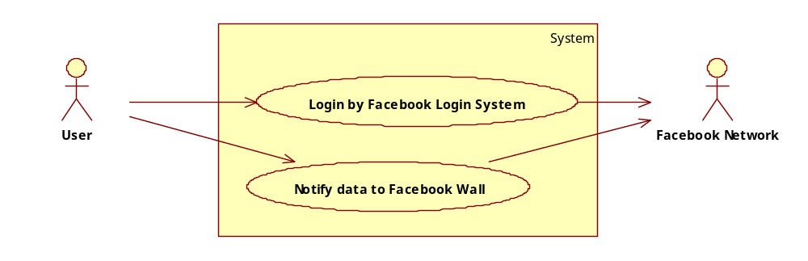
USE CASE-4 SPECIFICATION
Use-case No. | 004 | Use-case Version |  | 1.1
Use-case Name | Notify to Facebook
Author | PhatVD
Date | 11/03/2011 | Priority | Normal
Actor:
User, Facebook
Summary:
User log into the system using accounting from Facebook. When user is interested in any data invisualization system, he can notify for his friends in Facebook.
Goal:
Visualization system data are notified in Facebook.
Triggers
Click notify button
Preconditions:
- User must have an account.
- User have logged in with above account.
PostConditions:
The indicator data is shared to Facebook
Main Success Scenario:
- User clicks on the login button in main interface of the system using Facebook login system.
- User provides username and password to log in.
- User clicks on the “Control panel” button.
- User clicks on the Country Indicator
-Choose more than one indicator
- Drag pushpin to a country
- Click on the pushpin
- Open the second tab : “ country data”
- Click render chart
- Click share this data to social network button : “Notify on Facebook”
Alternative Scenario:
- User clicks on the login button in main interface of the system.
- User provides username and password to log in.
- User clicks on the “Control panel” button.
- User clicks on the Country Indicator
- Choose an indicator
- Drag more than one pushpin to the countries
- Tick all available countries in menu right
- Click compare
- Click share this data to social network button : “Notify on Facebook”
Alternative Scenario:
- User clicks on the login button in main interface of the system.
- User provides username and password to log in.
- User clicks on the “Control panel” button.
- Drag more than one pushpin to the countries
- Tick all available countries in menu right
- Click trade data button
- Click share this data to social network button : “Notify on Facebook”
Alternative Scenario:
- User clicks on the login button in main interface of the system.
- User view feed in his workspace
- Click share this data to social network button : “Notify on Facebook”

Exceptions:
- User didn’t fill in required fields.
Relationships:
N/A
Business Rules:
N/A
        - Use-case 05 – Get Contact From Window Live
- 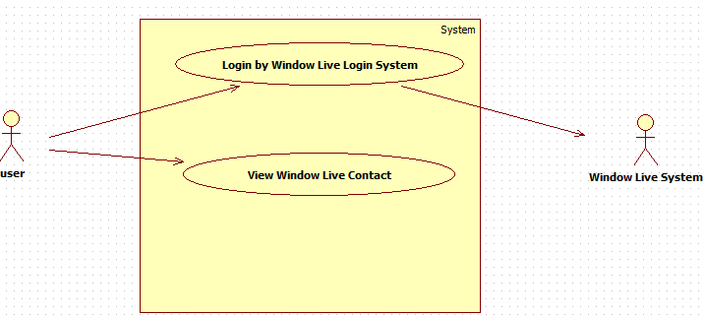

USE CASE-5 SPECIFICATION
Use-case No. | 005 | Use-case Version |  | 1.0
Use-case Name | Get Contact From Window Live
Author | PhatVD
Date | 11/03/2011 | Priority | Normal
Actor:
User, Social networks
Summary:
User log into the system using accounting from any social network supported. After that, user can view his contact in that social network if it’s supported.
Goal:
Help user communicate with his contact using the visualization system
Triggers
User click on “View my contact” in their user control panel.
Preconditions:
- User must have an account.
- User have logged in with above account.
PostConditions:
Enable to communicate with user’s contact
Main Success Scenario:
- User clicks on the login button in main interface of the system.
- User provides username and password to log in.
- User clicks on the “Control panel” button.
- User clicks on the “View my contact”
- The contact details of user appear
Alternative Scenario:
N/A
Exceptions:
- User didn’t fill in required fields.
Relationships:
N/A
Business Rules:
N/A

        - Use-case 06 – Send email to friend in Window Live
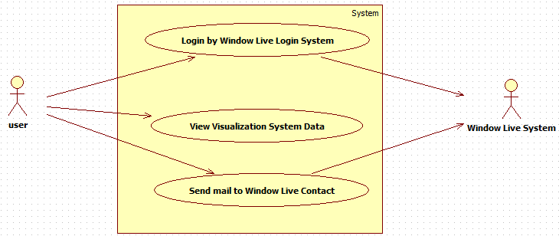
USE CASE-6 SPECIFICATION
Use-case No. | 006 | Use-case Version |  | 1.1
Use-case Name | Send email to friend in Window Live
Author | PhatVD
Date | 11/03/2011 | Priority | Normal
Actor:
User, Window Live
Summary:
User log into the system using accounting from Window Live. When user is interested in any data in country indicator, send it to his friend by email.
Goal:
Country‘s indicator data are notified in social networks.
Triggers
Click send mail button
Preconditions:
- User must have a Window Live account.
- User have logged in with above account.
PostConditions:
The system data is sent to user’s friend by email
Main Success Scenario:
- User clicks on the login button in main interface of the system using Window Live login system.
- User provides username and password to log in.
- User clicks on the “Control panel” button.
- User clicks on the Country Indicator
- Choose more than one indicator
- Drag pushpin to a country
- Click on the pushpin
- Open the second tab : “ country data”
- Click render chart
- Click “Send mail to friend”
- Choose friends from contact list
- Click send
Alternative Scenario:
- User clicks on the login button in main interface of the system.
- User provides username and password to log in.
- User clicks on the “Control panel” button.
- User clicks on the Country Indicator
- Choose an indicator
- Drag more than one pushpin to the countries
- Tick all available countries in menu right
- Click compare
- Click “Send mail to friend”
- Choose friends from contact list
- Click send
Alternative Scenario:
- User clicks on the login button in main interface of the system.
- User provides username and password to log in.
- User clicks on the “Control panel” button.
- Drag more than one pushpin to the countries
- Tick all available countries in menu right
- Click trade data button
- Click “Send mail to friend”
- Choose friends from contact list
- Click send
Alternative Scenario:
- User clicks on the login button in main interface of the system.
- User view feed in his workspace
- Click “Send mail to friend”
- Choose friends from contact list
- Click send
Exceptions:
- User didn’t fill in required fields.
Relationships:
N/A
Business Rules:
N/A
      - System feature 04 – Map navigation
This is the use-case diagram of all use case in this feature:
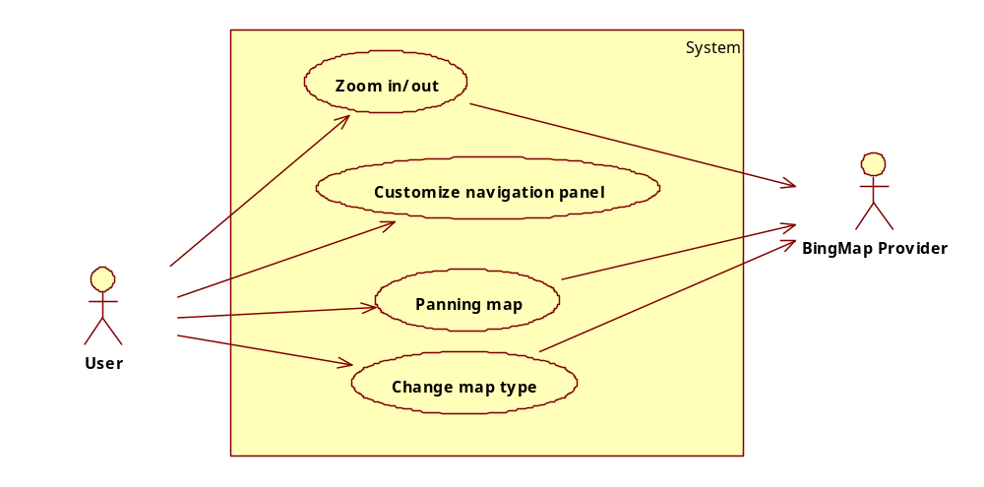
        - Use-case 01 – Zoom in/out
Use-case diagram:
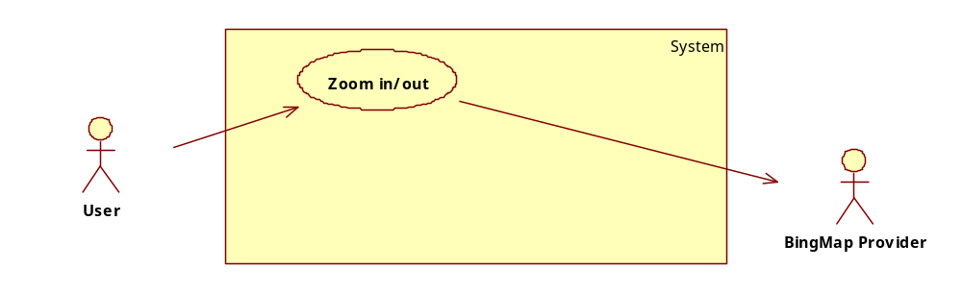
Use-case specification:
USE CASE-1 SPECIFICATION
Use-case No. | 001 | Use-case Version |  | 1.0
Use-case Name | Zoom in/out
Author | KhanhNQ
Date | 10/03/2011 | Priority | High
Actor:
User, BingMap Provider
Summary:
User zooms in the world map to see smaller countries or zoom out to have a broader view.
Goal:
Enable user to see smaller countries or have broad view of the world map.
Triggers
User scroll the middle button of the mouse or Click on (+), (-) button on navigation panel of the map.
Preconditions:
- The map must have been loaded.
Post Conditions:
The map change according to user’s action.
Main Success Scenario:
- User scrolls the middle button of the mouse up.
- The map zooms in and center around the location the mouse is at.
Alternative Scenario 01:
- User scrolls the middle button of the mouse down.
- The map zooms out and center around the location the mouse is at.
Alternative Scenario 02:
- User clicks on the (+) button on the navigation panel of the map.
- The map zooms in the center of the map.
Alternative Scenario 03:
- User clicks on the (+) button on the navigation panel of the map.
- The map zooms out the center of the map.
Exceptions:
N/A
Relationships:
Feature 01 – Use case 01, Feature 01 – Use case 02, Feature 01 – Use case 04, Feature 01 – Use case 05, Feature 01 – Use case 06, Feature 03, Feature 05 – Use case 01, Feature 05 – Use case 02.
Business Rules:
N/A
        - Use-case 02 – Customize navigation panel
Use-case diagram:
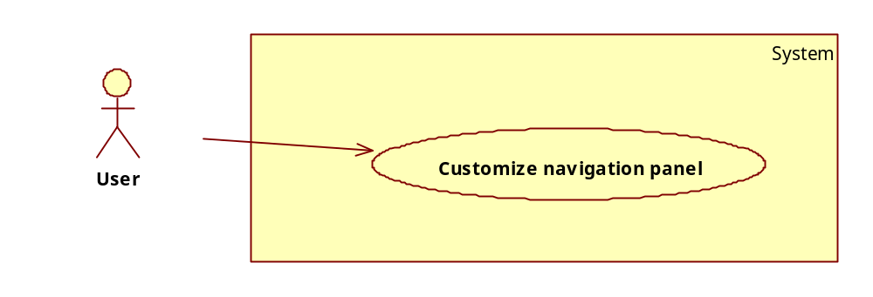
Use-case specification:
USE CASE-2 SPECIFICATION
Use-case No. | 002 | Use-case Version |  | 1.0
Use-case Name | Customize navigation panel
Author | KhanhNQ
Date | 10/03/2011 | Priority | Normal
Actor:
User
Summary:
User customizes the navigation panel of the map to make browsing and viewing of the map easier.
Goal:
Provide an option for user to customize the map view.
Triggers
User click on the “minimize” button on the control panel.
Preconditions:
N/A
Post Conditions:
- The control panel is minimized.
Main Success Scenario:
- User clicks on the “minimize” button on the control panel.
- The control panel minimize for clearer vision of the map.
Alternative Scenario:
- User clicks on the “restore” button.
- The control panel returns to normal for navigation and other control tasks.
Exceptions:
N/A
Relationships:
Feature 04 – Use case 01, Feature 04 – Use case 03, Feature 04 – Use case 04.
Business Rules:
N/A
        - Use-case 03 – Panning map
Use-case diagram:
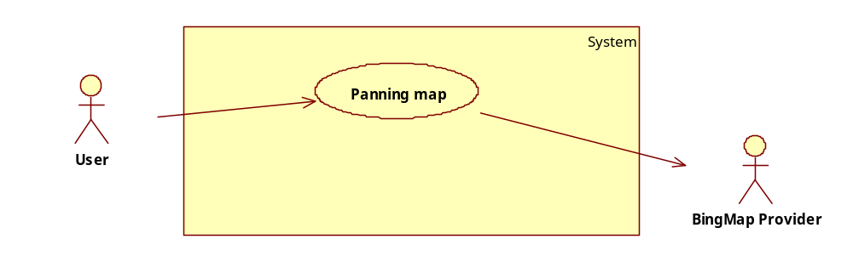
Use-case specification:
USE CASE-3 SPECIFICATION
Use-case No. | 003 | Use-case Version |  | 1.0
Use-case Name | Panning map
Author | KhanhNQ
Date | 10/03/2011 | Priority | Normal
Actor:
User, BingMap Provider
Summary:
User use mouse or arrows in the map navigation panel to travel on the map.
Goal:
Enable user to navigate on the world map.
Triggers
User clicks on the arrows on navigation panel or left clicks and drags the mouse.
Preconditions:
N/A
Post Conditions:
The map move according to user’s interactions.
Main Success Scenario:
- User left click on the map without releasing the left mouse.
- User moves the mouse opposite to the direction they want the map to move.
- Release the left mouse.
- The map move to the opposite of the direction user moves their mouse.
Alternative Scenario:
- User clicks on the arrow on navigation panel of the map.
- The map move to the direction of the arrow clicked.
Exceptions:
- N/A.
Relationships:
Feature 01 – Use case 01, Feature 01 – Use case 02, Feature 01 – Use case 04, Feature 01 – Use case 05, Feature 01 – Use case 06, Feature 03, Feature 05 – Use case 01, Feature 05 – Use case 02.
Business Rules:
N/A
        - Use-case 04 – Change map type
Use-case diagram:
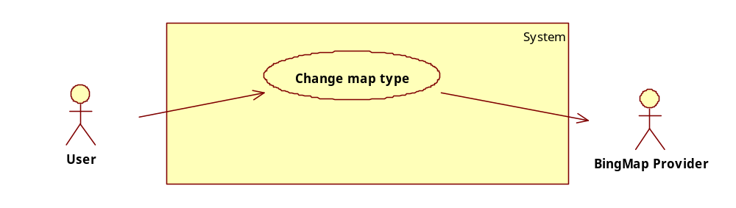
Use-case specification:
USE CASE-4 SPECIFICATION
Use-case No. | 004 | Use-case Version |  | 1.0
Use-case Name | Change map type
Author | KhanhNQ
Date | 10/03/2011 | Priority | Normal
Actor:
User, BingMap Provider
Summary:
User changes the type of map they want to show.
Goal:
Enable user to have a different view of the world map.
Triggers
User clicks on the type of the map they want to view.
Preconditions:
N/A
Post Conditions:
The map change to the type of map user selected.
Main Success Scenario:
- User clicks on the “Drawing” button on the navigation panel.
- The map changes to “Drawing” type of map.
Alternative Scenario:
- User clicks on the “Satellite” button on the navigation panel.
- The map changes to “Satellite” type of map.
Exceptions:
N/A
Relationships:
Feature 01 – Use case 01, Feature 01 – Use case 02, Feature 01 – Use case 04, Feature 01 – Use case 05, Feature 01 – Use case 06, Feature 03, Feature 05 – Use case 01, Feature 05 – Use case 02.
Business Rules:
N/A
      - System feature 05 – Manage country shortlist
This is the use-case diagram of all use case in this feature:
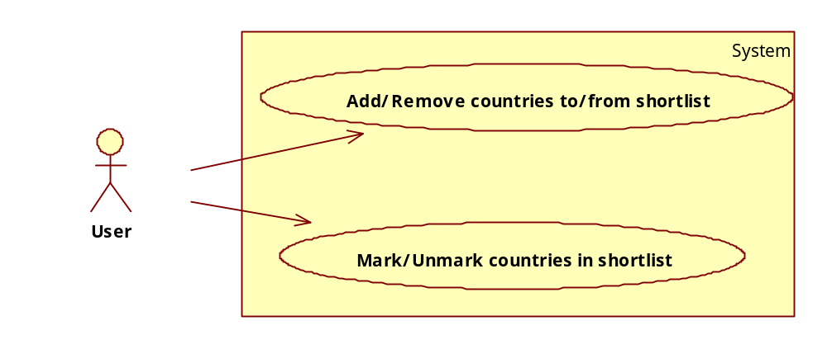
        - Use-case 01 – Add/Remove countries to/from shortlist
Use-case diagram:
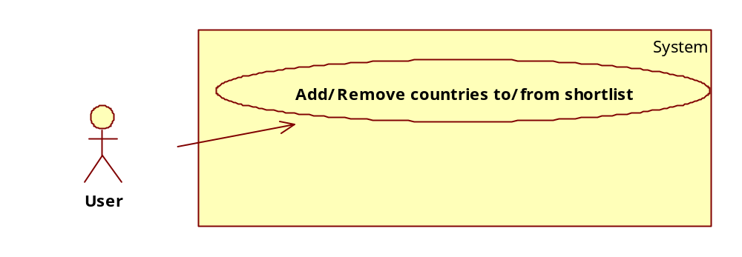
Use-case specification:
USE CASE-1 SPECIFICATION
Use-case No. | 001 | Use-case Version |  | 1.0
Use-case Name | Add/Remove countries to/from shortlist
Author | KhanhNQ
Date | 10/03/2011 | Priority | High
Actor:
User
Summary:
User adds countries to the shortlist to select them easier later on.
Goal:
Create a list of countries user selected so that they can select it later on.
Triggers
User drags a pin on the world map or click on the delete button on the shortlist.
Preconditions:
The shortlist must have at least one country to be removed.
Post Conditions:
A country is added or removed from the shortlist.
Main Success Scenario:
- User drags a pin to the world map.
- The country where the pin was dragged to is added the shortlist.
Alternative Scenario:
- User clicks on the “delete” button beside a country in the shortlist.
- The countries beside the clicked “delete” button is removed from the shortlist.
Exceptions:
N/A
Relationships:
Feature 01 – Use case 01, Feature 01 – Use case 02, Feature 01 – Use case 04, Feature 01 – Use case 05, Feature 01 – Use case 06.
Business Rules:
N/A
        - Use-case 02 – Mark/Unmark countries in shortlist
Use-case diagram:
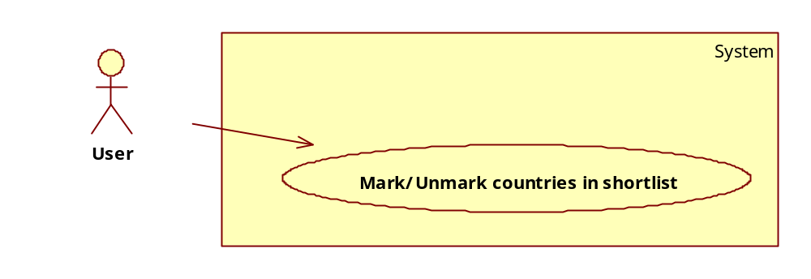
Use-case specification:
USE CASE-2 SPECIFICATION
Use-case No. | 002 | Use-case Version |  | 1.0
Use-case Name | Mark/Unmark countries in shortlist
Author | KhanhNQ
Date | 10/03/2011 | Priority | Normal
Actor:
User
Summary:
User mark or unmark countries in the shortlist to select them for comparison or other tasks.
Goal:
Select countries in the shortlist to compare statistics or performing other tasks.
Triggers
User clicks on the checkboxes beside the countries they want to check/uncheck.
Preconditions:
- The shortlist must have at least one country.
Post Conditions:
- The country beside the checkbox is mark/unmark.
Main Success Scenario:
- User clicks on the checkboxes beside the countries they want to select.
- The countries are marked.
Alternative Scenario:
- User clicks on the checkboxes beside the countries they want to de-select.
- The countries are unmarked.
Exceptions:
- N/A.
Relationships:
Feature 01 – Use case 01, Feature 01 – Use case 02, Feature 01 – Use case 04, Feature 01 – Use case 05, Feature 01 – Use case 06.
Business Rules:
N/A

Software System Attributes

Reliability
- This isn’t a critical system and reliability of the system doesn’t need to be available at all time, but it shouldn’t be unavailable for more than 1/7 of its first testing run time.
- All diagram and statistic except prediction must be accurate compare to data from data sources.

Availability
- The system should be able to available 90% of the time, excluding periodic maintenance.

Security
- The system should ensure security of account and password information of users.
- All data regarding user’s activity must not be recorded on the system without consent of user.

Maintainability
- All the developers should follow coding conventions, naming convention and others
- All document including but not restricted to user requirement document, system requirement document, system design document, module design document, usage instruction must be deliver upon completion of the system.

Portability
- No portability is required, but if it doesn’t consume too much resource, makes the system available for other operating system beside windows too.

Performance
- Acceptable performance is less than 30 seconds of response time.

Entity relationship diagram:
ID
Name
Region
Belong to
Have
Belong to
ID
Country
ISO code
Name
Longitude
Latitude
Code
Income level
ID
Name
Of
Value
Year
Tab
ID
Name
Indicator
ID
Code
Name
Description
Unit
Have
Name
ID
Workspace
Have
User
ID
Name
Birthday
E-Mail
Account
Password

Other material (if any)
N/A

