**Program 1**

Write a Cursor program using MySQL to retrieve the email-ids(build an email list) of employees from employees table.

.  
[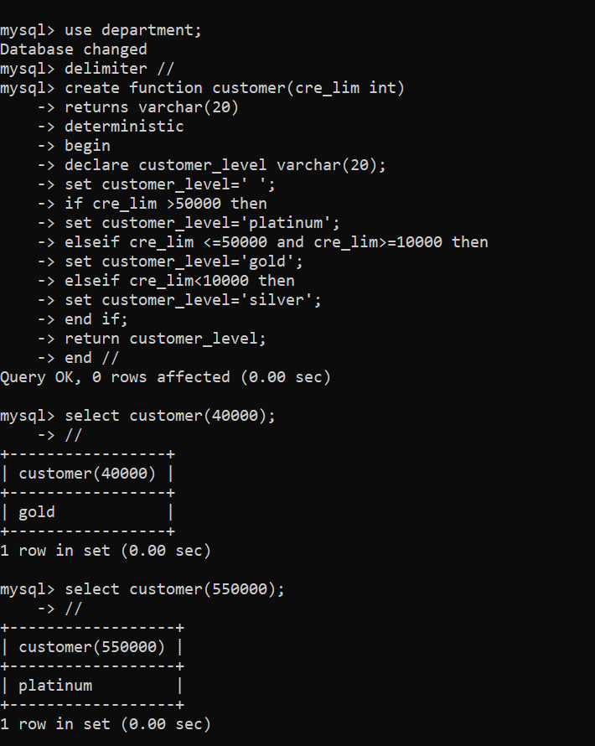](https://user-images.githubusercontent.com/113232880/194353395-2cabc3da-af1f-477f-ae4a-42820de07088.png)