4.1 Support Vector Machine

Support Vector Machine or SVM is one of the most popular Supervised Learning algorithms, which is used for Classification as well as Regression problems.

It is one of the memory efficient algorithm. The main target of this algorithm is to create a boundary that can separate different class labels. This is very useful for various classifications that we come across daily in our day-to-day life.

This best decision boundary is called a hyperplane.

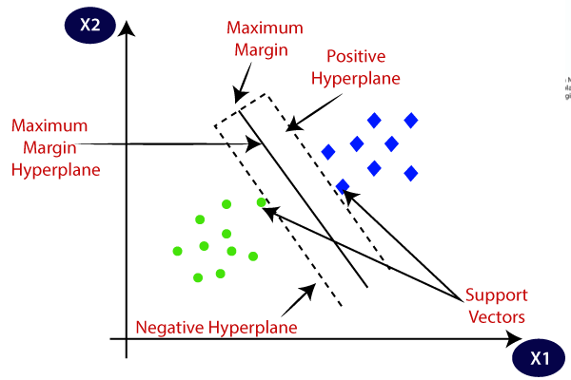

Hyperplanes:

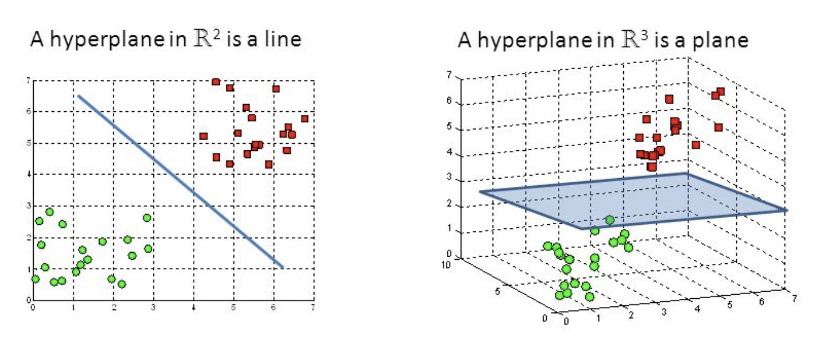

Support vectors:

Support vectors are data points that are closer to the hyperplane. They can change the position and orientation of the hyperplane based on the data points. They are used to classify the labels.

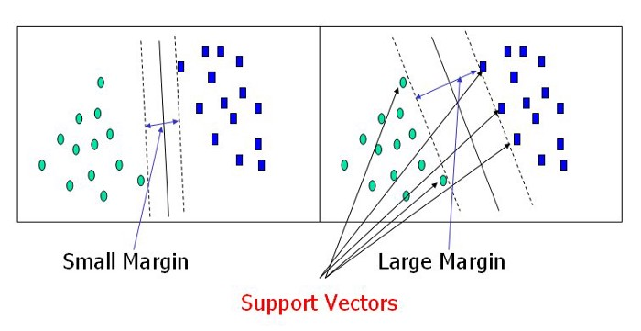

Algorithm:

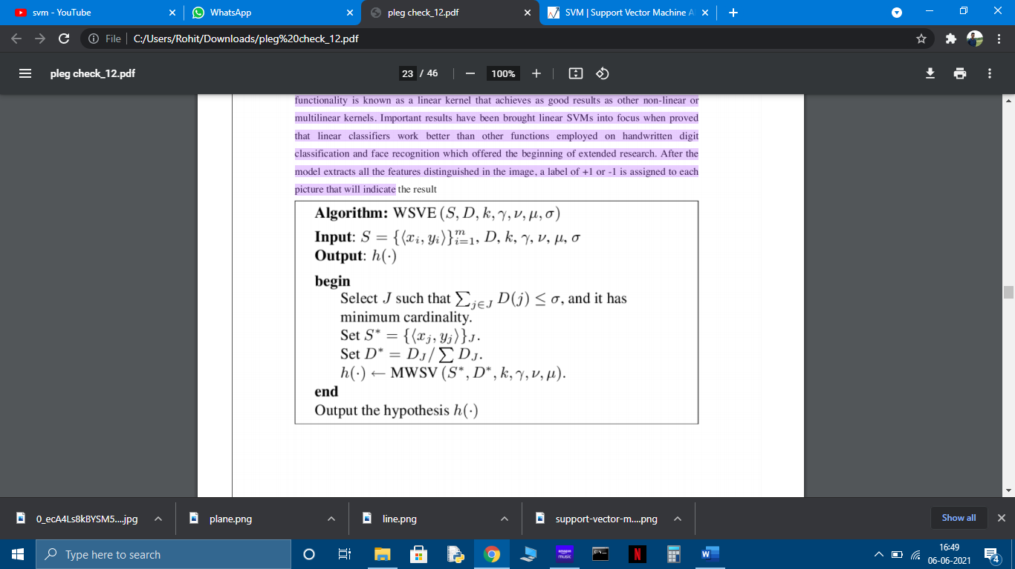

Random Forest:

Random Forest is a well known AI calculation that has a place with the supervised learning method. It very well may be utilized for both order and relapse issues in ML. It depends on the idea of troupe realizing, which is a cycle of consolidating numerous classifiers to tackle an unpredictable issue and to improve the exhibition of the model.

As the name recommends, " Random Forest is a classifier that contains various choice trees on different subsets of the given dataset and takes the normal to improve the prescient precision of that dataset." Rather than depending on one choice tree, the Random Forest takes the expectation from each tree and dependent on the greater part votes of forecasts, and it predicts the last yield.

The more noteworthy number of trees in the Random Forest prompts higher exactness and forestalls the issue of overfitting.

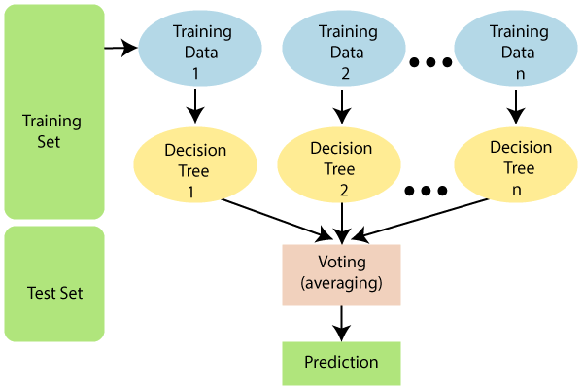

Algorithm:

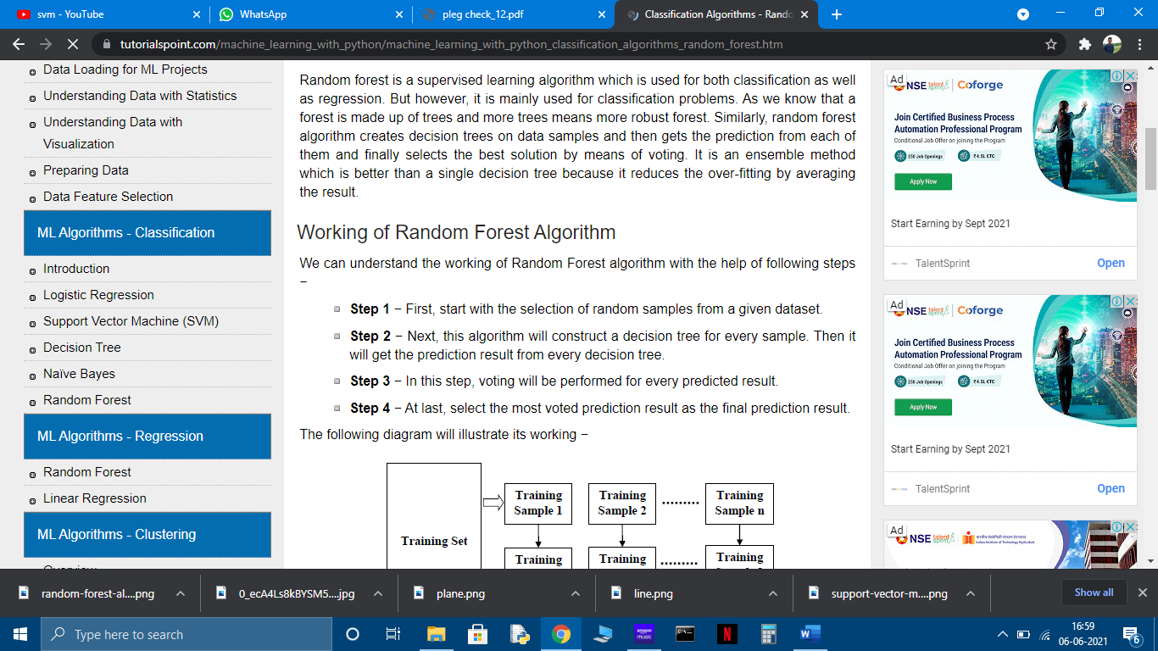

K-Nearest Neighbours

K-Nearest Neighbour is one of the simplest Machine Learning algorithms based on Supervised Learning technique .K-NN algorithm assumes the similarity between the new case/data and available cases and put the new case into the category that is most similar to the available categories. K-NN algorithm stores all the available data and classifies a new data point based on the similarity. This means when new data appears then it can be easily classified into a well suite category by using K- NN algorithm. K-NN algorithm can be used for Regression as well as for Classification but mostly it is used for the Classification problems. K-NN is a **non-parametric algorithm**, which means it does not make any assumption on underlying data.It is also called a **lazy learner algorithm** because it does not learn from the training set immediately instead it stores the dataset and at the time of classification, it performs an action on the dataset.

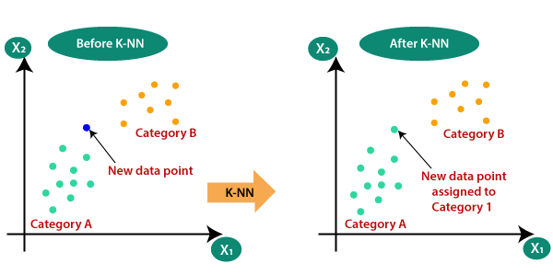

Working of K-NN:

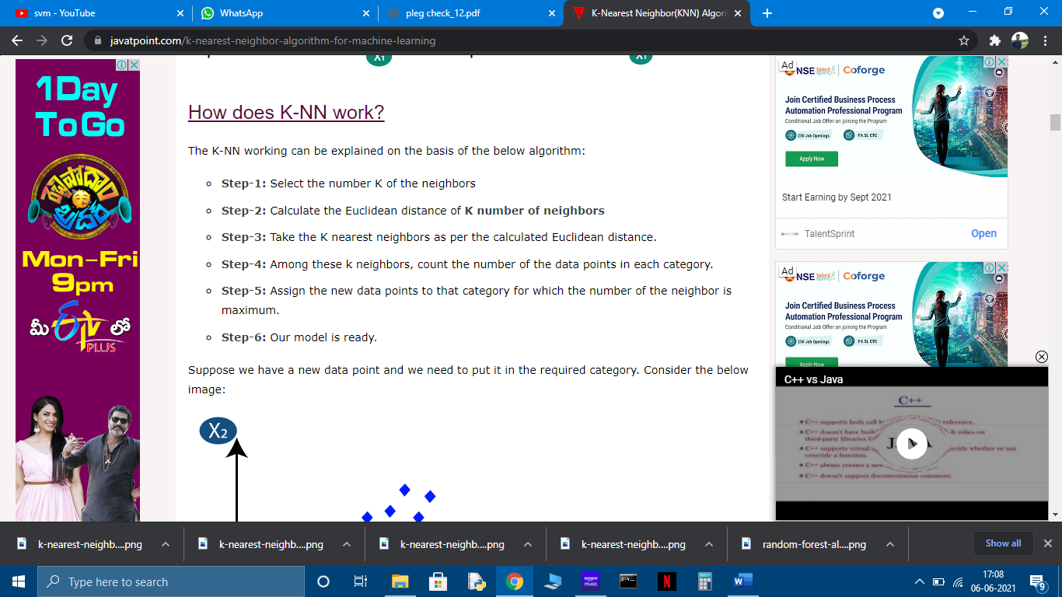

Explanation:

1. When new data point arrives

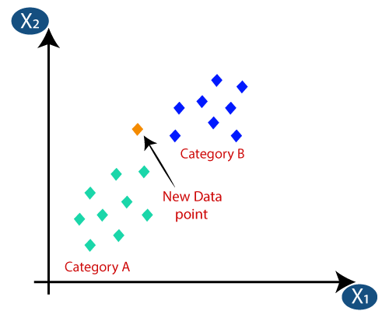

1. Calculate the Eucledian distance

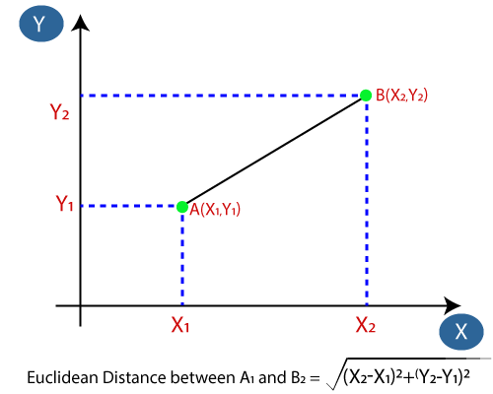

1. Classify the data point

