**Chapter 4**

**CONCEPTUAL FRAMEWORK**

The study entitled Project Blood Seeker is a Web Based Blood Banking System that provides available blood entries to all the people of Misamis Occidental who needs blood for their medical treatment purposes. This will serve as a search platform that will provide real-time results of bloods available in every blood banks and is capable to accept reservations and request online. All the blood entries of each blood bank will be visible through this website and can be easily access by the people who browse it. Users that will browse for available blood can be freely access the website and reserve blood anytime, anywhere.

Each blood bank will have an administrator who will handle all the records and reports of the blood going in and out in the blood bank. Through this, website administrator will require authentication process through a log in page that will verify their identification through its username and password. After the authentication process, administrator can now be exercise its fully authorization to View, Update, Create, and Delete Information in the Website records to his/her assigned blood bank chapter. After the changes and modification to the records the administrator can now save and it will now be available for viewing and available to be reserve by the people who needs blood.

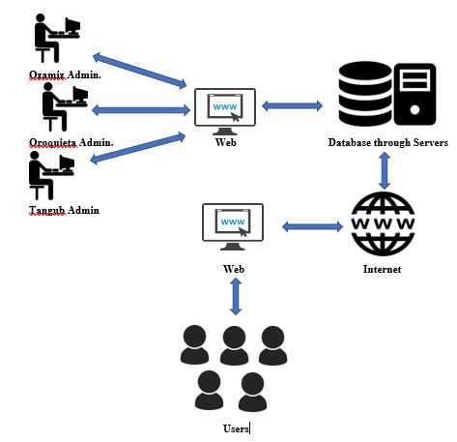

**Figure 4.0: CONCEPTUAL FRAMEWORK**

As shown in figure above, there will be three administrator that will manage the system. Each administrator from different blood banks will pass through authentication process and after that, they are given the privilege to access the records in the administrator pages through the web and they are given the authority to modify and manage the records from their own blood banks branches assigned. Once they are finished adding, modifying etc. The admin can store the records in one database that can support all the data coming from three sources. The records that are save in the administrator UI are then store into a single database that are established in a server. Then, it will be now available in the internet to be viewed by the users who will access and will find blood through their respective web browsers. Donors who wants to donate blood must submit their information to the database in order for the administrator to view their donation and will be recorded into one database in order to save their information.

**Tool and Technologies used:**

The following are the tools, programming languages and available technologies that are used in the developing the system.

**WAMP**

WAMP stands for Windows, Apache, MySql, PHP. This development tool is used to establish a mini server through local computer to exercise full stack development under the Windows OS platform. Through this tool, developers can run and test the system in local environment so that it will be properly running at the time that the system will be publish online.

**Visual Studio Code**

Visual Studio Code is a source code editor develop by Microsoft for windows, linux and macOS. This tool will be used by the developer for coding the system. this will be the core of the development since this tool is very important because this will be used in programming codes through different languages such as Javascript, PHP and other components in the system.

**Sublime Text 3**

Sublime Text 3 is a cross platform source code editor with a python application programming interface. This is also used to program codes through different languages such as Javascript, PHP, etc. this tool will be use by programmers of the team as they preferred to use such tool.

**MySql Workbench**

MySQL Workbench is a database design tool that consolidate SQL development, administration, database design such as making entity relationship diagram, creation and maintenance into a single environment for the MySQL database system. This tool will be use to design and integrate SQL queries that will be use for the database of the system that are able to store data and information to the system.

**Adobe Photoshop CS6**

Adobe Photoshop CS6 is a photo editing tool use to design and edit photos and other graphical component of the system to enhance the Graphics Interface of the system in order to be accessible and easy to visualize system for the comfortabilities of the users who will visit the website.

**GitHub**

Github is a web-based Git or version control repository. It provides [access control](https://en.wikipedia.org/wiki/Access_control) and several collaboration features. This tool is used by the developer to establish collaboration to each and every member of the team to work with the program codes/modules and consolidate it into one version.

**System Development Model**

The researchers used the Waterfall Model to develop the system. This will help the proponents in the development of the proposed project.

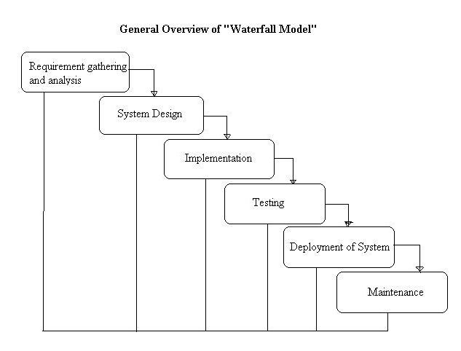

Project Blood Seeker Systems Development Life Cycle

The Project Blood Seeker will be developed using waterfall model through the development process. this will allow a gradual development for its deliverables. Each phase and stages must be done throughout the development process. Each stage must present a complete development of the system including certain functions of the system that is expected to be done. This are the following things that the proponents must undergo in every stage of the model.

* **Requirement Gathering and analysis** − All possible data and information that are required in the system to be developed are gathered and analyze in this stage. Interview and surveys are the activities in this phase, through those activities, proponents are able to gather helpful information and it will be use in the next phase of the system.
* **System Design** – In this stage, the proponents are able to capture how the system works and the logic behind it. In this system, proponents follow web design pyramid in designing the system. starting from component design, architecture design, navigational design, content design, aesthetic design, and the interface design are being captured in this phase.
* **Implementation** – At this phase, coding takes place. Programming languages are used by the proponents in order to turn the system into a working program. Modules are then distributed to every programmer and consolidate afterwards.
* **Integration and Testing** – All modules and components developed in the implementation stage will undergo the testing process. Each module will be tested through unit and integration testing and final will be the system testing which will be tested the whole system. This system will be tested by the proponents as well as random people.
* **Deployment of system** – At this stage, deployment or the delivery of the system takes place. Installation of the system in the exact operational workstation and short time of training are the activities in this phase of development.
* **Maintenance** − There are some issues which come up in the client environment. Proponents fixed those issues, remove those bugs and add some features that are most requested by the users of the system. because of the changes proponents will then released a new version of the system, those are the activities in this phase of development.