**Chapter 5**

**PROJECT BLOOD SEEKER (Web Based Blood Banking System)**

Project Blood Seeker (Web Based Blood Banking System) is a web based system that will help those people find blood urgently and minimize those existing problems, the web based system authorizes by the three-red cross administrator and also the user and the donor can access the web based system.

Using the web based system, it is easy for the user to look for available blood and also the user has a capability to reserve and request a specific blood group. The system authorizes by the administrator which is responsible to operate the database and website to store inform**a**tion and data coming from every users and blood donors and update the website information in order the user can let to search for blood donors. With the help of this system, problems existing will be lessened.

**System Objectives**

The study aims to develop a web based blood banking system that can be used in searching blood in different blood banks within Misamis Occidental.

It specifically aims to:

1. Provide web based blood banking system that is accessible, reliable and can view data from within the area.
2. Store information about blood and registration through forms
3. Can add, update and delete records from every blood banks.
4. Accommodate multiple users connecting each blood banks.
5. Display accurate results based on the user’s preference in searching for available blood
6. Capable to reserve those bloods available by every blood seekers as well as request for blood.
7. Able to view, edit and print reports of all records of blood donated and distributed.
8. Establish a server that is capable of accommodating multiple blood banks that will be connected to each other.

**System Scope and Delimitation**

The system focuses on people that need a blood urgently. The web based system will let the user search/view available blood and has a capability to reserve and request the blood. And also, the administrator of each blood bank can store data and can access data from other blood banks within Misamis Occidental. The system will not cover other concerns except those things that stated above.

**Physical Environment and Resources**

These are the system specifications that will be used by the proponents in developing the research:

**Developer Tools/Application**

**Hardware Platforms:**

Laptop

* RAM : 4.00 GB
* Hard Disk Drive : 1000 GB
* Processor : Intel Core i3 5th generation 2.0GHz
* Mouse
* Printer

**Software Platforms:**

* Operating System : Windows 8 and up 64bit
* Software Tools : WAMP, Visual Studio Code, Sublime Text, Mysql Workbench
* Language : HTML, Javascript, PHP, Mysql, Jquery

**Peopleware**

The Three Administrator of the Red Cross in Misamis Occidental has an authority to manage the system in updating the data of the blood banks and also manage the data coming from the user and donor.

**Use Case Modelling**

Admin

Admin

**Fig. 5.0: Administrator Use Case Diagram**



**Fig. 5.1: Donor Use Case Diagram**



**Fig. 5.2: Users Use Case Diagram**

**Actor List**

1. **Blood Bank Administrator –** is one who responsible to operate the database and website in which to store information and data coming from every users and blood donors and update the website information in order the user can let to search for specific blood.
2. **Donors –** a person who gives blood for transfusion in which it is voluntary procedure which the donor will fill up the given form and wait for confirmation of the administrator.
3. **Users –** is one who view the availability of blood in every blood banks and has a capability to request and reserve those bloods to the patient that needed.

**Administrator Use Case List**

**U1. Log-in** -The administrator must login his/her account before he/she can access the administration side of the website.

**U2. View Record –** Administrator can view the list of records on the landing page of the administrator side of the website.

**U3. Update Record** – When there are some errors in the records, administrator can exercise its authority to update the records in its own blood bank assigned.

**U4. Create Record** – Administrator can add new records and specified its information’s to a form that will validate information if its valid.

**U5. Delete Record –** Administrator can delete records for some reasons such as redundancy, errors, not important details etc.

**U6. View Reports –**  Administrator can view reports for those blood going out in its offices in a month.

**U7. Modify Reports –** When errors will be found in the report, the administrator can modify those errors to be exact.

**U8. Print Reports –** Administrators can print reports for some legal purposes of the blood bank that required printed reports of the transaction in every blood banks.

**U9. Log-out –** When administrator is done, they can log out the accounts that they log in to secure privacy.

**Use Case Description**

**Table 5.0**

**LOGIN**

|  |  |
| --- | --- |
| U1: Login | |
| Pre-Condition: None | |
| Actor’s Action | System Response |
| 1. Admin Enter Username and Password | 1. The system checks if username and password are being provided. 2. The system will verify the username and password if it is already valid. |
| Post-Condition: Admin landing page appears | |
| Abnormal Path: If the username and password is invalid, the system will notify that it is invalid and will ask to enter again. | |

**Table 5.1**

**View Record**

|  |  |
| --- | --- |
| U2: View Record | |
| Pre-Condition: Admin Login | |
| Actor’s Action | System Response |
| 1. Clicks the navigation to view records within its specific blood bank. 2. Admin will input the specific blood banks to what they prefer to view | 1. The system will provide input fields to filter results 2. The system will response list of all blood recorded in a specific blood bank. |
| Post-Condition: System will view the list of bloods available in their respective blood bank by default. | |
| Abnormal Path: If any specific blood bank doesn’t have any record, the system will ask to enter another specific blood group with their specific blood bank | |

**Table 5.2**

**Update Record**

|  |  |
| --- | --- |
| U3: Update Record | |
| Pre-Condition: Admin Login | |
| Actor’s Action | System Response |
| 1. Clicks the navigation panel to update records within its specific blood bank. 2. Admin will fill up input fields to where they wish to update 3. Click the update button to update record. | 1. The system will view the not updated information of a specific blood record 2. The system will output the updated record to the Admin |
| Post-Condition: System will update specific record in one database which means it will be updated to also to every blood banks who will view it | |
| Abnormal Path: Admin cannot update records from other blood banks. | |

**Table 5.3**

**Create Record**

|  |  |
| --- | --- |
| U4: Create Record | |
| Pre-Condition: Admin Login | |
| Actor’s Action | System Response |
| 1. Clicks the navigation panel to add records 2. Admin will fill up the forms with exact information 3. Click the save button to save record. | 1. The system will view the create record form to the admin 2. The system will verify info being inputted 3. Record will save into database |
| Post-Condition: System will update specific record in one database which means it will be updated to also to every blood banks who will view it | |
| Abnormal Path: Invalid Information will cause error in creating record, it will notify the admin | |

**Table 5.4**

**Create Record**

|  |  |
| --- | --- |
| U5: Delete Record | |
| Pre-Condition: Admin Login | |
| Actor’s Action | System Response |
| 1. Clicks delete record tab 2. Admin will click the delete button to which he/she wish to delete 3. Admin will response to the notification if he/she really wants to delete a specific record | 1. The system will view records with delete button beside it. 2. The system will notify if he/she is sure to delete the specific record 3. Record will be deleted to the entire database |
| Post-Condition: Record will be deleted from the database and it can be no longer seen in every record to every blood banks | |
| Abnormal Path: None | |

**Table 5.5**

**View Reports**

|  |  |
| --- | --- |
| U6: View Reports | |
| Pre-Condition: Admin Login | |
| Actor’s Action | System Response |
| 1. Clicks reports navigation | 1. The system will view reports to which it will consist of blood information that are going out within the blood bank |
| Post-Condition: Reports are can be now modify or be printed. | |
| Abnormal Path: None | |

**Table 5.6**

**Modify Reports**

|  |  |
| --- | --- |
| U7: Modify Reports | |
| Pre-Condition: Admin Login/View Reports | |
| Actor’s Action | System Response |
| 1. Click view reports navigation 2. Admin can Create, Update, Delete report. | 1. The system will view all the records in a report format 2. The system will execute to every command from the admin. 3. Report can now be available for printing |
| Post-Condition: Report will have its format for printing | |
| Abnormal Path: Reports will be invalid if there is missing information | |

**Table 5.7**

**Print Reports**

|  |  |
| --- | --- |
| U8: Print Reports | |
| Pre-Condition: Admin Login/View Reports | |
| Actor’s Action | System Response |
| 1. Click print report button | 1. The system will view the report format of the records 2. The system will print the report through a output devices such as printer |
| Post-Condition: System will notify that printing is succsessfull | |
| Abnormal Path: Report will be invalid if there is an error within the printer or the report | |

**Table 5.8**

**Log-out**

|  |  |
| --- | --- |
| U1: Log-out | |
| Pre-Condition: Log-in | |
| Actor’s Action | System Response |
| 1. Admin Log out Button | 1. The system will warn the admin if they are sure to log out 2. The system will terminate the login session. |
| Post-Condition: The system will return to admin login page | |
| Abnormal Path: None | |

**Donor Use Case List**

**U1. Register –** Every blood donor will require to register their information to be authorize and verify if they can donate blood.

**U2. Log-in –** Blood donors will have an authentication process to which they will require to log-in if they are going to donate blood.

**U3. Search Blood –**  Donor can also search blood even they will not login with their accounts.

**U4. Request Blood –** Donor can also request for blood donation if they are going to need blood for their own patient.

**U5. Donate Blood –** By the use of authentication process, the donor can now donate blood if they are already login through his/her account.

**U6. View Blood Info. -**  Donor can view blood info at the time that they are searching for blood also for their patient.

**U7. Log-out –** Donor can log out their account to preserve their account privacy.

**Table 5.9**

**Register**

|  |  |
| --- | --- |
| U1: Register | |
| Pre-Condition: None | |
| Actor’s Action | System Response |
| 1. Donor click the register button 2. Donor Fill up form by their exact information and click register if they are finished | 1. The system will provide a registration form to the donor 2. The system will verify if their information is valid 3. The system will notify the donor if the registration is successful |
| Post-Condition: The user will be redirected to the log in page of the website | |
| Abnormal Path: None | |

**Table 5.10**

**Log in**

|  |  |
| --- | --- |
| U1: Log in | |
| Pre-Condition: Registration | |
| Actor’s Action | System Response |
| 1. Donor sign in through the log in fields | 1. The system will check if information is being provided 2. The system will validate the information being inputted. 3. The system will prompt if the login session is successful |
| Post-Condition: The donor will be redirected to the donation page | |
| Abnormal Path: If login error occurs. The system will require to log in again | |

**Table 5.11**

**Search Blood**

|  |  |
| --- | --- |
| U1: Search Blood | |
| Pre-Condition: None | |
| Actor’s Action | System Response |
| 1. Donor will click the navigation bar to search blood page 2. Donor fill up the fields by what type of blood they look for then click search button | 1. The system will provide input fields to be inputted by donors to filter search results 2. The system will validate the information being inputted. 3. The system will show the list of blood within the blood specification being inputted |
| Post-Condition: The donor will be allowed to click the blood results and to show more information about the blood. | |
| Abnormal Path: None | |

**Table 5.12**

**Request Blood**

|  |  |
| --- | --- |
| U1: Request Blood | |
| Pre-Condition: None | |
| Actor’s Action | System Response |
| 1. Donor will click the navigation bar to request blood page 2. Donor fill up the fields by their exact and valid information | 1. The system will provide forms for requesting for blood donors 2. The system will validate the information being inputted. 3. The system will notify if request is being successful |
| Post-Condition: None | |
| Abnormal Path: None | |

**Table 5.13**

**Donate Blood**

|  |  |
| --- | --- |
| U1: Donate Blood | |
| Pre-Condition: Login | |
| Actor’s Action | System Response |
| 1. Donor will click the navigation bar to donate blood page 2. Donor fill up the fields by their exact and valid information | 1. The system will provide forms for donating for blood 2. The system will validate the information being inputted. 3. The system will notify if blood donation is being process by the admin |
| Post-Condition: The system will give information if when or where will be the donation takes place | |
| Abnormal Path: If none registered donator they are not allowed to donate blood | |

**Table 5.14**

**View Blood Info**

|  |  |
| --- | --- |
| U1: View Blood Info | |
| Pre-Condition: None | |
| Actor’s Action | System Response |
| 1. Donor will click the blood entry after they search for it | 1. The system will provide additional information for the blood being chosen |
| Post-Condition: None | |
| Abnormal Path: None | |

**User Use Case List**

**U1. Search Blood –**  User can also search blood even they will not login with their accounts.

**U2. Reserve Blood –** User can reserve the blood being searched.

**U3. Request Blood –**User can also request for blood donation if they are going to need blood for their own patient.

**U6. View Blood Info. -**  User can view blood info at the time that they are searching for blood also for their patient.

**Table 5.15**

**User Search Blood**

|  |  |
| --- | --- |
| U1: Search Blood | |
| Pre-Condition: None | |
| Actor’s Action | System Response |
| 1. User will click the navigation bar to search blood page 2. User fill up the fields by what type of blood they look for then click search button | 1. The system will provide input fields to be inputted by donors to filter search results 2. The system will validate the information being inputted. 3. The system will show the list of blood within the blood specification being inputted |
| Post-Condition: The user will be allowed to click the blood results and to show more information about the blood. | |
| Abnormal Path: None | |

**Table 5.16**

**Reserve Blood**

|  |  |
| --- | --- |
| U1: Reserve Blood | |
| Pre-Condition: Search Blood | |
| Actor’s Action | System Response |
| 1. User will click the reserve blood button if they are willing to get those blood | 1. The system will provide forms for reservation 2. The system will validate the information being inputted. 3. The system will prompt if reservation is successful |
| Post-Condition: None. | |
| Abnormal Path: If blood is already reserve it will prompt some error | |

**Table 5.17**

**Request Blood**

|  |  |
| --- | --- |
| U1: Request Blood | |
| Pre-Condition: None | |
| Actor’s Action | System Response |
| 1. User will click the navigation bar to request blood page 2. User fill up the fields by their exact and valid information | 1. The system will provide forms for requesting for blood donors 2. The system will validate the information being inputted. 3. The system will notify if request is being successful |
| Post-Condition: None | |
| Abnormal Path: None | |

**Table 5.17**

**View Blood Info**

|  |  |
| --- | --- |
| U1: View Blood Info | |
| Pre-Condition: None | |
| Actor’s Action | System Response |
| 1. User will click the blood entry after they search for it | 1. The system will provide additional information for the blood being chosen |
| Post-Condition: None | |
| Abnormal Path: None | |

**Class Diagram**

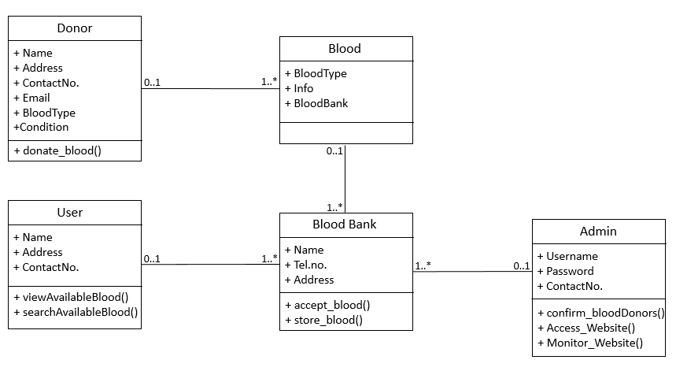

**Fig.5.3: Class Diagram**

**Sequence Diagram for Administrator**

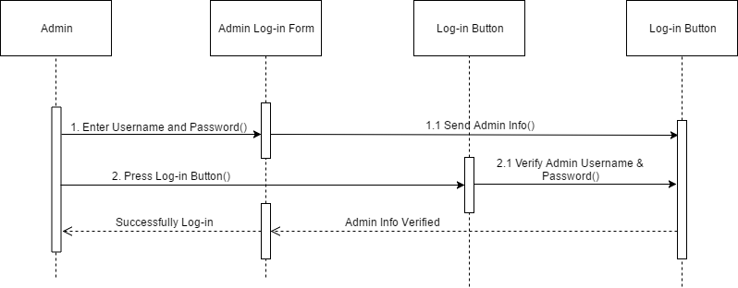

**Figure 5.4 Administrator Login Sequence Diagram**

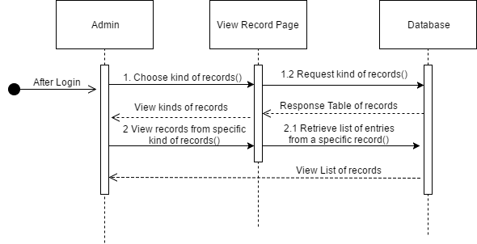

**Figure 5.5 Administrator View Record Sequence Diagram**

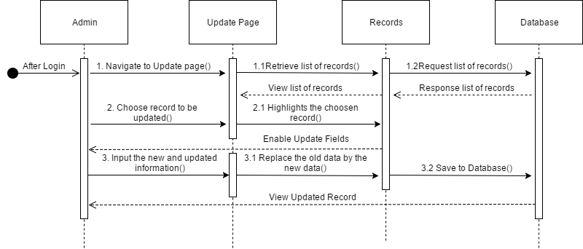

**Figure 5.6 Administrator Update Record Sequence Diagram**

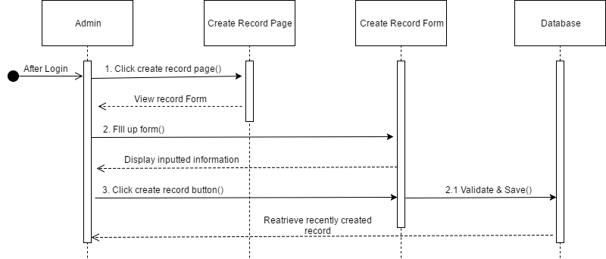

**Figure 5.7 Administrator Create Record Sequence Diagram**

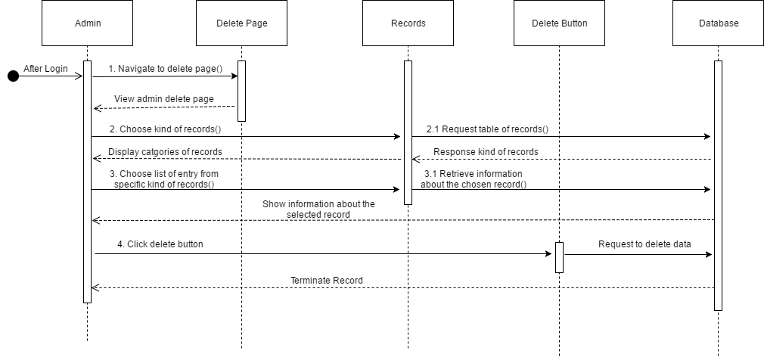

**Figure 5.8 Administrator Delete Record Sequence Diagram**

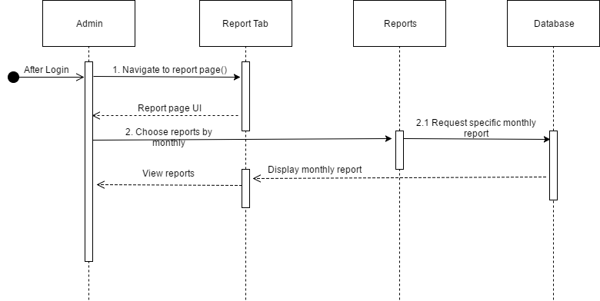

**Figure 5.9 Administrator View Report Sequence Diagram**

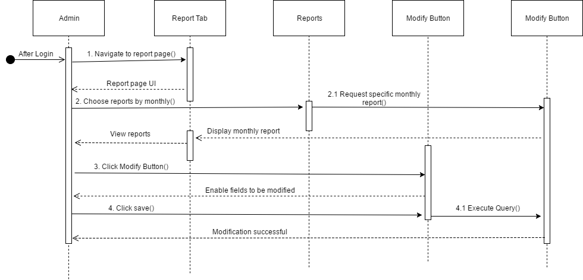

**Figure 5.10 Administrator Modify Report Sequence Diagram**

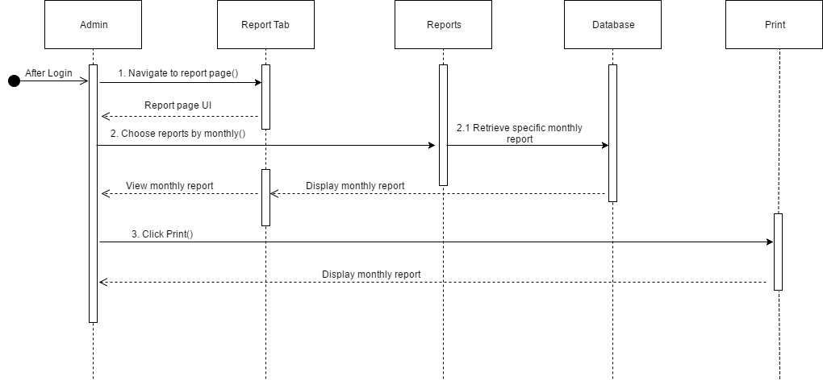

**Figure 5.10 Administrator Print Report Sequence Diagram**

**Sequence Diagram for Donors & Users**

**Figure 5.11 Donor Registration Sequence Diagram**

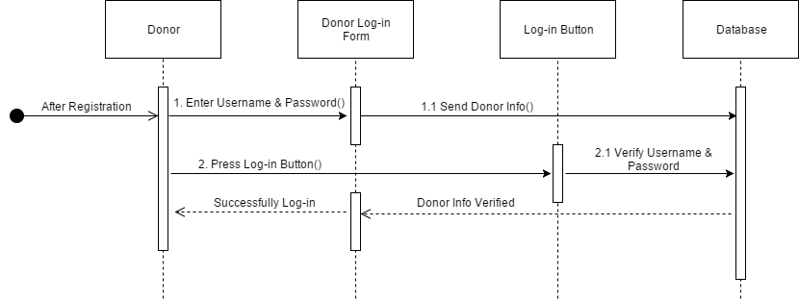

**Figure 5.12 Donor Log in Sequence Diagram**

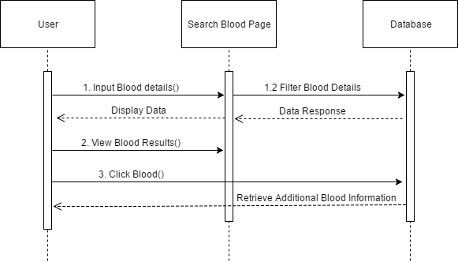

**Figure 5.13 Donor & Users Search Blood Sequence Diagram**



**Figure 5.14 Donor and Users Reserve Blood Sequence Diagram**

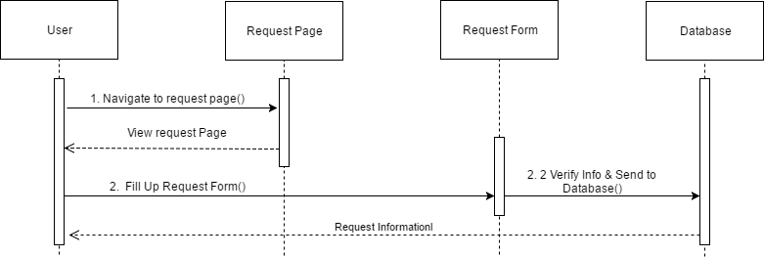

**Figure 5.15 Donor & Users Request Blood Sequence Diagram**

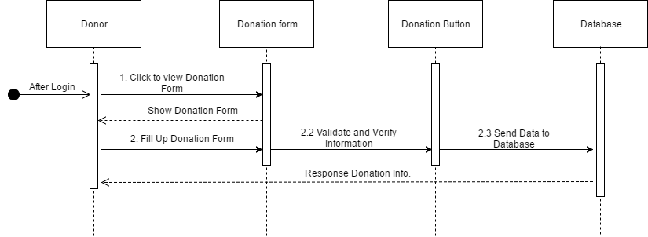

**Figure 5.16 Donor’s Donation Blood Sequence Diagram**



**Figure 5.17 Donor’s & Users View Blood Info. Sequence Diagram**

**Activity Diagram**

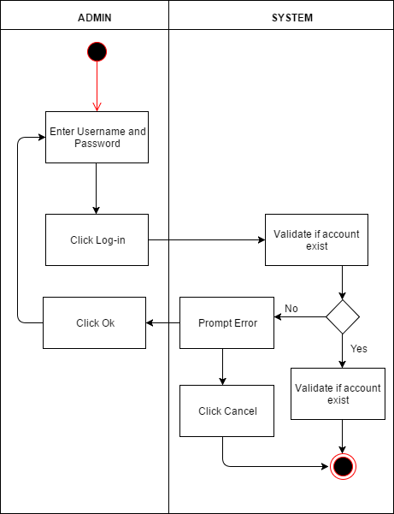

**Figure 5.18 Admin Login Activity Diagram**

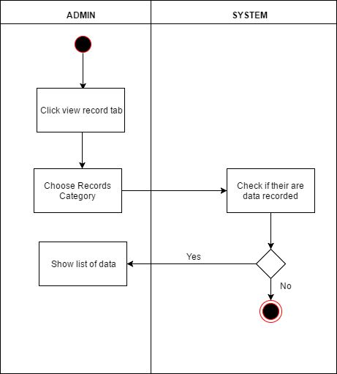

**Figure 5.19 Admin View Record Activity Diagram**

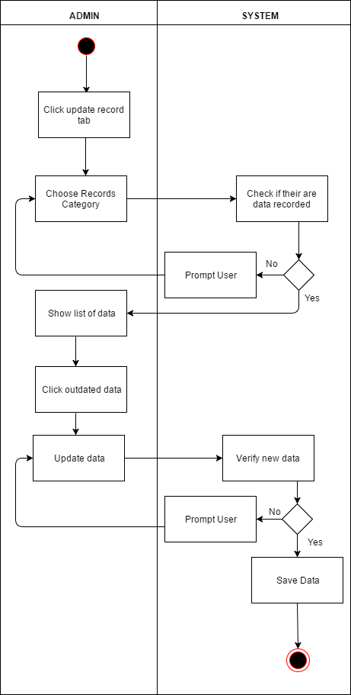

**Figure 5.20 Admin Update Record Activity Diagram**

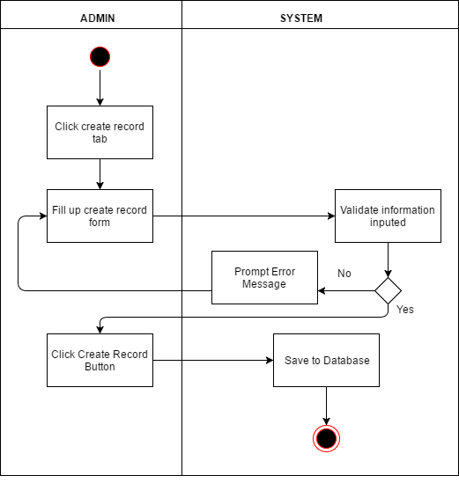

**Figure 5.21 Admin Create Record Activity Diagram**

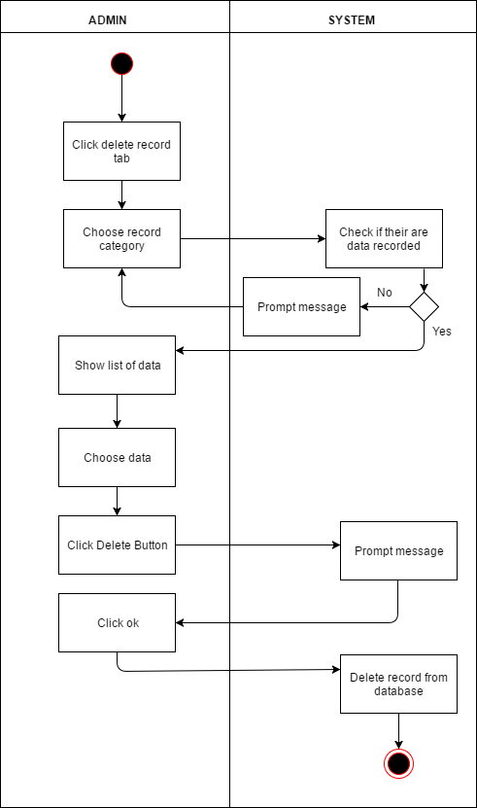

**Figure 5.22 Admin Delete Record Activity Diagram**

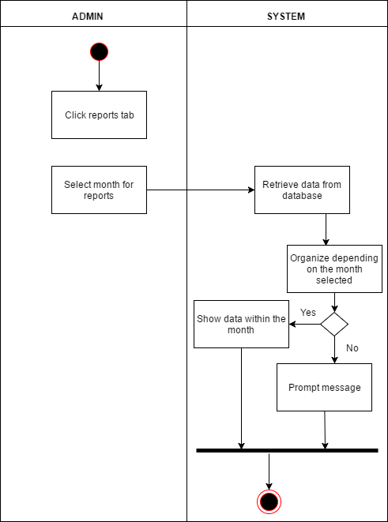

**Figure 5.23 Admin View Report Activity Diagram**

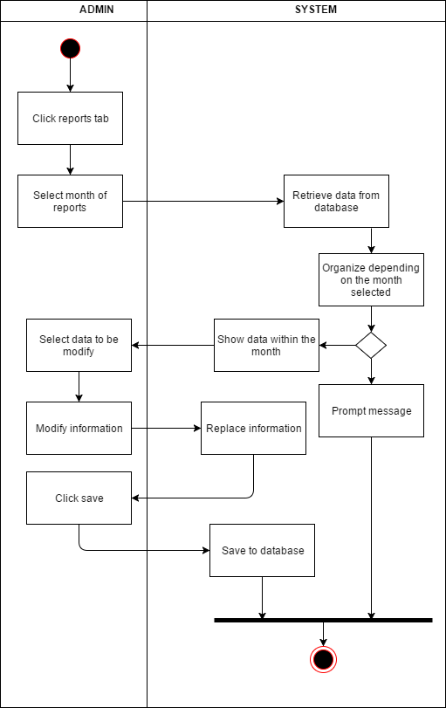

**Figure 5.24 Admin Modify Report Activity Diagram**

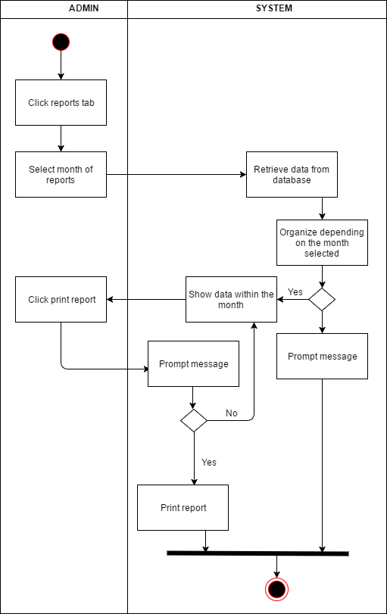

**Figure 5.25 Admin Print Report Activity Diagram**

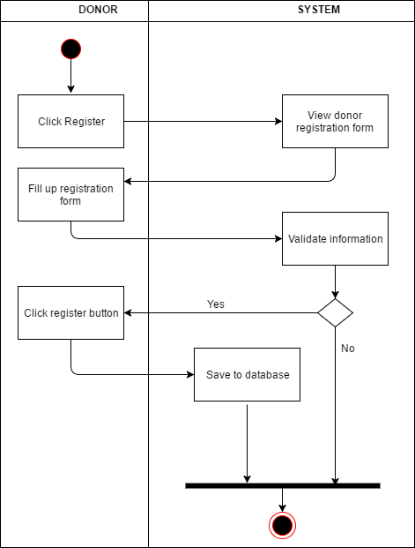

**Figure 5.24 Donor Registration Activity Diagram**



**Figure 5.18 Donor Login Activity Diagram**



**Figure 5.19 Donor & User Search Blood Activity Diagram**

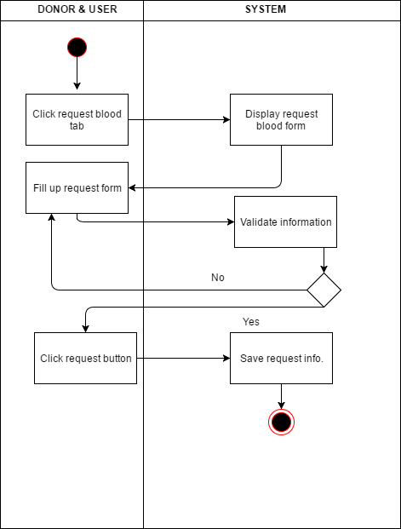

**Figure 5.20 Donor & User Request Blood Activity Diagram**

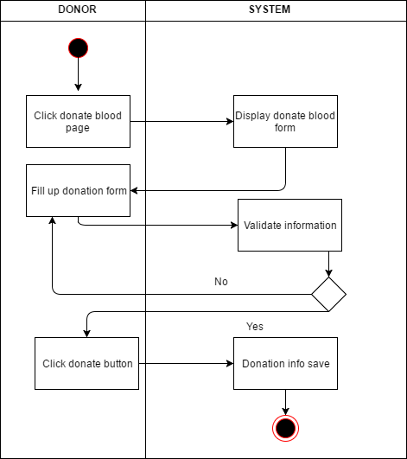

**Figure 5.21 Donor Donate Blood Activity Diagram**

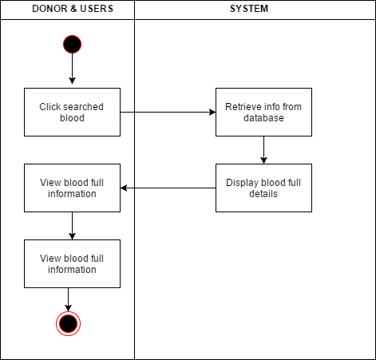

**Figure 5.22 Donor & Users Activity Diagram**