***Game Report – Final Project***

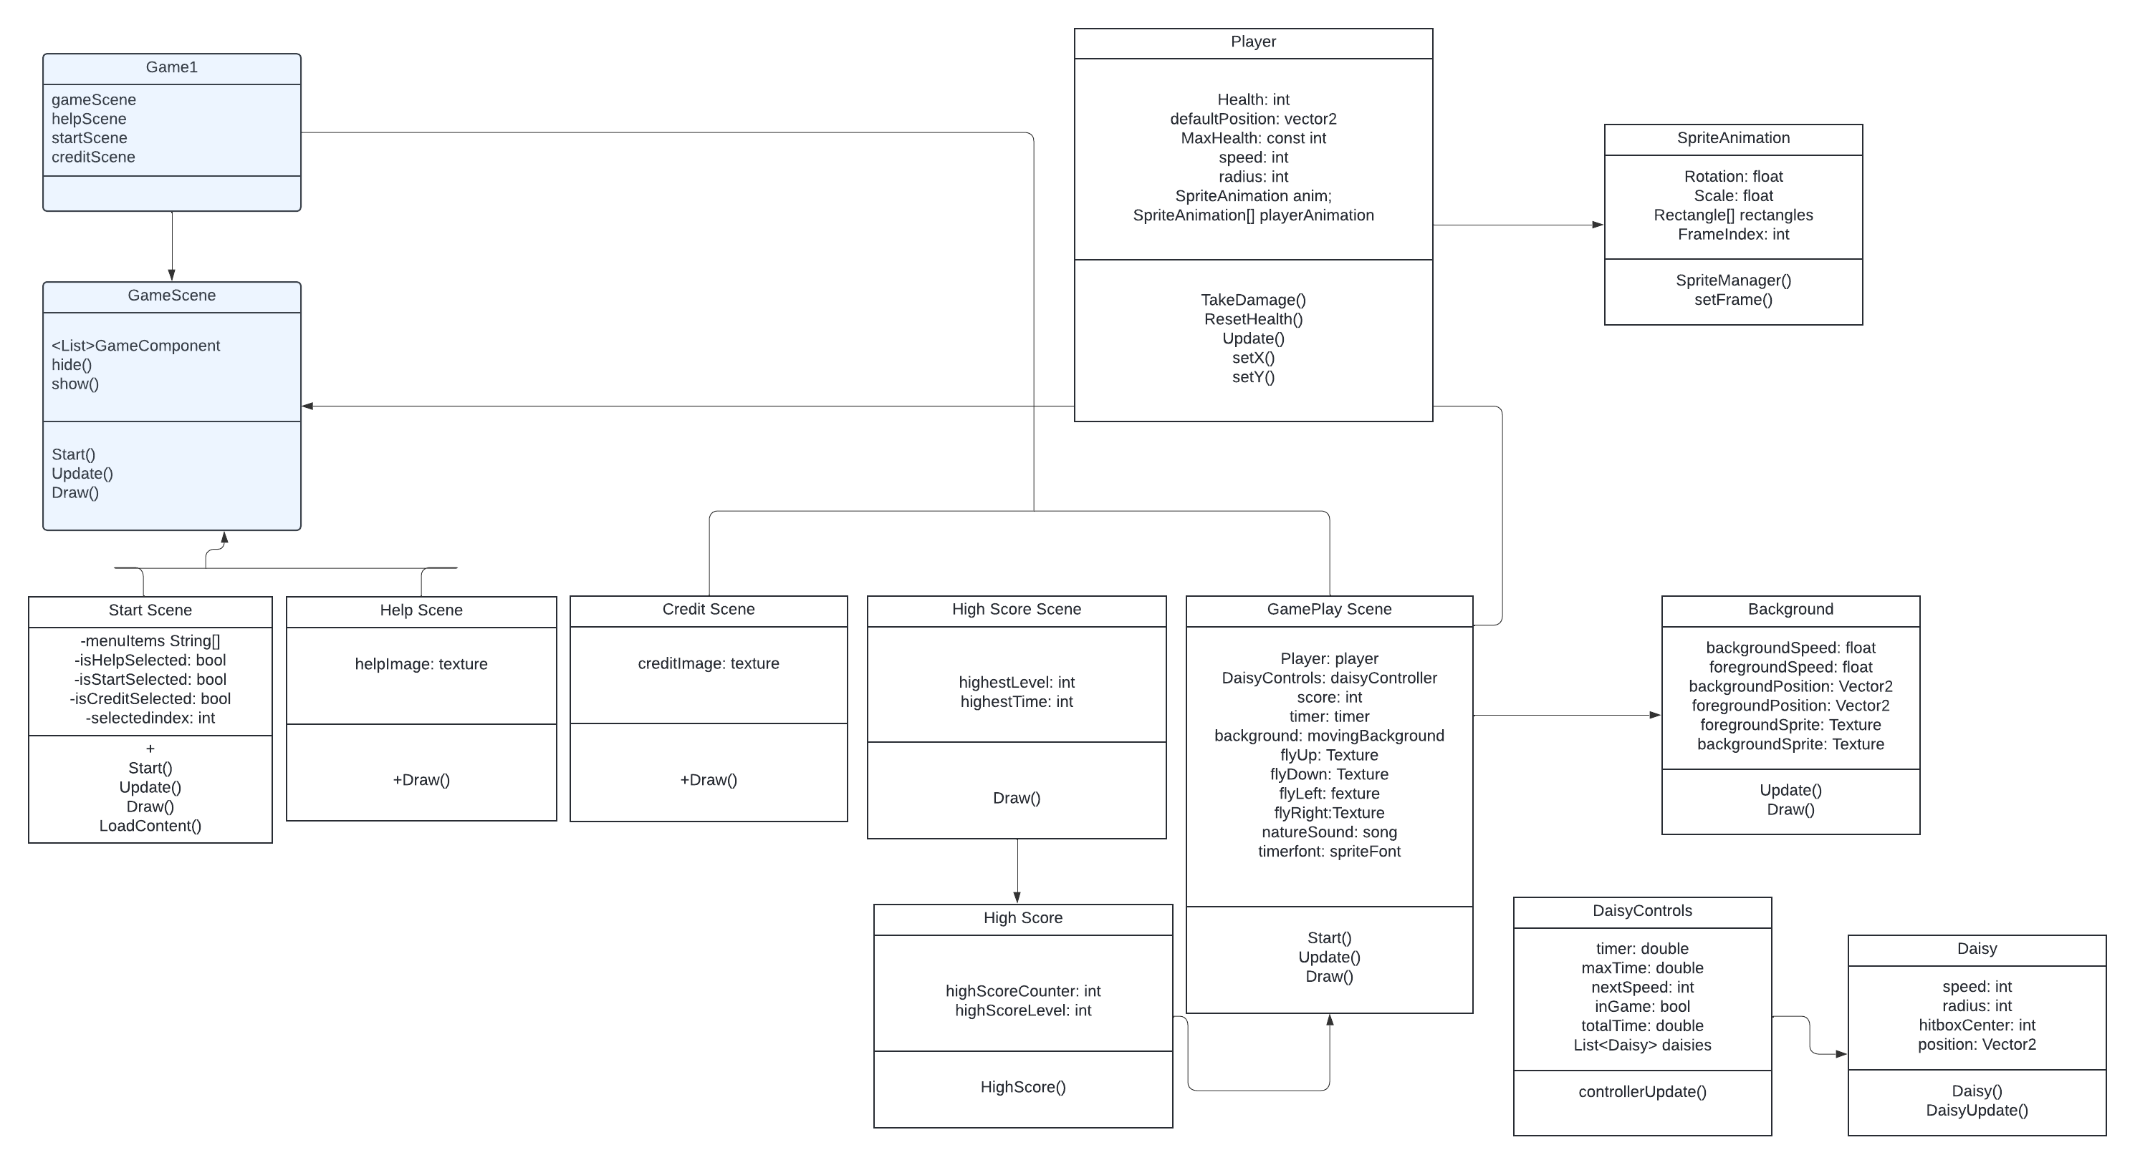The game's core mechanics revolve around the fluid and fast pace dance of avoidance and movement, with the fairy character using her flight to weave between the swirling daisies that come spiraling through the air. As the player guides her through the forest, the challenge escalates with each level, introducing daisies that drift unpredictably or in intricate patterns, designed to test the player's reflexes and precision. The fairy's health is visually represented by a cluster of hearts that hover near her, each lost when a daisy's touch is not avoided.

***Game Process and References***

We then used photoshop to modify the sprite sheet to our desired look:

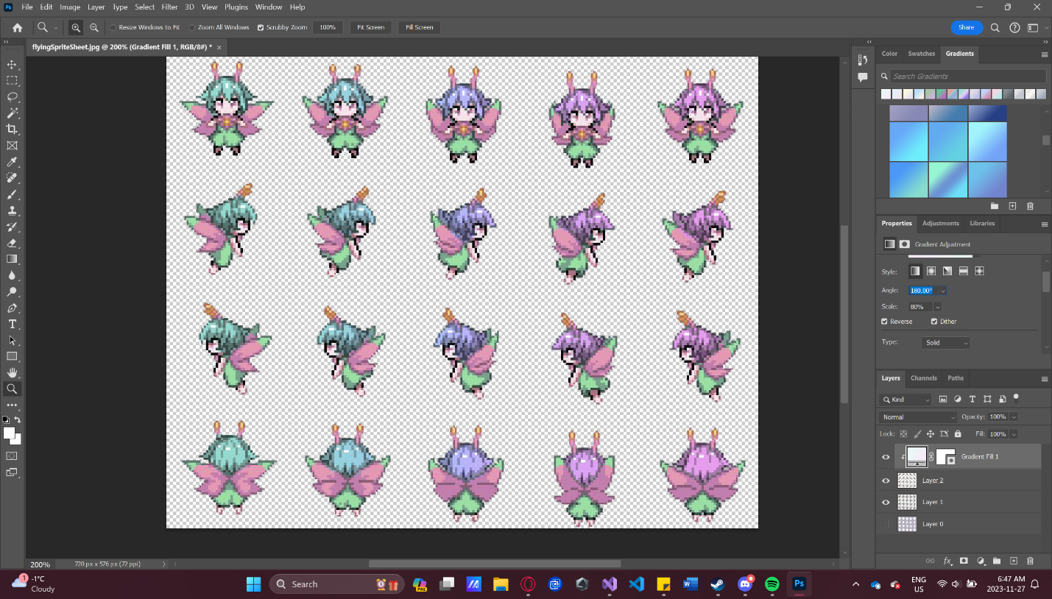

The rest of our game elements were generated images using DALL-E to suit our specific needs:

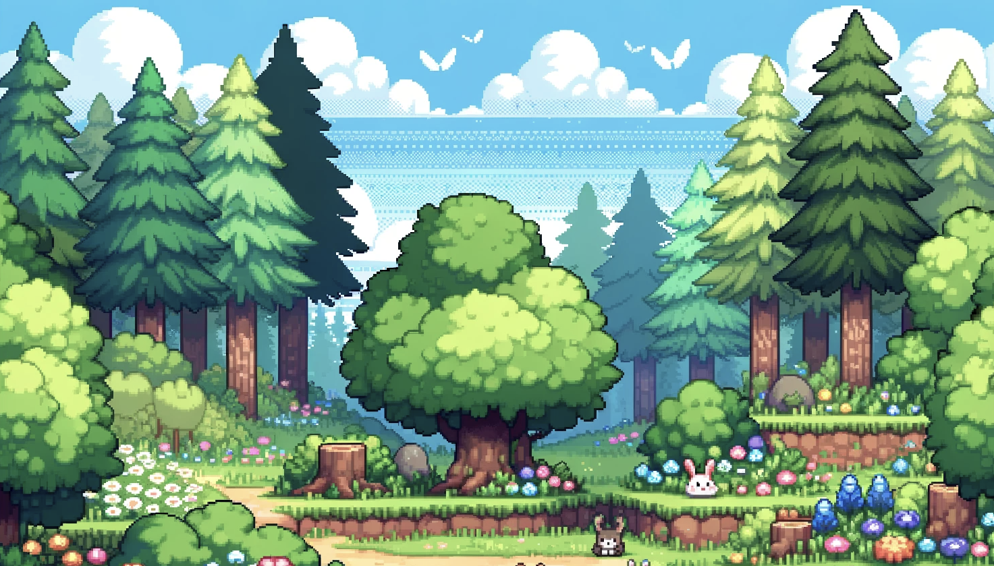

“Friendly Forest tiled backdrop”

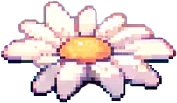

“Daisy Obstacle”

Modified in photoshop for a transparent background.

Pixel art heart stock image we obtained online, and then edited in photoshop to suit our needs.

<https://www.vectorstock.com/royalty-free-vector/pixel-art-8bit-life-three-hearts-red-glitch-set-vector-27629920>