# install.packages("pwr")

library(pwr)

library(tidyverse)

setwd("C:\\Users\\ASUS\\Desktop\\五234 R\\HW6") #放你的路徑

data2 <- read.csv("ecommerce.csv")

# Remove missing values

data2 <- na.omit(data2)

# Data2

# Website A: proportion of converted

subset_A <- data2 %>%

filter(landing_page == "old_page" & converted == 1)

purchased_A <- nrow(subset_A)

visitors_A <- nrow(data2 %>% filter(landing_page == "old_page"))

phat_A <- purchased_A / visitors_A

# Website B: proportion of converted

subset_B <- data2 %>% filter(landing_page == "new_page" & converted == 1)

purchased_B <- nrow(subset_B)

visitors_B <- nrow(data2 %>% filter(landing_page == "new_page"))

phat_B <- purchased_B / visitors_B

# Uplift calculation

uplift <- (phat_B - phat_A) / phat_A * 100

# Pooled proportion

p_pool <- (purchased_A + purchased_B) / (visitors_A + visitors_B)

# Standard error of the pooled proportion

SE_pool <- sqrt(p_pool * (1 - p_pool) * ((1 / visitors_A) + (1 / visitors_B)))

# Point Estimate or Difference in proportion

d_hat <- phat_B - phat_A

# Z-score

z_score <- d_hat / SE_pool

# Two-sided p-value

p_value <- pnorm(q = -abs(z_score), mean = 0, sd = 1) * 2

# Confidence interval

ci <- c(d_hat - qnorm(0.975) * SE_pool, d_hat + qnorm(0.975) * SE_pool)

# SE and CI for website A and B separately

se_hat_A <- sqrt(phat_A * (1 - phat_A) / visitors_A)

ci_A <- c(phat_A - qnorm(0.975) * se_hat_A, phat_A + qnorm(0.975) * se_hat_A)

se_hat_B <- sqrt(phat_B * (1 - phat_B) / visitors_B)

ci_B <- c(phat_B - qnorm(0.975) * se_hat_B, phat_B + qnorm(0.975) * se_hat_B)

# 1-sample test

prop.test(c(purchased_A + purchased_B), c(visitors_A + visitors_B))

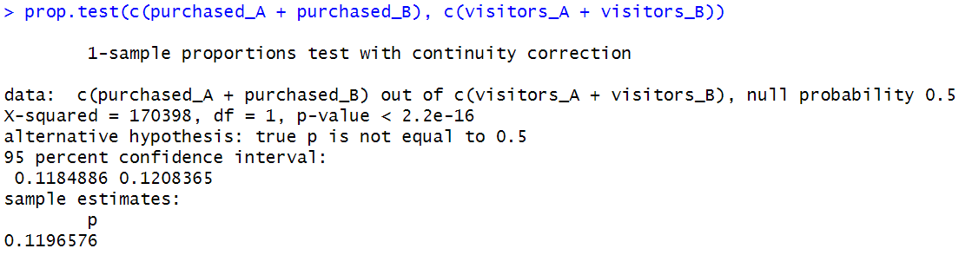

**整體接受狀況結果為顯著**

# 2-sample test

prop.test(c(purchased_A, purchased_B), c(visitors_A, visitors_B))

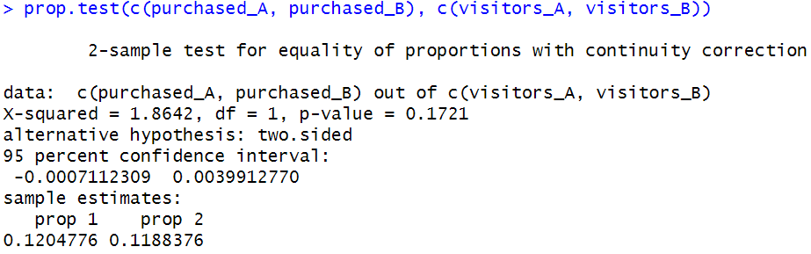

**p-value 為0.17無顯著差異**

# Chi-squared test

chisq.test(data2$converted, data2$website)

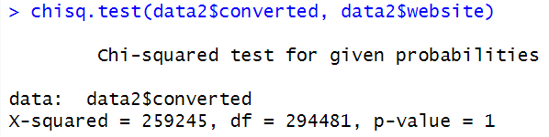

**p-value = 1 ，無顯著差異，兩個變數是獨立的**

**無論改網頁與否對客戶的差異不大**

**若有更多資料，可再針對地區、年齡、性別等資料作分析**

# Fake data

x <- seq(from = 90, by = 10, length.out = 6)

n <- rep(1000, 6)

prop.test(x, n) # goodness-of-fit test

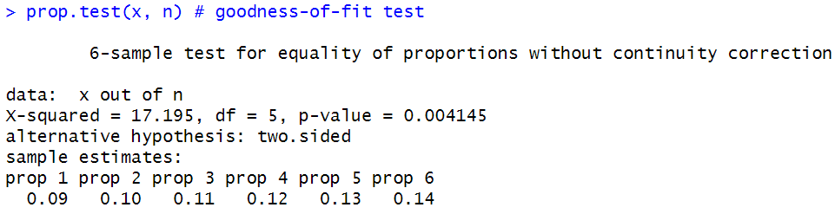

pairwise.prop.test(x, n, p.adjust.method = "none")

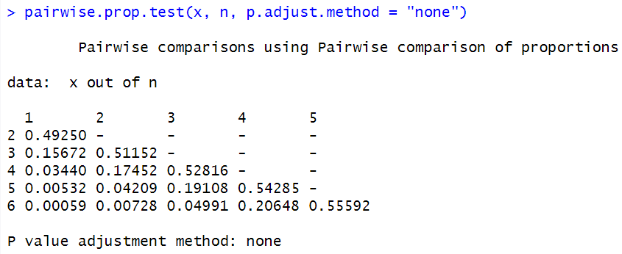

# Sample size determination

pwr.anova.test(k = 2, n = NULL, f = 0.2, sig.level = 0.05, power = 0.8)

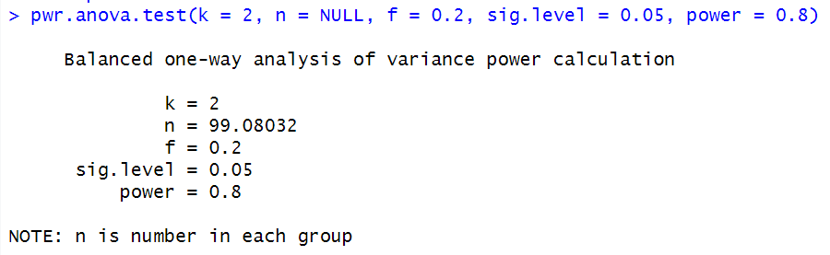

pwr.t.test(n = NULL, d = 0.3, sig.level = 0.05, power = 0.8, type = "two.sample", alternative = "greater")

