HW4

P76061182 張之耀

1(a). Implement two neural networks with wide hidden layer.

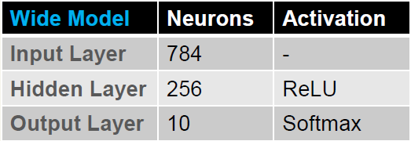

Result：

Epoch：100

Batch size：6000

Learning rate：0.00001

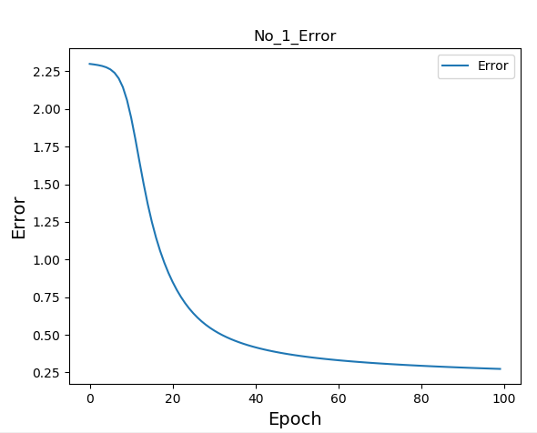

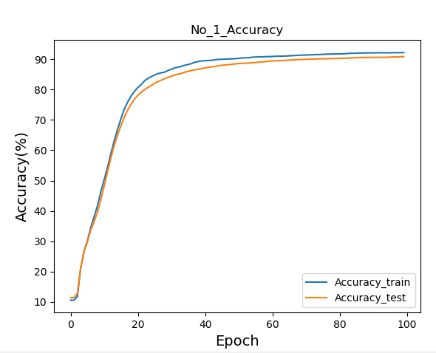

2(b). Implement two neural networks with deep hidden layer.

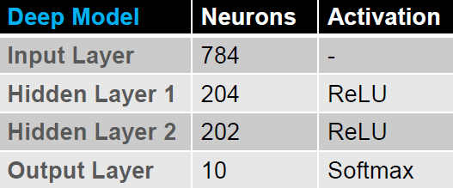

Result：

Epoch：100

Batch size：1000

Learning rate：0.00003

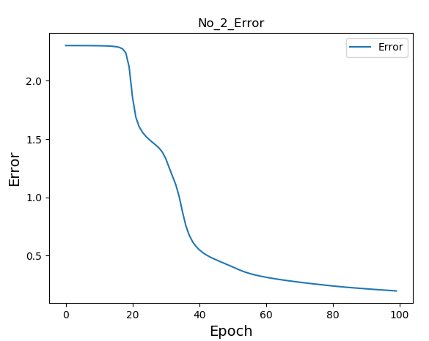

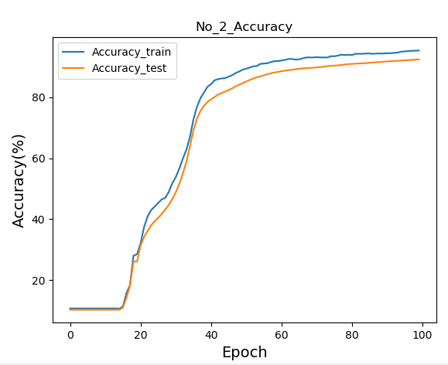

2(a). Implement an autoencoder(AE) to learn the representation of the MNIST dataset.

Show the results of the AE-based dimension reduction such as HW3-A.

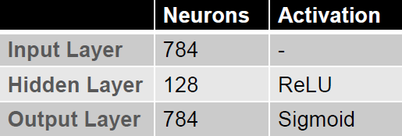

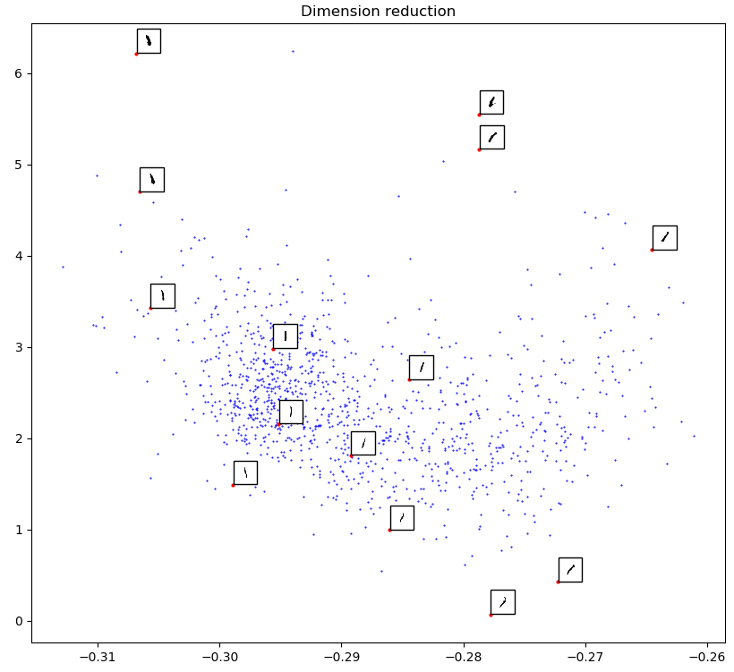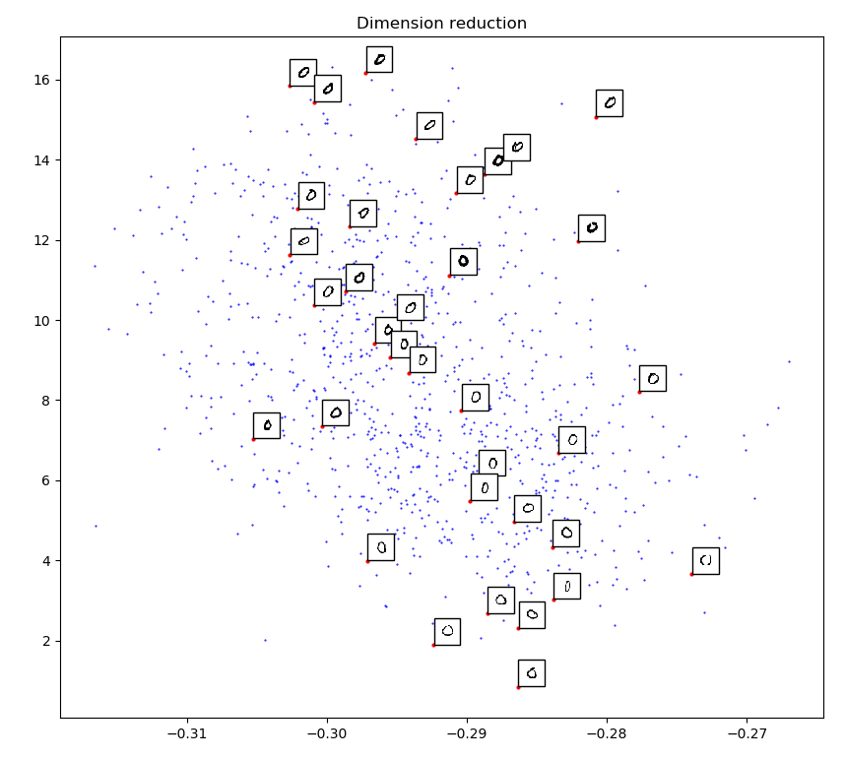

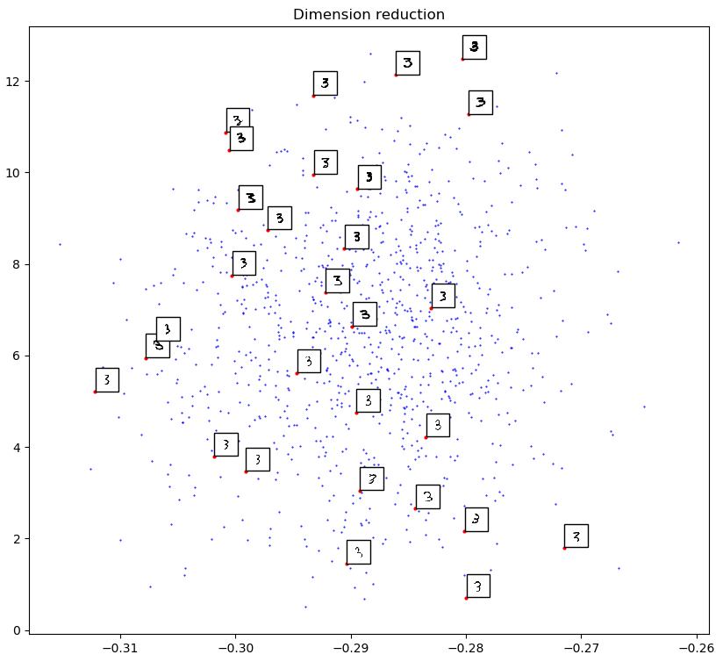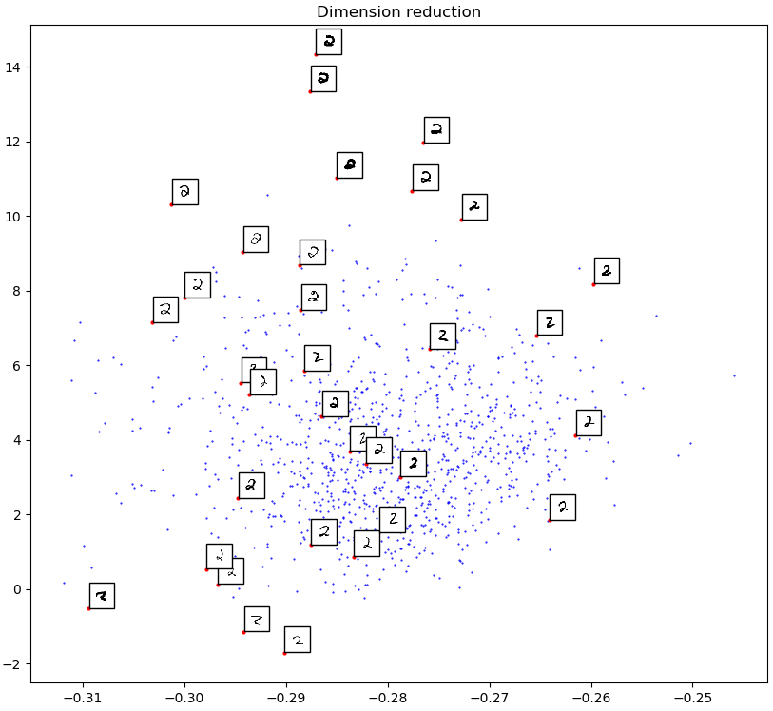

2(b). Visualize the reconstruction results and the filters.

Result：

Epoch：70

Batch size：600

Learning rate：0.00001

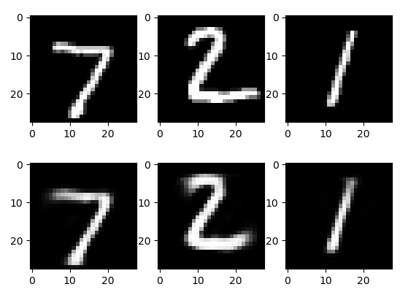

Origin

Reconstruction

