Optimum Design
Homework #4 (Due 05/22/2018)

Numerically solve the following problems by any commercial software or your own code. For example, you can use one of the Matlab optimization functions or the C code in Numerical Recipes in C.

1. Maximize the volume of a cylindrical container with top and bottom radius=x₁ and height=x₂. The total surface area must be equal to 24π.

2. Solve the following muscle force distribution problem. (The solution and the background ideas can be found in the paper by R.T. Raikova and B.I. Prilutsky, 2001. Sensitivity of predicted muscle forces to parameters of the optimization-based human leg model revealed by analytical and numerical analyses. Journal of Biomechanics, 34, 1243-1255.)
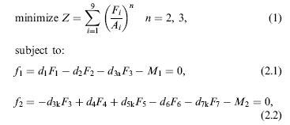

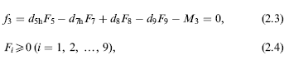
The values of the terms in the constants are given below:
M1=4; M2=33; M3=31;
The values of d1, d2, d3a, d3k, d4, d5k, d5h, d6, d7k, d7h, d8, d9 are included in the following vector: d=[0.0298 0.044 0.044 0.0138 0.0329 0.0329 0.0279 0.025 0.025 0.0619 0.0317 0.0368];
The values of A_{i} are also included in the vector A=[11.5 92.5 44.3 98.1 20.1 6.1 45.5 31.0 44.3];

3.
