**TITLE_OF_ARTICLE**

## Abstract

ABSTRACT_PARAGRAPH

### Keywords

KEYWORD

### Highlights

## 2. LEVEL_1_TITLE

### 2.1 LEVEL_2_TITLE

#### 2.1.1 LEVEL_3_TITLE

CITE_1ST_PAPER [1] CITE_2ND_PAPER [2] CITE_3RD_PAPER [3]

* BULLETS_1
* BULLETS_2
* BULLETS_3

1. LIST_ITEM_1
2. LIST_ITEM_2
3. LIST_ITEM_3

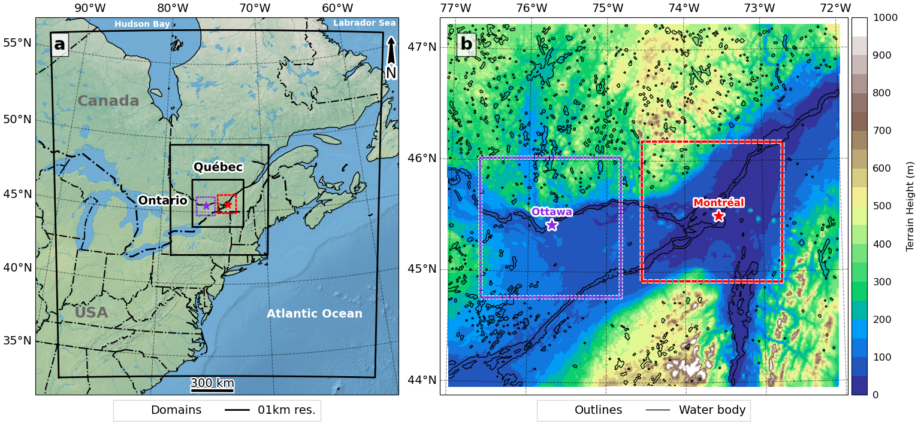

**Figure** 1: FULL_SIZE_FIGURE_TITLE

CITE_FULL_SIZE_FIGURE **Figure.** 1

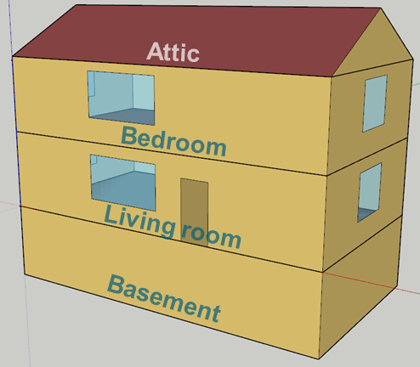

**Figure** 2: HALF_SIZE_FIGURE_TITLE

CITE_HALF_SIZE_FIGURE **Figure.** 2

**Table** 1: TABLE_TITLE.

| HEAD_1 | HEAD_2 |
| --- | --- |
| ROW_1 | ROW_2 |

CITE_TABLE **Table.** 1

INLINE_EQUATIONS INLINE_EQUATIONS

SINGLE_LINE_EQUATIONS

SINGLE_LINE_EQUATIONS

## Acknowledgements

FUNDING_SOURCES

## References

1. Shu, C.; Gaur, A.; Wang, L.L.; Bartko, M.; Laouadi, A.; Ji, L.; Lacasse, M. Added Value of Convection Permitting Climate Modelling in Urban Overheating Assessments. *Building and Environment* **2022**, *207*, 108415.

2. Shu, C.; Wang, L.L.; Mortezazadeh, M. Dimensional Analysis of Reynolds Independence and Regional Critical Reynolds Numbers for Urban Aerodynamics. *Journal of Wind Engineering and Industrial Aerodynamics* **2020**, *203*, 104232.

3. Shu, C.; Wang, L.L.; Zhang, C.; Qi, D. Air Curtain Effectiveness Rating Based on Aerodynamics. *Building and Environment* **2020**, *169*, 106582.

## APPENDIX