101124_introtoR.R

janiec-w

2024-10-11

# 10/11/24 Intro to R  
x <- 1:50  
plot(x)

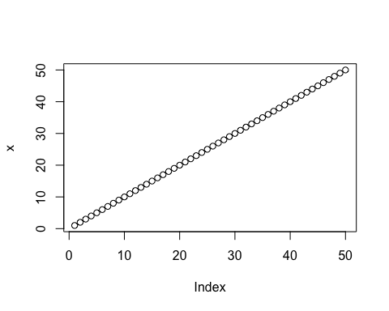

plot(x, sin(x), type="l", col="blue")

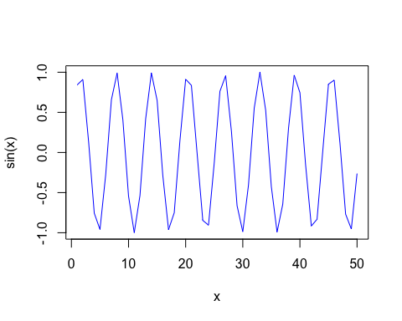

plot(x, sin(x), type="l", col="red", lwd=5)

