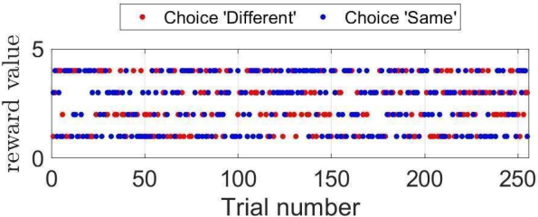

**Rewards**

**Bayesian Agent Agent**

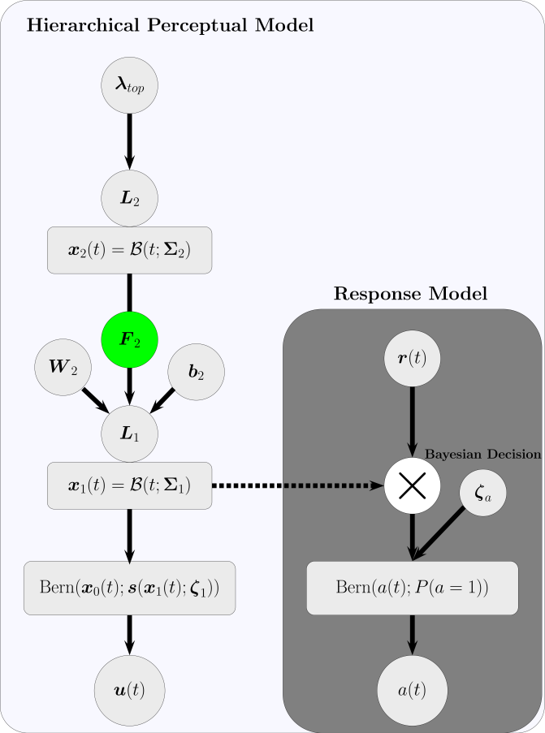

**Decision**

**Observation**

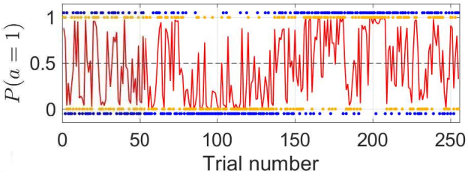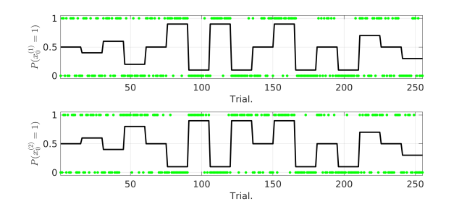

We develop a hierarchical Bayesian model for decision-making given uncertain multi-dimensional binary sensory inputs. By representing the tendency and volatility of the sensory inputs in a hierarchy manner, the model captures the correlations between the dimensions of the sensory space, therefore is able to generate probable recognitions on volatile environments and make decisions contingent on the structure of the sensory inputs.