**CCMS**

**Isssue1: Identification of faulty bulb in the street**

**Approaches:**

1.The CCMS is connected to the SLC and DCU that fetches the data from the cloud using Wi-Fi or GPRS that is being fed by the devices that are used to lodge a complaint and the data that is collected by the CCMS. The advantages of installing cellular based infrastructure are:

* **Scalability**: Cellular communication provide reliable connectivity that can scale from very low to high data throughput to support a wide range of public lighting applications
* **Ease of installation and maintenance**: Just turn on the cellular node, it immediately connects with the secure, reliable cellular network that’s already in place.
* **Standardization**: Once deployed, streetlights can remain in the field for decades. If the cellular public lighting solutions can build solutions based on global standards that will be supported for many years.

The connection can be:

* **Point-to-point cellular systems**, where each lighting pole has its own cellular connection enabling fast, seamless installation and pole commissioning, and eliminating the need for RF gateways
* **RF mesh or power line communication (PLC) systems**, where groups of lights are connected to nearby gateways over RF short-range radio networks or PLC, which in turn aggregate data for transport over cellular networks
* **Hybrid systems**, where communication nodes at the fixture combine short-range RF radio for pole-to-pole communications and cellular for two-way communications with CMS platforms

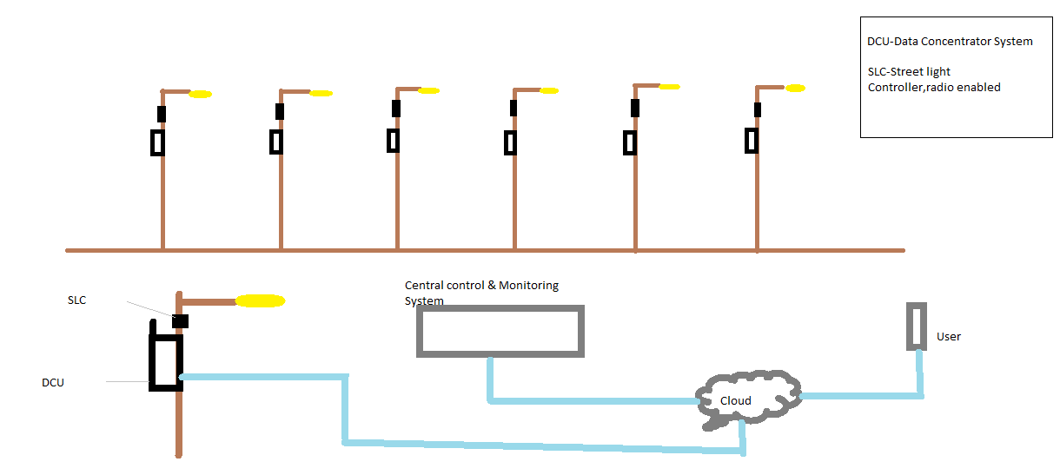

A new concept of *dimming* the lights can be introduced which can save more electricity.

2.If the customer lodges the complaint, he should be requested to send a picture that can be attained with the corresponding geolocation, this way the location of the fault that associated with the respective location of the streetlight can be received

**Issue 2: Number of faulty bulbs**

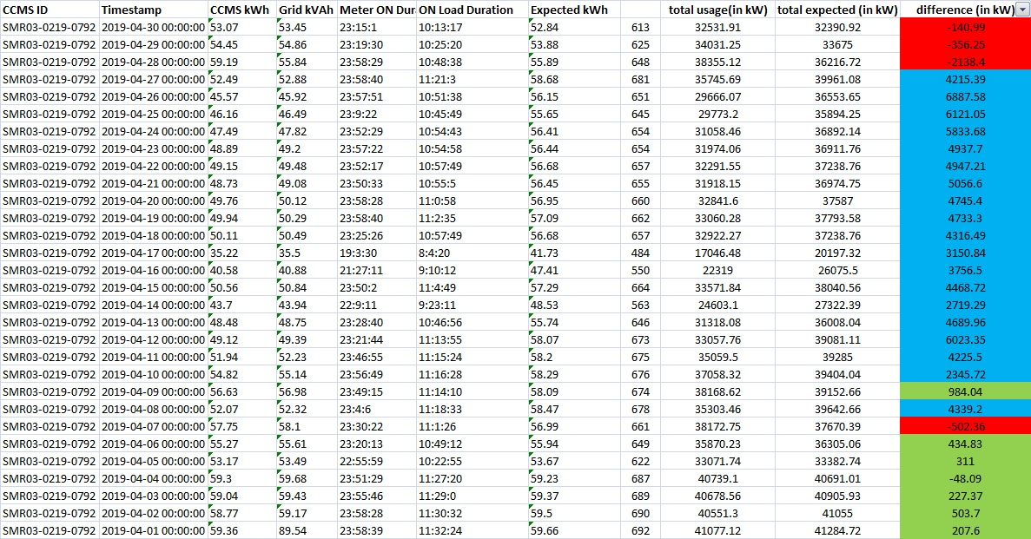

Observation:

* + Red: power consumption is less than the expected power consumption
  + Blue: power consumption is more than the expected power consumption
  + Green: marginal error (these can be neglected)

To find the faulty bulbs, taking the first record the difference is 140kW approx. that is being lost. Considering that the streetlights have ran for 10 hours (approx.) provided by the onload Duration. We can divide the difference with the onload duration to receive 14kW is being lost. Based on these we can derive into theories

* If the bulbs used are of 14kW then there could be 1 faulty bulb
* If the bulbs are LED(2kW) used are of 14kW then there could be 7 faulty bulbs.
* If the watts consumed more than the marginal error, it must be reported. That could either lead to unauthorized usage or theft.

**Issue 3: Complaint handling**

Observation:

1. Several complaints aren’t attended that could be due to time constraints of any technical issues. This can be eliminated by introducing an application for customer grievances.
2. Most of the complained has been lodged from Delhi. If this is the case a preventive measure can be considered in that specific location prior to the further complaints being received.

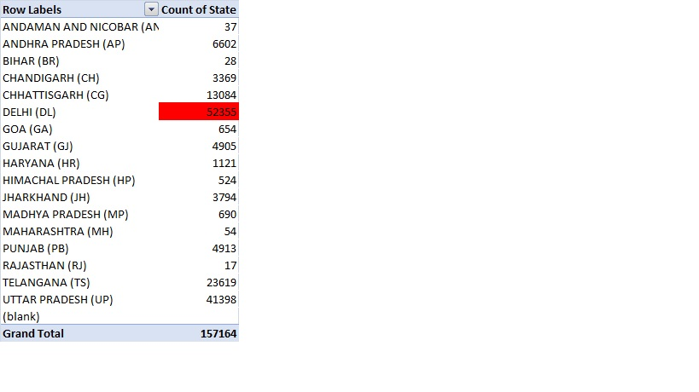

**Approaches:**

* If the complaints are repetitive or very common among that area its is more feasible to change the respective connections associated with that specific CCMS.