Technological University of the Philippines

COLLEGE OF INDUSTRIAL EDUCATION

Manila

**LESSON PLAN**

Course: BTVTED COMPRO 4/A Date: 11/21/2022

Subject: IPT Time: 7:00-10:00

1. **OBJECTIVES**

At the end of the lesson, the students should be able to:

1. To understand the importance of JavaScript on HTML
2. To make a interactive web pages.
3. To

-

***NOTE****: Your objective must be SMARTER-C (Specific, Measurable, Attainable, Realistic, Time bound, Effective, Reliable, and Challenging) Use Condition, behavioral verbs and criteria. 1.* ***Conditions*** *(a statement that describes the conditions under which the behavior is to be performed); 2.* ***Behavioral Verb*** *(an action word that connotes an observable student behavior); 3.* ***Criteria*** *(a statement that specifies how well the student must perform the behavior).*

1. **SUBJECT MATTER**
2. Topic: JavaScript HTML DOM Elements
3. Specific Competency: JS HTML DOM

Materials Needed:

a. PowerPoint Presentation

b. Computer/Laptop

c. Visual Code Studio

Reference/s:

1. [JavaScript DOM Elements (w3schools.com)](https://www.w3schools.com/js/js_htmldom_elements.asp)

1. **PROCEDURE**
2. Preparation
3. Daily routine
4. Greetings
5. Review of the past lesson and checking of assignments / agreements

* Ask about previous lesson

1. Presentation
2. Motivation
3. Raised-up questions

The instructor will question as to what Javascript is and what it can perform for HTML.

JavaScript is a text-based programming language used both on the client-side and server-side that allows you to make web pages interactive. Incorporating JavaScript improves the user experience of the web page by converting it from a static page into an interactive one.

1. Definition of Technical Terms / Unlocking of Difficulty (Define strange or unfamiliar terms used in the lesson / topic)

Javascript - JavaScript is a text-based programming language used both on the client-side and server-side that allows you to make web pages interactive.

1. Lesson Proper *Discuss here the content of the lesson.*  *Safety precautions may be emphasized whenever or wherever it is appropriate or needed.*
2. Teacher demonstration

JavaScript HTML DOM Elements

This lesson teaches you how to find and access HTML elements in an HTML page.

## **Finding HTML Elements**

Often, with JavaScript, you want to manipulate HTML elements.

To do so, you have to find the elements first. There are several ways to do this:

* Finding HTML elements by id
* Finding HTML elements by tag name
* Finding HTML elements by class name
* Finding HTML elements by CSS selectors
* Finding HTML elements by HTML object collections

## **Finding HTML Element by Id**

The easiest way to find an HTML element in the DOM, is by using the element id.

This example finds the element with id="intro":



If the element is found, the method will return the element as an object (in element).

If the element is not found, element will contain null.

## **Finding HTML Elements by Tag Name**

This example finds all <p> elements:



This example finds the element with id="main", and then finds all <p> elements inside "main":

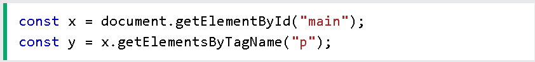

## **Finding HTML Elements by Class Name**

If you want to find all HTML elements with the same class name, use getElementsByClassName().

This example returns a list of all elements with class="intro".



## **Finding HTML Elements by CSS Selectors**

If you want to find all HTML elements that match a specified CSS selector (id, class names, types, attributes, values of attributes, etc), use the querySelectorAll() method.

This example returns a list of all <p> elements with class="intro".



## **Finding HTML Elements by HTML Object Collections**

This example finds the form element with id="frm1", in the forms collection, and displays all element values:

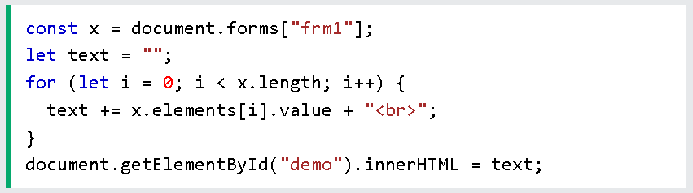

The following HTML objects (and object collections) are also accessible:

* [document.anchors](https://www.w3schools.com/js/tryit.asp?filename=tryjs_doc_anchors)
* [document.body](https://www.w3schools.com/js/tryit.asp?filename=tryjs_doc_body)
* [document.documentElement](https://www.w3schools.com/js/tryit.asp?filename=tryjs_doc_element)
* [document.embeds](https://www.w3schools.com/js/tryit.asp?filename=tryjs_doc_embeds)
* [document.forms](https://www.w3schools.com/js/tryit.asp?filename=tryjs_doc_forms)
* [document.head](https://www.w3schools.com/js/tryit.asp?filename=tryjs_doc_head)
* [document.images](https://www.w3schools.com/js/tryit.asp?filename=tryjs_doc_images)
* [document.links](https://www.w3schools.com/js/tryit.asp?filename=tryjs_doc_links)
* [document.scripts](https://www.w3schools.com/js/tryit.asp?filename=tryjs_doc_scripts)
* [document.title](https://www.w3schools.com/js/tryit.asp?filename=tryjs_doc_title)

1. Application (*Return demonstration of the student or simultaneous performance of the teacher and the student*)

Use the getElementById method to find the <p> element, and change its text to "Hello"

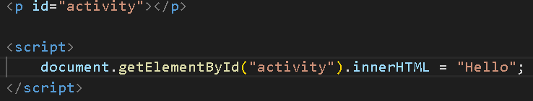

Answer:

**

1. Generalization (*Have the students state what they have learned from the lesson*)

* Instructor will ask the student what did they learned from the lesson

1. Evaluation (*A short quiz say 5-item multiple choice or a performance evaluation or both measured using a rubric*)
2. **ASSIGNMENT / AGREEMENT**
3. Follow-up assignment (*An assigned task as a follow-up application of the present lesson*)
4. Advance Assignment: (*Tasks or topics to be discussed on the next lesson)*
5. *Reference/s needed to do the assignment.*

REMINDER:

*See to it that all parts of the plan are parallel or congruent to the objectives.*