**bug: from Operator panel**

**step1:**

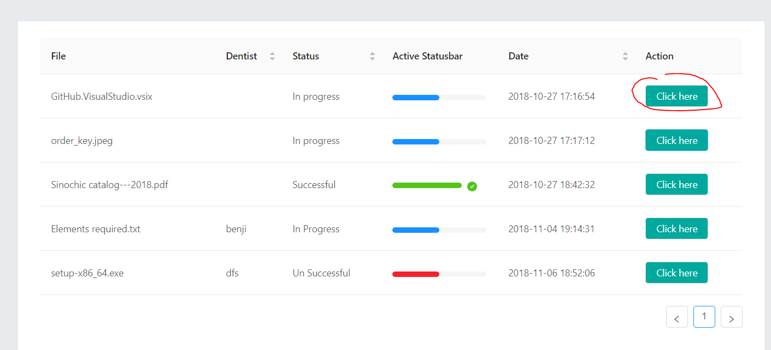

**Step2: clicking on file to download it, nothing happens, no download**

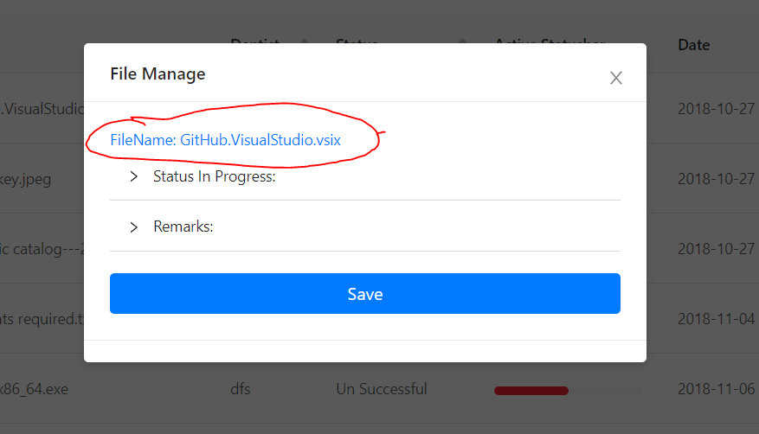

**Step3: going back to operator panel and clicking on another file**

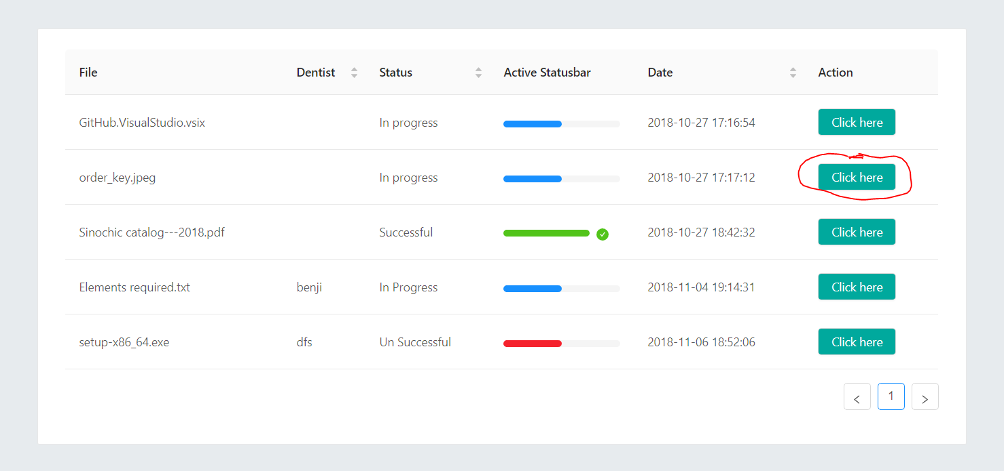

**Step4: I see the name of the previous “Github.v” instead of the current file selected “order_key.jpg”, and I will keep seeing the name of the first file selected unless I refresh.**