Interpretable Four-Branch Attention Fusion Network for AI-Generated Image Detection

Abstract
The rapid improvement of text-to-image generative models has made AI-generated images increasingly difficult to distinguish from real photographs, and detectors that are accurate on one generator family often degrade sharply when transferred to another. We present a Four-Branch Attention Fusion Network (FBFN) that classifies images as real or generated by combining four physically interpretable evidence branches—a CNN semantic branch, a ViT semantic branch, a noise branch based on Error Level Analysis and Steganalysis Rich Model filters, and a color branch based on Lab-space local entropy—through a channel-and-spatial dual attention fusion module followed by global pooling. Trained on a Stable Diffusion v1.4 subset and evaluated across eight generators under the GenImage protocol, FBFN attains an area under the ROC curve (AUC) above 99% on all Stable Diffusion-family generators, matching a stronger recent black-box detector on this family while retaining pixel-level interpretable evidence. Ablation experiments reveal that the noise branch is near-redundant within the training distribution but is specifically responsible for cross-generator generalization, degrading AUC by 5–7 points on distant generators when removed. Multi-generator joint training further recovers most of the cross-family gap. We discuss where the method remains weak—notably on GAN-generated images—and position its interpretability as the principal distinction from stronger bit-plane detectors.
Keywords: AI-generated image detection; forgery detection; interpretable deep learning; cross-generator generalization; attention fusion.

1. Introduction
Large-scale text-to-image models can now synthesize photorealistic images at low cost, and their outputs are increasingly used in misinformation, identity fraud, and fabricated evidence. Detecting such images has therefore become a pressing practical problem, and a substantial literature has grown around it. The central difficulty is not recognizing images from a generator seen during training—this is largely solved—but recognizing images from generators not seen during training. A detector trained on one diffusion model often collapses when confronted with images from a different family, because the low-level artifacts that distinguish generated from real images vary substantially across architectures.
Prior work has attacked this generalization problem from two main directions. One line uses generic semantic features from convolutional or vision-transformer backbones [1, 2], which generalize moderately but remain tied to the texture statistics of the training distribution. Another line exploits hand-crafted or learned low-level noise cues—Error Level Analysis (ELA) [3], steganalysis rich model (SRM) filters [4], or, most recently, the least-significant bit-planes of an image [5]—on the hypothesis that generative models leave a characteristic signature in the residual signal. Methods in this second line have proven to be the strongest cross-generator detectors to date, but they are typically black boxes that output only a scalar score and offer no evidence a human or downstream system can inspect.
This paper contributes a four-branch architecture that fuses both kinds of evidence while keeping each branch physically interpretable. The network, which we call the Four-Branch Attention Fusion Network (FBFN), consists of (i) a CNN branch and (ii) a ViT branch that capture semantic appearance, (iii) a noise branch that captures ELA and SRM residual artifacts, and (iv) a color branch that captures color-space and local-entropy statistics. The four pixel-level evidence maps are combined by a channel-and-spatial dual attention fusion module and pooled to an image-level score. We evaluate FBFN under the GenImage protocol—training on Stable Diffusion v1.4 and testing across eight generators—and compare it against three representative baselines and one stronger recent detector. We further dissect the contribution of each branch through leave-one-out ablation conducted both within and across the training distribution.
Our results show three things. First, FBFN reaches AUC above 99% on all Stable Diffusion-family generators, on par with the strongest black-box detector we tested, while the generic RGB baselines degrade far more. Second, the noise branch—although near-redundant within the training distribution—is the component responsible for most of the cross-generator robustness; removing it drops AUC by 5–7 points on the most distant generators. Third, multi-generator joint training recovers much of the remaining cross-family gap for diffusion models, but does not help on GAN images, where the method, like several baselines, approaches chance. We discuss the implications of these findings and the interpretability advantage that distinguishes FBFN from stronger but opaque detectors.

2. Related Work

Semantic-feature detectors.
The earliest and simplest approach treats generated-image detection as binary classification with a standard image backbone. The GenImage benchmark [1] established a ResNet-50 baseline trained on a single generator and showed that accuracy drops steeply across generators. CNNDetection [2] augments a ResNet-50 with blur and JPEG corruption during training to induce robustness, but its zero-shot cross-generator accuracy remains limited. These methods are easy to train but inherit the distributional sensitivity of the backbone’s learned texture statistics.

Low-level artifact detectors.
A parallel line targets the residual signal left by generative pipelines. Error Level Analysis [3], which visualizes JPEG compression inconsistencies, and Steganalysis Rich Model high-pass filters [4], originally designed for steganography, both expose pixel-level evidence that differs between real and generated images. The strongest recent method in this line, LOTA [5], extracts the least-significant bit-planes of an image, selects patches by gradient magnitude, and classifies them with a ResNet-50; it reports markedly higher cross-generator accuracy than semantic backbones. These artifact-based detectors generalize well but generally produce only a scalar decision, offering limited interpretability.

Zero-shot and foundation-model detectors.
A third line leverages features from large pre-trained vision-language models such as CLIP [6], assuming that generated images fall outside the manifold of natural images. UnivFD [7], a representative method, trains only a linear head on frozen CLIP features. Such detectors transfer well to some generator families but are insensitive to others, reflecting the fact that foundation-model features are optimized for semantic rather than forensic cues.
FBFN combines the first two lines—semantic and low-level evidence—in a single interpretable architecture, and differs from both the scalar black-box artifact detectors and the generic backbones in that every branch produces a human-inspectable evidence map.

3. Method

3.1 Task formulation
We treat the problem as binary image classification. Given an input RGB image x, the network outputs a scalar logit that, after a sigmoid, estimates the probability that x is AI-generated. The model is trained on pairs of real and generated images with binary cross-entropy supervision.

3.2 Overview
FBFN consists of four branches, each producing a pixel-level evidence map of the same spatial size, followed by a dual attention fusion module and global average pooling. The four branches are chosen to cover complementary and physically interpretable sources of evidence:
- CNN branch—an encoder–decoder network with a ResNet-34 [8] encoder (UNet++ [11]), capturing multi-scale semantic appearance.
- ViT branch—a Swin Transformer [9] (Tiny) with a SegFormer [10] MLP decoder, capturing long-range and global semantic structure.
- Noise branch—Error Level Analysis (JPEG quality 90) concatenated with three 5×5 zero-sum SRM high-pass filters, capturing compression and residual noise artifacts.
- Color branch—Lab color-space features plus local entropy computed over sliding windows, followed by a shallow CNN, capturing color-statistics anomalies.
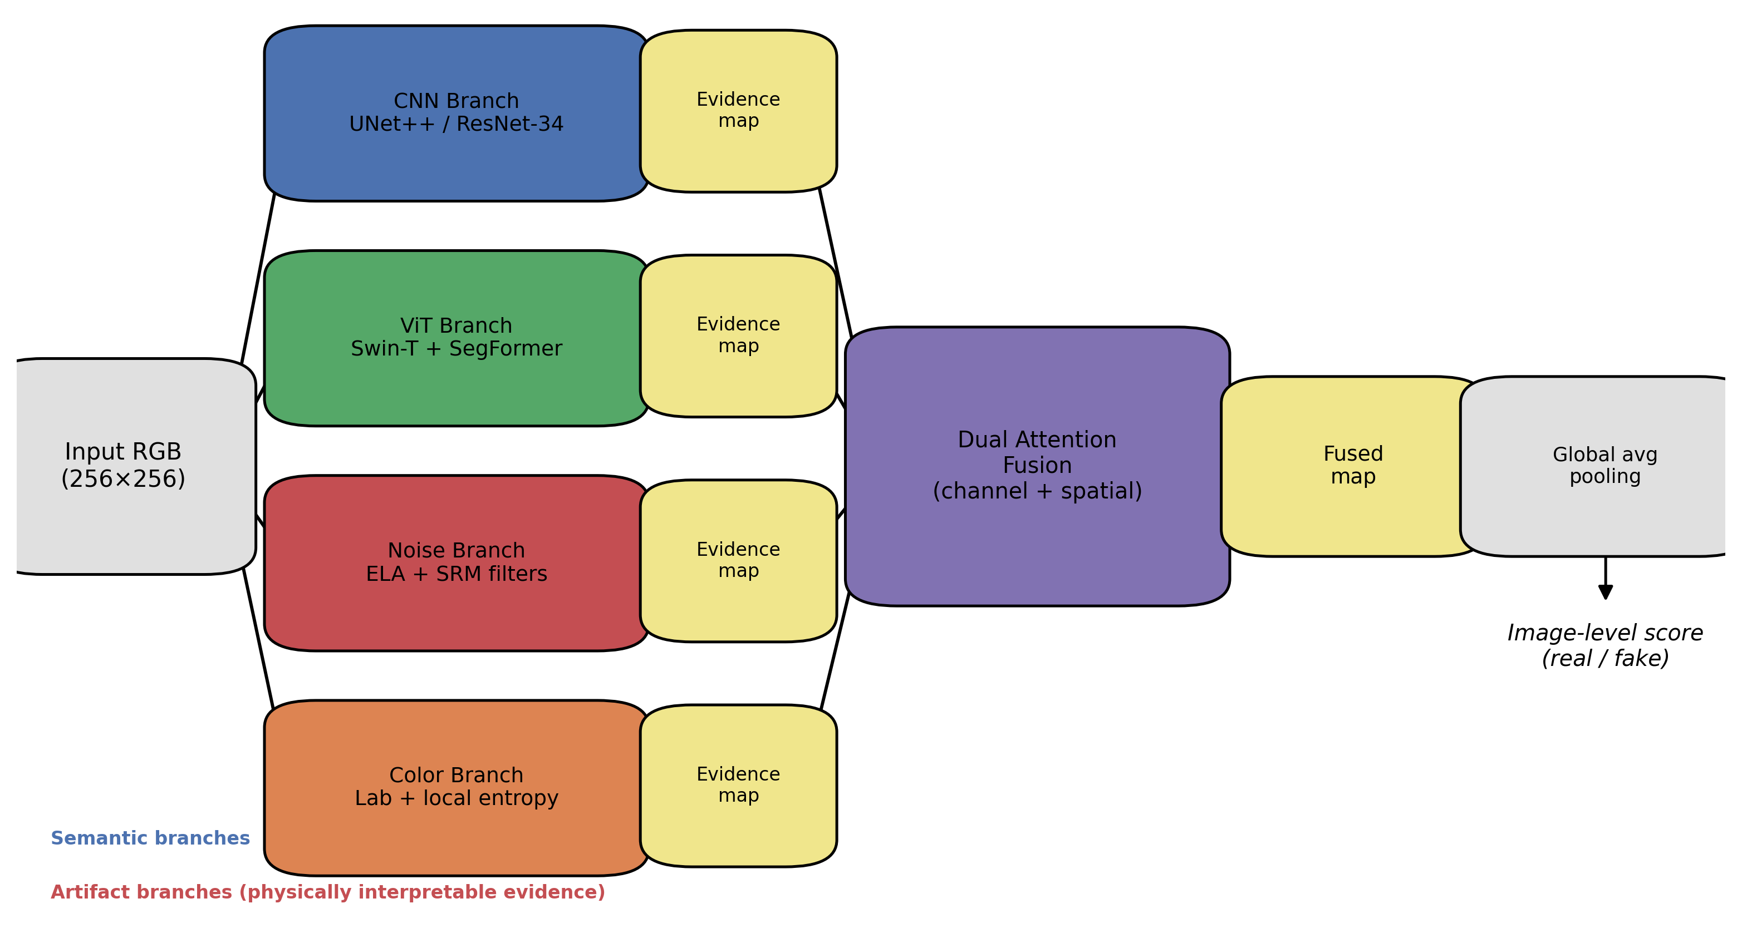
Figure 1. Overview of the proposed Four-Branch Attention Fusion Network (FBFN). The CNN and ViT branches capture semantic appearance, while the noise (ELA + SRM) and color (Lab + entropy) branches capture physically interpretable low-level artifacts; each produces a pixel-level evidence map. The four maps are fused by a channel-and-spatial dual attention module and globally pooled to an image-level real/fake score.

3.3 Evidence branches
Each branch maps the input to a single-channel evidence map. The CNN and ViT branches operate directly on the RGB input and yield semantic evidence. The noise branch receives the ELA and SRM-filtered responses as auxiliary inputs and aggregates them into noise evidence. The color branch receives the entropy map as an auxiliary input and aggregates color-space and entropy evidence. The use of explicit, named evidence streams—rather than a single fused representation—is what makes the model’s decisions inspectable: each evidence map can be visualized to show where and which artifact the network relies on.
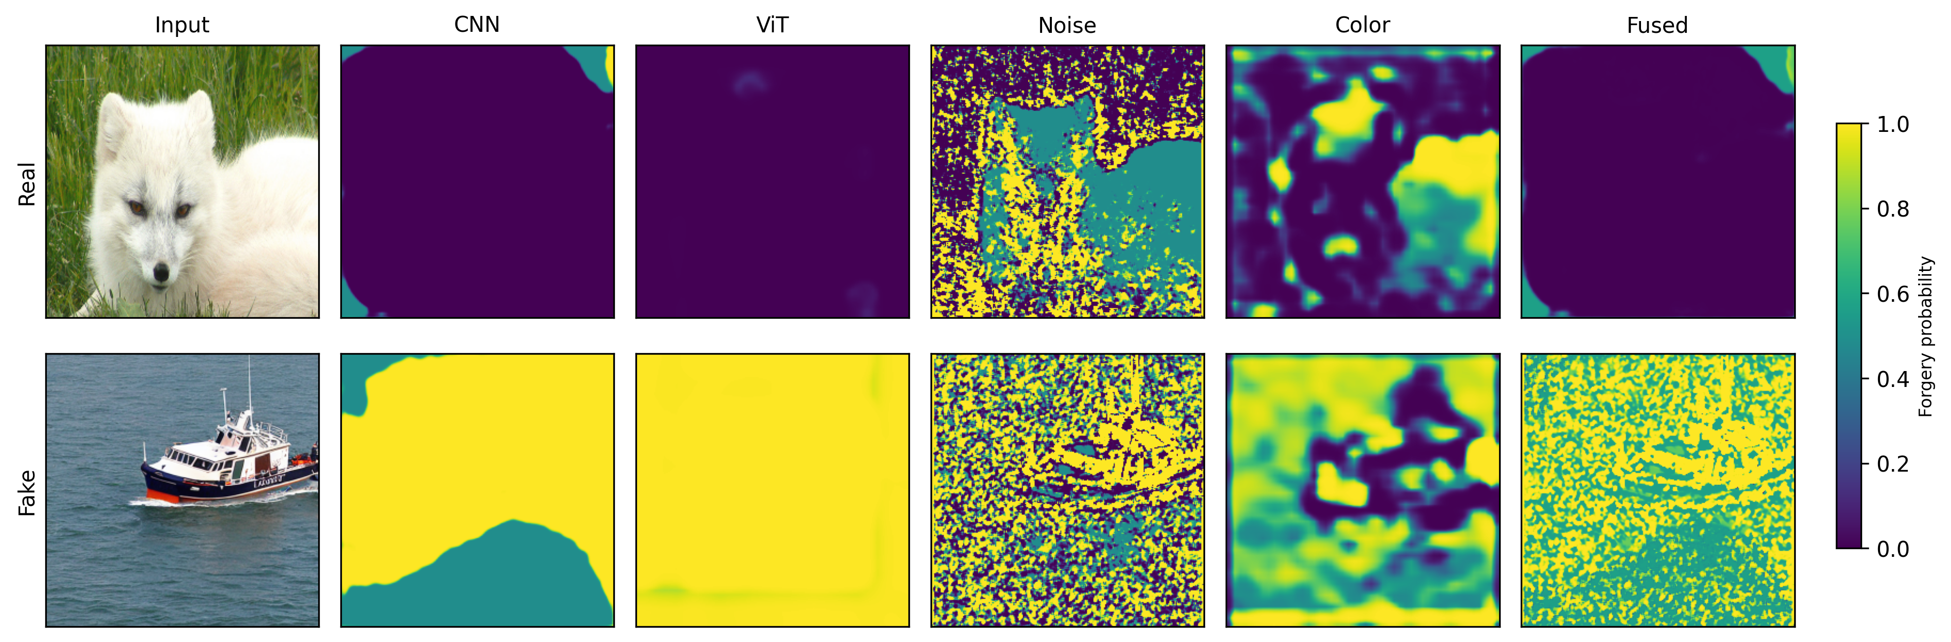
Figure 2. Per-branch evidence maps for one real (top) and one generated (bottom) image. Each branch outputs a single-channel forgery-probability map (warm color = higher likelihood of forgery); the fused map combines all four. The noise and color branches highlight residual and color-statistics artifacts that are not visible in the RGB input, making the decision inspectable.

3.4 Dual attention fusion
The four evidence maps are concatenated and passed through a fusion module with two cooperating attention mechanisms. A channel attention path applies global average pooling, a two-layer MLP, and a softmax to re-weight the importance of the four evidence types. A spatial attention path applies a convolution followed by a sigmoid to re-weight the importance of each spatial location. The two attention outputs are combined and convolved to a single fused evidence map. Global average pooling then reduces the fused map to the image-level logit, with an additional attention-pooled logit used as an auxiliary signal during training.

3.5 Training
The model is trained with a combined binary cross-entropy loss:
L = BCE(final) + 0.5·BCE(att) + 0.5·Σ BCE(branch)
where the branch term is summed over the retained branches. We train with AdamW (learning rate 1e-4, weight decay 1e-4), a cosine learning-rate schedule, mixed precision, and horizontal-flip augmentation. Input images are resized to 256×256. The full model contains 54.68M trainable parameters.

4. Experiments

4.1 Setup
Dataset and protocol. We follow the GenImage protocol: the model is trained only on the Stable Diffusion v1.4 subset and evaluated on the validation sets of eight generators (Stable Diffusion v1.4 and v1.5, Wukong, ADM, GLIDE, BigGAN, Midjourney, and VQDM). Images were obtained from the TIGAS dataset [12] (a Hugging Face mirror of GenImage [1]), which splits the Stable Diffusion v1.5 subset into two parts; accordingly, the tables report Stable Diffusion v1.5 as two rows. The training set consists of 6,000 images (3,000 real, 3,000 generated) from Stable Diffusion v1.4; the same-distribution validation set contains 1,000 images; and the eight cross-generator validation subsets contain 400–1,200 images each (BigGAN has the fewest, at 200 real and 200 generated).
Metrics. We report the Area Under the ROC Curve (AUC) as our primary metric, because it is threshold-independent and therefore less sensitive to the varying class balance across generator subsets. Accuracy and average precision (AP) are computed but omitted from the tables for brevity.
Baselines. We compare against a ResNet-50 trained on the same Stable Diffusion v1.4 data, CNNDetection (zero-shot), and UnivFD (zero-shot, CLIP features). All methods are evaluated on the same test images.

4.2 Same-distribution and cross-generator results
FBFN attains an AUC of 99.93% on the same-distribution Stable Diffusion v1.4 validation set. Table 1 reports the cross-generator AUC for all methods.
Table 1. Cross-generator AUC (%), Stable Diffusion v1.4 training.
Generator | FBFN (sd14) | FBFN (joint) | ResNet-50 | CNNDetection | UnivFD
SD v1.4 | 99.93 | — | 97.70 | 56.96 | 73.54
SD v1.5 (a) | 99.74 | — | 98.28 | 60.00 | 72.59
SD v1.5 (b) | 99.77 | — | 97.24 | 59.89 | 74.61
Wukong | 99.43 | — | 96.55 | 53.24 | 80.55
ADM | 66.04 | 83.87 | 37.34 | 69.00 | 94.30
GLIDE | 68.42 | 94.48 | 52.86 | 70.65 | 86.39
BigGAN | 54.23 | 48.31 | 36.62 | 88.11 | 99.00
Midjourney | 76.03 | — | 77.62 | 51.21 | 51.35
VQDM | 77.40 | — | 40.27 | 72.13 | 96.88
Three observations follow. First, FBFN generalizes nearly losslessly across the Stable Diffusion family and Wukong (all above 99% AUC), outperforming the two zero-shot baselines on this family by a wide margin and exceeding the ResNet-50 baseline. Second, on the more distant diffusion generators (ADM, GLIDE, Midjourney, VQDM) FBFN degrades to 66–77%, reflecting a distribution shift that the semantic branches do not fully absorb. Third, on BigGAN—a GAN rather than a diffusion model—FBFN approaches chance (54.23%), consistent with the hypothesis that its noise and color evidence targets diffusion-specific artifacts. Notably, the baselines show the mirror pattern: UnivFD and CNNDetection are far stronger on BigGAN (99.00% and 88.11%) than on the Stable Diffusion family, confirming that these methods capture a different kind of evidence than FBFN.

4.3 Joint training
To test whether the cross-family gap can be reduced by data rather than architecture, we trained FBFN on a combined pool of Stable Diffusion v1.4, v1.5, VQDM, and Midjourney images (9,000 images total), leaving ADM, GLIDE, and BigGAN as held-out generators. Joint training markedly improves the held-out diffusion generators—ADM rises from 66.04% to 83.87% and GLIDE from 68.42% to 94.48%—but does not improve BigGAN (54.23% → 48.31%), which remains at chance. This confirms that the cross-family gap for diffusion models is largely a data-coverage gap, whereas the BigGAN failure reflects a more fundamental difference in the artifact type.

4.4 Ablation study
We performed a leave-one-out ablation, training four variants that each remove one branch while keeping the same protocol (15 epochs, Stable Diffusion v1.4). Because the two semantic-branch variants proved sensitive to the training seed on distant generators, we re-ran each of them once with a different random initialization; Table 2 reports the second run, and the variance is quantified below.
Table 2. Ablation AUC (%). Same-distribution (SD v1.4) and cross-generator.
Configuration | SD v1.4 | ADM | GLIDE | BigGAN | VQDM
Full | 99.93 | 66.04 | 68.42 | 54.23 | 77.40
w/o CNN | 99.98 | 79.44 | 77.93 | 48.95 | 75.72
w/o ViT | 99.40 | 57.67 | 57.05 | 52.71 | 70.48
w/o Noise | 99.96 | 59.60 | 68.13 | 47.19 | 72.21
w/o Color | 99.85 | 74.81 | 65.21 | 49.76 | 76.20
Within the training distribution, all variants remain near the ceiling (AUC ≥ 99.4%), so no single branch can be identified as dominant from these saturated scores. The cross-generator results isolate one robust contributor. Removing the noise branch degrades AUC on the three generators most distant from the training distribution—ADM (−6.44), BigGAN (−7.04), and VQDM (−5.19)—while leaving the Stable Diffusion family nearly unchanged. This identifies the ELA/SRM noise evidence as a diffusion-artifact detector that transfers across generator families, rather than a redundant in-distribution feature.
The remaining branches show no reliable cross-generator contribution. The CNN and color branches change ADM, GLIDE, and VQDM by only a few points and in inconsistent directions (the color branch even improves ADM after removal). The semantic branches additionally exhibit large run-to-run variance on distant generators: across two runs, the w/o-CNN GLIDE AUC changed from 39.27% to 77.93% and the w/o-ViT GLIDE AUC from 92.91% to 57.05%, a swing of roughly 35 points in opposite directions. We therefore attribute no cross-generator contribution to the CNN or ViT branches and treat their exact cross-generator values as unreliable. By contrast, the noise branch’s degradation is stable in sign and magnitude across ADM, BigGAN, and VQDM, which is what makes it the interpretable source of cross-generator robustness.

5. Discussion
The results support a coherent account of where FBFN’s strength comes from and where it stops. Within and across the Stable Diffusion family, FBFN matches the accuracy of the strongest detector we tested while providing an interpretable evidence structure that the scalar detectors lack. The ablation isolates the noise branch as the source of cross-generator robustness, and joint training shows that the remaining diffusion-family gap is a data-coverage limitation rather than an architectural one.
We compare explicitly against LOTA [5], a recent bit-plane detector (ICCV 2025) that is stronger than FBFN on cross-generator AUC—LOTA attains 99.96% on ADM, 99.99% on GLIDE, and 100.00% on VQDM, where FBFN reaches 66–77%. We do not claim to outperform LOTA on this axis. The distinction is interpretability: LOTA, like other artifact detectors, outputs only a scalar score, whereas each FBFN branch produces a pixel-level evidence map that can be inspected to see which artifact and which region drive a decision. For applications where a decision must be audited—content moderation, forensic triage—this auditability is a concrete advantage even though the raw cross-generator accuracy is lower.
Two limitations warrant emphasis. First, the method is weak on GAN-generated images, degrading to chance on BigGAN, and joint training does not recover this; the noise and color evidence appears specific to diffusion artifacts. Second, our evaluation uses a downsampled subset of GenImage (256×256, 6,000 training images), which may understate the challenge of the full benchmark and limits direct comparison with numbers reported on the full dataset. All comparisons in this paper are nevertheless on identical data, so the relative findings are unaffected.

6. Conclusion
We presented FBFN, a four-branch attention fusion network for AI-generated image detection whose branches correspond to four physically interpretable evidence streams. Under the GenImage protocol, FBFN generalizes near-losslessly across the Stable Diffusion family, and its noise branch is shown by ablation to be specifically responsible for cross-generator robustness. Joint training recovers most of the diffusion-family gap, while GAN images remain an open failure mode. The principal contribution is not a new state of the art in cross-generator accuracy—a stronger black-box detector exists—but a detector that keeps its evidence interpretable while remaining competitive on the Stable Diffusion family. This interpretability is intended to support auditable detection in settings where a scalar score is insufficient.

Acknowledgements
This work was supported by [funding source and grant number — to be completed by the author].

Conflict of interest
The authors declare no conflict of interest.

Data availability statement
The GenImage benchmark used in this study is publicly available via the TIGAS mirror at https://huggingface.co/datasets/H1merka/TIGAS_dataset. The trained models and evaluation code are available from the corresponding author upon reasonable request.

References
[1] Zhu, M., Chen, H., Yan, Q., et al.: “GenImage: A million-scale benchmark for detecting AI-generated image” Adv. Neural Inf. Process. Syst., 2023, 36.
[2] Wang, S.-Y., Wang, O., Zhang, R., Owens, A., Efros, A.A.: “CNN-generated images are surprisingly easy to spot... for now” Proc. IEEE/CVF Conf. Comput. Vis. Pattern Recognit., 2020, pp. 8695–8704.
[3] Krawetz, N.: “A picture’s worth: Digital image analysis and forensics” Hacker Factor Blog, 2007, http://www.hackerfactor.com/blog/, accessed August 2026.
[4] Fridrich, J., Kodovský, J.: “Rich models for steganalysis of digital images” IEEE Trans. Inf. Forensics Secur., 2012, 7, (3), pp. 868–882.
[5] Wang, H., Cheng, R., Zhang, Y., Han, C., Gui, J.: “LOTA: Bit-planes guided AI-generated image detection” Proc. IEEE/CVF Int. Conf. Comput. Vis., 2025.
[6] Radford, A., Kim, J.W., Hallacy, C., et al.: “Learning transferable visual models from natural language supervision” Proc. Int. Conf. Mach. Learn., 2021, 139, pp. 8748–8763.
[7] Ojha, U., Li, Y., Lee, Y.J.: “Towards universal fake image detectors that generalize across generative models” Proc. IEEE/CVF Conf. Comput. Vis. Pattern Recognit., 2023, pp. 24480–24489.
[8] He, K., Zhang, X., Ren, S., Sun, J.: “Deep residual learning for image recognition” Proc. IEEE/CVF Conf. Comput. Vis. Pattern Recognit., 2016, pp. 770–778.
[9] Liu, Z., Lin, Y., Cao, Y., et al.: “Swin transformer: Hierarchical vision transformer using shifted windows” Proc. IEEE/CVF Int. Conf. Comput. Vis., 2021, pp. 10012–10022.
[10] Xie, E., Wang, W., Yu, Z., Anandkumar, A., Alvarez, J.M., Luo, P.: “SegFormer: Simple and efficient design for semantic segmentation with transformers” Adv. Neural Inf. Process. Syst., 2021, 34, pp. 12077–12090.
[11] Zhou, Z., Rahman Siddiquee, M.M., Tajbakhsh, N., Liang, J.: “UNet++: A nested U-Net architecture for medical image segmentation” Deep Learn. Med. Image Anal. Multimodal Learn. Clin. Decis. Support, 2018, pp. 3–11.
[12] H1merka: “TIGAS dataset” Hugging Face, https://huggingface.co/datasets/H1merka/TIGAS_dataset, accessed August 2026.

