Report

# Test Setup

The central part of the test setup is done via the framework provided, for which we write a separate independent test method to test the running time, number of backtracks and number of assignments for each different problem, which are all logged and measured for further analysis. Since there might be variations with CPU execution time, repeated tests are done for each combination, and an average is calculated for each performance measure to ensure the maximum accuracy.

For the number of combinations to test, we choose to test all combinations of all possible permutation, this result in 390 different combinations for each 15 different problems. Since we were lucky enough to finish all the codes 3 days after the project is released, we have sufficient time test out all possible combinations without worrying about narrowing the number of combinations. The second reason to test on such a large scale is that it provides us with more comprehensive data for analysis.

However, due the nature of such a large scale test, number of tests and timeout is chosen differently for each difficulty level. Below is a glimpse of the test setup

---------------------------------------------

NumTest | Difficulty | Timeout

---------------------------------------------

20 | 'E' | 30/60

5 | 'M' | 60/120

1 | 'H' | 300/600

---------------------------------------------

The test machine spec is i7 6700hq, with 16GB of ram, running on Windows 10 Education.

# 1.2 Interpretation of raw data set

Four different data are collected for each test, which are id, running time, number of backtracks and number of assignments for each different problem. For Example, the following dataset in PE.txt, in section PE1.txt

id numBacktracks numAssignments avgtime

16 1 5 0.026801705360412598

First value is the id of the combination. The name of the combination algorithm can be obtained from id_list.txt, from which we can obtain:

16 ['NKD', 'MRV', 'LCV']

Thus, we can interpret this data by saying, the algorithm with Naked Double, MRV and LCV, is able to solve PE1.txt in 26.8ms, with 1 backtracks and 5 assignment nodes.

If the combination cannot solve the Sudoku puzzle in given timeout limit, the runtime is recorded as infinity, indicating failure in solving the puzzle.

# Combinations

There are a total of 390 different combinations in our test, each of which correspond to a specific ordering of the algorithms. For each example, with naked triple and naked double, two different combination can be generated , as illustrated below

NKD, NKT, None, None

NKT, NKD, None, None

In our experiments, we find that the order the algorithms do matter in terms of the runtime performance. This possibly due to the number of hints available to NKD and NKT.

# 1.4 Comparison Methods

Multiple aspects of comparisons can be obtained by comparing the raw dataset’s three performance measure. The following sections describe those aspects in more detail

* + 1. Solving

The solving ability of a combination of algorithm is defined by its ability to solve a Sudoku puzzle in given set of time. If the algorithm cannot solve the problem in given time limit, we consider it as failure. However, solving ability of each combination could vary greatly across different Sudoku puzzle. In some cases, some combination is able to solve PH1 in 10 seconds, but fail to solve PH2 in 300 seconds time limit. To address this problem, we introduce penalty time.

* + 1. Penalty time

Recall that if a combination cannot solve in given limit time, runtime is recorded as infinity. In order to measure the mean the runtime of each algorithms, but also consider failure cases, we introduce penalty time. If a combination fails to solve the puzzle, a penalty time which is twice the timeout is added to the running time. E.g. if timeout is 300, penalty time would be 600.

Then the average is calculated by considering penalty time during the calculation. However, it should be stressed that penalty time does not depict a precise view of the performance of the combination, but only allows us to compare the performance of different algorithms.

The mean of the runtime of a combination should not be interrupted as a precise running time measure, but only a mere indicator for comparing itself with other combination.

* + 1. Puzzle Difficulty

In this report, all x-axis are categorized into three different parts, PE, PM and PH, which in turn means the average of 5 sub problems.

* + 1. Number of Backtracks and Assignments

The number of backtracks records the number of deadend during backtracking search. The number of assignments records the number of non-deadend nodes during backtracking search that lead to the correct solution.

Both backtracks and assignments measure the space complexity of the algorithms. In general cases space used is associated with difficulty level, since the harder the problem is, the more search it needs to do. Both of them are also positively associated with runtime of the combination. This is also due to the fact that good combination algorithms try to terminate deadend as early as possibly to prevent backtracks. Those combinations that cannot solve the problem always generate huge number of backtracks and assignments.

# 1.5 Defining the Best Combination

When considering the best combinations out of the 390 combos, combinations that cannot solve all puzzles are excluded from the list. Because the best combination should always be able to solve a puzzle in given time constraint.

The second factor taken into account is the average runtime. The less time it runs, the better it is. The third factor is the space complexity.

There are two reasons we favour runtime over space complexity, the first reason is that our test machine, which has 16GB of ram, so memory is large enough that space used do not necessarily affect the performance. The second reason is that runtime is a better indicator that shows fast the combination is.

# Evaluation

We first start off by looking at how heuristics and the other of other consistency checking affect each consistency checking

Looking at the

looking at the above chart, for PE problem, all combinations merely make a difference. But as the problem grow harder, the differences among combinations in terms of runtime start to emerge. From the graph we can see that, the most efficient subsequent combinations out of all three difficulties are:

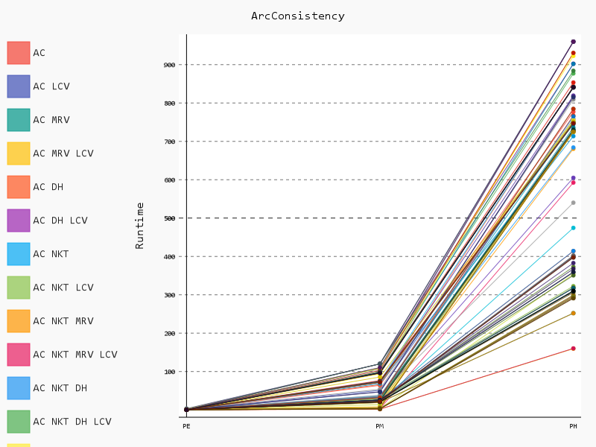

AC NKD NKT MRV LCV

AC NKT NKD MRV LCV

AC NKT NKD MRV

AC NKD NKT MRV

AC NKT NKD FC MRV LCV

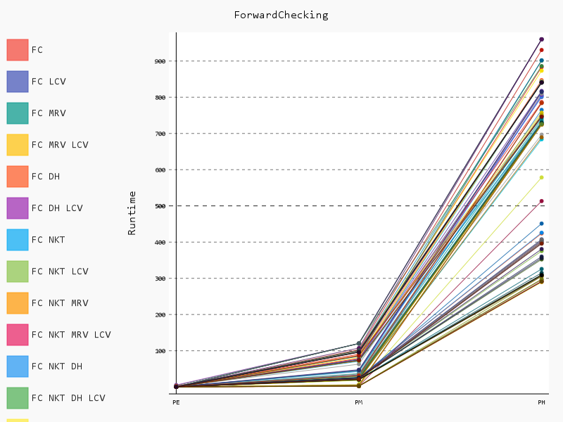

The most efficient combinations starting with FC are:

FC NKD NKT MRV LCV

FC NKT NKD AC MRV LCV

FC NKD NKT AC MRV LCV

FC NKT NKD MRV LCV

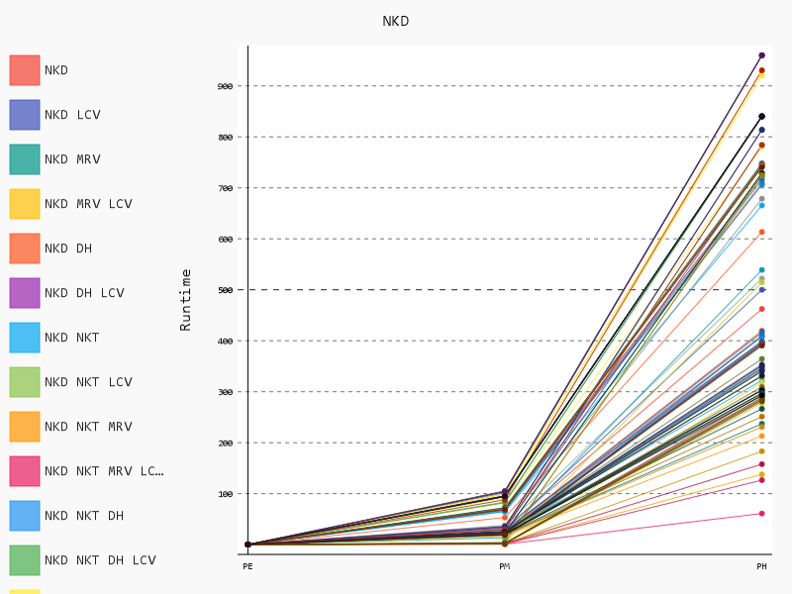

The most efficient combinations starting with NKD are:

NKD NKT MRV LCV

NKD NKT AC MRV LCV

NKD AC NKT MRV LCV

NKD NKT FC MRV LCV

NKD FC NKT MRV LCV

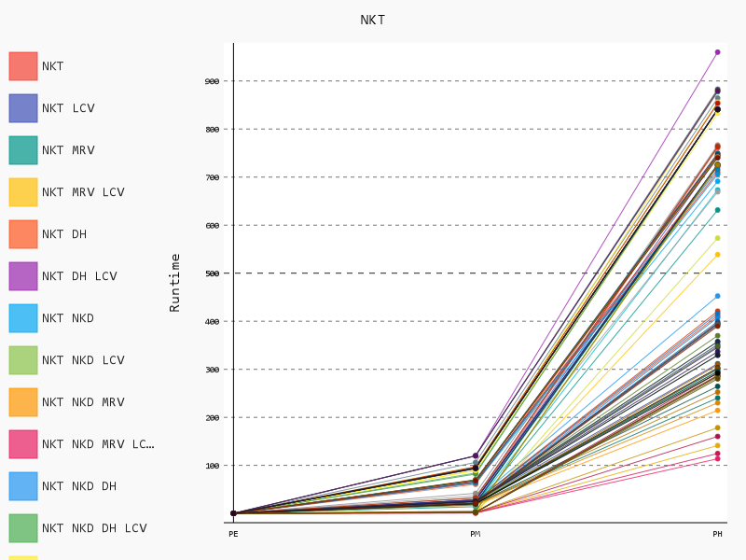

The most efficient combinations starting with NKT are:

NKT NKD MRV LCV

NKT NKD AC MRV LCV

NKT AC NKD MRV LCV

NKT NKD FC MRV LCV

NKT FC NKD MRV LCV

Looking at the above four different charts, we can see that by adding NKT and NKD to FC or AC, the runtime improves dramatically, on average increases by 214.3%. Both NKT and NKD boosts the performance significantly.

Interestingly, the top five most efficient combinations all contain variable length heuristics MRV and LCV. MRV chooses the most constraining variable first, then LCV tries to avoid failure by assigning values that leave the maximum number of choices. The idea of MRV is to prune impossible assignments as soon as possible, and LCV is to search the whole state space and find a solution as soon as possible.

Both NKD and NKT are heuristics that eliminate possible candidates by inferencing, the idea of NKD and NKT is also to solve the puzzle as quick as possible as well.

At this step, we can make an assumption that NKD and NKT are the best combinations for consistency checking, and MRV LCV are the best combinations for heuristics.

We can further explore the efficiency of each heuristics by looking at each of the heuristics combination.

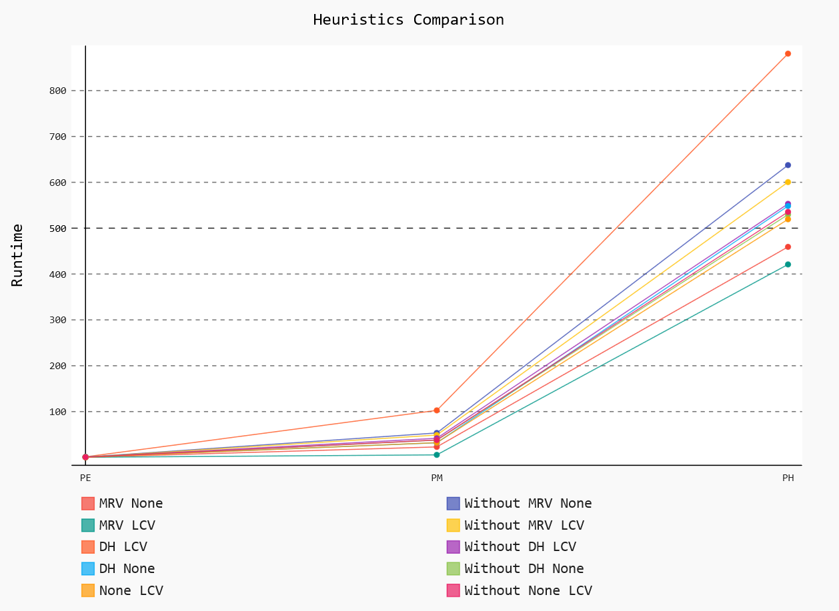

Looking at the graph above, it shows the average runtime of different combinations of heuristics ignoring consistency checking. We can find MRV LCV is the best possible combination for heuristics, it on average is 32.168% better than the other heuristic combinations.

The above illustration shows that while each heuristics may not work at best individually, the combinations can be powerful. The second place goes to MRV, None. Third place goes to None LCV. Combining the previous assumption, we can hypothesize that the best combination could be a combination of NKT, NKD and MRV None and MRV LCV and None LCV.

Now lets look at the solutions are able to solve all the puzzles in given time constraint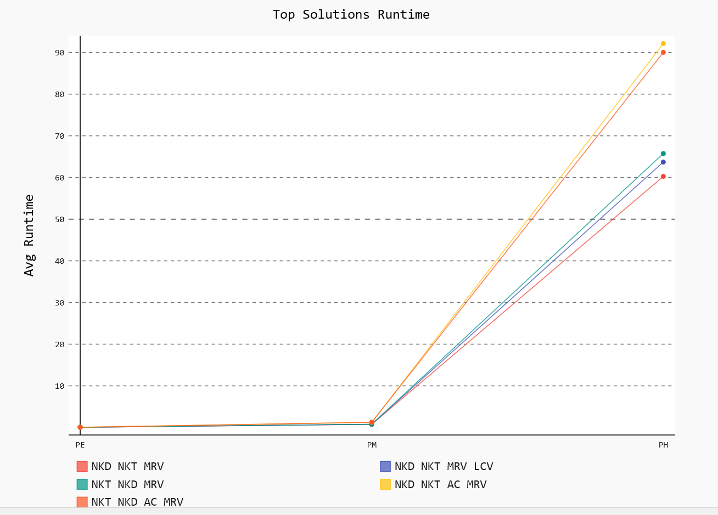

The above graph takes the average runtime of all the combinations that solve all the problems, so as to eliminate the variations. The best combination should be able to solve all problems in all cases in shortest amount of time, and in given space constraint.

We can see that the combination of NKD, NKT, MRV is the fastest combination of all, and is twice as fast as the second combination. The second place goes to NKD NKT MRV LCV. Third place goes to NKT NKD AC MRV.

The heuristics for best combinations are MRV and MRV LCV, and MRV, which proves our hypothesis about heuristics, it also shows that NKT NKD works best with MRV , and this sort of combination are the fastest.

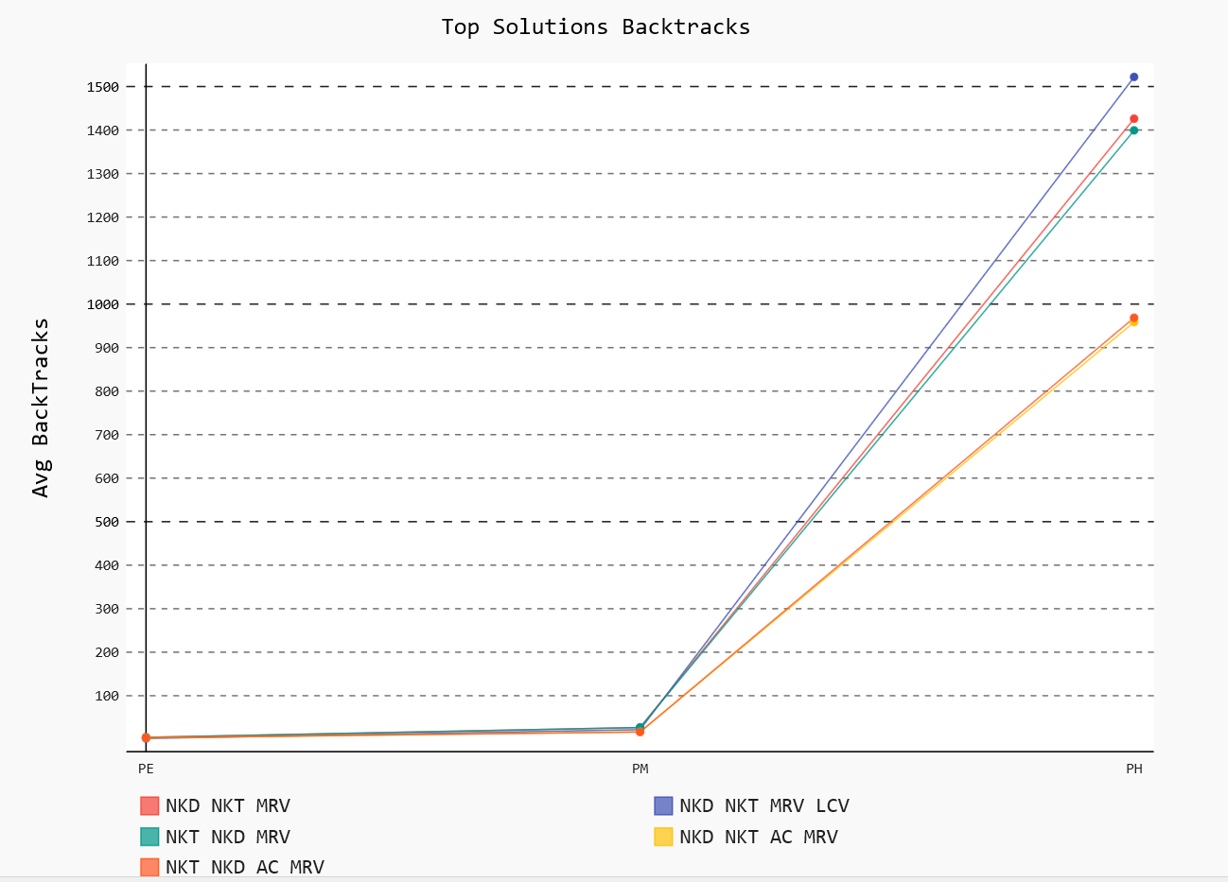

The above figure shows the average backtracks for each combination for each difficulty. As we can see, our previous best combinations still have a relatively low backtracks except NKD NKT MRV LCV. This combination although achieves second best runtime, but have a relatively higher average backtracks. This means higher space complexity.

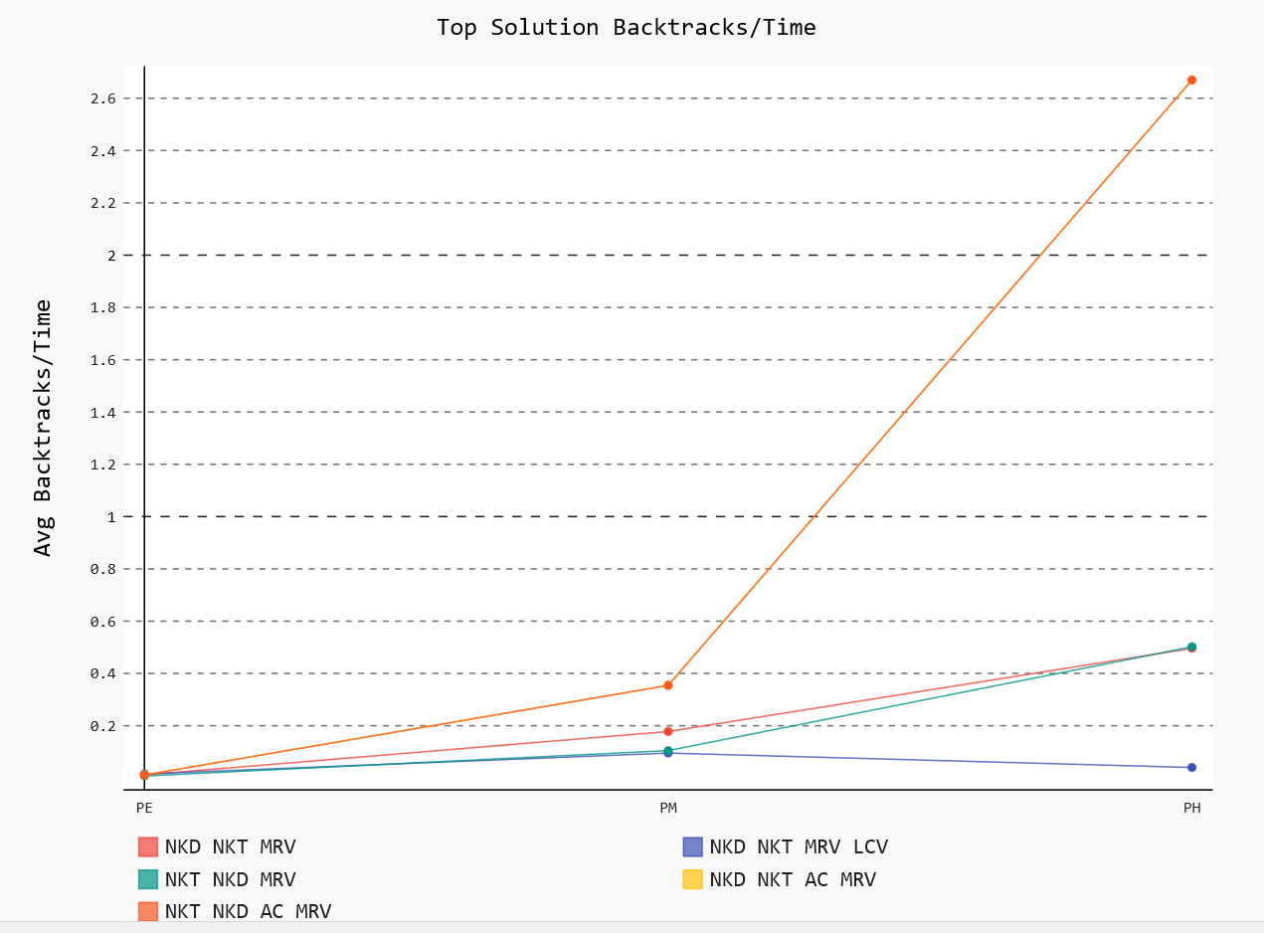

Looking at the charts for backtracks / time for all possible combinations, we can see that although NKD NKT MRV LCV has more space complexity, but it has less average time/backtracks. This is possibly due to the fact that LCV heuristics try to solve the problem as soon as possible, which result in more failure state. But overall, the runtime for this combination still ranks the second. This combination uses more space than NKD NKT MRV, but has less runtime.

On the other hand, NKD NKT MRV shows a reasonable balance among all three benchmarks, with runtime at the top, Number of Backtracks at 4th, and average time/backtrack at 2nd.

NKT NKD MRV has similar result with NKD NKT MRV. It is slightly slower, but uses slightly less space, and has the same average time/backtrack.

NKD NKT AC MRV and NKT NKD AC MRV has slower runtime among all five, but has less space complexity than the top 3. It seems to be reasonable strategy for people with less memory.

# 3.1 Conclusion

In this report we discussed different combinations and their performance measure at different difficulty level. We can conclude that the combination NKD, NKT, MRV and NKT NKD MRV is the best combination of all. It has the lowest average runtime, and its able to solve all problems.

However, it should be stressed that average runtime gives a good benchmark indicator for comparing each algorithms but it does not give a complete overall picture e.g. overall state space. It says nothing about the internal processing state.