**EPPS/GISC 4317: Python Programming for Social Sciences**

**Lab-1a: Introduction to course and Python**

**Objectives:**

* Downloading and installing Anaconda, and programming with Jupyter Notebooks as well.
* Once you need a guide, go to page 3 and review them.

**Homework (Tip: Be careful of your spacing!):**

* **Create a new Jupyter Notebook. Recreate the following text using markdown. First cell:**

**United States**

**Texas**

**Richardson**

**Green Hall**

3.402

* **In the second cell, write a sentence about one of your favorite movies that includes both bold and italic words. For example:**

My **favorite** movie, *The Two Towers*, has **beautiful** cinematography.

* **In the third cell, make a list of Fruits and a list of Veggies, with bulleted sub-lists of your favorite fruits and veggies, respectively.**
* **In the fourth cell, make a markdown heading titled “Mathematical”**
* **In the 5th through 8th cells, enter the following code and run:**

[5]:

# The sum of your choice of four floating values (replace with yours)

5.0 + 0.0001 + 8.9 + 2.003

[6]:

# Average age of the following kids: 9, 13, and 18

# Hint: Sum up the values and divide by the number of kids

(9 + 13 + 18) / 3

[7]:

# 9 squared minus 2 cubed

(9 ** 2) - (2 ** 3)

[8]:

# Quotient representing how many times your age can be divided by 3

19 // 3

* **In cell 9, use the markdown heading “Mathematical functions”**
* **In cells 10-12 enter and run:**

[6]:

# Highest bowling score among 68, 102, 147, 99, and 76

max(68, 102, 147, 99, 76)

[7]:

# Lowest ticket price among 19.99, 14.99, 9.99, and 24.99

min(19.99, 14.99, 9.99, 24.99)

[8]:

# Absolute value of wintertime temp in Canada: -28

abs(-28)

* **In cell 13, use the markdown heading “Boolean”**
* **In cells 14-17 enter and run:**

[9]:

# Price of three cups of coffee (2.50 each) is equal to the price of one beer (6.00)

2.50 * 3 == 6.00

[10]:

# Current year plus 25 years is less than or equal to 2050

2019 + 25 <= 2050

[11]:

# Your age times 2 is greater than 50...

# AND your age divided by 3 is less than 10

19 * 2 > 50 **and** 19 / 3 < 10

[12]:

# Movie ticket (12.99) is greater than a beer (6.00)...

# OR the price of a beer is less than a coffee (2.50)

12.99 > 6.00 **or** 6.00 < 2.50

* **At the top of each of your notebooks, you should always include:**
  + **Notebook title**
  + **Your name**
  + **Date you last updated the notebook**
  + **Purpose**

**Final Steps to submit your work:**

1. Save the above Jupyter Notebook as a PDF. You can either go to File->Download as->PDF in Jupyter, or if that doesn’t work, just use your browser’s Print functionality to print to PDF.
   1. Deliverable:
      1. PDF file to submit to eLearning

**Guide for homework**

**Task 1: Downloading & installing Anaconda**

1. You should only need to do this once per computer. If you use the same computer all semester then you won’t need to do it again. However if you switch computers, you will need to install Anaconda on the new machine as well.
2. Check the boxes to Show File Name Extension and Show Hidden File:

1. Open your Internet browser, go to: <https://anaconda.com/products/individual>
2. Scroll down to the bottom of the page where the downloads are. Lab tutorials in this course will assume you are using a Windows machine, but you have the option of using Mac or Linux as well if that is what you have. For Windows users, click “64-bit Graphical Installer.”
3. When it has finished downloading, run the setup file.
4. Click through the installation prompts until you get to “Installation Type.” Be sure to select “Just Me (recommended)”. This will allow you to install it even if you don’t have admin rights (such as in the lab).  
   Graphical user interface, text, application, email

   Description automatically generated
5. Click Next and choose the installation directory (the default

**C:\Users\UTD Net ID\AppData\Local\anaconda3** is fine).

1. On the next screen uncheck both boxes. Click Next and let it install. This will take several minutes.

1. Finally after it finishes installing, click through to finish the installer and then go to your Start Menu in Windows and you should see a folder of Anaconda3 applications.

1. The applications we will be using most this semester are Jupyter Notebook and Spyder. Click Jupyter Notebook to open Jupyter. A command prompt will open and then a few seconds later a new browser tab will open for Jupyter showing some directories.

1. Click the “New” button in the top right and click “Python 3” to create a new Python 3 notebook. Congratulations, you have successfully installed Anaconda & Jupyter! Leave this tab open while you complete the rest of the lab.

**Task 2: Programming in Jupyter Notebooks**

In this section we will learn to use Jupyter Notebooks.

**Step 1: The Python Window**

Anaconda includes Jupyter Notebooks as a built-in user interface. This serves as a quick and convenient way to run and prototype Python code.

1. Run Jupyter Notebook from the Start menu. If it does not show up, please refer back to last task to ensure you have installed Anaconda correctly.
2. It should open a new browser tab showing directories. Click the “New” button on the top right and select “Python 3” Notebook. A new tab should open for this Notebook.
3. Try running the following lines of code as cells in Jupyter (Don’t worry, we’ll get into the details about syntax next week). Use the + button to make a new cell:

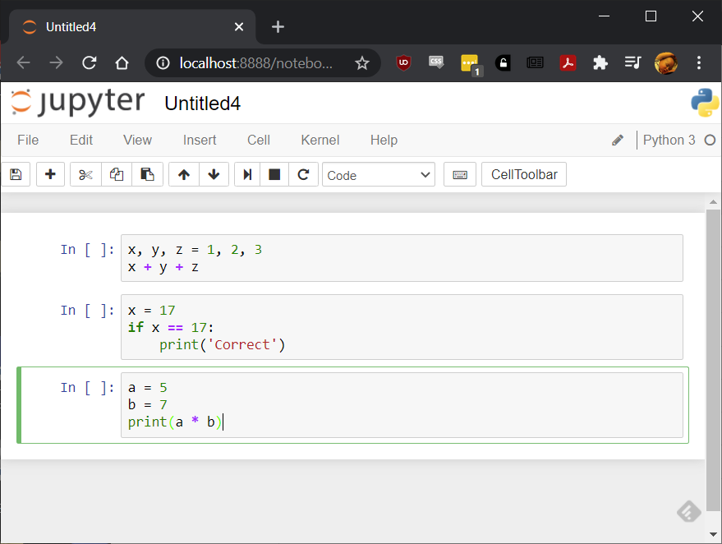

1. Let’s give our lab a meaningful name. Click on the “Untitled” title on top and change the name to Lab01.

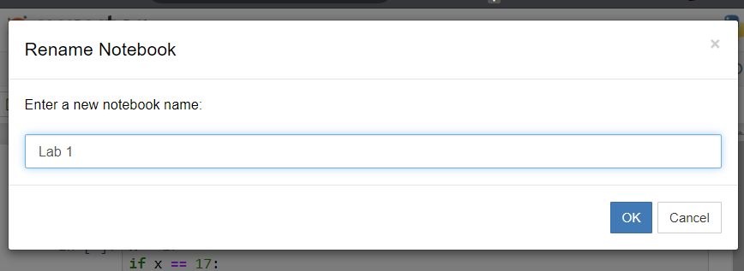

1. Jupyter automatically saves your notebook in the folder where you created it (usually at C:\User\your-netid). Check your folder for “Lab01.ipynb”. You can also create a sub-folder (like python-script) to store all homework.
2. In Jupyter you have the option of creating either a code cell or a markdown cell. Markdown cells are for documentation and making the notebook more human-readable. Let’s make a markdown cell above the first cell we entered. Highlight the first cell and go to Insert->Insert Cell Above.
3. In this new cell, change the type dropdown from Code to Markdown:

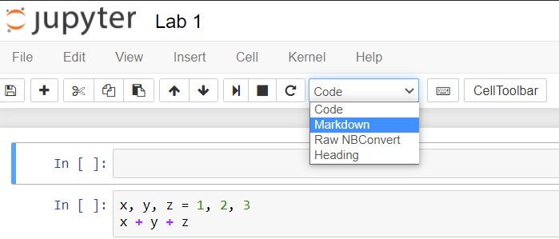

1. We can use the hashtag symbol in markdown to specify heading type, which corresponds to font size. Try entering the following and then press the Run button (or Shift+Enter) to see what happens (make sure you leave a space between the hashtag and the text):

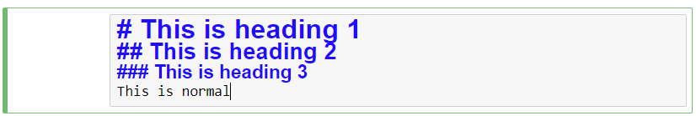

1. You can also change things like bold, italics, and bullets. Insert a new cell, change to Markdown and enter the following. Put two spaces at the end of the first line to force a new line:

