MVC

Model–View–Controller (MVC) is an architectural pattern used in software engineering. The pattern isolates business logic from input and presentation, permitting independent development, testing and maintenance of each.

- First described around 1980
- Many different derivatives, Model-View-Presenter (Passive View, Supervisor Controller), Presentation Model (Model-View-ViewModel) etc
- Many different implementations in web world– Java servlet, JSP, struct
- Ruby on Rails – 2004 David Heinemeier Hansson
- .NET monorails
- ASP.NET MVC

Ruby ob Rails – Design Philosophy

How to achieve simplicity

Convention over Configuration

A developer only needs to specify unconventional aspects of the application.

Opinionated Design

The designer believes there is one way (right way) to do things. Doing things the right way with the software, it will be very easy as the number of decisions that you have to make is reduced. On the other hand, doing things differently will be difficult and frustrating or even impossible.

Flexibility for Simplicity

ASP.NET MVC

ASP.NET MVC is…

Rails’ flavour of MVC implementation with .NET (ASP.NET on rails)

A new Web Project Type for ASP.NET.

On option

Not Web Form 4.0

Not replacement of ASP.NET Web Form. It is about alternative

It is build on top of ASP.NET infrastructure.

It has MemeberShip, Session, and Caching etc.

It doesn’t have Page Life cycle, ViewState

How does it work…

Browser initiates requests “/Product/List”

Route is determined

Controller (ProductController) is activated

Method (List) on Controller is invoke

List method does some stuff – load products data and push it to a view.

Renders View

Return the view back to the browser

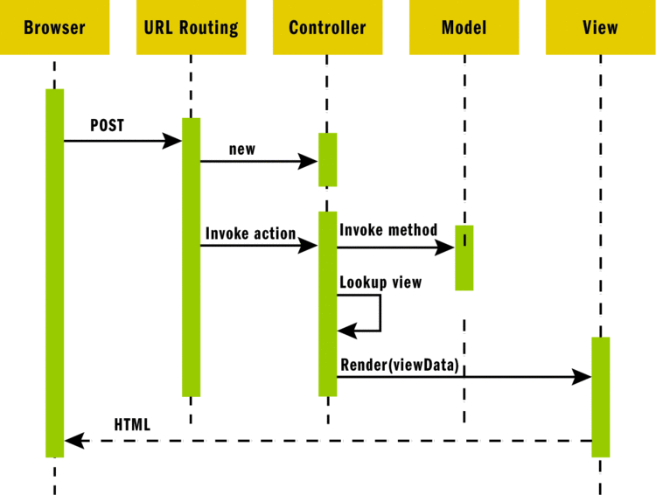

How different from ASP.NET Web Form…

Request / Response programming model

Not Event Driven programming model – not server side event

Doesn’t pretend to be stateful

No ViewState

Can’t use ServerControl (can’t use ServerControl which relies on ViewState)

Must write your own html

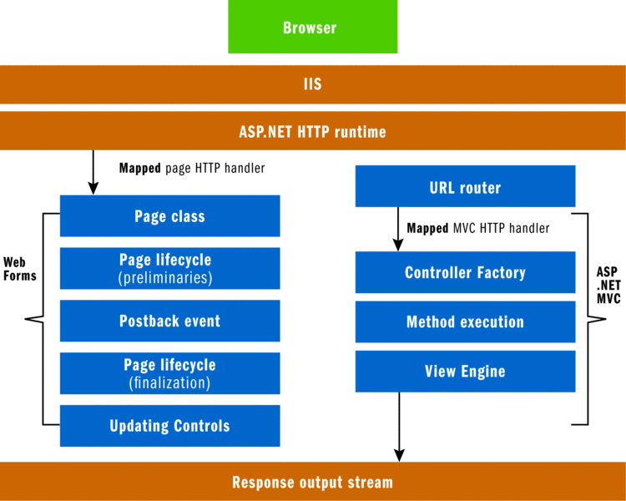

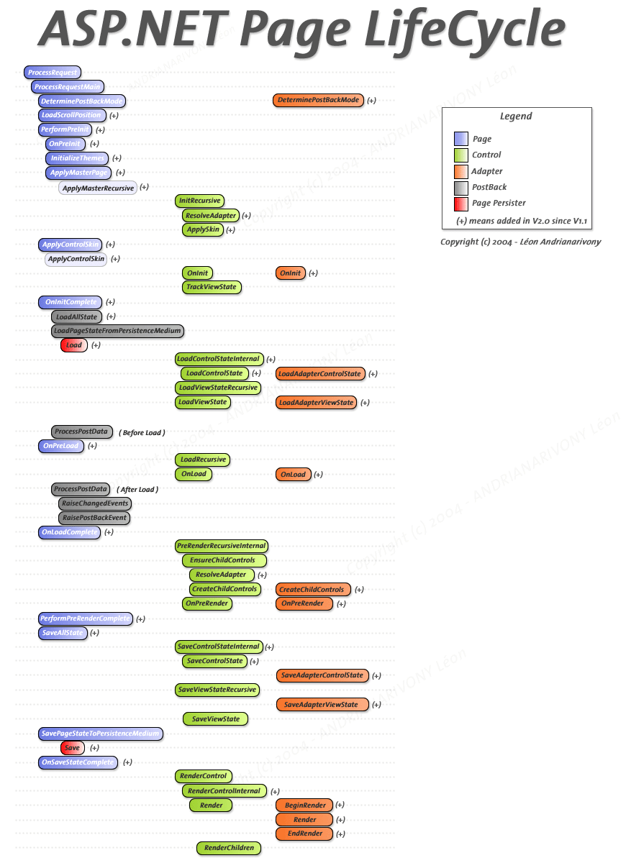

Benefits…

Simple – easy to learn, easy to use

Force clean separation of concerns

More control over your <html/>

A more easily Testable Framework

Plays Well With ajax

Programming ASP.NET 3.5 – 1166 pages

Programming Microsoft ASP.NET 3.5 - 1128 pages

Pro ASP.NET 3.5 in C# 2008 – 1498 pages

Professional ASP.NET 3.5 – 1704 pages

ASP.NET 3.5 Unleashed – 1920 pages

