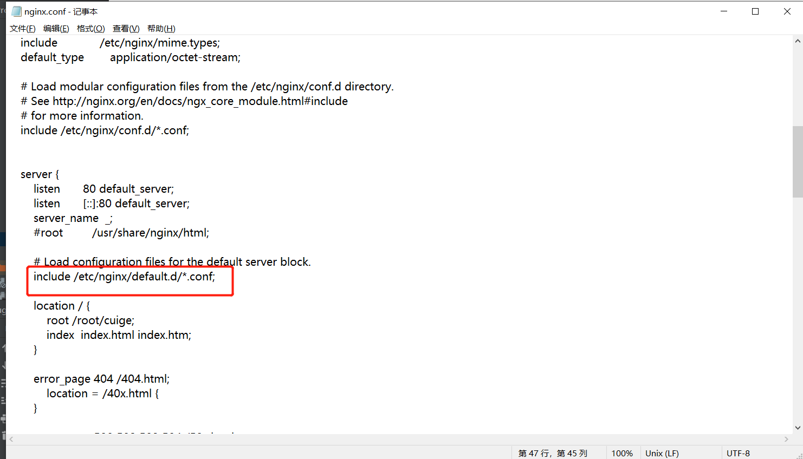

床垫项目：

server {

listen 9001;

server_name localhost;

#charset koi8-r;

#access_log logs/host.access.log main;

location / {

# root /root/changguoguo/end;

# index index.html index.htm;

root /root/wjc/dfkh/dist;

try_files $uri $uri/ /index.html;

}

location ~ ^/(backstage|merchant|equipment|miniapp) {

client_max_body_size 20m;

proxy_pass http://localhost:1001;

proxy_set_header Host $http_host;

proxy_set_header X-Real-IP $remote_addr;

proxy_set_header REMOTE-HOST $remote_addr;

proxy_set_header X-Forwarded-For $proxy_add_x_forwarded_for;

}

#error_page 404 /404.html;

# redirect server error pages to the static page /50x.html

#

error_page 500 502 503 504 /50x.html;

location = /50x.html {

root html;

}

===========================================================================

物业项目：

server {

listen 9000;

server_name localhost;

#charset koi8-r;

#access_log logs/host.access.log main;

location / {

root /root/wjc/dfkh/dist;

# index index.html index.htm;

try_files $uri $uri/ /index.html;

}

location /gykj-boot/ {

client_max_body_size 20m;

proxy_pass http://localhost:8010/;

proxy_set_header Host $http_host;

proxy_set_header X-Real-IP $remote_addr;

proxy_set_header REMOTE-HOST $remote_addr;

proxy_set_header X-Forwarded-For $proxy_add_x_forwarded_for;

}

#error_page 404 /404.html;

# redirect server error pages to the static page /50x.html

#

error_page 500 502 503 504 /50x.html;

location = /50x.html {

root html;

}